FORM 10-Q
UNITED STATES SECURITIES AND EXCHANGE COMMISSION
WASHINGTON, D.C. 20549
☒ |  |  | QUARTERLY REPORT PURSUANT TO SECTION 13 OR 15(d) OF THE SECURITIES EXCHANGE ACT OF 1934
 |  |  | For the quarterly period ended |  |  | June 30, 2026
☐ |  |  | TRANSITION REPORT PURSUANT TO SECTION 13 OR 15(d) OF THE SECURITIES EXCHANGE ACT OF 1934
 |  |  | For the transition period from ______ to ______
 |  |  | Commission file number |  |  | 1-10816

MGIC Investment Corporation
(Exact name of registrant as specified in its charter)
Wisconsin |  |  |  |  |  |  |  |  | 39-1486475
(State or other jurisdiction of incorporation or organization) |  |  |  |  |  |  |  |  | (I.R.S. Employer Identification No.)
250 E. Kilbourn Avenue |  |  |  |  |  |  |  |  | 53202
Milwaukee, |  |  | Wisconsin |  |  |  |  |  | (Zip Code)
(Address of principal executive offices)
(414) |  |  |  |  |  |  |  |  | 347-6480
(Registrant’s telephone number, including area code)

Securities registered pursuant to Section 12(b) of the Act:
Title of each class |  |  |  |  |  | Trading Symbol |  |  |  |  |  | Name of each exchange on which registered
Common stock |  |  |  |  |  | MTG |  |  |  |  |  | New York Stock Exchange

Indicate by check mark whether the registrant (1) has filed all reports required to be filed by Section 13 or 15(d) of the Securities Exchange Act of 1934 during the preceding 12 months (or for such shorter period that the registrant was required to file such reports), and (2) has been subject to such filing requirements for the past 90 days. Yes ☒ No ☐

Indicate by check mark whether the registrant has submitted electronically every Interactive Data File required to be submitted pursuant to Rule 405 of Regulation S-T during the preceding 12 months (or for such shorter period that the registrant was required to submit such files). Yes ☒ No ☐

Indicate by check mark whether the registrant is a large accelerated filer, an accelerated filer, a non-accelerated filer, or a smaller reporting company. See the definitions of “large accelerated filer,” “accelerated filer,” “smaller reporting company,” and “emerging growth company” in Rule 12b-2 of the Exchange Act. (Check one):
Large accelerated filer |  |  | ☒ |  |  | Accelerated filer ☐ |  |  | Non-accelerated filer ☐ |  |  | Smaller reporting company |  |  | ☐ |  |  | (Do not check if a smaller reporting company)
Emerging growth company |  |  | ☐ |  |  | If an emerging growth company, indicate by check mark if the registrant has elected not to use the extended transition period for complying with any new or revised financial accounting standards provided pursuant to Section 13(a) of the Exchange Act. o

Indicate by check mark whether the registrant is a shell company (as defined in Rule 12b-2 of the Exchange Act). YES ☐ NO x

Indicate the number of shares outstanding of each of the issuer’s classes of common stock, as of the latest practicable date: As of July 24, 2026, there were 205,124,840 shares of common stock of the registrant, par value $1.00 per share, outstanding.

Forward Looking Statements and Risk Factors
This report contains forward looking statements within the meaning of the U.S. Private Securities Litigation Reform Act of 1995. These statements are based on current assumptions, expectations, and projections and are subject to risks and uncertainties that could cause actual results to differ materially. Forward-looking statements consist of statements which relate to matters other than historical fact, including matters that inherently refer to future events. Among others, statements that include words such as "believe," "anticipate," "will" or "expect," or words of similar import, are forward-looking statements. Our actual results may differ, possibly materially, from those expressed or implied in such forward-looking statements. Factors and uncertainties that could cause actual results to differ can be found in the “Risk Factors” and “Forward-Looking Statements” sections included in MGIC Investment Corporation’s Annual Report on Form 10-K for the year ended December 31, 2025, as supplemented by our Quarterly Reports on Form 10-Q and other reports filed from time to time with the Securities and Exchange Commission. Such factors and uncertainties include, without limitation:
•Our results are dependent on U.S. economic and housing market conditions; adverse conditions may cause a decrease in new insurance written and/or an increase in delinquencies, claim frequency, and claim severity. Additionally, if the volume of low down payment home mortgage originations declines, the amount of new insurance that we write could decline.
•The substantial majority of MGIC’s new insurance written is for loans purchased by Fannie Mae and Freddie Mac (“the GSEs”); therefore, changes to their business practices or legislative, regulatory or administrative reforms could materially affect our business and financial results.
•Failure to comply with the GSEs’ Private Mortgage Insurance Eligibility Requirements (“PMIERs”) could limit our operations, or at the extreme, lead to suspension or termination of eligibility to insure loans purchased by the GSEs.
•Loss reserve estimates are subject to uncertainties; actual losses may differ materially from estimates. Additionally, because reserves are established only upon delinquency, losses may disproportionately impact earnings in certain periods.
•We operate in a highly regulated environment at both the federal and state levels; regulatory changes or enforcement actions may adversely affect our operations and/or financial results.
•If we fail to meet the State Capital Requirements of Wisconsin, we could be prevented from writing new business in all jurisdictions; we could be prevented from writing new business in a particular jurisdiction if we fail to meet the state capital requirements of that jurisdiction.
•Pandemics, severe weather events, and climate related developments may negatively affect home prices and affordability, potentially leading to an increase in delinquencies, claim frequency, and claim severity. Actions by government authorities, including FHFA and the GSEs, to address climate related issues could similarly affect our results.
•The availability, cost, and capital credit for reinsurance may change due to market conditions or GSE actions, potentially requiring us to retain more risk and maintain additional capital.
•Our financial results may be impacted if lenders and investors seek alternatives to private mortgage insurance. In addition, changes in GSE programs, growth in government market share, or changes to regulatory capital rules to limit capital relief for mortgage insurance could affect our business in similar ways.
•The premium rates we charge may prove inadequate due to unknown future economic conditions, modeling limitations or errors, or other unexpected events.
•The length of time our insurance policies remain in force (“persistency”) affects our results. Among other things, persistency can be influenced by interest rates, borrower equity, refinancing activity, and mortgage insurance cancellation requirements.
•Instability in financial markets or counterparty failures, including by reinsurers or mortgage servicers, could increase our credit risk and losses.
•Ineffective risk management programs, inaccurate data or model errors could impair our ability to identify and respond to risks, and materially adversely affect our business, results of operations, and financial condition.
•Technology system failures, cybersecurity breaches, or data privacy incidents could materially disrupt operations and cause financial and reputational damage.
•Changes in our underwriting practices and mix of business have the potential to increase risk and negatively affect our financial results.
•Our business depends on hiring and retaining experienced management and key personnel; the failure to do so could disrupt operations and negatively impact our financial condition.
•The mortgage insurance market is highly competitive. Competition from private mortgage insurers, government programs, and potential new market entrants —combined with pricing pressure and shifting customer preferences and relationships—could lead to a reduction in our new insurance written.
•Adverse rating agency actions could affect our competitiveness, GSE eligibility, and access to capital.
•Litigation and regulatory proceedings could result in fines, settlements, operational restrictions, or reputational harm.
•Our investment portfolio is exposed to risks that could adversely impact our operations and financial results. Future capital needs could require issuance of debt or equity, potentially diluting shareholders.
•Our stock price may fluctuate due to economic, industry, regulatory, or company specific developments.

MGIC Investment Corporation - Q2 2026 | 2

•Regulatory limits on dividends from our insurance subsidiaries have the potential to constrain holding company liquidity and our ability to pay shareholder dividends or repurchase stock in the future.
We are not undertaking any obligation to update any forward-looking statements or other statements we may make even though these statements may be affected by events or circumstances occurring after the forward looking statements or other statements were made. No investor should rely on the fact that such statements are current at any time other than the time at which this press release was delivered for dissemination to the public.

While we communicate with security analysts from time to time, it is against our policy to disclose to them any material non-public information or other confidential information. Accordingly, investors should not assume that we agree with any statement or report issued by any analyst irrespective of the content of the statement or report, and such reports are not our responsibility.

MGIC Investment Corporation and Subsidiaries
Form 10-Q
For the Quarter Ended June 30, 2026
Table of Contents
 |  |  |  |  |  | Page
PART I — FINANCIAL INFORMATION
Item 1 |  |  | Financial Statements:
 |  |  | Consolidated Balance Sheets - June 30, 2026 (Unaudited) and December 31, 2025 |  |  | 8
 |  |  | Consolidated Statements of Operations (Unaudited) - Three and Six Months Ended June 30, 2026 and 2025 |  |  | 9
 |  |  | Consolidated Statements of Comprehensive Income (Unaudited) - Three and Six Months Ended June 30, 2026 and 2025 |  |  | 10
 |  |  | Consolidated Statements of Shareholders’ Equity (Unaudited) - Three and Six Months Ended June 30, 2026 and 2025 |  |  | 11
 |  |  | Consolidated Statements of Cash Flows (Unaudited) - Six Months Ended June 30, 2026 and 2025 |  |  | 12
 |  |  | Notes to Consolidated Financial Statements (Unaudited) |  |  | 13
 |  |  | Note 1 - Nature of Business and Basis of Presentation |  |  | 13
 |  |  | Note 2 - Significant Accounting Policies |  |  | 13
 |  |  | Note 3 - Debt |  |  | 14
 |  |  | Note 4 - Earnings per Share |  |  | 14
 |  |  | Note 5 - Investments |  |  | 15
 |  |  | Note 6 - Fair Value Measurements |  |  | 18
 |  |  | Note 7 - Reinsurance |  |  | 20
 |  |  | Note 8 - Loss Reserves |  |  | 24
 |  |  | Note 9 - Other Comprehensive Income |  |  | 26
 |  |  | Note 10 - Benefit Plans |  |  | 27
 |  |  | Note 11 - Shareholders’ Equity |  |  | 28
 |  |  | Note 12 - Share-Based Compensation Plans |  |  | 28
 |  |  | Note 13 - Statutory Information |  |  | 29
 |  |  | Note 14 - Segment Reporting |  |  | 30
 |  |  | Note 15 - Litigation and Contingencies |  |  | 30
Item 2 |  |  | Management's Discussion and Analysis of Financial Condition and Results of Operations |  |  | 31
Item 3 |  |  | Quantitative and Qualitative Disclosures about Market Risk |  |  | 55
Item 4 |  |  | Controls and Procedures |  |  | 55
PART II — OTHER INFORMATION
Item 1 |  |  | Legal Proceedings |  |  | 56
Item 1A |  |  | Risk Factors |  |  | 56
Item 2 |  |  | Unregistered Sales of Equity Securities and Use of Proceeds |  |  | 56
Item 5 |  |  | Other Information |  |  | 56
Item 6 |  |  | Exhibits |  |  | 58
INDEX TO EXHIBITS |  |  |  |  |  | 58
SIGNATURES |  |  |  |  |  | 59

MGIC Investment Corporation - Q2 2026 | 4

Glossary of Terms and Acronyms
/ A
ARMs
Adjustable rate mortgages

ABS
Asset-backed securities

Annual Persistency
The percentage of our insurance remaining in force from one year prior.

ASC
Accounting Standards Codification

Available Assets
Assets, as designated under the PMIERs, that are readily available to pay claims, and include the most liquid investments

/ B
Book or book year
A group of loans insured in a particular calendar year

BPMI
Borrower-paid mortgage insurance

BPS
Basis points

/ C
CFPB
Consumer Financial Protection Bureau

CLO
Collateralized loan obligations

CMBS
Commercial mortgage-backed securities

COVID-19 Pandemic
An outbreak of the novel coronavirus disease, later named COVID-19. The outbreak of COVID-19 was declared a pandemic by the World Health Organization and a national emergency in the United States in March 2020.

Credit Score
A measure of consumer credit risk produced using credit scoring methodologies and data collected by the credit bureaus.

CRT
Credit risk transfer. The transfer of a portion of mortgage credit risk to the private sector through different forms of transactions and structures.

/ D
DAC
Deferred insurance policy acquisition costs

Debt-to-Income (“DTI”) Ratio
The ratio, expressed as a percentage, of a borrower’s total debt payments to gross income.

Delinquent Loan
A loan that is past due on a mortgage payment. A delinquent loan is typically reported to us by servicers when the loan has missed two or more payments. A loan will continue to be reported as delinquent until it becomes current, or a claim payment has been made. A delinquent loan is also referred to as a default.

Delinquency Rate
The percentage of insured loans that are delinquent

Direct
Before giving effect to reinsurance

/ E
EPS
Earnings per share

/ F
Fannie Mae
Federal National Mortgage Association

FCRA
Fair Credit Reporting Act

FHA
Federal Housing Administration

FHFA
Federal Housing Finance Agency

FHLB
Federal Home Loan Bank of Chicago, of which MGIC is a member

Freddie Mac
Federal Home Loan Mortgage Corporation

/ G
GAAP
Generally Accepted Accounting Principles in the United States

GSEs
Government Sponsored Enterprise. Collectively, Fannie Mae and Freddie Mac

/ H
Home Re Entities
Unaffiliated special purpose insurers domiciled in Bermuda that participate in our aggregate XOL Transactions through the ILN market

Home Re Transactions
MGIC Investment Corporation - Q2 2026 | 5

Excess-of-loss reinsurance transactions with the Home Re Entities

HOPA
Homeowners Protection Act

/ I
IBNR Reserves
Loss reserves established on loans we estimate are delinquent, but for which the delinquency has not been reported to us

IIF
Insurance in force is the unpaid principal balance, either reported to us by mortgage servicers or estimated by us, for the loans we insure.

ILN
Insurance-linked notes

/ L
LAE
Loss adjustment expenses, which includes the costs of settling claims, including legal and other expenses and general expenses of administering the claims settlement process

Loan-to-value ("LTV") ratio
The ratio, expressed as a percentage, of the dollar amount of the first mortgage loan to the value of the property at the time the loan became insured and does not reflect subsequent housing price appreciation or depreciation. Subordinate mortgages may also be present.

Long-Term Debt:
5.25% Notes
5.25% Senior Notes due on August 15, 2028, with interest payable semi-annually on February 15 and August 15 of each year

Loss Ratio
The ratio, expressed as a percentage, of losses incurred, net to net premiums earned

Low Down Payment Loans or Mortgages
Loans with less than 20% down payments

LPMI
Lender-paid mortgage insurance

/ M
MBS
Mortgage-backed securities

MD&A
Management's discussion and analysis of financial condition and results of operations

MGIC
Mortgage Guaranty Insurance Corporation, a subsidiary of MGIC Investment Corporation

MAC
MGIC Assurance Corporation, a subsidiary of MGIC

Minimum Required Assets
The minimum amount of Available Assets that must be held under the PMIERs which is based on an insurer’s book of RIF and is calculated from tables of factors with several risk dimensions, reduced for credit given for risk ceded under reinsurance transactions, and subject to a floor of $400 million

MPP
Minimum Policyholder Position, as required under certain state requirements. The “policyholder position” of a mortgage insurer is its net worth or surplus, contingency reserve and a portion of the reserves for unearned premiums.

/ N
N/A
Not applicable for the period presented

NAIC
The National Association of Insurance Commissioners

NIW
New Insurance Written, is the aggregate original principal amount of new mortgages that are insured for the first time during a period.

N/M
Data or calculation deemed not meaningful for the period presented

NPL Settlement
The commutation of coverage on non-performing loans, which are delinquent loans, at any stage in their delinquency.

/ O
OCI
Office of the Commissioner of Insurance of the State of Wisconsin

/ P
PMI
Private Mortgage Insurance (as an industry or product type)

PMIERs
Private Mortgage Insurer Eligibility Requirements issued by each of Fannie Mae and Freddie Mac to set forth requirements that an approved insurer must meet and maintain to provide mortgage guaranty insurance on loans delivered to or acquired by Fannie Mae or Freddie Mac, as applicable

Premium Yield
The ratio of premium earned divided by the average IIF outstanding for the period measured

Premium Rate
The contractual rate charged for coverage under our insurance policies
MGIC Investment Corporation - Q2 2026 | 6

Primary Insurance
Insurance that provides mortgage default protection on individual loans

Profit Commission
Payments we receive from reinsurers under each of our quota share reinsurance transactions if the annual loss ratio is below levels specified in the quota share reinsurance transaction

/ Q
QSR Transaction
Quota share reinsurance transaction with a group of unaffiliated reinsurers

/ R
RESPA
Real Estate Settlement Procedures Act

RIF
Risk in force, which for an individual loan insured by us, is equal to the unpaid loan principal balance, as reported to us, multiplied by the insurance coverage percentage. RIF is sometimes referred to as exposure.

Risk-to-Capital
Under certain state regulations, the ratio of RIF, net of reinsurance and exposure on policies currently in default and for which loss reserves have been established, to the level of statutory capital

RMBS
Residential mortgage-backed securities

/ S
State Capital Requirements
Under certain state regulations, the minimum amount of statutory capital relative to risk in force (or similar measure)

/ T
TILA
Truth in Lending Act

Traditional XOL Transaction
Excess-of-loss reinsurance transaction with a group of unaffiliated reinsurers

/ U
Underwriting expense ratio
The ratio, expressed as a percentage, of other underwriting and operating expenses, net, and amortization of DAC to net premiums written

Underwriting Profit
Net premiums earned minus losses incurred, net and other underwriting and operating expenses, net

USDA
U.S. Department of Agriculture

/ V
VA
U.S. Department of Veterans Affairs

VIE
Variable interest entity

/ X
XOL Transactions
Excess-of-loss reinsurance transactions executed through the Home Re Transactions and the Traditional XOL Transactions

MGIC Investment Corporation - Q2 2026 | 7

PART I. Financial Information

Item 1. Financial Statements

MGIC Investment Corporation and Subsidiaries
Consolidated Balance Sheets
(In thousands) |  |  |  |  |  |  |  |  | Note |  |  |  |  |  | June 30, 2026 |  |  |  |  |  | December 31, 2025
 |  |  |  |  |  |  |  |  |  |  |  |  |  |  | (Unaudited)
Assets
Investment portfolio: |  |  |  |  |  |  |  |  | 5 / 6
Fixed income, available-for-sale, at fair value (amortized cost 2026 - $5,632,757; 2025 - $5,642,929) |  |  |  |  |  |  |  |  |  |  |  |  |  |  | $ | 5,436,128 |  |  |  |  | $ | 5,489,945
Short-term, fixed income, available-for-sale, at fair value (amortized cost 2026 - $265,029; 2025 - $301,072) |  |  |  |  |  |  |  |  |  |  |  |  |  |  | 264,930 |  |  |  |  |  | 301,286
Equity securities, at fair value (cost 2026 - $16,360; 2025 - $16,286) |  |  |  |  |  |  |  |  |  |  |  |  |  |  | 15,274 |  |  |  |  |  | 15,322
Other invested assets, at cost |  |  |  |  |  |  |  |  |  |  |  |  |  |  | 1,109 |  |  |  |  |  | 1,109
Total investment portfolio |  |  |  |  |  |  |  |  |  |  |  |  |  |  | 5,717,441 |  |  |  |  |  | 5,807,662
Cash and cash equivalents |  |  |  |  |  |  |  |  |  |  |  |  |  |  | 207,277 |  |  |  |  |  | 368,989
Restricted cash and cash equivalents |  |  |  |  |  |  |  |  |  |  |  |  |  |  | 7,819 |  |  |  |  |  | 6,525
Accrued investment income |  |  |  |  |  |  |  |  |  |  |  |  |  |  | 57,594 |  |  |  |  |  | 58,009
Reinsurance recoverable on loss reserves |  |  |  |  |  |  |  |  | 7 |  |  |  |  |  | 76,144 |  |  |  |  |  | 65,055
Reinsurance recoverable on paid losses |  |  |  |  |  |  |  |  | 7 |  |  |  |  |  | 5,437 |  |  |  |  |  | 4,386
Premiums receivable |  |  |  |  |  |  |  |  |  |  |  |  |  |  | 69,694 |  |  |  |  |  | 58,184
Home office and equipment, net |  |  |  |  |  |  |  |  |  |  |  |  |  |  | 31,604 |  |  |  |  |  | 32,454
Deferred insurance policy acquisition costs |  |  |  |  |  |  |  |  |  |  |  |  |  |  | 7,473 |  |  |  |  |  | 8,377
Deferred income taxes, net |  |  |  |  |  |  |  |  |  |  |  |  |  |  | 131,243 |  |  |  |  |  | 18,512
Other assets |  |  |  |  |  |  |  |  |  |  |  |  |  |  | 215,256 |  |  |  |  |  | 211,333
Total Assets |  |  |  |  |  |  |  |  |  |  |  |  |  |  | $ | 6,526,982 |  |  |  |  | $ | 6,639,486
Liabilities and Shareholders’ Equity
Liabilities:
Loss reserves |  |  |  |  |  |  |  |  | 8 |  |  |  |  |  | $ | 492,001 |  |  |  |  | $ | 474,884
Unearned premiums |  |  |  |  |  |  |  |  |  |  |  |  |  |  | 84,511 |  |  |  |  |  | 93,026
Senior notes |  |  |  |  |  |  |  |  | 3 |  |  |  |  |  | 646,874 |  |  |  |  |  | 646,138
Federal tax credits payable |  |  |  |  |  |  |  |  |  |  |  |  |  |  | 162,624 |  |  |  |  |  | 135,344
Other liabilities |  |  |  |  |  |  |  |  |  |  |  |  |  |  | 127,613 |  |  |  |  |  | 142,543
Total Liabilities |  |  |  |  |  |  |  |  |  |  |  |  |  |  | 1,513,623 |  |  |  |  |  | 1,491,935
Contingencies |  |  |  |  |  |  |  |  | 15
Shareholders’ equity: |  |  |  |  |  |  |  |  | 11
Common stock ($1 par value, shares authorized 1,000,000; shares issued and outstanding 2026 - 206,603; 2025 - 219,367) |  |  |  |  |  |  |  |  |  |  |  |  |  |  | 206,603 |  |  |  |  |  | 219,367
Paid-in capital |  |  |  |  |  |  |  |  |  |  |  |  |  |  | 1,801,258 |  |  |  |  |  | 1,812,463
Accumulated other comprehensive income (loss), net of tax |  |  |  |  |  |  |  |  | 9 |  |  |  |  |  | (168,823) |  |  |  |  |  | (134,394)
Retained earnings |  |  |  |  |  |  |  |  |  |  |  |  |  |  | 3,174,321 |  |  |  |  |  | 3,250,115
Total Shareholders’ Equity |  |  |  |  |  |  |  |  |  |  |  |  |  |  | 5,013,359 |  |  |  |  |  | 5,147,551
Total Liabilities and Shareholders’ Equity |  |  |  |  |  |  |  |  |  |  |  |  |  |  | $ | 6,526,982 |  |  |  |  | $ | 6,639,486

See accompanying notes to consolidated financial statements.

MGIC Investment Corporation - Q2 2026 | 8

MGIC Investment Corporation and Subsidiaries
Consolidated Statements of Operations (Unaudited)
 |  |  |  |  |  |  |  |  |  |  |  |  |  |  | Three Months Ended June 30, |  |  |  |  |  |  |  |  |  |  |  | Six Months Ended June 30,
(In thousands, except per share data) |  |  |  |  |  |  |  |  | Note |  |  |  |  |  | 2026 |  |  |  |  |  | 2025 |  |  |  |  |  | 2026 |  |  |  |  |  | 2025
Revenues:
Premiums written:
Direct |  |  |  |  |  |  |  |  |  |  |  |  |  |  | $ | 279,441 |  |  |  |  | $ | 277,206 |  |  |  |  | $ | 565,963 |  |  |  |  | $ | 553,677
Assumed |  |  |  |  |  |  |  |  |  |  |  |  |  |  | 2,483 |  |  |  |  |  | 3,717 |  |  |  |  |  | 6,448 |  |  |  |  |  | 7,255
Ceded |  |  |  |  |  |  |  |  | 7 |  |  |  |  |  | (51,962) |  |  |  |  |  | (43,539) |  |  |  |  |  | (107,506) |  |  |  |  |  | (88,202)
Net premiums written |  |  |  |  |  |  |  |  |  |  |  |  |  |  | 229,962 |  |  |  |  |  | 237,384 |  |  |  |  |  | 464,905 |  |  |  |  |  | 472,730
Decrease in unearned premiums, net |  |  |  |  |  |  |  |  |  |  |  |  |  |  | 8,095 |  |  |  |  |  | 6,938 |  |  |  |  |  | 8,515 |  |  |  |  |  | 15,311
Net premiums earned |  |  |  |  |  |  |  |  | 7 |  |  |  |  |  | 238,057 |  |  |  |  |  | 244,322 |  |  |  |  |  | 473,420 |  |  |  |  |  | 488,041
Investment income, net of expenses |  |  |  |  |  |  |  |  |  |  |  |  |  |  | 59,465 |  |  |  |  |  | 60,995 |  |  |  |  |  | 121,207 |  |  |  |  |  | 122,438
Net gains (losses) on investments and other financial instruments |  |  |  |  |  |  |  |  | 5 |  |  |  |  |  | (2,226) |  |  |  |  |  | (1,426) |  |  |  |  |  | (2,395) |  |  |  |  |  | (685)
Other revenue |  |  |  |  |  |  |  |  |  |  |  |  |  |  | 92 |  |  |  |  |  | 354 |  |  |  |  |  | 233 |  |  |  |  |  | 685
Total Revenues |  |  |  |  |  |  |  |  |  |  |  |  |  |  | 295,388 |  |  |  |  |  | 304,245 |  |  |  |  |  | 592,465 |  |  |  |  |  | 610,479
Losses and Expenses:
Losses incurred, net |  |  |  |  |  |  |  |  | 8 |  |  |  |  |  | 10,986 |  |  |  |  |  | (2,835) |  |  |  |  |  | 44,228 |  |  |  |  |  | 6,756
Amortization of deferred insurance policy acquisition costs |  |  |  |  |  |  |  |  |  |  |  |  |  |  | 1,297 |  |  |  |  |  | 1,738 |  |  |  |  |  | 2,521 |  |  |  |  |  | 3,395
Other underwriting and operating expenses, net |  |  |  |  |  |  |  |  | 14 |  |  |  |  |  | 44,278 |  |  |  |  |  | 50,354 |  |  |  |  |  | 91,162 |  |  |  |  |  | 101,760
Interest expense |  |  |  |  |  |  |  |  |  |  |  |  |  |  | 8,899 |  |  |  |  |  | 8,899 |  |  |  |  |  | 17,798 |  |  |  |  |  | 17,798
Total Losses and Expenses |  |  |  |  |  |  |  |  |  |  |  |  |  |  | 65,460 |  |  |  |  |  | 58,156 |  |  |  |  |  | 155,709 |  |  |  |  |  | 129,709
Income before tax |  |  |  |  |  |  |  |  |  |  |  |  |  |  | 229,928 |  |  |  |  |  | 246,089 |  |  |  |  |  | 436,756 |  |  |  |  |  | 480,770
Provision for income tax |  |  |  |  |  |  |  |  |  |  |  |  |  |  | 47,783 |  |  |  |  |  | 53,607 |  |  |  |  |  | 89,308 |  |  |  |  |  | 102,828
Net Income |  |  |  |  |  |  |  |  |  |  |  |  |  |  | $ | 182,145 |  |  |  |  | $ | 192,482 |  |  |  |  | $ | 347,448 |  |  |  |  | $ | 377,942
Earnings per share:
Basic |  |  |  |  |  |  |  |  | 4 |  |  |  |  |  | $ | 0.87 |  |  |  |  | $ | 0.81 |  |  |  |  | $ | 1.63 |  |  |  |  | $ | 1.57
Diluted |  |  |  |  |  |  |  |  | 4 |  |  |  |  |  | $ | 0.86 |  |  |  |  | $ | 0.81 |  |  |  |  | $ | 1.62 |  |  |  |  | $ | 1.56
Weighted average common shares outstanding - basic |  |  |  |  |  |  |  |  | 4 |  |  |  |  |  | 209,923 |  |  |  |  |  | 236,333 |  |  |  |  |  | 213,012 |  |  |  |  |  | 240,218
Weighted average common shares outstanding - diluted |  |  |  |  |  |  |  |  | 4 |  |  |  |  |  | 210,945 |  |  |  |  |  | 237,971 |  |  |  |  |  | 214,548 |  |  |  |  |  | 242,209

See accompanying notes to consolidated financial statements.

MGIC Investment Corporation - Q2 2026 | 9

MGIC Investment Corporation and Subsidiaries
Consolidated Statements of Comprehensive Income (Unaudited)
 |  |  |  |  |  |  |  |  |  |  |  | Three Months Ended June 30, |  |  |  |  |  |  |  |  |  |  |  | Six Months Ended June 30,
(In thousands) |  |  |  |  |  | Note |  |  |  |  |  | 2026 |  |  |  |  |  | 2025 |  |  |  |  |  | 2026 |  |  |  |  |  | 2025
Net Income |  |  |  |  |  |  |  |  |  |  |  | $ | 182,145 |  |  |  |  | $ | 192,482 |  |  |  |  | $ | 347,448 |  |  |  |  | $ | 377,942
Other comprehensive income (loss), net of tax: |  |  |  |  |  | 9
Change in unrealized investment gains and losses |  |  |  |  |  | 5 |  |  |  |  |  | (1,491) |  |  |  |  |  | 28,523 |  |  |  |  |  | (34,729) |  |  |  |  |  | 80,194
Benefit plan adjustments |  |  |  |  |  |  |  |  |  |  |  | 150 |  |  |  |  |  | 2,953 |  |  |  |  |  | 300 |  |  |  |  |  | 2,999
Other comprehensive income (loss), net of tax |  |  |  |  |  |  |  |  |  |  |  | (1,341) |  |  |  |  |  | 31,476 |  |  |  |  |  | (34,429) |  |  |  |  |  | 83,193
Comprehensive Income (Loss) |  |  |  |  |  |  |  |  |  |  |  | $ | 180,804 |  |  |  |  | $ | 223,958 |  |  |  |  | $ | 313,019 |  |  |  |  | $ | 461,135

See accompanying notes to consolidated financial statements.

MGIC Investment Corporation - Q2 2026 | 10

MGIC Investment Corporation and Subsidiaries
Consolidated Statements of Shareholders' Equity (Unaudited)
 |  |  |  |  |  |  |  |  |  |  |  | Three Months Ended June 30, |  |  |  |  |  |  |  |  |  |  |  | Six Months Ended June 30,
(In thousands) |  |  |  |  |  | Note |  |  |  |  |  | 2026 |  |  |  |  |  | 2025 |  |  |  |  |  | 2026 |  |  |  |  |  | 2025
Common Stock
Balance, beginning of period |  |  |  |  |  |  |  |  |  |  |  | $ | 213,200 |  |  |  |  | $ | 240,194 |  |  |  |  | $ | 219,367 |  |  |  |  | $ | 248,449
Issuance of common stock, net under share-based compensation plans |  |  |  |  |  | 12 |  |  |  |  |  | 26 |  |  |  |  |  | 65 |  |  |  |  |  | 1,068 |  |  |  |  |  | 1,045
Purchases of common stock |  |  |  |  |  | 11 |  |  |  |  |  | (6,623) |  |  |  |  |  | (7,121) |  |  |  |  |  | (13,832) |  |  |  |  |  | (16,356)
Balance, end of period |  |  |  |  |  |  |  |  |  |  |  | 206,603 |  |  |  |  |  | 233,138 |  |  |  |  |  | 206,603 |  |  |  |  |  | 233,138
Paid-in Capital
Balance, beginning of period |  |  |  |  |  |  |  |  |  |  |  | 1,795,697 |  |  |  |  |  | 1,796,475 |  |  |  |  |  | 1,812,463 |  |  |  |  |  | 1,808,236
Issuance of common stock, net under share-based compensation plans |  |  |  |  |  | 12 |  |  |  |  |  | (264) |  |  |  |  |  | (98) |  |  |  |  |  | (23,461) |  |  |  |  |  | (19,946)
Equity compensation |  |  |  |  |  | 12 |  |  |  |  |  | 5,825 |  |  |  |  |  | 4,782 |  |  |  |  |  | 12,256 |  |  |  |  |  | 12,869
Balance, end of period |  |  |  |  |  |  |  |  |  |  |  | 1,801,258 |  |  |  |  |  | 1,801,159 |  |  |  |  |  | 1,801,258 |  |  |  |  |  | 1,801,159
Accumulated Other Comprehensive Income (Loss)
Balance, beginning of period |  |  |  |  |  |  |  |  |  |  |  | (167,482) |  |  |  |  |  | (236,445) |  |  |  |  |  | (134,394) |  |  |  |  |  | (288,162)
Other comprehensive income (loss), net of tax |  |  |  |  |  | 9 |  |  |  |  |  | (1,341) |  |  |  |  |  | 31,476 |  |  |  |  |  | (34,429) |  |  |  |  |  | 83,193
Balance, end of period |  |  |  |  |  |  |  |  |  |  |  | (168,823) |  |  |  |  |  | (204,969) |  |  |  |  |  | (168,823) |  |  |  |  |  | (204,969)
Retained Earnings
Balance, beginning of period |  |  |  |  |  |  |  |  |  |  |  | 3,195,872 |  |  |  |  |  | 3,339,660 |  |  |  |  |  | 3,250,115 |  |  |  |  |  | 3,403,852
Purchases of common stock |  |  |  |  |  | 11 |  |  |  |  |  | (171,734) |  |  |  |  |  | (175,327) |  |  |  |  |  | (358,741) |  |  |  |  |  | (392,431)
Net income |  |  |  |  |  |  |  |  |  |  |  | 182,145 |  |  |  |  |  | 192,482 |  |  |  |  |  | 347,448 |  |  |  |  |  | 377,942
Cash dividends |  |  |  |  |  | 11 |  |  |  |  |  | (31,962) |  |  |  |  |  | (31,199) |  |  |  |  |  | (64,501) |  |  |  |  |  | (63,747)
Balance, end of period |  |  |  |  |  |  |  |  |  |  |  | 3,174,321 |  |  |  |  |  | 3,325,616 |  |  |  |  |  | 3,174,321 |  |  |  |  |  | 3,325,616
Total Shareholders’ Equity |  |  |  |  |  |  |  |  |  |  |  | $ | 5,013,359 |  |  |  |  | $ | 5,154,944 |  |  |  |  | $ | 5,013,359 |  |  |  |  | $ | 5,154,944

See accompanying notes to consolidated financial statements.

MGIC Investment Corporation - Q2 2026 | 11

MGIC Investment Corporation and Subsidiaries
Consolidated Statements of Cash Flows (Unaudited)
 |  |  |  |  |  | Six Months Ended June 30,
(In thousands) |  |  |  |  |  | 2026 |  |  |  |  |  | 2025
Cash flows from operating activities:
Net income |  |  |  |  |  | $ | 347,448 |  |  |  |  | $ | 377,942
Adjustments to reconcile net income to net cash provided by operating activities:
Depreciation and amortization |  |  |  |  |  | 1,870 |  |  |  |  |  | 5,228
Deferred tax expense (benefit) |  |  |  |  |  | 5,456 |  |  |  |  |  | 5,943
Equity compensation |  |  |  |  |  | 12,256 |  |  |  |  |  | 12,869
Net (gains) losses on investments and other financial instruments |  |  |  |  |  | 2,395 |  |  |  |  |  | 685
Change in certain assets and liabilities:
Accrued investment income |  |  |  |  |  | 415 |  |  |  |  |  | 1,958
Reinsurance recoverable on loss reserves |  |  |  |  |  | (11,089) |  |  |  |  |  | (6,500)
Reinsurance recoverable on paid losses |  |  |  |  |  | (1,051) |  |  |  |  |  | 2,156
Premiums receivable |  |  |  |  |  | (11,510) |  |  |  |  |  | 300
Deferred insurance policy acquisition costs |  |  |  |  |  | 904 |  |  |  |  |  | 1,420
Loss reserves |  |  |  |  |  | 17,117 |  |  |  |  |  | (10,508)
Unearned premiums |  |  |  |  |  | (8,515) |  |  |  |  |  | (15,311)
Current income taxes |  |  |  |  |  | (74,394) |  |  |  |  |  | 61,484
Other, net |  |  |  |  |  | (19,436) |  |  |  |  |  | (31,019) |  |  | (1)
Net cash provided by (used in) operating activities |  |  |  |  |  | 261,866 |  |  |  |  |  | 406,647
Cash flows from investing activities:
Purchases of investments |  |  |  |  |  | (779,539) |  |  |  |  |  | (771,072)
Proceeds from sales of investments |  |  |  |  |  | 58,450 |  |  |  |  |  | 41,017
Proceeds from maturity of fixed income securities |  |  |  |  |  | 765,722 |  |  |  |  |  | 882,984
Additions to property and equipment |  |  |  |  |  | (657) |  |  |  |  |  | (145)
Net cash provided by (used in) investing activities |  |  |  |  |  | 43,976 |  |  |  |  |  | 152,784
Cash flows from financing activities:
Repurchase of common stock |  |  |  |  |  | (377,048) |  |  |  |  |  | (411,585)
Dividends paid |  |  |  |  |  | (66,819) |  |  |  |  |  | (64,677)
Payment of withholding taxes related to share-based compensation net share settlement |  |  |  |  |  | (22,393) |  |  |  |  |  | (18,901)
Net cash provided by (used in) financing activities |  |  |  |  |  | (466,260) |  |  |  |  |  | (495,163)
Net increase (decrease) in cash and cash equivalents and restricted cash and cash equivalents |  |  |  |  |  | (160,418) |  |  |  |  |  | 64,268
Cash and cash equivalents and restricted cash and cash equivalents at beginning of period |  |  |  |  |  | 375,514 |  |  |  |  |  | 234,627
Cash and cash equivalents and restricted cash and cash equivalents at end of period |  |  |  |  |  | $ | 215,096 |  |  |  |  | $ | 298,895
(1) Certain amounts have been reclassified to conform with current year presentation

See accompanying notes to consolidated financial statements.

MGIC Investment Corporation - Q2 2026 | 12

MGIC Investment Corporation and Subsidiaries
Notes to Consolidated Financial Statements
June 30, 2026
(Unaudited)

Note 1. Nature of Business and Basis of Presentation
MGIC Investment Corporation is a holding company which, through Mortgage Guaranty Insurance Corporation (“MGIC”), is principally engaged in the mortgage insurance business. We provide mortgage insurance to lenders throughout the United States and to government sponsored entities to protect against loss from defaults on low down payment residential mortgage loans. MGIC Assurance Corporation (“MAC”) and MGIC Indemnity Corporation (“MIC”), insurance subsidiaries of MGIC, provide insurance for certain mortgages under Fannie Mae and Freddie Mac (the “GSEs”) credit risk transfer programs. We operate as a single segment for purposes of evaluating financial performance and allocating resources.

The accompanying unaudited consolidated financial statements of MGIC Investment Corporation and its wholly-owned subsidiaries have been prepared in accordance with the instructions to Form 10-Q as prescribed by the Securities and Exchange Commission (“SEC”) for interim reporting and do not include all of the other information and disclosures required by accounting principles generally accepted in the United States of America (“GAAP”). These statements should be read in conjunction with the consolidated financial statements and notes thereto for the year ended December 31, 2025 included in our 2025 Annual Report on Form 10-K. As used below, “we,” “our” and “us” refer to MGIC Investment Corporation’s consolidated operations or to MGIC Investment Corporation, as the context requires.

In the opinion of management, the accompanying financial statements include all adjustments, consisting primarily of normal recurring accruals, necessary to fairly state our consolidated financial position and consolidated results of operations for the periods indicated. The consolidated results of operations for an interim period are not necessarily indicative of the results that may be expected for the year ending December 31, 2026.

The substantial majority of our new insurance written (“NIW”) has been for loans purchased by the GSEs. The current private mortgage insurer eligibility requirements ("PMIERs") of the GSEs include financial requirements, as well as business, quality control and certain transactional approval requirements. The financial requirements of the PMIERs require a mortgage insurer’s "Available Assets" (generally only the most liquid assets of an insurer) to equal or exceed its "Minimum Required Assets" (which are based on an insurer's book of risk in force, and calculated from tables of factors with several risk dimensions). Based on our application of the PMIERs, as of June 30, 2026, MGIC’s Available Assets are in excess of its Minimum Required Assets; therefore MGIC is in compliance with the PMIERs and eligible to insure loans purchased by the GSEs.

Subsequent Events
We have considered subsequent events through the date of this filing.

Note 2. Significant Accounting Policies
Prospective Accounting and Reporting Developments
Relevant new amendments to accounting standards, which are not yet effective or adopted.

Disaggregation of Income Statement Expenses: ASU 2024-03
In November 2024, the FASB issued ASU 2024-03 requiring additional disclosure of the nature of expenses included in the income statement. The new standard requires disclosures about specific expenses included in the expense captions presented on the face of the income statement as well as disclosures about selling expenses. ASU 2024-03 is effective for annual reporting periods beginning after December 15, 2026 and interim reporting periods within annual reporting periods beginning after December 15, 2027, as clarified by ASU 2025-01, Income Statement - Reporting Comprehensive Income - Expense Disaggregation Disclosures (Subtopic 220-40). The requirements will be applied prospectively with the option for retrospective application. Early adoption is permitted. We are currently evaluating the impacts the adoption of this guidance will have on our disclosures, but do not expect it to have a material impact.

MGIC Investment Corporation - Q2 2026 | 13

Note 3. Debt
Debt Obligations
The aggregate carrying value of our 5.25% Senior Notes (“5.25% Notes”) and the par value as of June 30, 2026 and December 31, 2025 is presented in table 3.1 below.
Long-Term Debt Obligation, Carrying Value
Table |  |  | 3.1
(In thousands) |  |  |  |  |  |  |  |  | June 30, 2026 |  |  |  |  |  | December 31, 2025
5.25% Notes, due August 2028 (par value: $650 million) |  |  |  |  |  |  |  |  | $ | 646,874 |  |  |  |  | $ | 646,138

The 5.25% Notes are an obligation of our holding company, MGIC Investment Corporation.

See Note 3 - “Debt” in our Annual Report on Form 10-K for the year ended December 31, 2025 for additional information pertaining to our debt obligation. As of June 30, 2026, we are in compliance with our debt covenants.

Interest Payments
Interest payments were $17.1 million for the six months ended June 30, 2026 and 2025.

Note 4. Earnings per Share
Basic earnings per share (“EPS”) is calculated by dividing net income by the weighted average number of shares of common stock outstanding, including participating securities. Our participating securities are comprised of vested restricted stock and restricted stock units (“RSUs”) with non-forfeitable rights to dividends. Diluted EPS includes the components of basic EPS and also gives effect to dilutive common stock equivalents. The determination of whether components are dilutive is calculated independently for each period. We calculate diluted EPS using the treasury stock method which reflects the potential dilution that could occur if unvested RSUs result in the issuance of common stock.

Table 4.1 reconciles the numerators and denominators used to calculate basic and diluted EPS.
Earnings Per Share
Table |  |  | 4.1
 |  |  |  |  |  |  |  |  | Three Months Ended June 30, |  |  |  |  |  |  |  |  |  |  |  | Six Months Ended June 30,
($ in thousands, except per share data) |  |  |  |  |  |  |  |  | 2026 |  |  |  |  |  | 2025 |  |  |  |  |  | 2026 |  |  |  |  |  | 2025
Net income - basic and diluted |  |  |  |  |  |  |  |  | $ | 182,145 |  |  |  |  | $ | 192,482 |  |  |  |  | $ | 347,448 |  |  |  |  | $ | 377,942
Basic weighted average common shares outstanding |  |  |  |  |  |  |  |  | 209,923 |  |  |  |  |  | 236,333 |  |  |  |  |  | 213,012 |  |  |  |  |  | 240,218
Dilutive effect of unvested RSUs |  |  |  |  |  |  |  |  | 1,022 |  |  |  |  |  | 1,638 |  |  |  |  |  | 1,536 |  |  |  |  |  | 1,991
Diluted weighted average common shares outstanding |  |  |  |  |  |  |  |  | 210,945 |  |  |  |  |  | 237,971 |  |  |  |  |  | 214,548 |  |  |  |  |  | 242,209
Earnings per share:
Basic earnings per share |  |  |  |  |  |  |  |  | $ | 0.87 |  |  |  |  | $ | 0.81 |  |  |  |  | $ | 1.63 |  |  |  |  | $ | 1.57
Diluted earnings per share |  |  |  |  |  |  |  |  | $ | 0.86 |  |  |  |  | $ | 0.81 |  |  |  |  | $ | 1.62 |  |  |  |  | $ | 1.56

MGIC Investment Corporation - Q2 2026 | 14

Note 5. Investments
Fixed Income Securities
Our fixed income securities classified as available-for-sale at June 30, 2026 and December 31, 2025 are shown in tables 5.1a and 5.1b below.
Details of Fixed Income Securities by Category as of June 30, 2026
Table |  |  | 5.1a
(In thousands) |  |  |  |  |  |  |  |  | Amortized Cost |  |  |  |  |  |  |  | Gross Unrealized Gains |  |  |  |  |  | Gross Unrealized (Losses) |  |  |  |  |  | Fair Value
U.S. Treasury securities and obligations of U.S. government corporations and agencies |  |  |  |  |  |  |  |  | $ | 284,121 |  |  |  |  |  |  | $ | 113 |  |  |  |  | $ | (3,046) |  |  |  |  | $ | 281,188
Obligations of U.S. states and political subdivisions |  |  |  |  |  |  |  |  | 1,849,688 |  |  |  |  |  |  |  | 9,958 |  |  |  |  |  | (139,081) |  |  |  |  |  | 1,720,565
Corporate debt securities |  |  |  |  |  |  |  |  | 2,722,787 |  |  |  |  |  |  |  | 16,908 |  |  |  |  |  | (65,022) |  |  |  |  |  | 2,674,673
ABS |  |  |  |  |  |  |  |  | 290,072 |  |  |  |  |  |  |  | 862 |  |  |  |  |  | (2,813) |  |  |  |  |  | 288,121
RMBS |  |  |  |  |  |  |  |  | 373,594 |  |  |  |  |  |  |  | 4,760 |  |  |  |  |  | (16,758) |  |  |  |  |  | 361,596
CMBS |  |  |  |  |  |  |  |  | 235,738 |  |  |  |  |  |  |  | 750 |  |  |  |  |  | (3,008) |  |  |  |  |  | 233,480
CLOs |  |  |  |  |  |  |  |  | 124,168 |  |  |  |  |  |  |  | 133 |  |  |  |  |  | (52) |  |  |  |  |  | 124,249
Foreign government debt |  |  |  |  |  |  |  |  | 4,488 |  |  |  |  |  |  |  | — |  |  |  |  |  | (431) |  |  |  |  |  | 4,057
Commercial paper |  |  |  |  |  |  |  |  | 13,130 |  |  |  |  |  |  |  | — |  |  |  |  |  | (1) |  |  |  |  |  | 13,129
Total fixed income securities |  |  |  |  |  |  |  |  | $ | 5,897,786 |  |  |  |  |  |  | $ | 33,484 |  |  |  |  | $ | (230,212) |  |  |  |  | $ | 5,701,058
Details of Fixed Income Securities by Category as of December 31, 2025
Table |  |  | 5.1b
(In thousands) |  |  |  |  |  |  |  |  | Amortized Cost |  |  |  |  |  |  |  | Gross Unrealized Gains |  |  |  |  |  | Gross Unrealized (Losses) |  |  |  |  |  | Fair Value
U.S. Treasury securities and obligations of U.S. government corporations and agencies |  |  |  |  |  |  |  |  | $ | 279,359 |  |  |  |  |  |  | $ | 958 |  |  |  |  | $ | (2,505) |  |  |  |  | $ | 277,812
Obligations of U.S. states and political subdivisions |  |  |  |  |  |  |  |  | 1,961,841 |  |  |  |  |  |  |  | 10,958 |  |  |  |  |  | (134,035) |  |  |  |  |  | 1,838,764
Corporate debt securities |  |  |  |  |  |  |  |  | 2,712,348 |  |  |  |  |  |  |  | 36,781 |  |  |  |  |  | (57,857) |  |  |  |  |  | 2,691,272
ABS |  |  |  |  |  |  |  |  | 225,478 |  |  |  |  |  |  |  | 2,418 |  |  |  |  |  | (1,335) |  |  |  |  |  | 226,561
RMBS |  |  |  |  |  |  |  |  | 366,671 |  |  |  |  |  |  |  | 8,169 |  |  |  |  |  | (16,816) |  |  |  |  |  | 358,024
CMBS |  |  |  |  |  |  |  |  | 237,974 |  |  |  |  |  |  |  | 2,484 |  |  |  |  |  | (1,675) |  |  |  |  |  | 238,783
CLOs |  |  |  |  |  |  |  |  | 99,182 |  |  |  |  |  |  |  | 129 |  |  |  |  |  | (24) |  |  |  |  |  | 99,287
Foreign government debt |  |  |  |  |  |  |  |  | 4,487 |  |  |  |  |  |  |  | — |  |  |  |  |  | (420) |  |  |  |  |  | 4,067
Commercial paper |  |  |  |  |  |  |  |  | 56,661 |  |  |  |  |  |  |  | — |  |  |  |  |  | — |  |  |  |  |  | 56,661
Total fixed income securities |  |  |  |  |  |  |  |  | $ | 5,944,001 |  |  |  |  |  |  | $ | 61,897 |  |  |  |  | $ | (214,667) |  |  |  |  | $ | 5,791,231
We had $12.5 million and $12.6 million of investments at fair value on deposit with various states as of June 30, 2026 and December 31, 2025, respectively, due to regulatory requirements of those state insurance departments.

In connection with our insurance and reinsurance activities within MAC and MIC, we are required to maintain assets in trusts for the benefit of contractual counterparties, which had investments at fair value of $188.5 million and $185.7 million at June 30, 2026 and December 31, 2025, respectively.

MGIC Investment Corporation - Q2 2026 | 15

The amortized cost and fair values of fixed income securities at June 30, 2026, by contractual maturity, are shown in table 5.2 below. Actual maturities will differ from contractual maturities because borrowers may have the right to call or prepay obligations with or without call or prepayment penalties. Because most mortgage and asset-backed securities are not due at a single maturity date, they are listed in separate categories.
Fixed Income Securities Maturity Schedule
Table |  |  | 5.2
 |  |  |  |  |  |  |  |  | June 30, 2026
(In thousands) |  |  |  |  |  |  |  |  | Amortized cost |  |  |  |  |  | Fair Value
Due in one year or less |  |  |  |  |  |  |  |  | $ | 668,519 |  |  |  |  | $ | 667,328
Due after one year through five years |  |  |  |  |  |  |  |  | 1,668,459 |  |  |  |  |  | 1,628,072
Due after five years through ten years |  |  |  |  |  |  |  |  | 1,672,759 |  |  |  |  |  | 1,608,662
Due after ten years |  |  |  |  |  |  |  |  | 864,477 |  |  |  |  |  | 789,550
 |  |  |  |  |  |  |  |  | 4,874,214 |  |  |  |  |  | 4,693,612
ABS |  |  |  |  |  |  |  |  | 290,072 |  |  |  |  |  | 288,121
RMBS |  |  |  |  |  |  |  |  | 373,594 |  |  |  |  |  | 361,596
CMBS |  |  |  |  |  |  |  |  | 235,738 |  |  |  |  |  | 233,480
CLOs |  |  |  |  |  |  |  |  | 124,168 |  |  |  |  |  | 124,249
Total |  |  |  |  |  |  |  |  | $ | 5,897,786 |  |  |  |  | $ | 5,701,058

Equity Securities
The cost and fair value of investments in equity securities at June 30, 2026 and December 31, 2025 are shown in tables 5.3a and 5.3b below.
Details of Equity Security Investments as of June 30, 2026
Table |  |  | 5.3a
(In thousands) |  |  |  |  |  |  |  |  | Cost |  |  |  |  |  | Fair Value Gains |  |  |  |  |  | Fair Value Losses |  |  |  |  |  | Fair Value
Equity securities |  |  |  |  |  |  |  |  | $ | 16,360 |  |  |  |  | $ | 27 |  |  |  |  | $ | (1,113) |  |  |  |  | $ | 15,274
Details of Equity Security Investments as of December 31, 2025
Table |  |  | 5.3b
(In thousands) |  |  |  |  |  |  |  |  | Cost |  |  |  |  |  | Fair Value Gains |  |  |  |  |  | Fair Value Losses |  |  |  |  |  | Fair Value
Equity securities |  |  |  |  |  |  |  |  | $ | 16,286 |  |  |  |  | $ | 42 |  |  |  |  | $ | (1,006) |  |  |  |  | $ | 15,322

Net Gains (Losses) on Investments and Other Financial Instruments
The net gains (losses) on investments and other financial instruments and the proceeds from the sale of fixed income securities classified as available-for-sale securities are shown in table 5.4 below.

Details of Net Gains (Losses) on Investments and Other Financial Instruments
Table |  |  | 5.4 |  |  | Three Months Ended June 30, |  |  |  |  |  |  |  |  |  |  |  | Six Months Ended June 30,
(in thousands) |  |  |  |  |  | 2026 |  |  |  |  |  | 2025 |  |  |  |  |  | 2026 |  |  |  |  |  | 2025
Fixed income securities:
Gains on sales |  |  |  |  |  | $ | 497 |  |  |  |  | $ | 575 |  |  |  |  | $ | 707 |  |  |  |  | $ | 924
Losses on sales |  |  |  |  |  | (2,460) |  |  |  |  |  | (2,520) |  |  |  |  |  | (2,470) |  |  |  |  |  | (2,549)
Equity securities gains (losses):
Changes in fair value |  |  |  |  |  | 46 |  |  |  |  |  | 89 |  |  |  |  |  | (122) |  |  |  |  |  | 209
Change in embedded derivative on Home Re Transactions(1) |  |  |  |  |  | (309) |  |  |  |  |  | 430 |  |  |  |  |  | (510) |  |  |  |  |  | 731
Net gains (losses) on investments and other financial instruments |  |  |  |  |  | $ | (2,226) |  |  |  |  | $ | (1,426) |  |  |  |  | $ | (2,395) |  |  |  |  | $ | (685)
Proceeds from sales of fixed income securities |  |  |  |  |  | $ | 57,432 |  |  |  |  | $ | 20,280 |  |  |  |  | $ | 58,437 |  |  |  |  | $ | 41,017
(1) See Note 6 "Fair Value Measurements" for discussion of the embedded derivative on the Home Re Transactions.

MGIC Investment Corporation - Q2 2026 | 16

Other Invested Assets
Our other invested assets balance includes an investment in FHLB stock that is carried at cost, which due to its nature approximates fair value. Ownership of FHLB stock provides access to a secured lending facility, subject to certain conditions, which includes requirements to post collateral and to maintain a minimum investment in FHLB stock.

Unrealized Investment Losses
Tables 5.5a and 5.5b below summarize, for all available-for-sale investments in an unrealized loss position at June 30, 2026 and December 31, 2025, the aggregate fair value and gross unrealized loss by the length of time those securities have been continuously in an unrealized loss position. The fair value amounts reported in tables 5.5a and 5.5b are estimated using the process described in Note 6 - “Fair Value Measurements” to these consolidated financial statements and in Note 2 - “Significant Accounting Policies” to the consolidated financial statements in our 2025 Annual Report on Form 10-K.
Unrealized Loss Aging for Securities by Type and Length of Time as of June 30, 2026
Table |  |  | 5.5a
 |  |  |  |  |  |  |  |  | Less Than 12 Months |  |  |  |  |  |  |  |  |  |  |  | 12 Months or Greater |  |  |  |  |  |  |  |  |  |  |  | Total
(In thousands) |  |  |  |  |  |  |  |  | Fair Value |  |  |  |  |  | Unrealized Losses |  |  |  |  |  | Fair Value |  |  |  |  |  | Unrealized Losses |  |  |  |  |  | Fair Value |  |  |  |  |  | Unrealized Losses
U.S. Treasury securities and obligations of U.S. government corporations and agencies |  |  |  |  |  |  |  |  | $ | 160,992 |  |  |  |  | $ | (744) |  |  |  |  | $ | 30,819 |  |  |  |  | $ | (2,302) |  |  |  |  | $ | 191,811 |  |  |  |  | $ | (3,046)
Obligations of U.S. states and political subdivisions |  |  |  |  |  |  |  |  | 200,110 |  |  |  |  |  | (3,037) |  |  |  |  |  | 1,030,622 |  |  |  |  |  | (136,044) |  |  |  |  |  | 1,230,732 |  |  |  |  |  | (139,081)
Corporate debt securities |  |  |  |  |  |  |  |  | 810,234 |  |  |  |  |  | (6,333) |  |  |  |  |  | 761,003 |  |  |  |  |  | (58,689) |  |  |  |  |  | 1,571,237 |  |  |  |  |  | (65,022)
ABS |  |  |  |  |  |  |  |  | 172,169 |  |  |  |  |  | (1,575) |  |  |  |  |  | 4,584 |  |  |  |  |  | (1,238) |  |  |  |  |  | 176,753 |  |  |  |  |  | (2,813)
RMBS |  |  |  |  |  |  |  |  | 51,103 |  |  |  |  |  | (351) |  |  |  |  |  | 150,115 |  |  |  |  |  | (16,407) |  |  |  |  |  | 201,218 |  |  |  |  |  | (16,758)
CMBS |  |  |  |  |  |  |  |  | 120,580 |  |  |  |  |  | (1,446) |  |  |  |  |  | 51,690 |  |  |  |  |  | (1,562) |  |  |  |  |  | 172,270 |  |  |  |  |  | (3,008)
CLOs |  |  |  |  |  |  |  |  | 32,231 |  |  |  |  |  | (52) |  |  |  |  |  | — |  |  |  |  |  | — |  |  |  |  |  | 32,231 |  |  |  |  |  | (52)
Foreign government debt |  |  |  |  |  |  |  |  | — |  |  |  |  |  | — |  |  |  |  |  | 4,057 |  |  |  |  |  | (431) |  |  |  |  |  | 4,057 |  |  |  |  |  | (431)
Commercial paper |  |  |  |  |  |  |  |  | 3,338 |  |  |  |  |  | (1) |  |  |  |  |  | — |  |  |  |  |  | — |  |  |  |  |  | 3,338 |  |  |  |  |  | (1)
Total |  |  |  |  |  |  |  |  | $ | 1,550,757 |  |  |  |  | $ | (13,539) |  |  |  |  | $ | 2,032,890 |  |  |  |  | $ | (216,673) |  |  |  |  | $ | 3,583,647 |  |  |  |  | $ | (230,212)
Unrealized Loss Aging for Securities by Type and Length of Time as of December 31, 2025
Table |  |  | 5.5b
 |  |  |  |  |  |  |  |  | Less Than 12 Months |  |  |  |  |  |  |  |  |  |  |  | 12 Months or Greater |  |  |  |  |  |  |  |  |  |  |  | Total
(In thousands) |  |  |  |  |  |  |  |  | Fair Value |  |  |  |  |  | Unrealized  Losses |  |  |  |  |  | Fair Value |  |  |  |  |  | Unrealized  Losses |  |  |  |  |  | Fair Value |  |  |  |  |  | Unrealized  Losses
U.S. Treasury securities and obligations of U.S. government corporations and agencies |  |  |  |  |  |  |  |  | $ | 15,762 |  |  |  |  | $ | (60) |  |  |  |  | $ | 51,113 |  |  |  |  | $ | (2,445) |  |  |  |  | $ | 66,875 |  |  |  |  | $ | (2,505)
Obligations of U.S. states and political subdivisions |  |  |  |  |  |  |  |  | 144,148 |  |  |  |  |  | (6,123) |  |  |  |  |  | 1,087,931 |  |  |  |  |  | (127,912) |  |  |  |  |  | 1,232,079 |  |  |  |  |  | (134,035)
Corporate debt securities |  |  |  |  |  |  |  |  | 258,349 |  |  |  |  |  | (1,180) |  |  |  |  |  | 887,659 |  |  |  |  |  | (56,677) |  |  |  |  |  | 1,146,008 |  |  |  |  |  | (57,857)
ABS |  |  |  |  |  |  |  |  | 49,774 |  |  |  |  |  | (1,103) |  |  |  |  |  | 22,965 |  |  |  |  |  | (232) |  |  |  |  |  | 72,739 |  |  |  |  |  | (1,335)
RMBS |  |  |  |  |  |  |  |  | 2,906 |  |  |  |  |  | (8) |  |  |  |  |  | 187,553 |  |  |  |  |  | (16,808) |  |  |  |  |  | 190,459 |  |  |  |  |  | (16,816)
CMBS |  |  |  |  |  |  |  |  | 15,363 |  |  |  |  |  | (30) |  |  |  |  |  | 82,994 |  |  |  |  |  | (1,645) |  |  |  |  |  | 98,357 |  |  |  |  |  | (1,675)
CLOs |  |  |  |  |  |  |  |  | 35,272 |  |  |  |  |  | (24) |  |  |  |  |  | — |  |  |  |  |  | — |  |  |  |  |  | 35,272 |  |  |  |  |  | (24)
Foreign government debt |  |  |  |  |  |  |  |  | — |  |  |  |  |  | — |  |  |  |  |  | 4,068 |  |  |  |  |  | (420) |  |  |  |  |  | 4,068 |  |  |  |  |  | (420)
Total |  |  |  |  |  |  |  |  | $ | 521,574 |  |  |  |  | $ | (8,528) |  |  |  |  | $ | 2,324,283 |  |  |  |  | $ | (206,139) |  |  |  |  | $ | 2,845,857 |  |  |  |  | $ | (214,667)

There were 996 and 712 securities in an unrealized loss position at June 30, 2026 and December 31, 2025, respectively. Based on current facts and circumstances, we believe the unrealized losses as of June 30, 2026 presented in table 5.5a above are not indicative of the ultimate collectability of the par value of the securities. The unrealized losses in all categories of our investments at June 30, 2026 were primarily caused by increases in prevailing interest rates. We also rely upon estimates of several credit and non-credit factors in our review and evaluation of individual investments to determine whether a credit impairment exists. All of the securities in an unrealized loss position are current with respect to their interest obligations.

MGIC Investment Corporation - Q2 2026 | 17

Note 6. Fair Value Measurements
Recurring Fair Value Measurements
The following describes the valuation methodologies generally used by the independent pricing sources, or by us, to measure financial instruments at fair value, including the general classification of such financial instruments pursuant to the valuation hierarchy.

Fixed Income Securities:
•U.S. Treasury Securities and Obligations of U.S. Government Corporations and Agencies: Securities with valuations derived from quoted prices for identical instruments in active markets that we can access are categorized in Level 1 of the fair value hierarchy. Securities valued by surveying the dealer community, obtaining relevant trade data, benchmark quotes and spreads and incorporating this information in the valuation process are categorized as Level 2 of the fair value hierarchy.
•Corporate Debt Securities are valued by obtaining relevant trade data, benchmark quotes and spreads and broker/dealer quotes and incorporating this information into the valuation process. These securities are generally categorized in Level 2 of the fair value hierarchy.
•Obligations of U.S. States & Political Subdivisions are valued by tracking, capturing, and analyzing quotes for active issues and trades reported via the Municipal Securities Rulemaking Board records. Daily briefings and reviews of current economic conditions, trading levels, spread relationships, and the slope of the yield curve provide further data for evaluation. These securities are generally categorized in Level 2 of the fair value hierarchy.
•Residential Mortgage-Backed Securities ("RMBS") are valued by monitoring interest rate movements, and other pertinent data daily. Incoming market data is enriched to derive spread, yield and/or price data as appropriate, enabling known data points to be extrapolated for valuation application across a range of related securities. These securities are generally categorized in Level 2 of the fair value hierarchy.
•Commercial Mortgage-Backed Securities ("CMBS") are valued using techniques that reflect market participants’ assumptions and maximize the use of relevant observable inputs including quoted prices for similar assets, benchmark yield curves and market corroborated inputs. Evaluation uses regular reviews of the inputs for securities covered, including executed trades, broker quotes, credit information, collateral attributes and/or cash flow waterfall as applicable. These securities are generally categorized in Level 2 of the fair value hierarchy.
•Asset-Backed Securities ("ABS") are valued using spreads and other information solicited from market buy-and-sell-side sources, including primary and secondary dealers, portfolio managers, and research analysts. Cash flows are generated for each tranche, benchmark yields are determined, and deal collateral performance and tranche level attributes including trade activity, bids, and offers are applied, resulting in tranche specific prices. These securities are generally categorized in Level 2 of the fair value hierarchy.
•Collateralized loan obligations ("CLOs") are valued by evaluating manager rating, seniority in the capital structure, assumptions about prepayment, default and recovery and their impact on cash flow generation. Loan level net asset values are determined and aggregated for tranches and as a final step prices are checked against available recent trade activity. These securities are generally categorized in Level 2 of the fair value hierarchy.
•Foreign government debt is valued by surveying the dealer community, obtaining relevant trade data, benchmark quotes and spreads and incorporating this information into the valuation process. These securities are generally categorized in Level 2 of the fair value hierarchy.
•Commercial Paper, with an original maturity greater than 90 days, is valued using market data for comparable instruments of similar maturity and average yields. These securities are generally categorized in Level 2 of the fair value hierarchy.

Equity Securities: Consist of actively traded, exchange-listed equity securities, including exchange traded funds (“ETFs”) and Bond Mutual Funds, with valuations derived from quoted prices for identical assets in active markets that we can access. These securities are valued in Level 1 of the fair value hierarchy.

Cash Equivalents: Consist of money market funds and treasury bills with valuations derived from quoted prices for identical assets in active markets that we can access. These securities are valued in level 1 of the fair value hierarchy. Instruments in this category valued using market data for comparable instruments are classified as level 2 in the fair value hierarchy.

MGIC Investment Corporation - Q2 2026 | 18

Assets measured at fair value, by hierarchy level, as of June 30, 2026 and December 31, 2025 are shown in tables 6.1a and 6.1b below. The fair value of the assets is estimated using the process described above, and in Note 2 - “Significant Accounting Policies” to the consolidated financial statements in our 2025 Annual Report on Form 10-K.
Assets Carried at Fair Value by Hierarchy Level as of June 30, 2026
Table |  |  | 6.1a
(In thousands) |  |  |  |  |  |  |  |  | Total Fair Value |  |  |  |  |  | Quoted Prices in Active Markets for Identical Assets  (Level 1) |  |  |  |  |  | Significant Other Observable Inputs  (Level 2)
U.S. Treasury securities and obligations of U.S. government corporations and agencies |  |  |  |  |  |  |  |  | $ | 281,188 |  |  |  |  | $ | 242,076 |  |  |  |  | $ | 39,112
Obligations of U.S. states and political subdivisions |  |  |  |  |  |  |  |  | 1,720,565 |  |  |  |  |  | — |  |  |  |  |  | 1,720,565
Corporate debt securities |  |  |  |  |  |  |  |  | 2,674,673 |  |  |  |  |  | — |  |  |  |  |  | 2,674,673
ABS |  |  |  |  |  |  |  |  | 288,121 |  |  |  |  |  | — |  |  |  |  |  | 288,121
RMBS |  |  |  |  |  |  |  |  | 361,596 |  |  |  |  |  | — |  |  |  |  |  | 361,596
CMBS |  |  |  |  |  |  |  |  | 233,480 |  |  |  |  |  | — |  |  |  |  |  | 233,480
CLOs |  |  |  |  |  |  |  |  | 124,249 |  |  |  |  |  | — |  |  |  |  |  | 124,249
Foreign government debt |  |  |  |  |  |  |  |  | 4,057 |  |  |  |  |  | — |  |  |  |  |  | 4,057
Commercial paper |  |  |  |  |  |  |  |  | 13,129 |  |  |  |  |  | — |  |  |  |  |  | 13,129
Total fixed income securities |  |  |  |  |  |  |  |  | 5,701,058 |  |  |  |  |  | 242,076 |  |  |  |  |  | 5,458,982
Equity securities |  |  |  |  |  |  |  |  | 15,274 |  |  |  |  |  | 15,274 |  |  |  |  |  | —
Cash equivalents (1) |  |  |  |  |  |  |  |  | 211,718 |  |  |  |  |  | 204,685 |  |  |  |  |  | 7,033
Total |  |  |  |  |  |  |  |  | $ | 5,928,050 |  |  |  |  | $ | 462,035 |  |  |  |  | $ | 5,466,015
Assets Carried at Fair Value by Hierarchy Level as of December 31, 2025
Table |  |  | 6.1b
(In thousands) |  |  |  |  |  |  |  |  | Total Fair Value |  |  |  |  |  | Quoted Prices in Active Markets for Identical Assets  (Level 1) |  |  |  |  |  | Significant Other Observable Inputs  (Level 2)
U.S. Treasury securities and obligations of U.S. government corporations and agencies |  |  |  |  |  |  |  |  | $ | 277,812 |  |  |  |  | $ | 241,056 |  |  |  |  | $ | 36,756
Obligations of U.S. states and political subdivisions |  |  |  |  |  |  |  |  | 1,838,764 |  |  |  |  |  | — |  |  |  |  |  | 1,838,764
Corporate debt securities |  |  |  |  |  |  |  |  | 2,691,272 |  |  |  |  |  | — |  |  |  |  |  | 2,691,272
ABS |  |  |  |  |  |  |  |  | 226,561 |  |  |  |  |  | — |  |  |  |  |  | 226,561
RMBS |  |  |  |  |  |  |  |  | 358,024 |  |  |  |  |  | — |  |  |  |  |  | 358,024
CMBS |  |  |  |  |  |  |  |  | 238,783 |  |  |  |  |  | — |  |  |  |  |  | 238,783
CLOs |  |  |  |  |  |  |  |  | 99,287 |  |  |  |  |  | — |  |  |  |  |  | 99,287
Foreign government debt |  |  |  |  |  |  |  |  | 4,067 |  |  |  |  |  | — |  |  |  |  |  | 4,067
Commercial paper |  |  |  |  |  |  |  |  | 56,661 |  |  |  |  |  | — |  |  |  |  |  | 56,661
Total fixed income securities |  |  |  |  |  |  |  |  | 5,791,231 |  |  |  |  |  | 241,056 |  |  |  |  |  | 5,550,175
Equity securities |  |  |  |  |  |  |  |  | 15,322 |  |  |  |  |  | 15,322 |  |  |  |  |  | —
Cash equivalents (1) |  |  |  |  |  |  |  |  | 371,219 |  |  |  |  |  | 363,423 |  |  |  |  |  | 7,796
Total |  |  |  |  |  |  |  |  | $ | 6,177,772 |  |  |  |  | $ | 619,801 |  |  |  |  | $ | 5,557,971
(1) Includes restricted cash equivalents
Additional fair value disclosures related to our investment portfolio are included in Note 5 – “Investments.”

In addition to the assets carried at fair value discussed above, we have embedded derivatives carried at fair value related to our Home Re Transactions that are classified as “Other liabilities” or “Other assets” in our consolidated balance sheets. The estimated fair value related to our embedded derivatives reflects the present value impact of the variation in investment income on the assets held by the reinsurance trusts and the contractual reference rate on the Home Re Transactions used to calculate the reinsurance premiums we estimate we will pay over the estimated remaining life. These liabilities or assets are categorized in Level 3 of the fair value hierarchy. At June 30, 2026 and December 31, 2025, the fair value of the embedded derivatives was a liability of $0.9 million and $0.4 million, respectively. (See Note 7 - "Reinsurance" for more information about our Home Re Transactions.)

Real estate acquired through claim settlement is carried at fair values and is reported in “Other assets” on the consolidated balance sheet. These assets are categorized as Level 3 of the fair value hierarchy. For the six months ended June 30, 2026 and 2025, purchases of real estate acquired were $4.2 million and $2.0 million, respectively. For the six months ended June 30, 2026 and 2025, sales of real estate acquired were $2.7 million and $2.2 million, respectively.

MGIC Investment Corporation - Q2 2026 | 19

Financial Assets and Liabilities Not Measured at Fair Value
Other invested assets include an investment in FHLB stock that is carried at cost, which due to restrictions that require it to be redeemed or sold only to the security issuer at par value, approximates fair value. The fair value of other invested assets is categorized as Level 2.
Financial liabilities include our outstanding debt obligation. The fair value of our 5.25% Notes was based on observable market prices and is categorized as level 2.
Table 6.2 presents the carrying value and fair value of our financial assets and liabilities disclosed, but not carried, at fair value at June 30, 2026 and December 31, 2025.
Financial Assets and Liabilities Not Measured at Fair Value
Table |  |  | 6.2
 |  |  |  |  |  |  |  |  | June 30, 2026 |  |  |  |  |  |  |  |  |  |  |  | December 31, 2025
(In thousands) |  |  |  |  |  |  |  |  | Carrying Value |  |  |  |  |  | Fair Value |  |  |  |  |  | Carrying Value |  |  |  |  |  | Fair Value
Financial assets
Other invested assets |  |  |  |  |  |  |  |  | $ | 1,109 |  |  |  |  | $ | 1,109 |  |  |  |  | $ | 1,109 |  |  |  |  | $ | 1,109
Financial liabilities
5.25% Senior Notes |  |  |  |  |  |  |  |  | 646,874 |  |  |  |  |  | 649,604 |  |  |  |  |  | 646,138 |  |  |  |  |  | 650,442

Note 7. Reinsurance
We have in place reinsurance agreements executed under quota share reinsurance (“QSR”) Transactions and excess-of-loss (“XOL”) Transactions as discussed below. The effect of all of our reinsurance transactions on our consolidated statement of operations is shown in table 7.1 below.
Reinsurance
Table |  |  | 7.1
 |  |  |  |  |  |  |  |  | Three Months Ended June 30, |  |  |  |  |  |  |  |  |  |  |  | Six Months Ended June 30,
(In thousands) |  |  |  |  |  |  |  |  | 2026 |  |  |  |  |  | 2025 |  |  |  |  |  | 2026 |  |  |  |  |  | 2025
Premiums earned:
Direct |  |  |  |  |  |  |  |  | $ | 287,520 |  |  |  |  | $ | 284,123 |  |  |  |  | $ | 574,447 |  |  |  |  | $ | 568,944
Assumed |  |  |  |  |  |  |  |  | 2,499 |  |  |  |  |  | 3,738 |  |  |  |  |  | 6,479 |  |  |  |  |  | 7,299
Ceded:
Ceded - quota share reinsurance (1) |  |  |  |  |  |  |  |  | (35,590) |  |  |  |  |  | (28,101) |  |  |  |  |  | (73,359) |  |  |  |  |  | (58,044)
Ceded - excess-of-loss reinsurance |  |  |  |  |  |  |  |  | (16,372) |  |  |  |  |  | (15,438) |  |  |  |  |  | (34,147) |  |  |  |  |  | (30,158)
Total ceded |  |  |  |  |  |  |  |  | (51,962) |  |  |  |  |  | (43,539) |  |  |  |  |  | (107,506) |  |  |  |  |  | (88,202)
Net premiums earned |  |  |  |  |  |  |  |  | $ | 238,057 |  |  |  |  | $ | 244,322 |  |  |  |  | $ | 473,420 |  |  |  |  | $ | 488,041
Losses incurred:
Direct |  |  |  |  |  |  |  |  | $ | 19,454 |  |  |  |  | $ | 1,146 |  |  |  |  | $ | 64,724 |  |  |  |  | $ | 17,163
Assumed |  |  |  |  |  |  |  |  | (71) |  |  |  |  |  | (23) |  |  |  |  |  | (73) |  |  |  |  |  | (18)
Ceded - quota share reinsurance |  |  |  |  |  |  |  |  | (8,397) |  |  |  |  |  | (3,958) |  |  |  |  |  | (20,423) |  |  |  |  |  | (10,389)
Losses incurred, net |  |  |  |  |  |  |  |  | $ | 10,986 |  |  |  |  | $ | (2,835) |  |  |  |  | $ | 44,228 |  |  |  |  | $ | 6,756
Other Reinsurance Impacts:
Profit commission on quota share reinsurance (1) |  |  |  |  |  |  |  |  | $ | 35,081 |  |  |  |  | $ | 32,299 |  |  |  |  | $ | 64,184 |  |  |  |  | $ | 60,994
Ceding commission on quota share reinsurance |  |  |  |  |  |  |  |  | 14,135 |  |  |  |  |  | 12,081 |  |  |  |  |  | 27,509 |  |  |  |  |  | 23,808
(1)Ceded premiums earned are shown net of profit commission.

Quota Share Reinsurance
We have entered into QSR Transactions with panels of third-party reinsurers to cede a fixed percentage of premiums earned and received and losses incurred on insurance covered by the transactions. We receive the benefit of a ceding commission equal to 20% of premiums ceded before profit commission. We also receive the benefit of a profit commission through a reduction of premiums we cede. The profit commission varies inversely with the level of losses on a “dollar for dollar” basis and can be eliminated at annual loss ratios higher than we have experienced on our QSR Transactions. Ceded losses incurred are impacted by the delinquencies covered by

MGIC Investment Corporation - Q2 2026 | 20

our QSR Transactions, our estimates of payments that will be ultimately made on those delinquencies, and claim payments covered by our QSR Transactions. Each of our QSR Transactions typically have annual loss ratio caps of 300% and lifetime loss ratio caps of 200%.

We can elect to terminate the QSR Transactions under specified scenarios without penalty upon prior written notice, including if we will receive less than 90% (80% for the Credit Union QSR Transaction) of the full credit amount under the PMIERs, full financial statement credit or full credit under applicable regulatory capital requirements for the risk ceded in any required calculation period.

Under the terms of our QSR Transactions, ceded premiums, ceding commissions, profit commission, and ceded losses paid and LAE paid are settled net on a quarterly basis. The ceded premiums due, after deducting the related ceding commission and profit commission is reported within Other liabilities on the consolidated balance sheets.

The reinsurance recoverable on loss reserves related to our QSR Transactions was $76.1 million as of June 30, 2026 and $65.1 million as of December 31, 2025. The reinsurance recoverable balance is secured by funds on deposit from the reinsurers (which does not include letters of credit), the minimum amount of which is based on the greater of 1) a reinsurer's funding requirements under PMIERs or 2) ceded reserves and unpaid losses. Each of the reinsurers under our QSR Transactions has an insurer financial strength rating of A- or better (or a comparable rating) by Standard and Poor's Rating Services, A.M. Best, Moody's, or a combination of the three.

Table 7.2 below provides additional detail regarding our QSR Transactions in effect as of June 30, 2026.

Quota Share Reinsurance
Table |  |  | 7.2
Quota Share Contract |  |  |  |  |  | Covered Policy Years |  |  | Quota Share % |  |  | Annual Loss Ratio to Exhaust Profit Commission (1) |  |  | Contractual Termination Date
2020 QSR and 2021 QSR |  |  |  |  |  | 2021 |  |  | 14.8 |  | % | 69.0 |  | % | December 31, 2036
2021 QSR and 2022 QSR |  |  |  |  |  | 2021 |  |  | 11.1 |  | % | 69.0 |  | % | December 31, 2036
2021 QSR and 2022 QSR |  |  |  |  |  | 2022 |  |  | 13.8 |  | % | 67.5 |  | % | December 31, 2037
2022 QSR and 2023 QSR |  |  |  |  |  | 2022 |  |  | 14.5 |  | % | 67.5 |  | % | December 31, 2037
2022 QSR and 2023 QSR |  |  |  |  |  | 2023 |  |  | 15.0 |  | % | 62.0 |  | % | December 31, 2034
2023 QSR |  |  |  |  |  | 2023 |  |  | 10.0 |  | % | 58.5 |  | % | December 31, 2034
2024 QSR |  |  |  |  |  | 2024 |  |  | 30.0 |  | % | 56.0 |  | % | 'December 31, 2035
2025 QSR |  |  |  |  |  | 2025 |  |  | 40.0 |  | % | 63.0 |  | % | 'December 31, 2036
2026 QSR |  |  |  |  |  | 2026 |  |  | 40.0 |  | % | 62.0 |  | % | December 31, 2037
Credit Union QSR |  |  |  |  |  | 2020-2025 |  |  | 65.0 |  | % | 50.0 |  | % | December 31, 2039
 |  |  |  |  |  | 2026-2030 (2) |  |  | 65.0 |  | % | 60.0 |  | % | December 31, 2044
(1)We will receive a profit commission provided the annual loss ratio on policies covered under the transaction remains below this ratio.
(2)We can elect early termination of the QSR Transaction beginning on December 31, 2028, and quarterly thereafter.

Table 7.3 provides additional detail regarding optional termination dates and optional reductions to our quota share percentage which can, in each case, be elected by us for a fee. Under the optional reduction to the quota share percentage, we may reduce our quota share percentage from the original percentage shown in table 7.2 to the percentage shown in table 7.3.

Quota Share Reinsurance
Table |  |  | 7.3
Quota Share Contract |  |  | Covered Policy Years |  |  | Optional Termination Date (1) |  |  | Optional Quota Share % Reduction Date (2) |  |  | Optional Reduced Quota Share %
2020 QSR and 2021 QSR |  |  | 2021 |  |  | December 31, 2027 |  |  | January 1, 2028 |  |  | 12.3% or 10%
2021 QSR and 2022 QSR |  |  | 2021 |  |  | December 31, 2027 |  |  | January 1, 2028 |  |  | 9.4% or 7%
2021 QSR and 2022 QSR |  |  | 2022 |  |  | June 30, 2028 |  |  | July 1, 2028 |  |  | 11.5% or 9.2%
2022 QSR and 2023 QSR |  |  | 2022 |  |  | June 30, 2028 |  |  | July 1, 2028 |  |  | 12.1% or 9.7%
2022 QSR and 2023 QSR |  |  | 2023 |  |  | December 31, 2026 |  |  | July 1, 2026 |  |  | 12.5% or 10%
2023 QSR |  |  | 2023 |  |  | December 31, 2026 |  |  | July 1, 2026 |  |  | 8% or 7%
2024 QSR |  |  | 2024 |  |  | December 31, 2027 |  |  | December 31, 2027 |  |  | 23% or 15%
2025 QSR |  |  | 2025 |  |  | December 31, 2027 |  |  | December 31, 2027 |  |  | 30% or 20%
2026 QSR |  |  | 2026 |  |  | December 31, 2028 |  |  | December 31, 2028 |  |  | 30% or 20%
(1)We can elect early termination of the QSR Transaction beginning on this date, and semi-annually thereafter.
(2)We can elect to reduce the quota share percentage beginning on this date, and semi-annually thereafter.

MGIC Investment Corporation - Q2 2026 | 21

Excess of Loss Reinsurance
We have XOL Transactions with panels of unaffiliated reinsurers executed through the traditional reinsurance market (“Traditional XOL Transactions”) and with unaffiliated special purpose insurers (“Home Re Transactions”).

Under our XOL Transactions, we retain the first layer of aggregate losses, after which the reinsurers provide second layer coverage up to the outstanding reinsurance coverage amount. We retain losses paid in excess of the outstanding reinsurance coverage amount.

Traditional XOL Transactions
The reinsurance premiums ceded under the Traditional XOL Transactions are based off of the remaining reinsurance coverage levels. The reinsured coverage levels are secured by funds on deposit from reinsurers (which does not include letters of credit), the minimum amount of which is based on the greater of 1) a reinsurer's funding requirements under PMIERs or 2) ceded reserves and unpaid losses. Each of the reinsurers under our Traditional XOL Transactions has an insurer financial strength rating of A- or better (or a comparable rating) by Standard and Poor’s Rating Services, A.M. Best, Moody’s, or a combination of the three. We can elect to terminate our Traditional XOL Transactions under specified scenarios without penalty upon prior written notice, including if we will receive less than the full credit amount under the PMIERs, full financial statement credit or full credit under applicable regulatory capital requirements for the risk ceded in any required calculation period.

Insurance Linked Notes
The Home Re Entities financed the coverages by issuing mortgage insurance-linked notes (“ILNs”) to unaffiliated investors in an aggregate amount equal to the initial reinsurance coverage amounts. Each ILN is non-recourse to any assets of MGIC or affiliates. The proceeds of the ILNs, which were deposited into reinsurance trusts for the benefit of MGIC, will be the source of reinsurance claim payments to MGIC and principal repayments on the ILNs.

The reinsurance premiums ceded to each Home Re Entity are composed of coverage, initial expense and supplemental premiums. The coverage premiums are generally calculated as the difference between the amount of interest payable by the Home Re Entity on the remaining reinsurance coverage levels, and the investment income collected on the collateral assets held in a reinsurance trust account and used to collateralize the Home Re Entity’s reinsurance obligation to MGIC. The amount of monthly reinsurance coverage premium ceded will fluctuate due to changes in the reference rate and changes in money market rates that affect investment income collected on the assets in the reinsurance trust. As a result, we concluded that each Home Re Transaction contains an embedded derivative that is accounted for separately as a freestanding derivative. The fair values of the derivatives at June 30, 2026 and December 31, 2025, were not material to our consolidated balance sheet and the change in fair value during the three and six months ended June 30, 2026 and June 30, 2025 were not material to our consolidated statements of operations. (See Note 5 - “Investments” and Note 6 - “Fair Value Measurements”.)

Payment of principal on the related ILNs will be suspended and the reinsurance coverage available to MGIC under the transactions will not be reduced by such principal payments until a target level of credit enhancement is obtained or if certain thresholds or “Trigger Events” are reached, as defined in the related ILNs transaction agreement. As of June 30, 2026, there were no "Trigger Events".

The following table provides a summary of our XOL Transactions that were in effect as of June 30, 2026.

Excess of Loss Reinsurance
Table 7.4a
 |  |  | Issue Date |  |  | Policy In Force Dates |  |  | Optional Call Date (1) |  |  | Legal Maturity
2026 Traditional XOL |  |  | January 1, 2026 |  |  | January 1, 2026 - December 31, 2026 |  |  | January 1, 2032 |  |  | 10 years
2025 Traditional XOL |  |  | June 1, 2025 |  |  | January 1, 2025 - December 31, 2025 |  |  | January 1, 2031 |  |  | 10 years
2024 Traditional XOL |  |  | April 1, 2024 |  |  | January 1, 2024 - December 31, 2024 |  |  | January 1, 2030 |  |  | 10 years
2023 Traditional XOL |  |  | April 1, 2023 |  |  | January 1, 2023 - December 29, 2023 |  |  | January 1, 2031 |  |  | 10 years
2022 Traditional XOL |  |  | April 1, 2022 |  |  | January 1, 2022 - December 30, 2022 |  |  | January 1, 2030 |  |  | 10 years
2021 Traditional XOL |  |  | December 1, 2025 |  |  | January 1, 2021 - December 31, 2021 |  |  | January 1, 2031 |  |  | 10 years
2020 Traditional XOL |  |  | March 1, 2025 |  |  | January 1, 2020 - December 31, 2020 |  |  | April 1, 2030 |  |  | 10 years
Home Re 2026-1, Ltd. |  |  | January 29, 2026 |  |  | January 1, 2022 - March 31, 2025 |  |  | January 25, 2031 |  |  | 10 years
Home Re 2023-1, Ltd. |  |  | October 23, 2023 |  |  | June 1, 2022 - August 31, 2023 |  |  | October 25, 2028 |  |  | 10 years
Home Re 2022-1, Ltd. |  |  | April 26, 2022 |  |  | May 29, 2021 - December 31, 2021 |  |  | April 25, 2028 |  |  | 12.5 years
Home Re 2021-2, Ltd. |  |  | August 3, 2021 |  |  | January 1, 2021 - May 28, 2021 |  |  | July 25, 2028 |  |  | 12.5 years
(1)We have the right to terminate the Home Re Transactions under certain circumstances, including an optional call feature that provides us the right to terminate if the outstanding principal balance of the related insurance-linked notes falls below 10% of the initial principal balance of the related insurance-linked notes, and on any payment date on or after the respective Optional Call Date. We can elect early termination of the Traditional XOL Transactions beginning on this date, and quarterly thereafter.

MGIC Investment Corporation - Q2 2026 | 22

Tables 7.4b and 7.4c provide additional information about our XOL Transactions in effect as of the dates indicated. Tables 7.4b and 7.4c exclude the 2026 Traditional XOL Transaction, which is still within its contractual fill-up period covering policies in force from January 1, 2026 through December 31, 2026. The 2026 Traditional XOL Transaction provides up to $184 million of reinsurance coverage on eligible NIW in 2026.
Table 7.4b |  |  |  |  |  | Remaining First Layer Retention
($ in thousands) |  |  | Initial First Layer Retention |  |  | June 30, 2026 |  |  | December 31, 2025
2025 Traditional XOL |  |  | $ | 95,966 |  | $ | 95,912 |  | $ | 95,966
2024 Traditional XOL |  |  | 125,016 |  |  | 122,496 |  |  | 124,458
2023 Traditional XOL |  |  | 70,578 |  |  | 67,476 |  |  | 69,060
2022 Traditional XOL |  |  | 82,523 |  |  | 75,399 |  |  | 78,023
2021 Traditional XOL |  |  | 142,291 |  |  | 142,195 |  |  | 142,291
2020 Traditional XOL |  |  | 68,343 |  |  | 68,287 |  |  | 68,288
Home Re 2026-1, Ltd. |  |  | 231,769 |  |  | 231,638 |  |  | N/A
Home Re 2023-1, Ltd. |  |  | 272,961 |  |  | 260,580 |  |  | 266,371
Home Re 2022-1, Ltd. |  |  | 325,589 |  |  | 316,119 |  |  | 318,906
Home Re 2021-2, Ltd. |  |  | 190,159 |  |  | 185,979 |  |  | 187,030
Table 7.4c |  |  |  |  |  |  |  |  |  |  |  | Remaining Excess of Loss Reinsurance Coverage (1)
($ in thousands) |  |  | Initial Excess of Loss Reinsurance Coverage (1) |  |  | Initial Funding Percentage (2) |  |  | Funding Percentage at 6/30/2026 (2) |  |  | June 30, 2026 |  |  | December 31, 2025
2025 Traditional XOL |  |  | $ | 151,851 |  | N/A |  |  | N/A |  |  | $ | 151,851 |  | $ | 151,851
2024 Traditional XOL |  |  | 187,220 |  |  | N/A |  |  | N/A |  |  | 164,204 |  |  | 187,220
2023 Traditional XOL |  |  | 96,942 |  |  | N/A |  |  | N/A |  |  | 53,215 |  |  | 64,217
2022 Traditional XOL |  |  | 142,642 |  |  | N/A |  |  | N/A |  |  | 91,397 |  |  | 100,274
2021 Traditional XOL |  |  | 250,000 |  |  | N/A |  |  | N/A |  |  | 250,000 |  |  | 250,000
2020 Traditional XOL |  |  | 250,592 |  |  | N/A |  |  | N/A |  |  | 250,592 |  |  | 250,592
Home Re 2026-1, Ltd. |  |  | 323,504 |  |  | 100 |  | % | 100 |  | % | 298,264 |  |  | N/A
Home Re 2023-1, Ltd. |  |  | 330,277 |  |  | 97 |  | % | 95 |  | % | 195,606 |  |  | 231,708
Home Re 2022-1, Ltd. |  |  | 473,575 |  |  | 100 |  | % | 100 |  | % | 167,497 |  |  | 207,641
Home Re 2021-2, Ltd. |  |  | 398,429 |  |  | 100 |  | % | 100 |  | % | 51,101 |  |  | 84,376
(1)The initial and remaining excess of loss reinsurance coverage is reduced by the applicable funding percentage.
(2)The funding percentage represents the aggregate outstanding note balances divided by the aggregate ending coverage amounts.

At the time the Home Re Transactions were entered into, we concluded that each Home Re Entity is a variable interest entity (“VIE”). A VIE is a legal entity that does not have sufficient equity at risk to finance its activities without additional subordinated financial support or is structured such that equity investors lack the ability to make sufficient decisions relating to the entity’s operations through voting rights or do not substantively participate in gains and losses of the entity. Given that MGIC (1) does not have the unilateral power to direct the activities that most significantly affect each Home Re Entity’s economic performance and (2) does not have the obligation, outside the terms of the reinsurance agreement, to absorb losses or the right to receive benefits of each Home Re Entity that could be significant to the Home Re Entity, consolidation of the Home Re Entities is not required.

We are required to disclose our maximum exposure to loss, which we consider to be an amount that we could be required to record in our statements of operations, as a result of our involvement with the VIEs under our Home Re Transactions. As of June 30, 2026, and December 31, 2025, we did not have material exposure to the VIEs as we have no investment in the VIEs and had no reinsurance claim payments due from the VIEs under our reinsurance transactions. We are unable to determine the timing or extent of claims from losses that may be ceded under the reinsurance transactions. The VIE assets are deposited in reinsurance trusts for the benefit of MGIC that will be the source of reinsurance claim payments to MGIC. The purpose of the reinsurance trusts is to provide security to MGIC for the obligations of the VIEs under the reinsurance transactions. The trustee of the reinsurance trusts, a recognized provider of corporate trust services, has established segregated accounts within the reinsurance trusts for the benefit of MGIC, pursuant to the trust agreements. The trust agreements are governed by, and construed in accordance with, the laws of the State of New York. If the trustee of the reinsurance trusts failed to distribute claim payments to us as provided in the reinsurance trusts, we would incur a loss related to our losses ceded under the reinsurance transactions and deemed unrecoverable. We are also unable to determine the impact such possible failure by the trustee to perform pursuant to the reinsurance trust agreements may have on our consolidated financial statements. As a result, we are unable to quantify our maximum exposure to loss related to our involvement with the VIEs. MGIC has certain termination rights under the reinsurance transactions should its claims not be paid.

MGIC Investment Corporation - Q2 2026 | 23

Table 7.5 presents the total assets of the Home Re Entities as of June 30, 2026 and December 31, 2025.
Home Re total assets
Table |  |  | 7.5
(In thousands) |  |  |  |  |  |  |  |  | Total VIE Assets
Home Re Entity |  |  |  |  |  |  |  |  | June 30, 2026 |  |  |  |  |  | December 31, 2025
Home Re 2026-1 Ltd. |  |  |  |  |  |  |  |  | $ | 303,250 |  |  |  |  | N/A
Home Re 2023-1 Ltd. |  |  |  |  |  |  |  |  | 201,649 |  |  |  |  |  | 237,900
Home Re 2022-1 Ltd. |  |  |  |  |  |  |  |  | 175,008 |  |  |  |  |  | 214,788
Home Re 2021-2 Ltd. |  |  |  |  |  |  |  |  | 56,774 |  |  |  |  |  | 89,865
The reinsurance trust agreements provide that the trust assets may generally only be invested in certain money market funds that (i) invest at least 99.5% of their total assets in cash or direct U.S. federal government obligations, such as U.S. Treasury bills, as well as other short-term securities backed by the full faith and credit of the U.S. federal government or issued by an agency of the U.S. federal government, (ii) have a principal stability fund rating of “AAAm” by S&P or a money market fund rating of “Aaamf” by Moody’s as of the Closing Date and thereafter maintain any rating with either S&P or Moody’s, and (iii) are permitted investments under the applicable credit for reinsurance laws and applicable PMIERs credit for reinsurance requirements.

Reinsurance transactions effective in subsequent periods
QSR Transactions
•We executed a 40% QSR Transaction with a group of unaffiliated reinsurers covering eligible NIW in 2027.

Traditional XOL Transactions
•We executed a traditional excess-of-loss reinsurance transaction which provides up to $168 million of reinsurance coverage on eligible NIW in 2027.

Note 8. Loss Reserves
We establish case reserves and LAE reserves on delinquent loans that were reported to us as two or more payments past due and have not become current or resulted in a claim payment. Such loans are referred to as being in our delinquency inventory. Case reserves are established by estimating the number of loans in our delinquency inventory that will result in a claim payment, which is referred to as the claim rate, and further estimating the amount of the claim payment, which is referred to as claim severity.

IBNR reserves are established for estimated losses from delinquencies we estimate have occurred prior to the close of an accounting period, but have not yet been reported to us. IBNR reserves are also established using estimated claim rates and claim severities.

Estimation of losses is inherently judgmental. The conditions that affect our estimates include the current and future state of the domestic economy, including unemployment and the strength of local housing markets; exposure on insured loans; the number of loans reported to us as delinquent; the amount of time between delinquency and claim filing (all else being equal, the longer the period between delinquency and claim filing, the greater the severity); the effectiveness of loss mitigation efforts; and curtailments and rescissions. Additionally, past and future government initiatives and actions taken by the GSEs to keep borrowers in their homes may impact our estimates. The actual amount of the claim payments may differ substantially from our loss reserve estimates, and changes in those estimates, whether arising from the factors described above or from other unforeseen circumstances, could materially affect our financial results, even in a stable economic environment.

In considering the potential sensitivity of the factors underlying our estimate of loss reserves, it is possible that even a relatively small change in our estimated claim rate or claim severity could have a material impact on loss reserves and, correspondingly, on our consolidated results of operations even in a stable economic environment. For example, as of June 30, 2026, assuming all other factors remain constant, a $1,000 increase/decrease in the average severity reserve factor would change the loss reserve amount by approximately +/- $7 million. A one percentage point increase/decrease in the average claim rate reserve factor would change the loss reserve amount by approximately +/- $19 million.

The “Losses incurred” section of table 8.1 below shows losses incurred on delinquencies that occurred in the current year and in prior years. The amount of losses incurred relating to delinquencies that occurred in the current year represents the estimated amount to be ultimately paid on such delinquencies. The amount of losses incurred relating to delinquencies that occurred in prior years represents the difference between the actual claim rate and claim severity associated with those delinquencies resolved in the current year compared to the estimated claim rate and claim severity at the prior year-end, as well as a re-estimation of amounts to be ultimately paid on delinquencies continuing from the end of the prior year. This re-estimation of the claim rate and claim severity is the result of our review of current trends in the delinquency inventory, such as percentages of delinquencies that have resulted in a claim, the amount of the claims relative to the average loan exposure, changes in the relative level of delinquencies by geography and changes in average loan exposure.

MGIC Investment Corporation - Q2 2026 | 24

The “Losses paid” section of table 8.1 below shows the amount of losses paid on delinquencies that occurred in the current year and losses paid on delinquencies that occurred in prior years.

Table 8.1 provides a reconciliation of beginning and ending loss reserves as of and for the six months ended June 30, 2026 and 2025.
Development of Reserves for Losses and Loss Adjustment Expenses
Table |  |  | 8.1
 |  |  |  |  |  |  |  |  | Six Months Ended June 30,
(In thousands) |  |  |  |  |  |  |  |  | 2026 |  |  |  |  |  | 2025
Reserve at beginning of period |  |  |  |  |  |  |  |  | $ | 474,884 |  |  |  |  | $ | 462,662
Less reinsurance recoverable |  |  |  |  |  |  |  |  | 65,055 |  |  |  |  |  | 47,281
Net reserve at beginning of period |  |  |  |  |  |  |  |  | 409,829 |  |  |  |  |  | 415,381
Losses incurred:
Losses and LAE incurred in respect of delinquency notices received in:
Current year |  |  |  |  |  |  |  |  | 117,760 |  |  |  |  |  | 111,093
Prior years (1) |  |  |  |  |  |  |  |  | (73,532) |  |  |  |  |  | (104,337)
Total losses incurred |  |  |  |  |  |  |  |  | 44,228 |  |  |  |  |  | 6,756
Losses paid:
Losses and LAE paid in respect of delinquency notices received in:
Current year |  |  |  |  |  |  |  |  | 62 |  |  |  |  |  | —
Prior years |  |  |  |  |  |  |  |  | 38,138 |  |  |  |  |  | 23,764
Total losses paid |  |  |  |  |  |  |  |  | 38,200 |  |  |  |  |  | 23,764
Net reserve at end of period |  |  |  |  |  |  |  |  | 415,857 |  |  |  |  |  | 398,373
Plus reinsurance recoverable |  |  |  |  |  |  |  |  | 76,144 |  |  |  |  |  | 53,781
Reserve at end of period |  |  |  |  |  |  |  |  | $ | 492,001 |  |  |  |  | $ | 452,154
(1)A positive number for prior year loss reserve development indicates a deficiency of prior year reserves. A negative number for prior year loss reserve development indicates a redundancy of prior year loss reserves. See the following table for more information about prior year loss reserve development.

The increase in the current year losses incurred in the six months ended June 30, 2026 as compared to the six months ended June 30, 2025 is primarily due to an increase in new delinquencies reported and an increase in estimated severity on current year delinquencies.

The favorable loss development on previously received delinquencies for the six months ended June 30, 2026 and June 30, 2025 primarily resulted from a decrease in the expected claim rate on previously received delinquencies. Home price appreciation experienced in recent years has allowed some borrowers to cure their delinquencies through the sale of their property.

The prior year loss reserve development for the six months ended June 30, 2026 and 2025 is shown in table 8.2 below.
Reserve Development on Previously Received Delinquencies
Table |  |  | 8.2
 |  |  |  |  |  |  |  |  | Six Months Ended June 30,
(In thousands) |  |  |  |  |  |  |  |  | 2026 |  |  |  |  |  | 2025
Increase (decrease) in estimated claim rate on primary defaults |  |  |  |  |  |  |  |  | $ | (65,125) |  |  |  |  | $ | (98,645)
Change in estimates related to severity on primary defaults, pool reserves, LAE reserves, reinsurance, and other |  |  |  |  |  |  |  |  | (8,407) |  |  |  |  |  | (5,692)
Total prior year loss development (1) |  |  |  |  |  |  |  |  | $ | (73,532) |  |  |  |  | $ | (104,337)
(1)A positive number for prior year loss reserve development indicates a deficiency of prior year loss reserves. A negative number for prior year loss reserve development indicates a redundancy of prior year loss reserves.

Premium Refunds
Our estimate of premiums to be refunded on expected claim payments is accrued for separately in “Other Liabilities” on our consolidated balance sheets and was $11.0 million and $11.4 million at June 30, 2026 and December 31, 2025, respectively.

MGIC Investment Corporation - Q2 2026 | 25

Note 9. Other Comprehensive Income
The pretax and related income tax benefit (expense) components of our other comprehensive income (loss) for the three and six months ended June 30, 2026 and 2025 are included in table 9.1 below.
Components of Other Comprehensive Income (Loss)
Table |  |  | 9.1
 |  |  |  |  |  |  |  |  | Three Months Ended June 30, |  |  |  |  |  |  |  |  |  |  |  | Six Months Ended June 30,
(In thousands) |  |  |  |  |  |  |  |  | 2026 |  |  |  |  |  | 2025 |  |  |  |  |  | 2026 |  |  |  |  |  | 2025
Net unrealized investment (losses) gains arising during the period |  |  |  |  |  |  |  |  | $ | (1,887) |  |  |  |  | $ | 36,105 |  |  |  |  | $ | (43,960) |  |  |  |  | $ | 101,511
Total income tax benefit (expense) |  |  |  |  |  |  |  |  | 396 |  |  |  |  |  | (7,582) |  |  |  |  |  | 9,231 |  |  |  |  |  | (21,317)
Net of tax |  |  |  |  |  |  |  |  | (1,491) |  |  |  |  |  | 28,523 |  |  |  |  |  | (34,729) |  |  |  |  |  | 80,194
Net changes in benefit plan assets and obligations |  |  |  |  |  |  |  |  | 190 |  |  |  |  |  | 3,738 |  |  |  |  |  | 380 |  |  |  |  |  | 3,796
Total income tax benefit (expense) |  |  |  |  |  |  |  |  | (40) |  |  |  |  |  | (785) |  |  |  |  |  | (80) |  |  |  |  |  | (797)
Net of tax |  |  |  |  |  |  |  |  | 150 |  |  |  |  |  | 2,953 |  |  |  |  |  | 300 |  |  |  |  |  | 2,999
Total other comprehensive income (loss) |  |  |  |  |  |  |  |  | $ | (1,697) |  |  |  |  | 39,843 |  |  |  |  |  | (43,580) |  |  |  |  |  | 105,307
Total income tax benefit (expense) |  |  |  |  |  |  |  |  | 356 |  |  |  |  |  | (8,367) |  |  |  |  |  | 9,151 |  |  |  |  |  | (22,114)
Total other comprehensive income (loss), net of tax |  |  |  |  |  |  |  |  | $ | (1,341) |  |  |  |  | $ | 31,476 |  |  |  |  | $ | (34,429) |  |  |  |  | $ | 83,193

The pretax and related income tax benefit (expense) components of the amounts reclassified from our accumulated other comprehensive income (loss) (“AOCI”) to our consolidated statements of operations for the three and six months ended June 30, 2026 and 2025 are included in table 9.2 below.
Reclassifications from AOCI
Table |  |  | 9.2
 |  |  |  |  |  |  |  |  | Three Months Ended June 30, |  |  |  |  |  |  |  |  |  |  |  | Six Months Ended June 30,
(In thousands) |  |  |  |  |  |  |  |  | 2026 |  |  |  |  |  | 2025 |  |  |  |  |  | 2026 |  |  |  |  |  | 2025
Reclassification adjustment for net realized (losses) gains (1) |  |  |  |  |  |  |  |  | $ | (2,747) |  |  |  |  | $ | (4,432) |  |  |  |  | $ | (2,845) |  |  |  |  | $ | (10,413)
Income tax benefit (expense) |  |  |  |  |  |  |  |  | 577 |  |  |  |  |  | 931 |  |  |  |  |  | 598 |  |  |  |  |  | 2,187
Net of tax |  |  |  |  |  |  |  |  | (2,170) |  |  |  |  |  | (3,501) |  |  |  |  |  | (2,247) |  |  |  |  |  | (8,226)
Reclassification adjustment related to benefit plan assets and obligations (2) |  |  |  |  |  |  |  |  | (190) |  |  |  |  |  | (3,738) |  |  |  |  |  | (380) |  |  |  |  |  | (3,796)
Income tax benefit (expense) |  |  |  |  |  |  |  |  | 40 |  |  |  |  |  | 785 |  |  |  |  |  | 80 |  |  |  |  |  | 797
Net of tax |  |  |  |  |  |  |  |  | (150) |  |  |  |  |  | (2,953) |  |  |  |  |  | (300) |  |  |  |  |  | (2,999)
Total reclassifications |  |  |  |  |  |  |  |  | (2,937) |  |  |  |  |  | (8,170) |  |  |  |  |  | (3,225) |  |  |  |  |  | (14,209)
Income tax benefit (expense) |  |  |  |  |  |  |  |  | 617 |  |  |  |  |  | 1,716 |  |  |  |  |  | 678 |  |  |  |  |  | 2,984
Total reclassifications, net of tax |  |  |  |  |  |  |  |  | $ | (2,320) |  |  |  |  | $ | (6,454) |  |  |  |  | $ | (2,547) |  |  |  |  | $ | (11,225)
(1)Increases (decreases) Net realized investment gains (losses) on the consolidated statements of operations.
(2)Decreases (increases) Other underwriting and operating expenses, net on the consolidated statements of operations.

A rollforward of AOCI for the six months ended June 30, 2026, including amounts reclassified from AOCI, are included in table 9.3 below.
Rollforward of AOCI
Table |  |  | 9.3
 |  |  |  |  |  |  |  |  | Six Months Ended June 30, 2026
(In thousands) |  |  |  |  |  |  |  |  | Net unrealized gains and (losses) on available-for-sale securities |  |  |  |  |  | Net benefit plan assets and (obligations) recognized in shareholders' equity |  |  |  |  |  | Total accumulated other comprehensive income (loss)
Balance at December 31, 2025, net of tax |  |  |  |  |  |  |  |  | $ | (120,686) |  |  |  |  | $ | (13,708) |  |  |  |  | $ | (134,394)
Other comprehensive income (loss) before reclassifications |  |  |  |  |  |  |  |  | (36,976) |  |  |  |  |  | — |  |  |  |  |  | (36,976)
Less: Amounts reclassified from AOCI |  |  |  |  |  |  |  |  | (2,247) |  |  |  |  |  | (300) |  |  |  |  |  | (2,547)
Balance, June 30, 2026, net of tax |  |  |  |  |  |  |  |  | $ | (155,415) |  |  |  |  | $ | (13,408) |  |  |  |  | $ | (168,823)

MGIC Investment Corporation - Q2 2026 | 26

Note 10. Benefit Plans
We have a non-contributory defined benefit pension plan, as well as a supplemental executive retirement plan that covered eligible employees through December 31, 2022. Effective January 1, 2023, these plans were frozen (no future benefits will be accrued for participants due to employment and no new participants will be added). Participants in these plans were fully vested in their benefits as of December 31, 2022. We also offer benefits for retired domestic employees and their eligible spouses and dependents under a postretirement benefit plan. Participation in this plan is limited to eligible employees that participated in the defined benefit pension plan.
Table 10.1 and 10.2 provide the components of net periodic benefit cost for our pension, supplemental executive retirement and other postretirement benefit plans for the three and six months ended June 30, 2026 and 2025.
Components of Net Periodic Benefit Cost
Table |  |  | 10.1
 |  |  |  |  |  |  |  |  | Three Months Ended June 30,
 |  |  |  |  |  |  |  |  | Pension and Supplemental Executive Retirement Plans |  |  |  |  |  |  |  |  |  |  |  | Other Postretirement Benefit Plans
(In thousands) |  |  |  |  |  |  |  |  | 2026 |  |  |  |  |  | 2025 |  |  |  |  |  | 2026 |  |  |  |  |  | 2025
Company service cost (1) |  |  |  |  |  |  |  |  | $ | 500 |  |  |  |  | $ | — |  |  |  |  | $ | 209 |  |  |  |  | $ | 235
Interest cost |  |  |  |  |  |  |  |  | 3,013 |  |  |  |  |  | 3,297 |  |  |  |  |  | 283 |  |  |  |  |  | 311
Expected return on plan assets |  |  |  |  |  |  |  |  | (3,079) |  |  |  |  |  | (3,442) |  |  |  |  |  | (3,395) |  |  |  |  |  | (2,911)
Amortization of:
Net actuarial losses (gains) |  |  |  |  |  |  |  |  | 948 |  |  |  |  |  | 546 |  |  |  |  |  | (962) |  |  |  |  |  | (693)
Prior service cost (credit) |  |  |  |  |  |  |  |  | 87 |  |  |  |  |  | 87 |  |  |  |  |  | 119 |  |  |  |  |  | 117
Cost of settlements and curtailments |  |  |  |  |  |  |  |  | — |  |  |  |  |  | 3,680 |  |  |  |  |  | — |  |  |  |  |  | —
Net periodic benefit cost (benefit) |  |  |  |  |  |  |  |  | $ | 1,469 |  |  |  |  | $ | 4,168 |  |  |  |  | $ | (3,746) |  |  |  |  | $ | (2,941)
Components of net periodic benefit cost
Table |  |  | 10.2
 |  |  |  |  |  |  |  |  | Six Months Ended June 30,
 |  |  |  |  |  |  |  |  | Pension and Supplemental Executive Retirement Plans |  |  |  |  |  |  |  |  |  |  |  | Other Postretirement Benefit Plans
(In thousands) |  |  |  |  |  |  |  |  | 2026 |  |  |  |  |  | 2025 |  |  |  |  |  | 2026 |  |  |  |  |  | 2025
Company service cost (1) |  |  |  |  |  |  |  |  | $ | 1,000 |  |  |  |  | $ | — |  |  |  |  | $ | 418 |  |  |  |  | $ | 469
Interest cost |  |  |  |  |  |  |  |  | 6,026 |  |  |  |  |  | 6,596 |  |  |  |  |  | 566 |  |  |  |  |  | 622
Expected return on plan assets |  |  |  |  |  |  |  |  | (6,157) |  |  |  |  |  | (6,884) |  |  |  |  |  | (6,789) |  |  |  |  |  | (5,822)
Amortization of:
Net actuarial losses (gains) |  |  |  |  |  |  |  |  | 1,895 |  |  |  |  |  | 1,092 |  |  |  |  |  | (1,923) |  |  |  |  |  | (1,385)
Prior service cost (credit) |  |  |  |  |  |  |  |  | 173 |  |  |  |  |  | 173 |  |  |  |  |  | 236 |  |  |  |  |  | 235
Cost of settlements and curtailments |  |  |  |  |  |  |  |  | — |  |  |  |  |  | 3,680 |  |  |  |  |  | — |  |  |  |  |  | —
Net periodic benefit cost (benefit) |  |  |  |  |  |  |  |  | $ | 2,937 |  |  |  |  | $ | 4,657 |  |  |  |  | $ | (7,492) |  |  |  |  | $ | (5,881)
(1)Effective January 1, 2026, company service cost includes expected administrative expenses of the defined benefit pension plan.

MGIC Investment Corporation - Q2 2026 | 27

Note 11. Shareholders’ Equity
Share Repurchase Programs
Repurchases of our common stock may be made from time to time on the open market (including through 10b5-1 plans) or through privately negotiated transactions. In the six months ended June 30, 2026, we repurchased 13.8 million shares for $369.2 million, inclusive of commissions. In 2025, we repurchased approximately 30.1 million shares of our common stock for $782.0 million, inclusive of commissions. As of June 30, 2026, we had remaining authorization to repurchase $806.0 million of our common stock under our existing share repurchase programs through December 31, 2028. Through July 24, 2026, we repurchased an additional 1.5 million shares for $42.4 million, inclusive of commissions.

Cash Dividends
In the first and second quarters of 2026, we paid quarterly cash dividends of $0.15 per share. On July 23, 2026, the Board of Directors declared a quarterly cash dividend to the holders of the company’s common stock of $0.17 per share payable on August 20, 2026, to shareholders of record on August 5, 2026.

Note 12. Share-Based Compensation
We have certain share-based compensation plans. Under the fair value method, compensation cost is measured at the grant date based on the fair value of the award and is recognized over the service period which generally corresponds to the vesting period. Awards under our plans generally vest over periods ranging from one to three years, although awards to our non-employee directors vest immediately. The grant date fair value of awards granted to executive officers and non-employee directors is calculated based on the stock price as of the grant date, discounted to account for the one year post-vesting holding period to which the awards are subject.

Table 12.1 shows the number of restricted stock units (RSUs) granted to employees and non-employee directors and the weighted average fair value per share during the periods presented.
Restricted Stock Unit Grants
Table |  |  | 12.1
 |  |  |  |  |  |  |  |  | Six months ended June 30,
 |  |  |  |  |  |  |  |  | 2026 |  |  |  |  |  |  |  |  | 2025
 |  |  |  |  |  |  |  |  | RSUs Granted  (in thousands) |  |  | Weighted Average Fair Value per Share |  |  |  |  |  | RSUs Granted  (in thousands) |  |  | Weighted Average Fair Value per Share
RSUs subject to performance conditions |  |  |  |  |  | (1) |  |  | 332 |  |  | $ | 25.02 |  |  |  |  | 339 |  |  | $ | 24.30
RSUs subject only to service conditions |  |  |  |  |  |  |  |  | 326 |  |  | 25.53 |  |  |  |  |  | 320 |  |  | 24.65
Non-employee director RSUs |  |  |  |  |  |  |  |  | 46 |  |  | 24.37 |  |  |  |  |  | 59 |  |  | 24.12
(1)Shares granted are subject to performance conditions under which the target number of shares granted may vest from 0% to 200%.

MGIC Investment Corporation - Q2 2026 | 28

Note 13. Statutory Information
Statutory Capital Requirements
The insurance laws of 16 jurisdictions, including Wisconsin, our domiciliary state, require a mortgage insurer to maintain a minimum amount of statutory capital relative to the RIF (or a similar measure) in order for the mortgage insurer to continue to write new business. We refer to these requirements as the “State Capital Requirements” and, together with the GSE Financial Requirements, as the “Financial Requirements.” While they vary among jurisdictions, the most common State Capital Requirements allow for a maximum risk-to-capital ratio of 25 to 1. A risk-to-capital ratio will increase if (i) the percentage decrease in capital exceeds the percentage decrease in insured risk, or (ii) the percentage increase in capital is less than the percentage increase in insured risk. Wisconsin does not regulate capital by using a risk-to-capital measure but instead requires a minimum policyholder position (“MPP”). MGIC’s “policyholder position” includes its net worth or surplus, and its contingency loss reserve. Our policyholders’ position was above the required MPP and our risk-to-capital ratio was below the maximum allowed by jurisdictions with State Capital Requirements at June 30, 2026.

Dividend Restrictions
MGIC is subject to statutory regulations as to payment of dividends. The maximum amount of dividends that MGIC may pay in any twelve-month period without regulatory approval by the OCI is the lesser of adjusted statutory net income or 10% of statutory policyholders’ surplus as of the preceding calendar year end. Adjusted statutory net income is defined for this purpose to be the greater of statutory net income, net of realized investment gains, for the calendar year preceding the date of the dividend or statutory net income, net of realized investment gains, for the three calendar years preceding the date of the dividend less dividends paid within the first two of the preceding three calendar years. The maximum dividend that could be paid, without regulatory approval, is reduced by dividends paid in the twelve months preceding the dividend payment date. Before making any dividend payments, we notify the OCI to ensure it does not object. In April 2026, MGIC paid a dividend of $400 million to the holding company.

Statutory Financial Information
The OCI recognizes only statutory accounting principles prescribed, or practices permitted by the State of Wisconsin for determining and reporting the financial condition and results of operations of an insurance company. The OCI has adopted certain prescribed accounting practices that differ from those found in other states. Specifically, Wisconsin domiciled companies record changes in the contingency loss reserves through their income statement as a change in underwriting deduction. As a result, in periods in which MGIC is increasing contingency loss reserves, statutory net income is reduced. The statutory net income, policyholders’ surplus, and contingency loss reserves of our insurance subsidiaries, including MGIC, are shown in table 13.1.

Financial Information of our Insurance Subsidiaries (including MGIC)
Table 13.1
 |  |  |  |  |  | Six Months Ended June 30,
(In thousands) |  |  |  |  |  | 2026 |  |  |  |  |  | 2025
Statutory net income |  |  |  |  |  | $ | 303,975 |  |  |  |  | $ | 342,930
 |  |  |  |  |  | As of,
(In thousands) |  |  |  |  |  | June 30, 2026 |  |  |  |  |  | December 31, 2025
Statutory policyholders' surplus |  |  |  |  |  | $ | 792,158 |  |  |  |  | $ | 894,278
Contingency loss reserves |  |  |  |  |  | 4,963,740 |  |  |  |  |  | 4,914,234

MGIC Investment Corporation - Q2 2026 | 29

Note 14. Segment Reporting
We operate as a single reportable segment, which is defined as Mortgage Insurance. This segment generates revenue by providing mortgage insurance to mortgage lending institutions and mortgage credit investors and by providing reinsurance under the GSEs credit risk transfer programs. The results of our Mortgage Insurance segment are reported within our financial statements as the consolidated financial results for MGIC Investment Corporation and subsidiaries. The accounting policies of the Mortgage Insurance segment are the same as those described in Note 2 - “Significant Accounting Policies” to the consolidated financial statements in our 2025 Annual Report on Form 10-K.

The Senior Management Oversight Committee (“SMOC”), acts as the Company's chief operating decision maker (“CODM”). The CODM uses consolidated net income (loss) as the primary GAAP measure to evaluate actual financial performance versus planned financial performance and to allocate resources. The measure of segment assets is reported on the balance sheet as total consolidated assets.

The table below presents a disaggregation of significant segment expenses as monitored by our CODM:
Significant Segment Expenses
Table |  |  | 14.1
 |  |  |  |  |  |  |  |  | Three Months Ended June 30, |  |  |  |  |  |  |  |  |  |  |  | Six Months Ended June 30,
(In thousands) |  |  |  |  |  |  |  |  | 2026 |  |  |  |  |  | 2025 |  |  |  |  |  | 2026 |  |  |  |  |  | 2025
Other underwriting and operating expenses net:
Employee costs |  |  |  |  |  |  |  |  | $ | 34,776 |  |  |  |  | $ | 36,351 |  |  |  |  | $ | 71,208 |  |  |  |  | $ | 73,311
Outside services (1) |  |  |  |  |  |  |  |  | 8,004 |  |  |  |  |  | 8,713 |  |  |  |  |  | 14,424 |  |  |  |  |  | 16,524
Premium taxes (2) |  |  |  |  |  |  |  |  | 5,423 |  |  |  |  |  | 5,237 |  |  |  |  |  | 10,926 |  |  |  |  |  | 10,647
Depreciation expense |  |  |  |  |  |  |  |  | 715 |  |  |  |  |  | 941 |  |  |  |  |  | 1,406 |  |  |  |  |  | 1,884
All other underwriting and operating (3) |  |  |  |  |  |  |  |  | (4,640) |  |  |  |  |  | (888) |  |  |  |  |  | (6,802) |  |  |  |  |  | (606)
Total other underwriting and operating expenses net |  |  |  |  |  |  |  |  | $ | 44,278 |  |  |  |  | $ | 50,354 |  |  |  |  | $ | 91,162 |  |  |  |  | $ | 101,760
(1)Outside services expense generally includes expenses related to outsourced IT services and consulting services.
(2)Premium taxes are taxes paid to states and municipalities based upon the amount of premiums written.
(3)All other underwriting and operating expenses include ceding commissions (a reduction to our underwriting expenses, see Note 7 - "Reinsurance"), computer hardware and software expenses, legal, audit, insurance, and general and administrative expenses.

Note 15. Litigation and Contingencies
We operate in a highly regulated industry that is subject to the risk of litigation and regulatory proceedings, including related to our claims paying practices. From time to time, we are involved in disputes and legal proceedings in the ordinary course of business. In our opinion, based on the facts known at this time, the ultimate resolution of these ordinary course disputes and legal proceedings will not have a material adverse effect on our financial condition or results of operations.
Under ASC 450-20, until a loss associated with settlement discussions or legal proceedings becomes probable and can be reasonably estimated, we do not accrue an estimated loss. When we determine that a loss is probable and can be reasonably estimated, we record our best estimate.

MGIC Investment Corporation - Q2 2026 | 30

Item 2. Management’s Discussion and Analysis of Financial Condition and Results of Operations

Introduction
The following is management’s discussion and analysis of the financial condition and results of operations of MGIC Investment Corporation for the second quarter of 2026. As used below, “we” and “our” refer to MGIC Investment Corporation’s consolidated operations. This form 10-Q should be read in conjunction with “Management’s Discussion and Analysis of Financial Condition and Results of Operations” in our Annual Report on Form 10-K for the year ended December 31, 2025. See the “Glossary of terms and acronyms” for definitions and descriptions of terms used throughout this MD&A. Our revenues and losses could be affected by the Risk Factors referred to under “Forward Looking Statements and Risk Factors” above, and they are an integral part of the MD&A.

Forward Looking and Other Statements
As discussed under “Forward Looking Statements and Risk Factors” above, actual results may differ materially from the results contemplated by forward looking statements. These forward looking statements speak only as of the date of this filing and are subject to change without notice. We are not undertaking any obligation to update any forward looking statements or other statements we may make in the following discussion or elsewhere in this document even though these statements may be affected by events or circumstances occurring after the forward looking statements or other statements were made. Therefore, no reader of this document should rely on these statements being current as of any time other than the time at which this document was filed with the Securities and Exchange Commission.

MGIC Investment Corporation - Q2 2026 | 31

Overview
Through our primary operating subsidiary, Mortgage Guaranty Insurance Corporation (“MGIC”), we provide mortgage insurance to lenders throughout the United States and to government sponsored entities to protect against loss from defaults on low down payment residential mortgage loans. Primary mortgage insurance provides mortgage default protection on individual loans and covers a percentage of the unpaid loan principal, delinquent interest and certain expenses associated with the default and subsequent foreclosure or sale approved by us, of the underlying property.

As of June 30, 2026, we had $304.8 billion of primary insurance in force and $81.8 billion of primary risk in force.

PMIERs
We operate under the requirements of the GSEs PMIERs and must maintain compliance with these requirements to be eligible to insure loans delivered to or purchased by that GSE. The PMIERs include financial requirements, as well as business, quality control and certain transaction approval requirements. The PMIERs provide that the GSEs may amend any provision of the PMIERs or impose additional requirements with an effective date specified by the GSEs.

The financial requirements of the PMIERs require a mortgage insurer’s "Available Assets" (generally only the most liquid assets of an insurer) to equal or exceed its "Minimum Required Assets" (which are generally based on an insurer's book of risk in force and calculated from tables of factors with several risk dimensions, reduced for credit given for risk ceded under reinsurance agreements and subject to a floor amount). Based on our application of the PMIERs as of June 30, 2026, MGIC’s Available Assets totaled $5.6 billion, or $2.7 billion in excess of its Minimum Required Assets.

MGIC is in compliance with the PMIERs and eligible to insure loans purchased by the GSEs; however, if our Available Assets fall below our Minimum Required Assets, we would not be in compliance with the PMIERs. Our ability to continue to comply with PMIERS financial requirements could be affected by several factors, including:
•Amendments to PMIERs, or changes to the way the GSEs interpret the existing PMIERs.
•An increase in the number of loan delinquencies. The PMIERs generally require us to hold significantly more Minimum Required Assets for delinquent loans than for performing loans, and the Minimum Required Assets required to be held increases as the number of payments missed on a delinquent loan increases. If we are required to hold more capital relative to our insured loans it could adversely affect our business and results of operations.
•The credit we receive for the investments in our investment portfolio. Under PMIERs, specified assets are excluded, limited or haircut for purposes of being counted as Available Assets.
•Changes to the amount of credit we receive for risk ceded under our QSR and XOL Transactions. Our reinsurance transactions enable us to earn higher returns on our Minimum Required Assets than we would without them because they generally reduce the Minimum Required Assets we must hold under PMIERs. For additional information see our risk factors titled "Our underwriting practices and the mix of business we write affects our Minimum Required Assets under the PMIERs, our premium yields and the likelihood of losses occurring" and "Reinsurance may be unavailable at current levels and prices, and/or the GSEs may reduce the amount of capital credit we receive for our reinsurance transactions" in Item 1A of our Annual Report on Form 10-K for the year ended December 31, 2025.
•Failure to meet certain transactional approval conditions imposed by PMIERs. Such failure may restrict or delay us from taking certain actions that would be advantageous to our investors.

GSE Reform
FHFA placed the GSEs into conservatorship on September 7, 2008 and the FHFA has the authority to control and direct their operations. Given that the Director of the FHFA serves at the pleasure of the President, the agency's agenda, policies and actions may be influenced by the then-current administration.

Congress and executive branch officials have periodically proposed various plans for the reform of the GSEs, including through privatization and/or termination of FHFA's conservatorship. However, it is unclear what reforms will ultimately be implemented, if any, and what the time frame for any such reforms will be. The potential impact of any such plan on our business and financial results remains uncertain.

For additional information about the business practices of the GSEs, see our risk factor titled “Changes in the business practices of Fannie Mae and Freddie Mac ("the GSEs"), federal legislation that changes their charters or a restructuring of the GSEs could reduce our revenues or increase our losses” in Item 1A of our Annual Report on Form 10-K for the year ended December 31, 2025.

State Regulations
The insurance laws of 16 jurisdictions, including Wisconsin, our domiciliary state, require a mortgage insurer to maintain a minimum amount of statutory capital relative to its RIF (or a similar measure) in order for the mortgage insurer to continue to write new business. We refer to these requirements as the “State Capital Requirements.” While they vary among jurisdictions, the most common State Capital Requirements allow for a maximum risk-to-capital ratio of 25 to 1. A risk-to-capital ratio will increase if (i) the percentage decrease in capital exceeds the percentage decrease in insured risk, or (ii) the percentage increase in capital is less than the percentage

MGIC Investment Corporation - Q2 2026 | 32

increase in insured risk. Wisconsin does not regulate capital by using a risk-to-capital measure but instead requires a MPP. MGIC’s “policyholder position” includes its net worth or surplus and its contingency reserve.

As of June 30, 2026, MGIC’s risk-to-capital ratio was 9.9 to 1, below the maximum allowed by the jurisdictions with State Capital Requirements, and its policyholder position was $3.6 billion above the required MPP of $2.1 billion. The calculation of our risk-to-capital ratio and MPP reflect full credit for the risk ceded under our reinsurance transactions. It is possible that under the revised State Capital Requirements discussed below, MGIC will not be allowed full credit for the risk ceded under such transactions. If MGIC is not allowed an agreed level of credit under either the State Capital Requirements or the PMIERs, MGIC may terminate the reinsurance transactions, without penalty.

At this time, we expect MGIC to continue to comply with the current State Capital Requirements; however, for additional information about matters that could negatively impact our compliance with State Capital Requirements refer to our risk factor titled “State capital requirements may prevent us from continuing to write new insurance on an uninterrupted basis” in Item 1A of our Annual Report on Form 10-K for the year ended December 31, 2025.
Regulatory and Legislative Developments
Credit Score Modernization
In recent years, the FHFA and the GSEs have undertaken initiatives to modernize the credit scoring framework used in mortgage underwriting and securitization. In June 2025, the FHFA directed the GSEs to adopt updated credit scoring models, including VantageScore 4.0 and FICO Score 10T, as part of a broader credit score modernization initiative. In April 2026, the GSEs began a phased implementation, initially permitting limited use of VantageScore 4.0 by certain approved lenders. FICO Score 10T is expected to be implemented at a later date. These changes may affect borrower eligibility and the mix of insured business, and the extent of any impact will depend on the pace of adoption and broader economic conditions.

Basel III Endgame
In July 2023, the Federal Reserve Board, Federal Deposit Insurance Corporation, and the Office of the Comptroller of the Currency proposed a revised regulatory capital rule, known as the Basel III End Game, that would impose higher capital standards on large U.S. banks. Under the proposed regulation's new expanded risk-based approach, it was interpreted that affected banks would no longer receive risk-based capital relief for mortgage insurance on loans held in their portfolios. In March 2026, the U.S. federal banking agencies rescinded the 2023 proposal and released a revised proposal. The 2026 proposal includes more granular risk-weight calculations for residential mortgage loans and maintains the existing treatment of mortgage insurance as a prudent underwriting standard. The proposal does not include the treatment of mortgage insurance as a part of the proposed risk-weight calculations.

Mortgage Insurance Earnings and Cash Flow Cycle
In general, the majority of any underwriting profit that a book generates occurs in the early years of the book, with the largest portion of any underwriting profit realized in the first year following the year the book was written. Subsequent years of a book may result in either underwriting profit or underwriting losses. This pattern generally results from the fact that relatively few of the losses ultimately incurred on delinquencies occur in the early years of a book, when premium revenue is highest, while subsequent years are affected by declining premium revenues, as the number of insured loans decreases, primarily due to loan prepayments, and increasing losses. The state of the economy, local housing markets, pandemics, natural disasters, and various other factors may result in delinquencies not following the typical pattern.

Key Factors Affecting Our Results
Our current and future business, results of operations and financial condition are impacted by macroeconomic conditions, such as interest rates, home prices, housing demand, level of employment, inflation, pandemics, restrictions on and costs of mortgage credit, and other factors. For additional information on how our business may be impacted by such circumstances refer to our Risk Factors published in Item 1A of our Annual Report on Form 10-K for the year ended December 31, 2025.

Premiums Written and Earned
Premiums written and earned during a given period are primarily driven by the insurance in force during all or a portion of the period. A change in the average IIF in the current period compared to an earlier period is a factor that will increase (when the average in force is higher) or reduce (when it is lower) premiums written and earned in the current period, although this effect may be enhanced or mitigated by the following factors:
•NIW: Increases IIF and is influenced by the volume of low down payment home mortgage originations and competition to provide credit enhancement on those mortgages from the FHA, the VA, and other mortgage insurers. Other alternatives to mortgage insurance also impact NIW, including GSE programs that may reduce or eliminate the demand for mortgage insurance.
•Cancellations: Reduce IIF and occur when borrowers refinance or achieve the required amount of home equity through loan amortization, loan payoffs, or home price appreciation. Refinance-related cancellations are influenced by the level of current mortgage interest rates compared to the mortgage coupon rates throughout the in force book, current home values relative to values when the loans in the in force book were insured and the terms on which mortgage credit is available. Policy rescissions also cause cancellations requiring us to return any premiums received, from the date of default, on the rescinded policies and claim payments. Cancellations of single premium policies, which are generally non-refundable, result in immediate recognition of any remaining unearned premium.

MGIC Investment Corporation - Q2 2026 | 33

•Premium rates: Vary by product type, the risk characteristics of the insured loans, competitive pressures, the percentage of coverage on the insured loans, and PMIERs capital requirements. The substantial majority of our monthly and annual mortgage insurance premiums are under premium plans for which, for the first ten years of the policy, the amount of premium is determined by multiplying the initial premium rate by the original loan balance; thereafter, the premium rate resets to a lower rate used for the remaining life of the policy. The remainder of our monthly and annual premiums are under premium plans for which premiums are determined by a fixed percentage of the loan’s amortizing balance over the life of the policy.
•Premiums ceded, net of profit commission: Ceded premiums under our QSR and XOL Transactions, are primarily affected by the percentage of our IIF subject to our reinsurance transactions. The profit commission under our QSR Transactions also varies inversely with the level of ceded losses incurred on a “dollar for dollar” basis and can be eliminated at ceded loss levels higher than what we have experienced on our QSR Transactions. As a result, lower levels of losses incurred result in a higher profit commission and less benefit from ceded losses incurred; higher levels of losses incurred result in more benefit from ceded losses incurred and a lower profit commission (or for certain levels of accident year loss ratios, its elimination). (See Note 7 - “Reinsurance” to our consolidated financial statements for a discussion of our reinsurance transactions.)

Investment Income
Our investment portfolio is composed principally of investment grade fixed income securities. The primary factors that influence investment income are the size of the portfolio and its yield. As measured by amortized cost (which excludes changes in fair value, such as from changes in interest rates), the size of the investment portfolio is mainly a function of cash generated from (or used in) operations, such as net premiums written, investment income, net claim payments and expenses, and cash provided by (or used for) non-operating activities, such as debt or stock issuances or repurchases, and dividends.

Losses Incurred
Losses incurred are the current expense that reflects claim payments, costs of settling claims, and changes in our estimates of payments that will ultimately be made as a result of delinquencies on insured loans. As explained under “Critical Accounting Estimates” in our 2025 10-K MD&A, we recognize an estimate of this expense only for delinquent loans. The level of new delinquencies has historically followed a seasonal pattern, with new delinquencies in the first half of the year lower than new delinquencies in the latter half of the year. The state of the economy, local housing markets, pandemics, natural disasters and various other factors, may result in delinquencies not following the typical pattern. Losses incurred are generally affected by:
•The state of the economy, including unemployment and housing values, each of which affects the likelihood that loans will become delinquent and whether loans that are delinquent cure their delinquency.
•The level of new notice and cure activity reported in a given period, influenced by factors such as the timing of servicer reporting, the number of business days in the period, and transfers of servicing between loan servicers.
•The mix of the in force book, with loans having higher risk characteristics generally resulting in higher delinquencies and claims.
•The size of insured loans, with higher average loan amounts on delinquent loans tending to increase losses incurred.
•The percentage of coverage on insured loans, with deeper coverage levels on delinquent loans tending to increase losses incurred.
•The distribution of claims over the life of a book. Historically, the first few years after loans are originated are a period of relatively low claims, with claims increasing substantially for several years subsequent and then declining. Annual persistency, the condition of the economy, including unemployment and housing prices, and other factors can affect this pattern. For example, a weak economy or housing value declines can lead to claims from older books increasing, continuing at stable levels or experiencing a lower rate of decline.
•Delinquencies covered by our reinsurance transactions would decrease losses incurred, net. See Note 7 - “Reinsurance” to our consolidated financial statements for a discussion of our reinsurance transactions.
•The rate at which we rescind policies or curtail claims. Our estimated loss reserves incorporate our estimates of future rescissions of policies and curtailments of claims, and reversals of rescissions and curtailments. We collectively refer to such rescissions and denials as “rescissions” and variations of this term. We call reductions to claims “curtailments.”

Underwriting and Other Expenses
Underwriting and other expenses includes items such as employee compensation, fees for professional and consulting services, depreciation and maintenance expense, and premium taxes, and are reported net of ceding commissions associated with our QSR Transactions. Employee compensation expenses are variable due to share-based compensation, changes in benefits, and changes in headcount. See Note 7 - “Reinsurance” and Note 14 - “Segment Reporting” to our consolidated financial statements for a discussion of ceding commission on our QSR Transactions and discussion on significant segment expenses.

Interest expense
Interest expense reflects the interest associated with our outstanding debt obligation discussed in Note 3 - “Debt” to our consolidated financial statements and “Liquidity and Capital Resources” below.

MGIC Investment Corporation - Q2 2026 | 34

Other
Certain activities that we do not consider being part of our fundamental operating activities may also impact our results of operations and are described below.
Gains (losses) on Investments and Other Financial Instruments:
•Fixed income securities: Investment gains and losses reflect the difference between the amount received on the sale of a fixed income security and the fixed income security’s cost basis, as well as any credit allowances and impairments on securities we intend to sell prior to recovery of its amortized cost basis. The amount received on the sale of fixed income securities is affected by the coupon rate of the security compared to the yield of comparable securities at the time of sale.
•Equity securities: Investment gains and losses reflect the periodic change in fair value.
•Financial instruments: Investment gains and losses on the embedded derivative on our Home Re Transactions reflect the present value impact of the variation in investment income on assets on the insurance-linked notes held by the reinsurance trusts and the contractual reference rate used to calculate the reinsurance premiums we estimate we will pay over the estimated remaining life.

Gains and Losses on Debt Extinguishment:
•Gains and losses on debt extinguishment result from discretionary activities that are undertaken to enhance our capital position, and/or improve our debt profile. Extinguishing our outstanding debt obligations early through these discretionary activities may result in gains or losses primarily driven by differences in the payment of consideration from the carrying value, and the write off of unamortized debt issuance costs on the extinguished portion of the debt.

Refer to “Explanation and reconciliation of our use of Non-GAAP financial measures” below to understand how these items impact our evaluation of our core financial performance.

Cybersecurity
As part of our business, we maintain large amounts of confidential and proprietary information both on our own servers and those of cloud computing services. This includes personal information of consumers and our employees. Personal information is subject to an increasing number of federal and state laws and regulations regarding privacy and data security, as well as contractual commitments. Any failure or perceived failure by us, or by the vendors with whom we share this information, to comply with such obligations may result in damage to our reputation, financial losses, litigation, increased costs, regulatory penalties or customer dissatisfaction.

All information technology systems are potentially vulnerable to damage or interruption from a variety of sources, including by cyber attacks, such as those involving ransomware. The Company discovers vulnerabilities and regularly blocks attempts at unauthorized access to its systems, through threats such as malware and computer virus attacks, unauthorized access, system failures and disruptions. Threats have the potential to jeopardize the information processed and stored in, and transmitted through, our computer systems and networks and otherwise cause interruptions or malfunctions in our operations, which could result in damage to our reputation, financial losses, litigation, increased costs, regulatory penalties or customer dissatisfaction. We could be similarly affected by threats against our vendors and/or third-parties with whom we share information.

Globally, attacks are expected to continue accelerating in both frequency and sophistication with increasing use by actors of tools, techniques, and technological advances that may hinder the Company’s ability to identify, investigate and recover from incidents. Such attacks may also increase as a result of retaliation by threat actors against actions taken by the U.S. and other countries in connection with wars and other global events. The Company operates under a hybrid workforce model and such model may be more vulnerable to security breaches.

While we have information security policies and systems in place to secure our information technology systems and to prevent unauthorized access to or disclosure of sensitive information, there can be no assurance with respect to our systems and those of our third-party vendors that unauthorized access to the systems or disclosure of the sensitive information, either through the actions of third parties or employees, will not occur. Due to our reliance on information technology systems, including ours and those of our customers and third-party service providers, and to the sensitivity of the information that we maintain, unauthorized access to the systems or disclosure of the information could adversely affect our reputation, severely disrupt our operations, result in a loss of business and expose us to material claims for damages and may require that we provide free credit monitoring services to individuals affected by a security breach.

Should we experience an unauthorized disclosure of information or a cyber attack, including those involving ransomware, some of the costs we incur may not be recoverable through insurance, or legal or other processes, and this may have a material adverse effect on our results of operations.

For additional information about our IT systems and cybersecurity, see our risk factor titled “Failed, disrupted, or inadequate information technology systems may materially impact our operations and adversely affect our financial results" and "We could be materially adversely affected by a cyber security breach or failure of information security controls" in Item 1A of our Annual Report on Form 10-K for the year ended December 31, 2025.

MGIC Investment Corporation - Q2 2026 | 35

Explanation and Reconciliation of Our Use of Non-GAAP Financial Measures

Non-GAAP Financial Measures
We believe that use of the Non-GAAP financial measures of adjusted pre-tax operating income (loss), adjusted net operating income (loss) and adjusted net operating income (loss) per diluted share facilitate the evaluation of the company's core financial performance thereby providing relevant information to investors. These measures are not recognized in accordance with GAAP and should not be viewed as alternatives to GAAP measures of performance.

Adjusted Pre-Tax Operating Income (Loss) is defined as GAAP income (loss) before tax, excluding the effects of net realized investment gains (losses), gain and losses on debt extinguishment, and infrequent or unusual non-operating items where applicable.

Adjusted Net Operating Income (Loss) is defined as GAAP net income (loss) excluding the after-tax effects of net realized investment gains (losses), gain and losses on debt extinguishment and infrequent or unusual non-operating items where applicable. The amounts of adjustments to components of pre-tax operating income (loss) are tax effected using a federal statutory tax rate of 21%.

Adjusted Net Operating Income (Loss) per Diluted Share is calculated in a manner consistent with the accounting standard regarding earnings per share by dividing (i) adjusted net operating income (loss) by (ii) diluted weighted average common shares outstanding, which reflects share dilution from unvested restricted stock units.

Although adjusted pre-tax operating income (loss) and adjusted net operating income (loss) exclude certain items that have occurred in the past and are expected to occur in the future, the excluded items represent items that are: (1) not viewed as part of the operating performance of our primary activities; or (2) impacted by both discretionary and other economic or regulatory factors and are not necessarily indicative of operating trends, or both. These adjustments, along with the reasons for their treatment, are described below. Trends in the profitability of our fundamental operating activities can be more clearly identified without the fluctuations of these adjustments. Other companies may calculate these measures differently. Therefore, their measures may not be comparable to those used by us.

(1)Net Realized Investment Gains (Losses): The recognition of net realized investment gains or losses can vary significantly across periods as the timing of individual securities sales is highly discretionary and is influenced by such factors as market opportunities, our tax and capital profile, and overall market cycles.
(2)Gains and Losses on Debt Extinguishment: Gains and losses on debt extinguishment result from discretionary activities that are undertaken to enhance our capital position and/or improve our debt profile.
(3)Infrequent or Unusual Non-Operating Items: Items that are non-recurring in nature and are not part of our primary operating activities.

MGIC Investment Corporation - Q2 2026 | 36

Non-GAAP Reconciliations
Reconciliation of Income before tax / Net income to Adjusted pre-tax operating income / Adjusted net operating income
 |  |  |  |  |  | Three Months Ended June 30,
 |  |  |  |  |  | 2026 |  |  |  |  |  |  |  |  |  |  |  |  |  |  |  |  |  | 2025
(In thousands, except per share amounts) |  |  |  |  |  | Pre-tax |  |  |  |  |  | Tax effect |  |  |  |  |  | Net  (after-tax) |  |  |  |  |  | Pre-tax |  |  |  |  |  | Tax effect |  |  |  |  |  | Net  (after-tax)
Income before tax / Net income |  |  |  |  |  | $ | 229,928 |  |  |  |  | 47,783 |  |  |  |  |  | $ | 182,145 |  |  |  |  | $ | 246,089 |  |  |  |  | 53,607 |  |  |  |  |  | $ | 192,482
Adjustments:
Net realized investment (gains) losses |  |  |  |  |  | 1,963 |  |  |  |  |  | 412 |  |  |  |  |  | 1,551 |  |  |  |  |  | 1,944 |  |  |  |  |  | 408 |  |  |  |  |  | 1,536
Adjusted pre-tax operating income / Adjusted net operating income |  |  |  |  |  | $ | 231,891 |  |  |  |  | $ | 48,195 |  |  |  |  | $ | 183,696 |  |  |  |  | $ | 248,033 |  |  |  |  | $ | 54,015 |  |  |  |  | $ | 194,018
Reconciliation of Net income per diluted share to Adjusted net operating income per diluted share
Weighted average shares - diluted |  |  |  |  |  |  |  |  |  |  |  |  |  |  |  |  |  | 210,945 |  |  |  |  |  |  |  |  |  |  |  |  |  |  |  |  |  | 237,971
Net income per diluted share |  |  |  |  |  |  |  |  |  |  |  |  |  |  |  |  |  | $ | 0.86 |  |  |  |  |  |  |  |  |  |  |  |  |  |  |  |  | $ | 0.81
Net realized investment (gains) losses |  |  |  |  |  |  |  |  |  |  |  |  |  |  |  |  |  | 0.01 |  |  |  |  |  |  |  |  |  |  |  |  |  |  |  |  |  | 0.01
Adjusted net operating income per diluted share |  |  |  |  |  |  |  |  |  |  |  |  |  |  |  |  |  | $ | 0.87 |  |  |  |  |  |  |  |  |  |  |  |  |  |  |  |  | $ | 0.82
Reconciliation of Income before tax / Net income to Adjusted pre-tax operating income / Adjusted net operating income
 |  |  |  |  |  | Six Months Ended June 30,
 |  |  |  |  |  | 2026 |  |  |  |  |  |  |  |  |  |  |  |  |  |  |  |  |  | 2025
(In thousands, except per share amounts) |  |  |  |  |  | Pre-tax |  |  |  |  |  | Tax effect |  |  |  |  |  | Net  (after-tax) |  |  |  |  |  | Pre-tax |  |  |  |  |  | Tax effect |  |  |  |  |  | Net  (after-tax)
Income before tax / Net income |  |  |  |  |  | $ | 436,756 |  |  |  |  | $ | 89,308 |  |  |  |  | $ | 347,448 |  |  |  |  | $ | 480,770 |  |  |  |  | $ | 102,828 |  |  |  |  | $ | 377,942
Adjustments:
Net realized investment (gains) losses |  |  |  |  |  | 1,763 |  |  |  |  |  | 370 |  |  |  |  |  | 1,393 |  |  |  |  |  | 1,625 |  |  |  |  |  | 341 |  |  |  |  |  | 1,284
Adjusted pre-tax operating income / Adjusted net operating income |  |  |  |  |  | $ | 438,519 |  |  |  |  | $ | 89,678 |  |  |  |  | $ | 348,841 |  |  |  |  | $ | 482,395 |  |  |  |  | $ | 103,169 |  |  |  |  | $ | 379,226
Reconciliation of Net income per diluted share to Adjusted net operating income per diluted share
Weighted average diluted shares outstanding |  |  |  |  |  |  |  |  |  |  |  |  |  |  |  |  |  | 214,548 |  |  |  |  |  |  |  |  |  |  |  |  |  |  |  |  |  | 242,209
Net income per diluted share |  |  |  |  |  |  |  |  |  |  |  |  |  |  |  |  |  | $ | 1.62 |  |  |  |  |  |  |  |  |  |  |  |  |  |  |  |  | $ | 1.56
Net realized investment (gains) losses |  |  |  |  |  |  |  |  |  |  |  |  |  |  |  |  |  | 0.01 |  |  |  |  |  |  |  |  |  |  |  |  |  |  |  |  |  | 0.01
Adjusted net operating income per diluted share |  |  |  |  |  |  |  |  |  |  |  |  |  |  |  |  |  | $ | 1.63 |  |  |  |  |  |  |  |  |  |  |  |  |  |  |  |  | $ | 1.57

MGIC Investment Corporation - Q2 2026 | 37

Mortgage Insurance Portfolio
New Insurance Written
NIW for the second quarter of 2026 was $17.8 billion (Q2 2025: $16.4 billion) and $32.2 billion for the six months ended June 30, 2026 (YTD June 30, 2025: $26.6 billion). The increase for the six months ended June 30, 2026 reflects a larger expected purchase origination market. We expect our full-year 2026 NIW to remain relatively flat compared with 2025.

Even when home prices are stable or rising, mortgages with certain characteristics have higher probabilities of claims. In general, these characteristics include mortgages with high LTV and DTI ratios and low credit scores, which are determined at the time of loan origination. When home prices increase, interest rates increase and/or the percentage of our NIW from purchase transactions increases, our NIW on mortgages with DTI ratios over 45% and LTVs over 95% may fluctuate. We consider a variety of loan characteristics when assessing the risk of a loan.

The following tables provide information about loan risk characteristics associated with our NIW for the periods indicated.
Primary NIW by Credit Score
 |  |  |  |  |  |  |  |  | Three Months Ended June 30, |  |  |  |  |  |  |  |  |  |  |  | Six Months Ended June 30,
(% of primary NIW) |  |  |  |  |  |  |  |  | 2026 |  |  |  |  |  | 2025 |  |  |  |  |  | 2026 |  |  |  |  |  | 2025
760 and greater |  |  |  |  |  |  |  |  | 52.2 |  | % |  |  |  | 51.5 |  | % |  |  |  | 51.4 |  | % |  |  |  | 51.3 |  | %
740 - 759 |  |  |  |  |  |  |  |  | 16.9 |  | % |  |  |  | 17.8 |  | % |  |  |  | 17.4 |  | % |  |  |  | 17.6 |  | %
720 - 739 |  |  |  |  |  |  |  |  | 12.7 |  | % |  |  |  | 13.1 |  | % |  |  |  | 12.9 |  | % |  |  |  | 13.2 |  | %
700 - 719 |  |  |  |  |  |  |  |  | 8.3 |  | % |  |  |  | 9.1 |  | % |  |  |  | 8.4 |  | % |  |  |  | 9.2 |  | %
680 - 699 |  |  |  |  |  |  |  |  | 5.1 |  | % |  |  |  | 4.9 |  | % |  |  |  | 5.0 |  | % |  |  |  | 5.1 |  | %
660 - 679 |  |  |  |  |  |  |  |  | 2.9 |  | % |  |  |  | 2.5 |  | % |  |  |  | 2.9 |  | % |  |  |  | 2.6 |  | %
640 - 659 |  |  |  |  |  |  |  |  | 1.2 |  | % |  |  |  | 0.6 |  | % |  |  |  | 1.3 |  | % |  |  |  | 0.6 |  | %
639 and less |  |  |  |  |  |  |  |  | 0.7 |  | % |  |  |  | 0.5 |  | % |  |  |  | 0.7 |  | % |  |  |  | 0.4 |  | %
Total |  |  |  |  |  |  |  |  | 100 |  | % |  |  |  | 100 |  | % |  |  |  | 100 |  | % |  |  |  | 100 |  | %
Primary NIW by Loan-to-Value
 |  |  |  |  |  |  |  |  | Three Months Ended June 30, |  |  |  |  |  |  |  |  |  |  |  | Six Months Ended June 30,
(% of primary NIW) |  |  |  |  |  |  |  |  | 2026 |  |  |  |  |  | 2025 |  |  |  |  |  | 2026 |  |  |  |  |  | 2025
95.01% and above |  |  |  |  |  |  |  |  | 14.7 |  | % |  |  |  | 13.2 |  | % |  |  |  | 14.3 |  | % |  |  |  | 13.1 |  | %
90.01% to 95.00% |  |  |  |  |  |  |  |  | 46.7 |  | % |  |  |  | 46.4 |  | % |  |  |  | 45.8 |  | % |  |  |  | 46.1 |  | %
85.01% to 90.00% |  |  |  |  |  |  |  |  | 28.0 |  | % |  |  |  | 30.1 |  | % |  |  |  | 29.1 |  | % |  |  |  | 30.0 |  | %
80.01% to 85.00% |  |  |  |  |  |  |  |  | 10.6 |  | % |  |  |  | 10.3 |  | % |  |  |  | 10.8 |  | % |  |  |  | 10.8 |  | %
Total |  |  |  |  |  |  |  |  | 100 |  | % |  |  |  | 100 |  | % |  |  |  | 100 |  | % |  |  |  | 100 |  | %
Primary NIW by Debt-to-Income Ratio
 |  |  |  |  |  | Three Months Ended June 30, |  |  |  |  |  |  |  |  |  |  |  | Six Months Ended June 30,
(% of primary NIW) |  |  |  |  |  | 2026 |  |  |  |  |  | 2025 |  |  |  |  |  | 2026 |  |  |  |  |  | 2025
45.01% and above |  |  |  |  |  | 25.3 |  | % |  |  |  | 26.3 |  | % |  |  |  | 25.3 |  | % |  |  |  | 28.1 |  | %
38.01% to 45.00% |  |  |  |  |  | 29.1 |  | % |  |  |  | 30.8 |  | % |  |  |  | 29.1 |  | % |  |  |  | 30.7 |  | %
38.00% and below |  |  |  |  |  | 45.6 |  | % |  |  |  | 42.9 |  | % |  |  |  | 45.6 |  | % |  |  |  | 41.2 |  | %
Total |  |  |  |  |  | 100 |  | % |  |  |  | 100 |  | % |  |  |  | 100 |  | % |  |  |  | 100 |  | %
Primary NIW by Policy Payment Type
 |  |  |  |  |  | Three Months Ended June 30, |  |  |  |  |  |  |  |  |  |  |  | Six Months Ended June 30,
(% of primary NIW) |  |  |  |  |  | 2026 |  |  |  |  |  | 2025 |  |  |  |  |  | 2026 |  |  |  |  |  | 2025
Monthly premiums |  |  |  |  |  | 96.8 |  | % |  |  |  | 97.7 |  | % |  |  |  | 96.6 |  | % |  |  |  | 97.5 |  | %
Single premiums |  |  |  |  |  | 3.2 |  | % |  |  |  | 2.3 |  | % |  |  |  | 3.4 |  | % |  |  |  | 2.5 |  | %
Total |  |  |  |  |  | 100 |  | % |  |  |  | 100 |  | % |  |  |  | 100 |  | % |  |  |  | 100 |  | %

MGIC Investment Corporation - Q2 2026 | 38

Primary NIW by Type of Mortgage
 |  |  |  |  |  | Three Months Ended June 30, |  |  |  |  |  |  |  |  |  |  |  | Six Months Ended June 30,
(% of primary NIW) |  |  |  |  |  | 2026 |  |  |  |  |  | 2025 |  |  |  |  |  | 2026 |  |  |  |  |  | 2025
Purchases |  |  |  |  |  | 90.1 |  | % |  |  |  | 94.2 |  | % |  |  |  | 85.3 |  | % |  |  |  | 94.3 |  | %
Refinances |  |  |  |  |  | 9.9 |  | % |  |  |  | 5.8 |  | % |  |  |  | 14.7 |  | % |  |  |  | 5.7 |  | %
Total |  |  |  |  |  | 100 |  | % |  |  |  | 100 |  | % |  |  |  | 100 |  | % |  |  |  | 100 |  | %

The following table provides information about loans with one or more of the following characteristics associated with our NIW: LTV ratios greater than 95%, borrowers having credit scores below 680, and borrowers having DTI ratios greater than 45%, each attribute as determined at the time of loan origination.
Primary NIW by Number of Risk Characteristics
 |  |  |  |  |  | Three Months Ended June 30, |  |  |  |  |  |  |  |  | Six Months Ended June 30,
(% of primary NIW) |  |  |  |  |  | 2026 |  |  | 2025 |  |  |  |  |  | 2026 |  |  | 2025
One |  |  |  |  |  | 35.5 |  | % | 34.6 |  | % |  |  |  | 35.4 |  | % | 36.0 |  | %
Two or more |  |  |  |  |  | 4.6 |  | % | 4.2 |  | % |  |  |  | 4.6 |  | % | 4.4 |  | %

Insurance in Force and Risk in Force
The amount of our IIF and RIF is impacted by the amount of NIW, cancellations, and principal payments received on our primary IIF during the period. Cancellation activity is impacted by refinancing activity, policies cancelled when borrowers achieve the required amount of home equity, and cancellations due to claim payment. Refinancing activity has historically been affected by the level of mortgage interest rates and the level of home price appreciation. Cancellations generally move inversely to the change in the direction of interest rates, although they generally lag a change in direction. The following table presents a summary of the change in our IIF and RIF for the periods indicated.
Primary IIF and RIF
 |  |  |  |  |  |  |  |  | Three Months Ended June 30, |  |  |  |  |  |  |  |  |  |  |  | Six Months Ended June 30,
(In billions) |  |  |  |  |  |  |  |  | 2026 |  |  |  |  |  | 2025 |  |  |  |  |  | 2026 |  |  |  |  |  | 2025
NIW |  |  |  |  |  |  |  |  | $ | 17.8 |  |  |  |  | $ | 16.4 |  |  |  |  | $ | 32.2 |  |  |  |  | $ | 26.6
Cancellations, principal payments, and other reductions |  |  |  |  |  |  |  |  | (15.7) |  |  |  |  |  | (13.2) |  |  |  |  |  | (30.5) |  |  |  |  |  | (25.0)
Increase (decrease) in primary IIF |  |  |  |  |  |  |  |  | $ | 2.1 |  |  |  |  | $ | 3.2 |  |  |  |  | $ | 1.7 |  |  |  |  | $ | 1.6
Direct primary IIF as of June 30, |  |  |  |  |  |  |  |  |  |  |  |  |  |  |  |  |  |  |  |  | $ | 304.8 |  |  |  |  | $ | 297.0
Direct primary RIF as of June 30, |  |  |  |  |  |  |  |  |  |  |  |  |  |  |  |  |  |  |  |  | $ | 81.8 |  |  |  |  | $ | 79.5

The composition of our primary RIF and IIF by policy year is shown below for the periods indicated.
Primary IIF and RIF by Policy Year
 |  |  |  |  |  | As of June 30,
($ in millions) |  |  |  |  |  | 2026 |  |  |  |  |  |  |  |  |  |  |  | 2025
Policy year |  |  |  |  |  | Insurance in force |  |  |  |  |  | Risk in Force |  |  |  |  |  | Insurance in Force |  |  |  |  |  | Risk in Force
2004 and prior |  |  |  |  |  | $ | 924 |  |  |  |  | $ | 262 |  |  |  |  | $ | 1,087 |  |  |  |  | $ | 308
2005 - 2008 |  |  |  |  |  | 6,965 |  |  |  |  |  | 1,863 |  |  |  |  |  | 8,244 |  |  |  |  |  | 2,202
2009 - 2019 |  |  |  |  |  | 17,926 |  |  |  |  |  | 4,748 |  |  |  |  |  | 23,838 |  |  |  |  |  | 6,309
2020 |  |  |  |  |  | 25,124 |  |  |  |  |  | 6,981 |  |  |  |  |  | 33,708 |  |  |  |  |  | 9,256
2021 |  |  |  |  |  | 50,878 |  |  |  |  |  | 14,301 |  |  |  |  |  | 62,689 |  |  |  |  |  | 17,327
2022 |  |  |  |  |  | 47,876 |  |  |  |  |  | 13,029 |  |  |  |  |  | 55,513 |  |  |  |  |  | 14,918
2023 |  |  |  |  |  | 29,343 |  |  |  |  |  | 7,677 |  |  |  |  |  | 36,486 |  |  |  |  |  | 9,482
2024 |  |  |  |  |  | 42,606 |  |  |  |  |  | 11,156 |  |  |  |  |  | 50,813 |  |  |  |  |  | 13,239
2025 |  |  |  |  |  | 53,231 |  |  |  |  |  | 13,921 |  |  |  |  |  | 24,642 |  |  |  |  |  | 6,414
2026 |  |  |  |  |  | 29,882 |  |  |  |  |  | 7,830 |  |  |  |  |  | — |  |  |  |  |  | —
Total |  |  |  |  |  | $ | 304,755 |  |  |  |  | $ | 81,768 |  |  |  |  | $ | 297,020 |  |  |  |  | $ | 79,455

MGIC Investment Corporation - Q2 2026 | 39

The following table sets forth portfolio statistics associated with our primary IIF and RIF as of June 30, 2026.
Portfolio Statistics by Policy Year
 |  |  | Weighted Avg. Interest Rate |  |  | Delinquency Rate % |  |  | Cede Rate % (1) |  |  | % of Original Remaining IIF
Policy Year
2004 and prior |  |  | 7.3 |  | % | 12.6 |  | % | — |  | % | N/M
2005-2008 |  |  | 7.0 |  | % | 8.9 |  | % | — |  | % | 2.9 |  | %
2009-2019 |  |  | 4.4 |  | % | 4.0 |  | % | — |  | % | 4.6 |  | %
2020 |  |  | 3.2 |  | % | 1.8 |  | % | 5.1 |  | % | 22.0 |  | %
2021 |  |  | 3.1 |  | % | 2.2 |  | % | 27.4 |  | % | 43.2 |  | %
2022 |  |  | 4.9 |  | % | 2.5 |  | % | 29.3 |  | % | 64.5 |  | %
2023 |  |  | 6.5 |  | % | 2.3 |  | % | 26.9 |  | % | 63.8 |  | %
2024 |  |  | 6.6 |  | % | 1.7 |  | % | 30.7 |  | % | 75.8 |  | %
2025 |  |  | 6.5 |  | % | 0.7 |  | % | 39.3 |  | % | 87.9 |  | %
2026 |  |  | 6.1 |  | % | 0.1 |  | % | 39.3 |  | % | 98.4 |  | %
(1)Cede Rate % is calculated as the risk in force ceded to our QSR Transactions divided by the total direct primary risk in force.

Credit Profile of Our Primary RIF
Our 2009 and later books possess significantly improved risk characteristics when compared to our 2005-2008 books. We believe changes such as more rigorous underwriting standards, higher quality credit profiles, strengthened mortgage loan servicing and government support to help borrowers stay in their homes, have led to improved credit performance on our 2009 and later books.

Annual Persistency
Our Annual Persistency was 83.3% at June 30, 2026 compared with 84.7% at June 30, 2025. Since 2018, our Annual Persistency ranged from a high of 86.3% at September 30, 2023 to a low of 60.7% at March 31, 2021. Our persistency rate is primarily affected by the level of current mortgage interest rates compared to the mortgage coupon rates on our IIF, which affects the vulnerability of the IIF to refinancing; and the current amount of equity that borrowers have in the homes underlying our IIF.

CRT Programs
In connection with the GSEs' CRT programs, an insurance subsidiary of MGIC provides insurance and reinsurance covering portions of the credit risk related to certain reference pools of mortgages acquired by the GSEs. Our RIF, as reported to us, related to these programs was approximately $495 million and $482 million as of June 30, 2026 and December 31, 2025, respectively.

MGIC Investment Corporation - Q2 2026 | 40

Consolidated Results of Operations
The following section of the MD&A provides a comparative discussion of MGIC Investment Corporation’s Consolidated Results of Operations for the three and six months ended June 30, 2026 and 2025.

Summary Results of Operations
 |  |  |  |  |  | Three Months Ended June 30, |  |  |  |  |  |  |  |  |  |  |  |  |  |  |  |  |  | Six Months Ended June 30,
(in thousands, except per share data and effective tax rate) |  |  |  |  |  | 2026 |  |  |  |  |  | 2025 |  |  |  |  |  | Change |  |  |  |  |  | 2026 |  |  |  |  |  | 2025 |  |  |  |  |  | Change
Revenues
Net premiums earned |  |  |  |  |  | $ | 238,057 |  |  |  |  | $ | 244,322 |  |  |  |  | (3) |  | % |  |  |  | $ | 473,420 |  |  |  |  | 488,041 |  |  |  |  |  | (3) |  | %
Net investment income |  |  |  |  |  | 59,465 |  |  |  |  |  | 60,995 |  |  |  |  |  | (3) |  | % |  |  |  | 121,207 |  |  |  |  |  | 122,438 |  |  |  |  |  | (1) |  | %
Net gains (losses) on investments and other financial instruments |  |  |  |  |  | (2,226) |  |  |  |  |  | (1,426) |  |  |  |  |  | N/M |  |  |  |  |  | (2,395) |  |  |  |  |  | (685) |  |  |  |  |  | N/M
Other revenue |  |  |  |  |  | 92 |  |  |  |  |  | 354 |  |  |  |  |  | N/M |  |  |  |  |  | 233 |  |  |  |  |  | 685 |  |  |  |  |  | N/M
Total revenues |  |  |  |  |  | 295,388 |  |  |  |  |  | 304,245 |  |  |  |  |  | (3) |  | % |  |  |  | 592,465 |  |  |  |  |  | 610,479 |  |  |  |  |  | (3) |  | %
Losses and expenses
Losses incurred, net |  |  |  |  |  | 10,986 |  |  |  |  |  | (2,835) |  |  |  |  |  | 488 |  | % |  |  |  | 44,228 |  |  |  |  |  | 6,756 |  |  |  |  |  | 555 |  | %
Underwriting and other expenses, net |  |  |  |  |  | 45,575 |  |  |  |  |  | 52,092 |  |  |  |  |  | (13) |  | % |  |  |  | 93,683 |  |  |  |  |  | 105,155 |  |  |  |  |  | (11) |  | %
Interest expense |  |  |  |  |  | 8,899 |  |  |  |  |  | 8,899 |  |  |  |  |  | 0 |  | % |  |  |  | 17,798 |  |  |  |  |  | 17,798 |  |  |  |  |  | 0 |  | %
Total losses and expenses |  |  |  |  |  | 65,460 |  |  |  |  |  | 58,156 |  |  |  |  |  | 13 |  | % |  |  |  | 155,709 |  |  |  |  |  | 129,709 |  |  |  |  |  | 20 |  | %
Income before tax |  |  |  |  |  | 229,928 |  |  |  |  |  | 246,089 |  |  |  |  |  | (7) |  | % |  |  |  | 436,756 |  |  |  |  |  | 480,770 |  |  |  |  |  | (9) |  | %
Provision for income taxes |  |  |  |  |  | 47,783 |  |  |  |  |  | 53,607 |  |  |  |  |  | (11) |  | % |  |  |  | 89,308 |  |  |  |  |  | 102,828 |  |  |  |  |  | (13) |  | %
Net income |  |  |  |  |  | $ | 182,145 |  |  |  |  | $ | 192,482 |  |  |  |  | (5) |  | % |  |  |  | $ | 347,448 |  |  |  |  | $ | 377,942 |  |  |  |  | (8) |  | %
Net income per diluted share |  |  |  |  |  | $ | 0.86 |  |  |  |  | $ | 0.81 |  |  |  |  | 6 |  | % |  |  |  | $ | 1.62 |  |  |  |  | $ | 1.56 |  |  |  |  | 4 |  | %
Effective tax rate |  |  |  |  |  | 20.8 |  | % |  |  |  | 21.8 |  | % |  |  |  | (1.0) bps |  |  |  |  |  | 20.4 |  | % |  |  |  | 21.4 |  | % |  |  |  | (1.0) bps
Non-GAAP Financial Measures (1)
Adjusted pre-tax operating income |  |  |  |  |  | $ | 231,891 |  |  |  |  | $ | 248,033 |  |  |  |  | (7) |  | % |  |  |  | $ | 438,519 |  |  |  |  | $ | 482,395 |  |  |  |  | (9) |  | %
Adjusted net operating income |  |  |  |  |  | 183,696 |  |  |  |  |  | 194,018 |  |  |  |  |  | (5) |  | % |  |  |  | 348,841 |  |  |  |  |  | 379,226 |  |  |  |  |  | (8) |  | %
Adjusted net operating income per diluted share |  |  |  |  |  | $ | 0.87 |  |  |  |  | $ | 0.82 |  |  |  |  | 6 |  | % |  |  |  | $ | 1.63 |  |  |  |  | $ | 1.57 |  |  |  |  | 4 |  | %
(1)See "Explanation and Reconciliation of our use of Non-GAAP Financial Measures."

The decrease in net income and adjusted net operating income for the three and six months ended June 30, 2026, is primarily due to an increase in losses incurred, net and a decrease in net premiums earned, partially offset by a decrease in underwriting and other expenses, net and a decrease in the provision for income taxes. Diluted income per share and adjusted operating income per diluted share increased primarily due to decreases in the number of diluted weighted shares outstanding partially offset by decreases in net income.

MGIC Investment Corporation - Q2 2026 | 41

Revenues
Net Premiums Earned
The decrease in net premiums earned for the three and six months ended June 30, 2026, was primarily driven by an increase in ceded premiums written.

Premium Yield
Net premium yield is net premiums earned divided by average IIF during the period. The following table presents the key drivers of our net premium yield for each of the three and six months ended June 30, 2026 and June 30, 2025.
Premium Yield
 |  |  |  |  |  | Three Months Ended June 30, |  |  |  |  |  |  |  |  | Six Months Ended June 30,
(in basis points) |  |  |  |  |  | 2026 |  |  | 2025 |  |  |  |  |  | 2026 |  |  | 2025
In force portfolio yield (1) |  |  |  |  |  | 37.8 |  |  | 38.3 |  |  |  |  |  | 37.8 |  |  | 38.2
Premium refunds |  |  |  |  |  | (0.2) |  |  | (0.1) |  |  |  |  |  | (0.2) |  |  | 0.0
Accelerated earnings on single premium policies |  |  |  |  |  | 0.2 |  |  | 0.2 |  |  |  |  |  | 0.2 |  |  | 0.2
Total direct premium yield |  |  |  |  |  | 37.8 |  |  | 38.4 |  |  |  |  |  | 37.8 |  |  | 38.4
Ceded premiums earned, net of profit commission and assumed premiums (2) |  |  |  |  |  | (6.5) |  |  | (5.4) |  |  |  |  |  | (6.7) |  |  | (5.5)
Net premium yield |  |  |  |  |  | 31.3 |  |  | 33.0 |  |  |  |  |  | 31.1 |  |  | 32.9
(1) Total direct premiums earned, excluding premium refunds and accelerated premiums from single premium policy cancellations divided by average primary insurance in force.
(2) Assumed premiums include those from our participation in GSE CRT programs, of which the impact on the net premium yield was 0.4 bps and 0.5 bps for the six months ended June 30, 2026 and June 30, 2025, respectively.

With elevated Annual Persistency and continued high credit quality for NIW expected in 2026, we expect our in force portfolio premium yield to remain relatively flat during 2026; however, due to impacts from accelerated earnings on single premium policies and reinsurance, among other things, our net premium yield may fluctuate from one period to the next.

See “Overview - Factors Affecting Our Results” for factors that influence the amount of net premiums written and earned during a given period.

Reinsurance Transactions
Quota Share Reinsurance
Our quota share reinsurance affects various lines of our statements of operations and therefore we believe it should be analyzed by reviewing its total effect on our pre-tax income, described as follows.
•We cede a fixed percentage of premiums earned and received on insurance covered by the transactions. Ceded premiums are primarily affected by the percentage of our IIF subject to our QSR Transactions
•We receive the benefit of a profit commission through a reduction in the premiums we cede. The profit commission varies inversely with the level of losses incurred on a "dollar for dollar" basis and can be eliminated at loss levels higher than what we have experienced on the QSR Transactions. As a result, lower levels of ceded losses incurred result in less benefit from ceded losses incurred, and a higher profit commission; higher levels of ceded losses incurred result in more benefit from ceded losses incurred and a lower profit commission (or for certain levels of accident year loss ratios, its elimination).
•We receive the benefit of a ceding commission through a reduction in underwriting expenses equal to 20% of premiums ceded (before the effect of the profit commission).
•We cede a fixed percentage of losses incurred on insurance covered by the transactions. Ceded losses incurred are impacted by the delinquencies covered by our QSR Transactions, our estimates of payments that will be ultimately made on those delinquencies, and claim payments covered by our QSR Transactions.

MGIC Investment Corporation - Q2 2026 | 42

The following table provides information related to our QSR Transactions for the presented periods.
 |  |  |  |  |  | Three Months Ended June 30, |  |  |  |  |  |  |  |  |  |  |  | Six Months Ended June 30,
($ in thousands) |  |  |  |  |  | 2026 |  |  |  |  |  | 2025 |  |  |  |  |  | 2026 |  |  |  |  |  | 2025
Ceded premiums written and earned, net of profit commission |  |  |  |  |  | $ | 35,590 |  |  |  |  | $ | 28,101 |  |  |  |  | $ | 73,359 |  |  |  |  | $ | 58,044
% of direct premiums written |  |  |  |  |  | 13 |  | % |  |  |  | 10 |  | % |  |  |  | 13 |  | % |  |  |  | 10 |  | %
% of direct premiums earned |  |  |  |  |  | 12 |  | % |  |  |  | 10 |  | % |  |  |  | 13 |  | % |  |  |  | 10 |  | %
Profit commission |  |  |  |  |  | $ | 35,081 |  |  |  |  | $ | 32,299 |  |  |  |  | $ | 64,184 |  |  |  |  | $ | 60,994
Ceding commissions |  |  |  |  |  | $ | 14,135 |  |  |  |  | $ | 12,081 |  |  |  |  | $ | 27,509 |  |  |  |  | $ | 23,808
Ceded losses incurred |  |  |  |  |  | $ | 8,397 |  |  |  |  | $ | 3,958 |  |  |  |  | $ | 20,423 |  |  |  |  | $ | 10,389
 |  |  |  |  |  | As of June 30,
Ceded RIF ($ in millions) |  |  |  |  |  | 2026 |  |  |  |  |  | 2025
2021 QSR |  |  |  |  |  | 3,419 |  |  |  |  |  | 4,127
2022 QSR |  |  |  |  |  | 3,352 |  |  |  |  |  | 4,015
2023 QSR |  |  |  |  |  | 1,622 |  |  |  |  |  | 1,988
2024 QSR |  |  |  |  |  | 2,854 |  |  |  |  |  | 3,388
2025 QSR |  |  |  |  |  | 4,695 |  |  |  |  |  | 2,320
2026 QSR |  |  |  |  |  | 2,803 |  |  |  |  |  | N/A
Credit Union QSR |  |  |  |  |  | 3,409 |  |  |  |  |  | 2,990
Total ceded RIF |  |  |  |  |  | $ | 22,154 |  |  |  |  | $ | 18,828

Covered risk
The percentages of our NIW, new risk written, IIF, and RIF subject to our QSR Transactions as shown in the following table will vary from period to period in part due to the mix of our risk written during the period and the number of active QSR Transactions.
Quota Share Reinsurance
 |  |  |  |  |  | Three Months Ended June 30, |  |  |  |  |  |  |  |  |  |  |  | Six Months Ended June 30,
 |  |  |  |  |  | 2026 |  |  |  |  |  | 2025 |  |  |  |  |  | 2026 |  |  |  |  |  | 2025
NIW subject to QSR Transactions |  |  |  |  |  | 87.6 |  | % |  |  |  | 87.7 |  | % |  |  |  | 87.1 |  | % |  |  |  | 87.4 |  | %
New Risk Written subject to QSR Transactions |  |  |  |  |  | 93.2 |  | % |  |  |  | 93.4 |  | % |  |  |  | 92.9 |  | % |  |  |  | 93.3 |  | %
IIF subject to QSR Transactions |  |  |  |  |  | 76.2 |  | % |  |  |  | 71.1 |  | % |  |  |  | 76.2 |  | % |  |  |  | 71.1 |  | %
RIF subject to QSR Transactions |  |  |  |  |  | 79.6 |  | % |  |  |  | 74.3 |  | % |  |  |  | 79.6 |  | % |  |  |  | 74.3 |  | %

Excess of Loss Reinsurance
We have XOL Transactions with panels of unaffiliated reinsurers executed through the traditional reinsurance market (“Traditional XOL Transactions”) and with unaffiliated special purpose insurers (“Home Re Transactions”). For policies covered by our XOL Transactions, we retain the first layer of the aggregate losses paid, and the reinsurers will then provide second layer coverage up to the outstanding reinsurance coverage amount. We retain losses paid in excess of the outstanding reinsurance coverage amount. Our XOL Transactions provide reinsurance coverage for a portion of the risk associated with certain mortgage insurance policies having insurance coverage in force dates from January 1, 2020 through December 31, 2026.

The calculated credit for XOL Transactions under PMIERs is generally based on the PMIERs requirement of the covered loans and the attachment and detachment point of the coverage. PMIERs credit is haircut for the uncollateralized portion of the reinsured risk and is generally not given for the reinsured risk above the PMIERs requirement. The current attachment, current detachment, and PMIERs required asset credit for each of our XOL Transactions as of June 30, 2026, are presented in the table below. The table below excludes the 2026 Traditional XOL which is still within its contractual fill-up period covering policies in force from January 1, 2026 through

MGIC Investment Corporation - Q2 2026 | 43

December 31, 2026.
($ In thousands) |  |  |  |  |  | Initial Attachment % (1) |  |  | Initial Detachment % (2) |  |  | Current Attachment % (1) |  |  | Current Detachment % (2) |  |  | PMIERs Required Asset Credit
2025 Traditional XOL |  |  |  |  |  | 2.53% |  |  | 6.53% |  |  | 2.72% |  |  | 7.04% |  |  | $ | 146,038
2024 Traditional XOL |  |  |  |  |  | 2.67% |  |  | 6.67% |  |  | 3.28% |  |  | 7.67% |  |  | 157,875
2023 Traditional XOL |  |  |  |  |  | 2.91% |  |  | 6.91% |  |  | 4.11% |  |  | 7.35% |  |  | 51,148
2022 Traditional XOL |  |  |  |  |  | 2.60% |  |  | 7.10% |  |  | 3.37% |  |  | 7.46% |  |  | 87,879
2021 Traditional XOL |  |  |  |  |  | 1.25% |  |  | 3.48% |  |  | 1.41% |  |  | 3.88% |  |  | 240,346
2020 Traditional XOL |  |  |  |  |  | 0.75% |  |  | 3.50% |  |  | 1.08% |  |  | 5.03% |  |  | 240,883
Home Re 2026-1 |  |  |  |  |  | 2.40% |  |  | 5.75% |  |  | 2.70% |  |  | 6.18% |  |  | 283,350
Home Re 2023-1 |  |  |  |  |  | 3.00% |  |  | 6.75% |  |  | 4.04% |  |  | 7.25% |  |  | 182,512
Home Re 2022-1 |  |  |  |  |  | 2.75% |  |  | 6.75% |  |  | 4.90% |  |  | 7.50% |  |  | 129,156
Home Re 2021-2 |  |  |  |  |  | 2.10% |  |  | 6.50% |  |  | 5.69% |  |  | 7.25% |  |  | 26,018
(1) The percentage represents the cumulative losses as a percentage of adjusted risk in force that MGIC retains prior to the XOL taking losses.
(2) The percentage represents the cumulative losses as a percentage of adjusted risk in force that must be reached before MGIC begins absorbing losses after the XOL layer.

Ceded premiums on our XOL Transactions were $16.3 million and $34.1 million for the three and six months ended June 30, 2026, and $15.4 million and $30.1 million for the three and six months ended June 30, 2025.

See Note 7 - “Reinsurance" to our consolidated financial statements for additional discussion of our QSR and XOL Transactions.

Losses and Expenses
Losses Incurred, Net
As discussed in “Critical Accounting Estimates” in our 2025 10-K MD&A, we establish case loss reserves for future claims on delinquent loans that were reported to us as two payments past due and have not become current or resulted in a claim payment. Such loans are referred to as being in our delinquency inventory. Case loss reserves are established based on estimating the number of loans in our delinquency inventory that will result in a claim payment, which is referred to as the claim rate, and further estimating the amount of the claim payment, which is referred to as claim severity.

IBNR reserves are established for estimated losses from delinquencies we estimate have occurred prior to the close of an accounting period, but have not yet been reported to us. IBNR reserves are also established using estimated claim rates and claim severities.

Estimation of losses is inherently judgmental. The conditions that affect our estimates include the current and future state of the domestic economy, including unemployment and the strength of local housing markets; exposure on insured loans; the number of loans reported to us as delinquent; the amount of time between delinquency and claim filing (all else being equal, the longer the period between delinquency and claim filing, the greater the severity); the effectiveness of loss mitigation efforts; and curtailments and rescissions. Additionally, past and future government initiatives and actions taken by the GSEs to keep borrowers in their homes may impact our estimates. The actual amount of the claim payments may differ substantially from our loss reserve estimates, and changes in those estimates, whether arising from the factors described above or from other unforeseen circumstances, could materially affect our financial results, even in a stable economic environment.

Generally, losses follow a seasonal trend in which the second half of the year has weaker credit performance than the first half, with higher new notice activity and a lower cure rate. The state of the economy, local housing markets, pandemics, natural disasters, and various other factors may result in delinquencies not following the typical pattern.

For information on how pandemics and natural disasters could affect losses incurred, net see our Risk Factors titled “The effects of pandemics, severe weather events, or other disasters may adversely impact our results of operations and financial condition". in Item 1A of our Annual Report on Form 10-K for the year ended December 31, 2025. If we have not received a notice of delinquency with respect to a loan and if we have not estimated the loan to be delinquent as of June 30, 2026 through our IBNR reserve, then we have not yet recorded an incurred loss with respect to that loan. See our Risk Factor titled “Because we establish loss reserves only upon a loan delinquency rather than based on estimates of our ultimate losses on risk in force, losses may have a disproportionate adverse effect on our earnings in certain periods” in Item 1A of our Annual Report on Form 10-K for the year ended December 31, 2025.

MGIC Investment Corporation - Q2 2026 | 44

The following table details the financial impact of the significant components of losses incurred for the periods indicated.
Composition of Losses Incurred
 |  |  | Three Months Ended June 30, |  |  |  |  |  |  |  |  |  |  |  | Six Months Ended June 30,
($ in thousands) |  |  | 2026 |  |  |  |  |  | 2025 |  |  |  |  |  | 2026 |  |  |  |  |  | 2025
Current year / New notices |  |  | $ | 53,289 |  |  |  |  | $ | 51,596 |  |  |  |  | $ | 117,760 |  |  |  |  | $ | 111,093
Prior year reserve development |  |  | (42,303) |  |  |  |  |  | (54,431) |  |  |  |  |  | (73,532) |  |  |  |  |  | (104,337)
Losses incurred, net |  |  | $ | 10,986 |  |  |  |  | $ | (2,835) |  |  |  |  | $ | 44,228 |  |  |  |  | $ | 6,756
Loss Ratio |  |  | 4.6 |  | % |  |  |  | (1.2) |  | % |  |  |  | 9.3 |  | % |  |  |  | 1.4 |  | %
The increase in current year losses incurred for the three and six months ended June 30, 2026 compared with the same periods in the prior year is primarily due to an increase in new delinquencies reported and an increase in estimated severity on current year delinquencies.

The favorable development for both periods primarily resulted from a decrease in the expected claim rate on previously received delinquencies. Home price appreciation experienced in recent years has allowed some borrowers to cure their delinquencies through the sale of their property.

See "New Notice Activity" and "Claims Severity" below for additional factors and trends that impact these loss reserve assumptions.

Delinquency Inventory
A rollforward of our primary delinquency inventory for the three and six months ended June 30, 2026 and 2025 appears in the table below. The information concerning new notices and cures is compiled from monthly reports received from loan servicers. The level of new notice and cure activity reported in a particular month can be influenced by, among other things, the date on which a servicer generates its report, the number of business days in a month and transfers of servicing between loan servicers.
Delinquency Inventory Rollforward
 |  |  |  |  |  |  |  |  | Three Months Ended June 30, |  |  |  |  |  |  |  |  |  |  |  | Six Months Ended June 30,
 |  |  |  |  |  |  |  |  | 2026 |  |  |  |  |  | 2025 |  |  |  |  |  | 2026 |  |  |  |  |  | 2025
Delinquency inventory at beginning of period |  |  |  |  |  |  |  |  | 27,006 |  |  |  |  |  | 25,438 |  |  |  |  |  | 27,072 |  |  |  |  |  | 26,791
New notices |  |  |  |  |  |  |  |  | 12,433 |  |  |  |  |  | 11,970 |  |  |  |  |  | 26,224 |  |  |  |  |  | 24,935
Cures |  |  |  |  |  |  |  |  | (12,814) |  |  |  |  |  | (12,588) |  |  |  |  |  | (26,207) |  |  |  |  |  | (26,569)
Paid claims |  |  |  |  |  |  |  |  | (455) |  |  |  |  |  | (341) |  |  |  |  |  | (912) |  |  |  |  |  | (653)
Rescissions and denials |  |  |  |  |  |  |  |  | (18) |  |  |  |  |  | (35) |  |  |  |  |  | (25) |  |  |  |  |  | (60)
Delinquency inventory at end of period |  |  |  |  |  |  |  |  | 26,152 |  |  |  |  |  | 24,444 |  |  |  |  |  | 26,152 |  |  |  |  |  | 24,444

MGIC Investment Corporation - Q2 2026 | 45

New Notice Activity
The table below presents our new delinquency notices received, delinquency inventory, and the average number of missed payments for the loans in our delinquency inventory by policy year:
New Notices and Delinquency Inventory During the Period
June 30, 2026
Policy Year |  |  | New Delinquency Notices Received in the Three Months Ended |  |  | New Delinquency Notices Received in the Six Months Ended |  |  | Delinquency Inventory |  |  | Avg. Number of Missed Payments of Delinquency Inventory
2004 and prior |  |  | 587 |  |  | 1,192 |  |  | 1,500 |  |  | 13
2005-2008 |  |  | 1,728 |  |  | 3,739 |  |  | 4,391 |  |  | 14
2009-2017 |  |  | 805 |  |  | 1,764 |  |  | 1,792 |  |  | 8
2018 |  |  | 562 |  |  | 1,179 |  |  | 1,224 |  |  | 7
2019 |  |  | 560 |  |  | 1,259 |  |  | 1,215 |  |  | 7
2020 |  |  | 1,132 |  |  | 2,346 |  |  | 2,069 |  |  | 6
2021 |  |  | 2,238 |  |  | 4,711 |  |  | 4,317 |  |  | 6
2022 |  |  | 1,854 |  |  | 3,967 |  |  | 4,073 |  |  | 7
2023 |  |  | 992 |  |  | 2,094 |  |  | 2,193 |  |  | 7
2024 |  |  | 1,157 |  |  | 2,399 |  |  | 2,262 |  |  | 6
2025 |  |  | 733 |  |  | 1,489 |  |  | 1,052 |  |  | 4
2026 |  |  | 85 |  |  | 85 |  |  | 64 |  |  | 2
Total |  |  | 12,433 |  |  | 26,224 |  |  | 26,152 |  |  | 8
Claim rate on new notices (1) |  |  | 7.5 |  | %
June 30, 2025
Policy Year |  |  | New Delinquency Notices Received in the Three Months Ended |  |  | New Delinquency Notices Received in the Six Months Ended |  |  | Delinquency Inventory |  |  | Avg. Number of Missed Payments of Delinquency Inventory
2004 and prior |  |  | 660 |  |  | 1,355 |  |  | 1,607 |  |  | 15
2005-2008 |  |  | 1,954 |  |  | 4,092 |  |  | 5,006 |  |  | 15
2009-2017 |  |  | 1,091 |  |  | 2,352 |  |  | 2,421 |  |  | 8
2018 |  |  | 617 |  |  | 1,286 |  |  | 1,350 |  |  | 8
2019 |  |  | 657 |  |  | 1,387 |  |  | 1,285 |  |  | 7
2020 |  |  | 1,143 |  |  | 2,369 |  |  | 2,064 |  |  | 6
2021 |  |  | 2,281 |  |  | 4,755 |  |  | 4,295 |  |  | 6
2022 |  |  | 1,820 |  |  | 3,871 |  |  | 3,668 |  |  | 6
2023 |  |  | 894 |  |  | 1,885 |  |  | 1,643 |  |  | 5
2024 |  |  | 765 |  |  | 1,493 |  |  | 1,036 |  |  | 4
2025 |  |  | 88 |  |  | 90 |  |  | 69 |  |  | 2
Total |  |  | 11,970 |  |  | 24,935 |  |  | 24,444 |  |  | 9
Claim rate on new notices (1) |  |  | 7.5 |  | %
(1) Claim rate at the time new delinquency notices are received.

Claims Severity
Factors that impact claim severity include:
•economic conditions at time of claim filing, including home prices compared to home prices at the time of placement of coverage,
•exposure of the loan, which is the unpaid principal balance of the loan times our insurance coverage percentage,
•length of time between delinquency and claim filing (which impacts the amount of interest and expenses, with a longer time between default and claim filing generally increasing severity), and
•curtailments.

MGIC Investment Corporation - Q2 2026 | 46

As discussed in Note 8 - “Loss Reserves,” in estimating our loss reserves we consider historical trends in delinquency development; however, results may fluctuate from period to period and may not necessarily be indicative of a sustained long term trend. In recent years, an increase in third party property sales, prior to claim settlement has resulted in a decrease in the average claim paid and the average claim paid as a percentage of exposure. We expect average claims paid as a percentage of exposure to increase as we receive delinquencies that have not experienced the same level of home price appreciation. The extent and timing of their increase is uncertain.

The majority of loans insured prior to 2014 (which represent 23% of the loans in the delinquency inventory) are covered by master policy terms that, except under certain circumstances, do not limit the number of years that an insured can include interest when filing a claim. Under our current master policy terms, an insured can include accumulated interest when filing a claim only for the first three years the loan is delinquent. In each case, the insured must comply with its obligations under the terms of the applicable master policy.
Claims Severity Trend
Period |  |  |  |  |  | Average exposure on claim paid |  |  |  |  |  | Average claim paid |  |  |  |  |  | % Paid to exposure |  |  |  |  |  | Average number of missed payments at claim received date
Q2 2026 |  |  |  |  |  | $ | 67,477 |  |  |  |  | $ | 54,659 |  |  |  |  | 81.0 |  | % |  |  |  | 25
Q1 2026 |  |  |  |  |  | 56,479 |  |  |  |  |  | 42,655 |  |  |  |  |  | 75.5 |  | % |  |  |  | 27
Q4 2025 |  |  |  |  |  | 59,228 |  |  |  |  |  | 46,061 |  |  |  |  |  | 77.8 |  | % |  |  |  | 29
Q3 2025 |  |  |  |  |  | 55,846 |  |  |  |  |  | 39,689 |  |  |  |  |  | 71.1 |  | % |  |  |  | 30
Q2 2025 |  |  |  |  |  | 50,411 |  |  |  |  |  | 36,536 |  |  |  |  |  | 72.5 |  | % |  |  |  | 30
Q1 2025 |  |  |  |  |  | 55,297 |  |  |  |  |  | 38,826 |  |  |  |  |  | 70.2 |  | % |  |  |  | 34

The table below shows the number of consecutive months a borrower is delinquent. Historically as a delinquency ages it is more likely to result in a claim.
Delinquency Inventory - Consecutive Months Delinquent
 |  |  |  |  |  | June 30, 2026 |  |  | December 31, 2025 |  |  | June 30, 2025
3 months or less |  |  |  |  |  | 9,268 |  |  | 10,389 |  |  | 8,552
4-11 months |  |  |  |  |  | 9,682 |  |  | 9,559 |  |  | 8,868
12 months or more (1) |  |  |  |  |  | 7,202 |  |  | 7,124 |  |  | 7,024
Total |  |  |  |  |  | 26,152 |  |  | 27,072 |  |  | 24,444
3 months or less |  |  |  |  |  | 35% |  |  | 38% |  |  | 35%
4-11 months |  |  |  |  |  | 37% |  |  | 35% |  |  | 36%
12 months or more |  |  |  |  |  | 28% |  |  | 27% |  |  | 29%
Total |  |  |  |  |  | 100% |  |  | 100% |  |  | 100%
(1)Approximately 21%, 22%, and 24% of the primary delinquency inventory delinquent for 12 consecutive months or more has been delinquent for at least 36 consecutive months as of June 30, 2026, December 31, 2025, and June 30, 2025, respectively.

The length of time a loan is in the delinquency inventory can differ from the number of payments that the borrower has not made or is considered delinquent. These differences typically result from a borrower making monthly payments that do not result in the loan becoming fully current. Generally, a defaulted loan with more missed payments is more likely to result in a claim. The number of payments that a borrower is delinquent is shown in the following table.
Delinquency Inventory - Number of Payments Delinquent
 |  |  |  |  |  |  |  |  | June 30, 2026 |  |  |  |  |  | December 31, 2025 |  |  |  |  |  | June 30, 2025
3 payments or less |  |  |  |  |  |  |  |  | 12,874 |  |  |  |  |  | 14,121 |  |  |  |  |  | 12,260
4-11 payments |  |  |  |  |  |  |  |  | 8,905 |  |  |  |  |  | 8,747 |  |  |  |  |  | 7,963
12 payments or more (1) |  |  |  |  |  |  |  |  | 4,373 |  |  |  |  |  | 4,204 |  |  |  |  |  | 4,221
Total |  |  |  |  |  |  |  |  | 26,152 |  |  |  |  |  | 27,072 |  |  |  |  |  | 24,444
3 payments or less |  |  |  |  |  |  |  |  | 49 |  | % |  |  |  | 52 |  | % |  |  |  | 50 |  | %
4-11 payments |  |  |  |  |  |  |  |  | 34 |  | % |  |  |  | 32 |  | % |  |  |  | 33 |  | %
12 payments or more |  |  |  |  |  |  |  |  | 17 |  | % |  |  |  | 16 |  | % |  |  |  | 17 |  | %
Total |  |  |  |  |  |  |  |  | 100 |  | % |  |  |  | 100 |  | % |  |  |  | 100 |  | %
(1)Approximately 14%, 16%, and 20% of the primary delinquency inventory with 12 payments or more delinquent has at least 36 payments delinquent as of June 30, 2026, December 31, 2025, and June 30, 2025, respectively.

MGIC Investment Corporation - Q2 2026 | 47

Net Losses and LAE paid
The following table presents our net losses and LAE paid for the periods presented.
Net Losses and LAE Paid
 |  |  |  |  |  |  |  |  | Three Months Ended June 30, |  |  |  |  |  |  |  |  |  |  |  | Six Months Ended June 30,
(In millions) |  |  |  |  |  |  |  |  | 2026 |  |  |  |  |  | 2025 |  |  |  |  |  | 2026 |  |  |  |  |  | 2025
Direct primary (excluding settlements) |  |  |  |  |  |  |  |  | $ | 24 |  |  |  |  | $ | 13 |  |  |  |  | $ | 44 |  |  |  |  | $ | 25
Reinsurance |  |  |  |  |  |  |  |  | (5) |  |  |  |  |  | (2) |  |  |  |  |  | (9) |  |  |  |  |  | (4)
LAE and other |  |  |  |  |  |  |  |  | 2 |  |  |  |  |  | 1 |  |  |  |  |  | 3 |  |  |  |  |  | 3
Net losses and LAE paid |  |  |  |  |  |  |  |  | $ | 21 |  |  |  |  | $ | 12 |  |  |  |  | $ | 38 |  |  |  |  | $ | 24
The increase in net losses and LAE paid during the three and six months ended June 30, 2026 when compared with the same periods in the prior year was primarily driven by an increase in our claims received along with an increase in the average claim paid. The primary average claim paid can vary materially from period to period based upon a variety of factors, including the local market conditions, average loan amount, average coverage percentage, the amount of time between delinquency and claim filing, and our loss mitigation efforts on loans for which claims are paid. Home price appreciation and pre-claim third-party sales have mitigated net losses and LAE in recent years; however, the positive impact of both factors has moderated relative to prior years. We expect net losses and LAE paid to increase; however, the magnitude and timing of their increase is uncertain.

Loss reserves
The loss reserves appear in the table below for the periods indicated.
Loss Reserves
 |  |  |  |  |  |  |  |  | June 30, 2026 |  |  | December 31, 2025 |  |  | June 30, 2025
Primary (in millions):
Direct case loss reserves |  |  |  |  |  |  |  |  | $ | 428 |  | $ | 412 |  | $ | 392
Direct IBNR and LAE reserves |  |  |  |  |  |  |  |  | 62 |  |  | 60 |  |  | 58
Total primary direct loss reserves |  |  |  |  |  |  |  |  | $ | 490 |  | $ | 472 |  | $ | 450
Ending delinquent inventory (count based) |  |  |  |  |  |  |  |  | 26,152 |  |  | 27,072 |  |  | 24,444
Percentage of loans delinquent (delinquency rate) |  |  |  |  |  |  |  |  | 2.37 |  | % | 2.43 |  | % | 2.21 |  | %
Average total primary loss reserves per delinquency |  |  |  |  |  |  |  |  | $ | 18,732 |  | $ | 17,449 |  | $ | 18,395
Primary claims received inventory included in ending delinquent inventory (count based) |  |  |  |  |  |  |  |  | 355 |  |  | 398 |  |  | 295

The primary delinquency inventory for the top 10 jurisdictions (based on June 30, 2026 delinquency inventory) as of June 30, 2026, December 31, 2025 and June 30, 2025 appears in the following table.
Delinquency Inventory by Jurisdiction
 |  |  |  |  |  |  |  |  |  | June 30, 2026 |  |  |  |  |  | December 31, 2025 |  |  |  |  |  | June 30, 2025
Florida * |  |  |  |  |  |  |  |  |  | 2,240 |  |  |  |  |  | 2,291 |  |  |  |  |  | 2,081
Texas |  |  |  |  |  |  |  |  |  | 2,110 |  |  |  |  |  | 2,245 |  |  |  |  |  | 2,037
Illinois * |  |  |  |  |  |  |  |  |  | 1,700 |  |  |  |  |  | 1,769 |  |  |  |  |  | 1,593
California |  |  |  |  |  |  |  |  |  | 1,606 |  |  |  |  |  | 1,623 |  |  |  |  |  | 1,468
Pennsylvania * |  |  |  |  |  |  |  |  |  | 1,505 |  |  |  |  |  | 1,522 |  |  |  |  |  | 1,381
Michigan |  |  |  |  |  |  |  |  |  | 1,302 |  |  |  |  |  | 1,301 |  |  |  |  |  | 1,088
New York * |  |  |  |  |  |  |  |  |  | 1,236 |  |  |  |  |  | 1,204 |  |  |  |  |  | 1,184
Ohio * |  |  |  |  |  |  |  |  |  | 1,210 |  |  |  |  |  | 1,276 |  |  |  |  |  | 1,136
Georgia |  |  |  |  |  |  |  |  |  | 1,018 |  |  |  |  |  | 1,040 |  |  |  |  |  | 936
North Carolina |  |  |  |  |  |  |  |  |  | 784 |  |  |  |  |  | 766 |  |  |  |  |  | 738
All other jurisdictions |  |  |  |  |  |  |  |  |  | 11,441 |  |  |  |  |  | 12,035 |  |  |  |  |  | 10,802
Total |  |  |  |  |  |  |  |  |  | 26,152 |  |  |  |  |  | 27,072 |  |  |  |  |  | 24,444
Note: Asterisk denotes jurisdictions in the table above that predominately use a judicial foreclosure process, which generally increases the amount of time it takes for a foreclosure to be completed.

MGIC Investment Corporation - Q2 2026 | 48

The primary average RIF on delinquent loans at June 30, 2026, December 31, 2025 and June 30, 2025 for the top 5 jurisdictions (based on the June 30, 2026 delinquency inventory) appears in the following table.
Primary Average RIF - Delinquent Loans
 |  |  |  |  |  | June 30, 2026 |  |  |  |  |  | December 31, 2025 |  |  |  |  |  | June 30, 2025
Florida |  |  |  |  |  | $ | 77,318 |  |  |  |  | $ | 73,620 |  |  |  |  | $ | 71,298
Texas |  |  |  |  |  | 71,261 |  |  |  |  |  | 68,787 |  |  |  |  |  | 66,174
Illinois |  |  |  |  |  | 48,875 |  |  |  |  |  | 48,443 |  |  |  |  |  | 48,036
California |  |  |  |  |  | 118,352 |  |  |  |  |  | 114,904 |  |  |  |  |  | 113,989
Pennsylvania |  |  |  |  |  | 48,625 |  |  |  |  |  | 48,413 |  |  |  |  |  | 46,631
All other jurisdictions |  |  |  |  |  | 61,049 |  |  |  |  |  | 59,991 |  |  |  |  |  | 58,551
All jurisdictions |  |  |  |  |  | $ | 65,279 |  |  |  |  | $ | 63,760 |  |  |  |  | $ | 62,240
The primary average RIF on all loans was $73,990, $72,995, and $71,741 at June 30, 2026, December 31, 2025, and June 30, 2025, respectively.

The primary delinquency inventory by policy year at June 30, 2026, December 31, 2025 and June 30, 2025 appears in the following table.
Delinquency Inventory by Policy Year
 |  |  |  |  |  | June 30, 2026 |  |  |  |  |  | December 31, 2025 |  |  |  |  |  | June 30, 2025
Policy year:
2004 and prior |  |  |  |  |  | 1,500 |  |  |  |  |  | 1,557 |  |  |  |  |  | 1,607
2005 - 2008 |  |  |  |  |  | 4,391 |  |  |  |  |  | 4,871 |  |  |  |  |  | 5,006
2009 - 2017 |  |  |  |  |  | 1,792 |  |  |  |  |  | 2,264 |  |  |  |  |  | 2,421
2018 |  |  |  |  |  | 1,224 |  |  |  |  |  | 1,424 |  |  |  |  |  | 1,350
2019 |  |  |  |  |  | 1,215 |  |  |  |  |  | 1,369 |  |  |  |  |  | 1,285
2020 |  |  |  |  |  | 2,069 |  |  |  |  |  | 2,268 |  |  |  |  |  | 2,064
2021 |  |  |  |  |  | 4,317 |  |  |  |  |  | 4,739 |  |  |  |  |  | 4,295
2022 |  |  |  |  |  | 4,073 |  |  |  |  |  | 4,227 |  |  |  |  |  | 3,668
2023 |  |  |  |  |  | 2,193 |  |  |  |  |  | 2,044 |  |  |  |  |  | 1,643
2024 |  |  |  |  |  | 2,262 |  |  |  |  |  | 1,844 |  |  |  |  |  | 1,036
2025 |  |  |  |  |  | 1,052 |  |  |  |  |  | 465 |  |  |  |  |  | 69
2026 |  |  |  |  |  | 64 |  |  |  |  |  | — |  |  |  |  |  | —
Total |  |  |  |  |  | 26,152 |  |  |  |  |  | 27,072 |  |  |  |  |  | 24,444
Generally, on our primary business, the third and fourth year after loan origination have been periods with the highest level of new delinquency notices. Factors such as Annual Persistency and economic conditions can impact the level and frequency of new notices we receive during a given period. As of June 30, 2026, 50% of our primary RIF was written subsequent to December 31, 2022, 66% of our primary RIF was written subsequent to December 31, 2021, and 83% of our primary RIF was written subsequent to December 31, 2020.

Underwriting and Other Expenses, Net
Underwriting and other expenses includes items such as employee compensation costs, outside service expenses, depreciation and maintenance expense, and premium taxes, and are reported net of ceding commissions.

Underwriting and other expenses, net for the three and six months ended June 30, 2026 were $45.6 million and $93.7 million, respectively, compared with $52.1 million and $105.2 million for the three and six months ended June 30, 2025. The decreases were primarily attributable to a decrease in outside service expenses and employee costs. See Note 14 - “Segment Reporting,” to our consolidated financial statements for additional discussion of significant segment expenses.
 |  |  |  |  |  | Three Months Ended June 30, |  |  |  |  |  |  |  |  |  |  |  | Six Months Ended June 30,
 |  |  |  |  |  | 2026 |  |  |  |  |  | 2025 |  |  |  |  |  | 2026 |  |  |  |  |  | 2025
Underwriting expense ratio |  |  |  |  |  | 19.8 |  | % |  |  |  | 21.9 |  | % |  |  |  | 20.2 |  | % |  |  |  | 22.2 |  | %
The underwriting expense ratio is the ratio, expressed as a percentage, of the underwriting and operating expenses, net and amortization of DAC to net premiums written. The underwriting expense ratio for the three and six months ended June 30, 2026, decreased compared with the same periods in the prior year primarily due to a decrease in underwriting and other expenses, net.

MGIC Investment Corporation - Q2 2026 | 49

Income Tax Expense and Effective Tax Rate
The decrease in our provision for income taxes in the three and six months ended June 30, 2026 as compared to the same periods in the prior year was primarily due to a decrease in income before tax. Our effective tax rate for the three and six months ended June 30, 2026 and 2025, approximated the federal statutory income tax rate of 21%.

Balance Sheet Review
The following sections mainly focus on the major developments on our Consolidated Balance Sheet since December 31, 2025.

Consolidated Balance Sheets - Assets
($ in thousands) |  |  | June 30, 2026 |  |  |  |  |  | December 31, 2025 |  |  |  |  |  | % Change
Investments |  |  | $ | 5,717,441 |  |  |  |  | $ | 5,807,662 |  |  |  |  | (2) |  | %
Cash and cash equivalents |  |  | 207,277 |  |  |  |  |  | 368,989 |  |  |  |  |  | (44) |  | %
Reinsurance recoverable on loss reserves (1) |  |  | 76,144 |  |  |  |  |  | 65,055 |  |  |  |  |  | 17 |  | %
Deferred incomes taxes, net |  |  | 131,243 |  |  |  |  |  | 18,512 |  |  |  |  |  | 609 |  | %
Other assets |  |  | 394,877 |  |  |  |  |  | 379,268 |  |  |  |  |  | 4 |  | %
Total Assets |  |  | $ | 6,526,982 |  |  |  |  | $ | 6,639,486 |  |  |  |  | (2) |  | %
(1) See "Liabilities and Equity" section below for further discussion.

Investments - Our investment portfolio primarily consists of a diverse mix of highly rated fixed income securities. The average duration and investment yield of our investment portfolio as of June 30, 2026 and December 31, 2025 are shown in the table below.

Portfolio Duration and Embedded Investment Yield
 |  |  |  |  |  |  |  |  | June 30, 2026 |  |  |  |  |  | December 31, 2025
Effective duration (in years) |  |  |  |  |  |  |  |  | 4.1 |  |  |  |  |  | 4.2
Pre-tax yield (1) |  |  |  |  |  |  |  |  | 4.0% |  |  |  |  |  | 4.0%
After-tax yield (1) |  |  |  |  |  |  |  |  | 3.2% |  |  |  |  |  | 3.2%
(1)Embedded investment yield is calculated on a yield-to-worst basis.

The security ratings of our fixed income investments as of June 30, 2026 and December 31, 2025 are shown in the table below.

Fixed Income Security Ratings
Security Ratings (1) |  |  |  |  |  | June 30, 2026 |  |  |  |  |  | December 31, 2025
AAA |  |  |  |  |  | 14% |  |  |  |  |  | 12%
AA |  |  |  |  |  | 35% |  |  |  |  |  | 36%
A |  |  |  |  |  | 33% |  |  |  |  |  | 34%
BBB |  |  |  |  |  | 18% |  |  |  |  |  | 18%
(1)Ratings are provided by one or more of: Moody's, Standard & Poor's and Fitch Ratings. If three ratings are available, the middle rating is used, otherwise the lowest rating is used.
Cash and Cash Equivalents - Our cash and cash equivalents balance decreased to $207.3 million as of June 30, 2026, from $369.0 million as of December 31, 2025, as cash used in financing activities was only partially offset by net cash generated from operating and investing activities.

Deferred income taxes, net - Our net deferred tax asset was $131.2 million and $18.5 million at June 30, 2026 and December 31, 2025, respectively. The change was primarily attributable to the benefit associated with transferable tax credits that were purchased and deferred during the six months ended June 30, 2026.

MGIC Investment Corporation - Q2 2026 | 50

Consolidated Balance Sheets - Liabilities and Equity
(in thousands) |  |  | June 30, 2026 |  |  |  |  |  | December 31, 2025 |  |  |  |  |  | % Change
Loss reserves |  |  | $ | 492,001 |  |  |  |  | $ | 474,884 |  |  |  |  | 4 |  | %
Unearned premiums |  |  | 84,511 |  |  |  |  |  | 93,026 |  |  |  |  |  | (9) |  | %
Long-term debt |  |  | 646,874 |  |  |  |  |  | 646,138 |  |  |  |  |  | 0 |  | %
Federal tax credit payable |  |  | 162,624 |  |  |  |  |  | 135,344 |  |  |  |  |  | 20 |  | %
Other liabilities |  |  | 127,613 |  |  |  |  |  | 142,543 |  |  |  |  |  | (10) |  | %
Total Liabilities |  |  | $ | 1,513,623 |  |  |  |  | $ | 1,491,935 |  |  |  |  | 1 |  | %
Common stock |  |  | 206,603 |  |  |  |  |  | 219,367 |  |  |  |  |  | (6) |  | %
Paid-in capital |  |  | 1,801,258 |  |  |  |  |  | 1,812,463 |  |  |  |  |  | (1) |  | %
Accumulated other comprehensive income (loss), net of tax |  |  | (168,823) |  |  |  |  |  | (134,394) |  |  |  |  |  | (26) |  | %
Retained earnings |  |  | 3,174,321 |  |  |  |  |  | 3,250,115 |  |  |  |  |  | (2) |  | %
Total Shareholders’ Equity |  |  | $ | 5,013,359 |  |  |  |  | $ | 5,147,551 |  |  |  |  | (3) |  | %

Loss Reserves and Reinsurance Recoverable on Loss Reserves - Our loss reserves include estimates of losses and settlement expenses on (1) loans in our delinquency inventory (known as case reserves), (2) IBNR delinquencies, and (3) LAE. Our gross reserves are reduced by reinsurance recoverable on loss reserves to calculate a net reserve balance. Reinsurance recoverables on loss reserves were $76.1 million and $65.1 million as of June 30, 2026 and December 31, 2025, respectively. The reinsurance recoverable is impacted by the mix of delinquencies covered by our QSR Transactions. The increase in loss reserves, net of reinsurance recoverable, is primarily due to loss reserves established on new notices partially offset by favorable development on previously received delinquencies. See Note 8 - “Loss Reserves,” to our consolidated financial statements for additional information on the composition of our loss reserves.

Federal Tax Credit Payable - We have purchased transferable federal tax credits from third parties. The increase to the federal tax credit payable during the six months ended June 30, 2026, is primarily due to the purchase of additional tax credits, partially offset by the payment for amounts owed for tax credits.

MGIC Investment Corporation - Q2 2026 | 51

Liquidity and Capital Resources

Consolidated Cash Flow Analysis
We have three primary types of cash flows: (1) operating cash flows, which consist mainly of cash generated by our insurance operations and income earned on our investment portfolio, less amounts paid for claims, interest expense and operating expenses, (2) investing cash flows related primarily to the purchase, sale and maturity of investments and (3) financing cash flows generally from activities that impact our capital structure, such as changes in debt and shares outstanding, and dividend payments. The following table summarizes our consolidated cash flows from operating, investing and financing activities:
Summary of Consolidated Cash Flows
 |  |  |  |  |  |  |  |  | Six Months Ended June 30,
($ in thousands) |  |  |  |  |  |  |  |  | 2026 |  |  |  |  |  | 2025
Total cash provided by (used in):
Operating activities |  |  |  |  |  |  |  |  | $ | 261,866 |  |  |  |  | $ | 406,647
Investing activities |  |  |  |  |  |  |  |  | 43,976 |  |  |  |  |  | 152,784
Financing activities |  |  |  |  |  |  |  |  | (466,260) |  |  |  |  |  | (495,163)
Increase (decrease) in cash and cash equivalents and restricted cash and cash equivalents |  |  |  |  |  |  |  |  | $ | (160,418) |  |  |  |  | $ | 64,268
The decrease in net cash provided by operating activities for the six months ended June 30, 2026 was primarily due to cash paid to third parties for the purchase of transferrable federal tax credits, a decrease in premiums received, and an increase in losses paid, partially offset by a decrease in underwriting expenses.

Net cash provided by investing activities for the six months ended June 30, 2026 and 2025, primarily reflects sales and maturities of fixed income securities that exceeded purchases of fixed income securities during the period.

Net cash used in financing activities for the six months ended June 30, 2026 and 2025, primarily reflects repurchases of our common stock, dividends to shareholders, and the payment of withholding taxes related to share-based compensation net share settlement.

In the next twelve months we will pay approximately $154.4 million for amounts owed to third parties for our purchase of transferable federal tax credits.

We also have purchase obligations totaling approximately $20.3 million which consist primarily of contracts related to our continued investment in our information technology infrastructure in the normal course of business. The majority of these obligations are under contracts that give us cancellation rights with notice. In the next twelve months we anticipate we will pay approximately $12.8 million for our purchase obligations.

Future contributions to our pension plan are impacted by the net funded status (the market value of our plan assets compared to the projected benefit obligation).

Capitalization
Debt - Holding Company
As of June 30, 2026, our holding company’s debt obligations were $650 million in aggregate principal amount consisting of our 5.25% Notes due in 2028. See Note 7 – “Debt” to our consolidated financial statements in our Annual Report on Form 10-K for the year ended December 31, 2025 for additional information about the terms of our indebtedness.

Liquidity Analysis - Holding Company
As of June 30, 2026 and December 31, 2025, we had approximately $0.9 billion and $1.1 billion, respectively, in cash and investments at our holding company. These resources are maintained primarily to service our debt interest expense, pay debt maturities, repurchase shares, pay dividends to shareholders, and to settle intercompany obligations. While these assets are held, we generate investment income that serves to offset a portion of our cash requirements. The payment of dividends from MGIC are the principal source of holding company cash inflow and their payment is restricted by insurance regulation. See Note 13 - “Statutory Information” to our consolidated financial statements for additional information about MGIC’s dividend restrictions. The payment of dividends from MGIC is also influenced by our view of the appropriate level of excess PMIERs Available Assets to maintain, which can change over time. Raising capital in the public markets is another potential source of holding company liquidity. The ability to raise capital in the public markets is subject to prevailing market conditions, investor demand for the securities to be issued, and our deemed creditworthiness.

During the six months ended June 30, 2026 we repurchased 13.8 million shares for $369.2 million. Through July 24, 2026, we repurchased an additional 1.5 million shares for $42.4 million inclusive of commissions.

MGIC Investment Corporation - Q2 2026 | 52

We paid dividends of $0.15 to shareholders in the first and second quarter of 2026. On July 23, 2026, the Board of Directors declared a quarterly cash dividend to the holders of the company’s common stock of $0.17 per share to shareholders of record on August 5, 2026. See Note 12 - “Shareholders’ Equity” to our consolidated financial statements for additional information on our share repurchase programs as well as dividends paid to shareholders.

Over the next twelve months the principal demand on our holding company resources will be interest payments on our 5.25% Notes approximating $34.0 million and dividends to shareholders. We believe our holding company has sufficient sources of liquidity to meet its payment obligations for the foreseeable future.

We may also use holding company cash to repurchase additional shares, however, our repurchases are subject to variation based on a variety of factors including our capital and liquidity position and the share price of our common stock. Such repurchases may be material, may be made for cash (funded by debt) and/or exchanges for other securities, and may be made in open market purchases (including through 10b5-1 plans), privately negotiated acquisitions or other transactions.

Significant cash and investments inflows at our holding company during the six months ended June 30, 2026:
•$400.0 million dividend received from MGIC, and
•$14.7 million of investment income.
Significant cash outflows at our holding company during the six months ended June 30, 2026:
•$377.1 million of net share repurchase transactions,
•$86.4 million paid to third parties for the purchase of tax credits,
•$66.8 million of cash dividends paid to shareholders, and
•$17.1 million of interest payments on our outstanding debt obligation.

The net unrealized losses on our holding company investment portfolio were approximately $3.2 million at June 30, 2026, and the portfolio had modified duration of approximately 0.9 years.

The ability of MGIC to pay dividends is restricted by insurance regulation. Amounts in excess of prescribed limits are deemed “extraordinary” and may not be paid if disapproved by the OCI. A dividend is extraordinary when the proposed dividend amount, plus dividends paid in the twelve months preceding the dividend payment date exceed the ordinary dividend level. In 2026, MGIC can pay $89 million of ordinary dividends without OCI approval, before taking into consideration dividends paid in the preceding twelve months. MGIC paid a dividend to our holding company of $400 million in the six months ended June 30, 2026. Future dividend payments from MGIC to the holding company will be determined in consultation with the board, and after considering any updated estimates about our business. We ask the Wisconsin OCI not to object before MGIC pays dividends to the holding company.

Debt at Subsidiaries
MGIC did not have any outstanding debt obligations at June 30, 2026. MGIC is a member of the FHLB, which provides MGIC access to an additional source of liquidity via a secured lending facility. We may borrow from the FHLB at any time.

Capital Adequacy
PMIERs
As of June 30, 2026, MGIC’s Available Assets under the PMIERs totaled approximately $5.6 billion, an excess of approximately $2.7 billion over its Minimum Required Assets; and MGIC is in compliance with the requirements of the PMIERs and eligible to insure loans delivered to or purchased by the GSEs.

The table below presents the PMIERS capital credit for our reinsurance transactions.

PMIERs - Reinsurance Credit
(In millions) |  |  |  |  |  | June 30, 2026 |  |  |  |  |  | December 31, 2025
QSR Transactions |  |  |  |  |  | $ | 1,515 |  |  |  |  | $ | 1,402
Home Re Transactions |  |  |  |  |  | 621 |  |  |  |  |  | 434
Traditional XOL Transactions |  |  |  |  |  | 1,005 |  |  |  |  |  | 966
Total capital credit for Reinsurance Transactions |  |  |  |  |  | $ | 3,141 |  |  |  |  | $ | 2,802

The total calculated PMIERs credit for risk ceded under our XOL Transactions are based on the PMIERs requirement of the covered policies and the attachment and detachment points of the coverage, all of which fluctuate over time. (See Note 1 - “Nature of Business and Basis of Presentation” and Note 7 - “Reinsurance”.)

MGIC Investment Corporation - Q2 2026 | 53

The PMIERs generally require us to hold significantly more Minimum Required Assets for delinquent loans than for performing loans and the Minimum Required Assets increases as the number of payments missed on a delinquent loan increases. Refer to “Overview - PMIERs” of this MD&A and our risk factor titled “We may not continue to meet the GSEs’ private mortgage insurer eligibility requirements and our returns may decrease if we are required to maintain more capital in order to maintain our eligibility” in Item 1A of our Annual Report on Form 10-K for the year ended December 31, 2025 for further discussion of PMIERs.

Risk-to-Capital
We compute our risk-to-capital ratio on a separate company statutory basis, as well as on a combined insurance operations basis. The risk-to-capital ratio is our net RIF divided by our policyholders’ position. Our net RIF includes both primary and pool risk in force, net of reinsurance and excludes risk on policies that are currently in default and for which case loss reserves have been established and the risk covered by reinsurance. MGIC’s policyholders’ position consists primarily of statutory policyholders’ surplus (which generally changes due to statutory net income/loss and dividends paid, among other things), plus the statutory contingency loss reserve. The statutory contingency loss reserve is reported as a liability on the statutory balance sheet. A mortgage insurance company is required to make annual additions to a contingency loss reserve of approximately 50% of earned premiums. These contributions must generally be maintained for a period of ten years. However, with regulatory approval a mortgage insurance company may make early withdrawals from the contingency loss reserve when incurred losses exceed 35% of earned premiums in a calendar year.

The table below presents our risk-to-capital calculation:
Risk-to-capital - MGIC
($ in millions) |  |  |  |  |  |  |  |  | June 30, 2026 |  |  |  |  |  | December 31, 2025
RIF - net (1) |  |  |  |  |  |  |  |  | $ | 56,297 |  |  |  |  | $ | 57,598
Statutory policyholders’ surplus |  |  |  |  |  |  |  |  | 785 |  |  |  |  |  | 887
Statutory contingency loss reserve |  |  |  |  |  |  |  |  | 4,903 |  |  |  |  |  | 4,853
Statutory policyholders’ position |  |  |  |  |  |  |  |  | $ | 5,688 |  |  |  |  | $ | 5,740
Risk-to-capital |  |  |  |  |  |  |  |  | 9:9:1 |  |  |  |  |  | 10.0:1
(1)RIF – net, as shown in the table above is net of reinsurance and exposure on policies currently delinquent ($1.4 billion at June 30, 2026 and $1.8 billion at December 31, 2025) for which loss reserves have been established.

For additional information regarding regulatory capital see Note 13 – “Statutory Information” to our consolidated financial statements as well as our Risk Factor titled “State Capital requirements may prevent us from continuing to write new insurance on an uninterrupted basis” in Item 1A of our Annual Report on Form 10-K for the year ended December 31, 2025.

Financial Strength Ratings
Financial strength ratings are published by third-party rating agencies as an independent opinion of an insurer’s financial strength and ability to meet ongoing insurance and contract obligations. The financial strength ratings for MGIC and MAC through the date of this filing are listed below:
MGIC Financial Strength Ratings
Rating Agency |  |  |  |  |  | Rating |  |  |  |  |  | Outlook
Standard and Poor’s Rating Services |  |  |  |  |  | A- |  |  |  |  |  | Positive
A.M. Best |  |  |  |  |  | A |  |  |  |  |  | Stable
Moody’s Investor Services |  |  |  |  |  | A2 |  |  |  |  |  | Stable
MAC Financial Strength Ratings
Rating Agency |  |  |  |  |  | Rating |  |  |  |  |  | Outlook
Standard and Poor's Rating Services |  |  |  |  |  | A- |  |  |  |  |  | Positive
A.M. Best |  |  |  |  |  | A |  |  |  |  |  | Stable

For further information about the importance of MGIC’s ratings, see our Risk Factor titled “Competition or changes in our relationships with our customers could reduce our revenues, reduce our premium yields and / or increase our losses” in Item 1A of our Annual Report on Form 10-K for the year ended December 31, 2025.

MGIC Investment Corporation - Q2 2026 | 54

Item 3. Quantitative and Qualitative Disclosures about Market Risk
Our investment portfolio is essentially a fixed income portfolio and is exposed to market risk. Important drivers of the market risk are credit spread risk and interest rate risk.

Credit Spread Risk is the risk that we will incur a loss due to adverse changes in credit spreads. Credit spread is the additional yield on fixed income securities above the risk-free rate (typically referenced as the yield on U.S. Treasury securities) that market participants require to compensate them for assuming credit, liquidity and/or prepayment risks.
We manage credit risk via our investment policy guidelines which primarily place our investments in investment grade securities and limit the amount of our credit exposure to any one issue, issuer and type of instrument. Guideline and investment portfolio detail is available in "Business – Section E, Investment Portfolio" in Item 1 of our Annual Report on Form 10-K for the year ended December 31, 2025.

Interest Rate Risk is the risk that we will incur a loss due to adverse changes in interest rates relative to the characteristics of our interest bearing assets.

One of the measures used to quantify this exposure is effective duration. Effective duration measures the price sensitivity of the assets to the changes in spreads. At June 30, 2026, the effective duration of our fixed income investment portfolio was 4.1 years, which means that an instantaneous parallel shift in the yield curve of 100 basis points would result in a change of 4.1% in the fair value of our fixed income portfolio. For an upward shift in the yield curve, the fair value of our portfolio would decrease and for a downward shift in the yield curve, the fair value would increase. See Note 5 – “Investments” to our consolidated financial statements for additional disclosure surrounding our investment portfolio.

Item 4. Controls and Procedures
Evaluation of Disclosure Controls and Procedures
Our management, with the participation of our principal executive officer and principal financial officer, has evaluated our disclosure controls and procedures (as defined in Rule 13a-15(e) under the Securities Exchange Act of 1934, as amended), as of the end of the period covered by this Quarterly Report on Form 10-Q. Based on such evaluation, our principal executive officer and principal financial officer concluded that such controls and procedures were effective as of the end of such period.

Changes in Internal Control Over Financial Reporting
There were no changes in our internal control over financial reporting that occurred during the second quarter of 2026 that materially affected, or is reasonably likely to materially affect, our internal control over financial reporting.

MGIC Investment Corporation - Q2 2026 | 55

PART II. OTHER INFORMATION

Item 1. Legal Proceedings
Certain legal proceedings arising in the ordinary course of business may be filed or pending against us from time to time. For information about such legal proceedings, you should review Note 15 - “Litigation and Contingencies” to our consolidated financial statements and our Risk Factor titled “We are subject to the risk of legal proceedings” in Item 1A in the Company’s Annual Report on Form 10-K for the year ended December 31, 2025.

Item 1A. Risk Factors
In addition to the information in this report, you should review the risk factors outlined in our Annual Report on Form 10-K for the year ended December 31, 2025. As of the date of this report, we are not aware of any material changes to those risk factors. Please carefully consider the risks and uncertainties discussed here and in our risk factor disclosures, as they could impact our business, operating results, and financial condition.

Item 2. Unregistered Sale of Equity Securities and Use of Proceeds

Issuer Purchases of Equity Securities
The following table provides information about purchases of MGIC Investment Corporation common stock by us during the three months ended June 30, 2026.
Share repurchases
Period Beginning |  |  |  |  |  | Period Ending |  |  |  |  |  | Total number of shares purchased |  |  |  |  |  | Average price paid per share |  |  |  |  |  | Total number of shares purchased as part of publicly announced plans or programs |  |  |  |  |  | Approximate dollar value of shares that may yet be purchased under the programs (1)
April 1, 2026 |  |  |  |  |  | April 30, 2026 |  |  |  |  |  | 2,172,779 |  |  |  |  |  | $ | 27.74 |  |  |  |  | 2,172,779 |  |  |  |  |  | $ | 922,337,899
May 1, 2026 |  |  |  |  |  | May 31, 2026 |  |  |  |  |  | 2,373,536 |  |  |  |  |  | 26.16 |  |  |  |  |  | 2,373,536 |  |  |  |  |  | 860,256,082
June 1, 2026 |  |  |  |  |  | June 30, 2026 |  |  |  |  |  | 2,077,024 |  |  |  |  |  | 26.12 |  |  |  |  |  | 2,077,024 |  |  |  |  |  | 806,009,214
 |  |  |  |  |  |  |  |  |  |  |  | 6,623,339 |  |  |  |  |  | $ | 26.66 |  |  |  |  | 6,623,339

(1)In April 2025, our Board of Directors approved a share repurchase program under which, as of June 30, 2026, we have $56.0 million in remaining authorization prior to December 31, 2027. In April 2026, our Board of Directors approved a share repurchase program, authorizing us to purchase an additional $750 million of common stock prior to December 31, 2028. Repurchases may be made from time to time on the open market (including through 10b5-1 plans) or through privately negotiated transactions. The repurchase program may be suspended for periods or discontinued at any time.

Item 5. Other Information
On May 4, 2026, Timothy J. Mattke, Chief Executive Officer, adopted a written plan for the sale of MGIC common stock that is intended to satisfy the affirmative defense conditions of Rule 10b5-1(c) under the Exchange Act. Mr. Mattke’s written plan provides for the sale of 619,784 shares of MGIC common stock in the aggregate. This written plan is scheduled to expire on the earlier of: (1) June 4, 2027; or (2) the date on which an aggregate of 619,784 shares of MGIC common stock have been sold.

The information set forth below is included for the purpose of providing disclosure under Item 5.03 Amendments to Articles of Incorporation or Bylaws; Change in Fiscal Year.
On July 23, 2026, the Board of Directors approved amendments to the Amended and Restated Bylaws of the Company. Below is a brief description of the substantive amendments.
•Section 2.14 was amended to provide that, to be timely, a shareholder’s notice of nominations or a proposal of business to be conducted at an annual meeting of shareholders must be received by the Secretary of the Company not less than 90 days nor more than 120 days prior to the first annual anniversary of the immediately preceding annual meeting. Prior to the amendment, the period for such notice was not less than 80 days nor more than 105 days prior to the first annual anniversary of the immediately preceding annual meeting.
•Section 2.14 was also amended so that in the event that the date for which the annual meeting of shareholders is called is advanced by more than 30 days or delayed by more than 30 days from the first annual anniversary of the immediately preceding annual meeting, notice by the shareholder to be timely must be so delivered not earlier than the 120th day prior to the date of such annual meeting and not later than the later of (A) the 90th day prior to the date of such annual meeting and (B) the seventh day following the day on which public announcement of the date of such annual meeting is first made.

MGIC Investment Corporation - Q2 2026 | 56

•Section 2.14 was amended to require shareholders and beneficial owners to provide additional information to the Company in connection with their nominations or proposals of other business and require that such information also be provided by any other participants involved in the solicitation of proxies, in addition to shareholders and beneficial owners.
•Section 2.14 was amended to require each director nominee to provide to the Company in connection with his or her nomination, additional information about the nominee and a written representation and agreement that the nominee will not enter into an agreement or understanding that provides for a voting commitment in connection with the nominees service as a director.
These amendments are effective July 23, 2026. The foregoing description is qualified in its entirety by reference to the actual text of the amendments.

MGIC Investment Corporation - Q2 2026 | 57

Item 6. Exhibits
The accompanying Index to Exhibits is incorporated by reference in answer to this portion of this Item, and except as otherwise indicated in the next sentence, the Exhibits listed in such Index are filed as part of this Form 10-Q. Exhibit 32 is not filed as part of this Form 10-Q but accompanies this Form 10-Q.

(Part II, Item 6)

Index to Exhibits
Exhibit Number |  |  |  |  |  | Description of Exhibit |  |  | Form |  |  | Exhibit(s) |  |  | Filing Date
3.2 |  |  |  |  |  | Amended and Restated Bylaws †
3.3 |  |  |  |  |  | Amendments to the Amended and Restated Bylaws †
31.1 |  |  |  |  |  | Certification of CEO under Section 302 of Sarbanes-Oxley Act of 2002 †
31.2 |  |  |  |  |  | Certification of CFO under Section 302 of Sarbanes-Oxley Act of 2002 †
32 |  |  |  |  |  | Certification of CEO and CFO under Section 906 of Sarbanes-Oxley Act of 2002 (as indicated in Item 6 of Part II, this Exhibit is not being “filed”) ††
101.INS |  |  |  |  |  | Inline XBRL Instance Document
101.SCH |  |  |  |  |  | Inline XBRL Taxonomy Extension Schema Document
101.CAL |  |  |  |  |  | Inline XBRL Taxonomy Extension Calculation Linkbase Document
101.DEF |  |  |  |  |  | Inline XBRL Taxonomy Extension Definition Linkbase Document
101.LAB |  |  |  |  |  | Inline XBRL Taxonomy Extension Label Linkbase Document
101.PRE |  |  |  |  |  | Inline XBRL Taxonomy Extension Presentation Linkbase Document
104 |  |  |  |  |  | Cover Page Interactive Data File (formatted as Inline XBRL and contained in Exhibit 101)

* Denotes a management contract or compensatory plan.
† Filed herewith.
†† Furnished herewith.

MGIC Investment Corporation - Q2 2026 | 58

SIGNATURES
Pursuant to the requirements of the Securities Exchange Act of 1934, the registrant has duly caused this report to be signed on its behalf by the undersigned thereunto duly authorized, on July 29, 2026.

MGIC INVESTMENT CORPORATION
/s/ Nathaniel H. Colson
Nathaniel H. Colson
Executive Vice President and Chief Financial Officer
/s/ Julie K. Sperber
Julie K. Sperber
Vice President, Controller and Chief Accounting Officer

Exhibit 3.2

MGIC Investment Corporation - Q2 2026 | 59
AMENDED AND RESTATED BYLAWS
OF
MGIC INVESTMENT CORPORATION
ADOPTED AS OF JULY 23, 2026

ARTICLE I. OFFICES

1.01. Principal and Business Offices. The corporation may have such principal and other business offices, either in or outside the State of Wisconsin, as the Board of Directors may designate or as the business of the corporation may require from time to time.

1.02. Registered Office. The registered office of the corporation required by the Wisconsin Business Corporation Law to be maintained in the State of Wisconsin may be, but need not be, identical with the principal office in the State of Wisconsin and the address of the registered office may be changed from time to time by the Board of Directors or by the registered agent. The business office of the registered agent of the corporation shall be identical to such registered office.

ARTICLE II. SHAREHOLDERS

2.01. Annual Meeting. The annual meeting of the shareholders (“Annual Meeting”) shall be held at such time and on such day as may be designated by, or in the manner provided in, a resolution of the Board of Directors. In fixing a meeting date for any Annual Meeting, the Board of Directors may consider such factors as it deems relevant within the good faith exercise of its business judgment.

2.02. Purposes of Annual Meeting. At each Annual Meeting, the shareholders shall elect directors and transact such other business as may properly come before the Annual Meeting in accordance with Section 2.14. If the election of directors shall not be held on the date fixed as herein provided, for any Annual Meeting, or any adjournment thereof, the Board of Directors shall cause the election to be held at a special meeting of shareholders (a “Special Meeting”) as soon thereafter as is practicable.

2.03. Special Meetings.

(a) In these Bylaws, the following terms shall have the meanings set forth below:
(i) “Business Day” shall mean any day other than a Saturday, a Sunday or a day on which banking institutions in the State of Wisconsin are authorized or obligated by law or executive order to close.

(ii) “Participant” shall have the meaning assigned to such term in in paragraphs (a)(ii)-(vi) of Instruction 3 to Item 4 of Schedule 14A promulgated under the Exchange Act (as defined below).
(iii) “Person” shall mean any individual, firm, corporation, partnership, joint venture, association, trust, unincorporated organization or other entity.

(iv) “proxy” shall have the meaning assigned to such term in Rule 14a-1 promulgated under the Exchange Act (and, in such Rule 14a-1, a consent or authorization shall be interpreted to include signature on a demand for purposes of construing all the definitions in this Section 2.03(a)).

(v) “Public Announcement” shall mean disclosure in a press release reported by a national news service or in a document publicly filed by the corporation with the Securities and Exchange Commission pursuant to Sections 13, 14 or 15(d) of the Exchange Act.

(vi) “Solicitation” shall have the meaning assigned to such term in Rule 14a-11 promulgated under the Exchange Act.

(vii) “Soliciting Shareholder” shall mean, with respect to any Special Meeting demanded by a shareholder or shareholders, any of the following Persons:

(A) if the number of shareholders signing the demand or demands of meeting delivered to the Secretary pursuant to Section 2.03(d) is ten or fewer, each shareholder signing any such demand;

(B) if the number of shareholders signing the demand or demands of meeting delivered to the Secretary pursuant to Section 2.03(d) is more than ten, each Person who either (I) was a Participant in any Solicitation of such demand or demands or (II) at the time of the delivery to the Secretary of the documents described in Section 2.03(d) had engaged or intends to engage in any Solicitation of Proxies for use at such Special Meeting (other than a Solicitation of Proxies on behalf of the corporation); or

(C) each Affiliate of a Soliciting Shareholder described in clause (A) or (B) above who is a member of such Soliciting Shareholder’s “group” for purposes of Rule 13d-5(b) under the Exchange Act, and any other Affiliate of such a Soliciting Shareholder for whom a majority of the directors then in office determine, reasonably and in good faith, that such Affiliate should be required to sign the written notice described in Section 2.03(d) and/or the written agreement described in Section 2.03(e) to prevent the purposes of this Section 2.03 from being evaded.

In addition, as used in this Article II, the term “Affiliate” shall have the meaning assigned to such term in Rule 12b-2 promulgated under the Securities Exchange Act of 1934, as amended (the “Exchange Act”).

(b) A Special Meeting, unless otherwise prescribed by the Wisconsin Business Corporation Law, may be called only by (i) the Board of Directors, (ii) the Chairman of the Board, (iii) the Chief Executive Officer, or (iv) the President, and shall be called by the Board of Directors, the Chairman of the Board, the Chief Executive Officer or the President upon the demand, in accordance with this Section 2.03, of the holders of record of shares representing at least 10% of all the votes entitled to be cast on any issue proposed to be considered at the Special Meeting.

(c) In order that the corporation may determine the shareholders entitled to demand a Special Meeting, the Board of Directors may fix a record date to determine the shareholders entitled to make such a demand (the “Demand Record Date”). The Demand Record Date shall not precede the date upon which the resolution fixing the Demand Record Date is adopted by the Board of Directors and shall not be more than ten days after the date upon which the resolution fixing the Demand Record Date is adopted by the Board of Directors. Any shareholder of record seeking to have shareholders demand a Special Meeting shall, by sending written notice to the corporate officer that is the Secretary of the corporation (the “Secretary”), by hand or by certified or registered mail, return receipt requested, at the principal office of the corporation, request the Board of Directors to fix a Demand Record Date. The Board of Directors shall promptly, but in all events within ten days after the date on which a valid request to fix a Demand Record Date is received, adopt a resolution fixing the Demand Record Date and the corporation shall make a Public Announcement of such Demand Record Date. If no Demand Record Date has been fixed by the Board of Directors within ten days after the date on which such request is received by the Secretary, the Demand Record Date shall be the 10th day after the first date on which a valid written request to set a Demand Record Date is received by the Secretary. To be valid, such written request shall set forth the purpose or purposes for which the Special Meeting is to be held, shall be signed by one or more shareholders of record (or their duly authorized proxies or other representatives), shall bear the date of signature of each such shareholder (or proxy or other representative) and shall set forth all information about each such shareholder and about the beneficial owner or owners, if any, on whose behalf the request is made that would be required to be set forth in a shareholder’s notice described in Section 2.14(b)(iii). Any business proposed to be brought before a Special Meeting must be a subject for which a Special Meeting must be called under the Wisconsin Business Corporation Law upon the demand of the holders of record of shares representing at least 10% of the votes entitled to be cast on such business.

2
(d) For a shareholder or shareholders to demand a Special Meeting, a written demand or demands for a Special Meeting by holders of record as of the Demand Record Date of shares representing at least 10% of all the votes entitled to be cast on any issue proposed to be considered at the Special Meeting must be delivered to the Secretary at the principal office of the corporation. To be valid, each written demand by a shareholder for a Special Meeting shall set forth the specific purpose or purposes for which the Special Meeting is to be held (which purpose or purposes shall be limited to the purpose or purposes set forth in the written request to set a Demand Record Date received by the corporation pursuant to Section 2.03(c), shall be signed by one or more Persons who as of the Demand Record Date are shareholders of record (or their duly authorized proxies or other representatives), shall bear the date of signature of each such shareholder (or proxy or other representative), and shall set forth the name and address, as they appear in the corporation’s books, of each shareholder signing such demand and the Disclosable Information (as defined in Section 2.14(e)) with respect to each such shareholder, shall be sent to the Secretary by hand or by certified or registered mail, return receipt requested, at the principal office of the corporation, and shall be received by the Secretary within 70 days after the Demand Record Date.

(e) The corporation shall not be required to call a Special Meeting upon shareholder demand unless, in addition to the documents required by Section 2.03(d), the Secretary receives a written agreement signed by each Soliciting Shareholder pursuant to which each Soliciting Shareholder, jointly and severally, agrees to pay the corporation’s costs of holding the Special Meeting, including the costs of preparing and mailing proxy materials for the corporation’s own solicitation, provided that if each of the resolutions introduced by any Soliciting Shareholder at such meeting is adopted, and each of the individuals nominated by or on behalf of any Soliciting Shareholder for election as a director at such meeting is elected, then the Soliciting Shareholders shall not be required to pay such costs.

(f) Except as provided in the following sentence, any Special Meeting shall be held at such hour and day as may be designated by whichever of the Board of Directors, the Chairman of the Board, the Chief Executive Officer or the President shall have called such meeting. In the case of any Special Meeting called by the Board of Directors, the Chairman of the Board, the Chief Executive Officer or the President upon the demand of shareholders (a “Demand Special Meeting”), such meeting shall be held at such hour and day as may be designated by the Board of Directors; provided, however, that the date of any Demand Special Meeting shall be not more than 70 days after the Meeting Record Date (as defined in Section 2.06); and provided further that in the event that the directors then in office fail to designate an hour and date for a Demand Special Meeting within ten days after the last date that valid written demands for such meeting by holders of record as of the Demand Record Date of shares representing at least 10% of all the votes entitled to be cast on each issue proposed to be considered at the Special Meeting are received by the Secretary in accordance with Section 2.03(d) (the “Delivery Date”), then such meeting shall be held at 2:00 P.M. local time on the 100th day after the Delivery Date or, if such 100th day is not a Business Day, on the first preceding Business Day. In fixing a meeting date for any Special Meeting, the Board of Directors, the Chairman of the Board, the Chief Executive Officer or the President may consider such factors as it or he or she deems relevant within the good faith exercise of its, his or her business judgment, including, without limitation, the nature of the action proposed to be taken, the facts and circumstances surrounding any demand for such meeting, and any plan of the Board of Directors to call an Annual Meeting or a Special Meeting for the conduct of related business.

(g) The corporation may engage one or more independent inspectors of elections to act as agents of the corporation for the purpose of promptly performing a ministerial review of the validity of any purported written demand or demands for a Special Meeting received by the Secretary. For the purpose of permitting the inspectors to perform such review, no purported demand shall be deemed to have been delivered to the Secretary until the earlier of (i) five Business Days following receipt by the Secretary of such purported demand and (ii) such date as the independent inspectors certify to the corporation that the valid demands received by the Secretary represent at least 10% of all the votes entitled to be cast on each issue proposed to be considered at the Special Meeting. Nothing contained in this Section 2.03(g) shall in any way be construed to suggest or imply that the Board of Directors or any shareholder shall not be entitled to contest the validity of any demand, whether during or after such five Business Day period, or to take any other action (including, without limitation, the commencement, prosecution or defense of any litigation with respect thereto).

3
(h) Notwithstanding anything in these Bylaws to the contrary, neither the Board of Directors nor any other Person shall be required to call a Special Meeting pursuant to this Section 2.03 except in accordance with this Section 2.03. If the Board of Directors shall determine that any request to fix a Demand Record Date or demand to call and hold a Special Meeting was not properly made in accordance with this Section 2.03, or shall determine that the shareholder or shareholders requesting that the Board of Directors, the Chairman of the Board, the Chief Executive Officer or the President fix such Demand Record Date or submitting a demand to call the Special Meeting have not otherwise complied with this Section 2.03, then neither the Board of Directors nor any other Person shall be required to fix such Demand Record Date or to call and hold the Special Meeting. In addition to the requirements of this Section 2.03, each Person requesting that the Board of Directors, the Chairman of the Board, the Chief Executive Officer or the President fix a Demand Record Date or call and hold a Special Meeting shall comply with all requirements of applicable law, including all requirements of the Wisconsin Business Corporation Law and the Exchange Act, with respect to any request to fix a Demand Record Date or demand to call a Special Meeting.

(i) Only such business shall be conducted at a Special Meeting as shall have been described in the notice of meeting sent to shareholders pursuant to Section 2.05.

2.04. Place of Meeting. (a) The Board of Directors, the Chairman of the Board, the Chief Executive Officer, the President or the Secretary may designate any place, either in or outside the State of Wisconsin, as the place of meeting for any Annual Meeting or for any Special Meeting or for any postponement or adjournment thereof, or (b) the Board of Directors, at its sole discretion, may determine that an Annual Meeting or Special Meeting or any postponement or adjournment thereof shall not be held at any place, but shall be held solely by means of remote communication. If no such designation or determination is made, the place of meeting shall be the principal business office of the corporation in the State of Wisconsin. Any meeting may be postponed or adjourned pursuant to Section 2.08(b) to reconvene at any place or by means of remote communication, in either case as designated by vote of the Board of Directors or by the Chairman of the Board, the Chief Executive Officer, the President or the Secretary.

2.05. Notice of Meeting. Written notice stating the date, time and place, if any, of any Annual Meeting or Special Meeting shall be delivered not less than three days (unless a longer period is required by the Wisconsin Business Corporation Law) nor more than 70 days before the date of such meeting either personally or by mail or electronic transmission in a manner authorized by the shareholder, by or at the direction of the Chairman of the Board, the Chief Executive Officer, the President or the Secretary, to each shareholder of record entitled to vote at such meeting and to such other shareholders as required by the Wisconsin Business Corporation Law. In the event of any Demand Special Meeting, such notice shall be sent not more than 45 days after the Delivery Date. For purposes of this Section 2.05, notice by electronic transmission (as defined in Section 3.05(a)) is written notice. If the Board of Directors has authorized participation by means of remote communication, the notice of meeting also shall describe the means of remote communication being used. Notice pursuant to this Section 2.05 shall be deemed to be effective, (i) if mailed, when deposited in the United States mail, addressed to the shareholder at its, his or her address as it appears on the stock record books of the corporation, with postage thereon prepaid, or (ii) when electronically transmitted to the shareholder in a manner authorized by the shareholder. Unless otherwise required by the Wisconsin Business Corporation Law or the articles of incorporation of the corporation, a notice of an Annual Meeting need not include a description of the purpose for which the meeting is called. In the case of any Special Meeting, (a) the notice of meeting shall describe any business that the Board of Directors shall have theretofore determined to bring before the meeting and (b) in the case of a Demand Special Meeting, the notice of meeting (i) shall describe any business set forth in the statement of purpose of the demands received by the Secretary in accordance with Section 2.03 and (ii) shall contain all of the information required in the notice received by the corporation in accordance with Section 2.14(b)(iii). If an Annual Meeting or Special Meeting is adjourned to a different date, time or place or will be held by a new means of remote communication, the corporation shall not be required to give notice of the new date, time, place or means of remote communication if the new date, time, place or means of remote communication is announced at the meeting before adjournment; provided, however, that if a new Meeting Record Date for an adjourned meeting is or must be fixed, the corporation shall give notice of the adjourned meeting to Persons who are shareholders as of the new Meeting Record Date.

2.06. Fixing of Record Date. The Board of Directors may fix in advance a date not less than 10 days and not more than 70 days prior to the date of any Annual Meeting or Special Meeting as the record date for the purpose of
4
determining shareholders entitled to notice of, and to vote at, such meeting (“Meeting Record Date”). In the case of any Demand Special Meeting, (i) the Meeting Record Date shall not be later than the 30th day after the Delivery Date and (ii) if the Board of Directors fails to fix the Meeting Record Date within 30 days after the Delivery Date, then the close of business on such 30th day shall be the Meeting Record Date. The shareholders of record on the Meeting Record Date shall be the shareholders entitled to notice of, and to vote at, the meeting. Except as provided by the Wisconsin Business Corporation Law for a court-ordered adjournment, a determination of shareholders entitled to notice of, and to vote at, any Annual Meeting or Special Meeting is effective for any adjournment of such meeting unless the Board of Directors fixes a new Meeting Record Date, which it shall do if the meeting is adjourned to a date more than 120 days after the date fixed for the original meeting. The Board of Directors may also fix in advance a date as the record date for the purpose of determining shareholders entitled to take any other action or determining shareholders for any other purpose. Such record date shall be not more than 70 days prior to the date on which the particular action, requiring such determination of shareholders, is to be taken. The record date for determining shareholders entitled to a distribution (other than a distribution involving a purchase, redemption or other acquisition of the corporation’s shares) or a share dividend is the date on which the Board of Directors authorizes the distribution or share dividend, as the case may be, unless the Board of Directors fixes a different record date.

2.07. Voting Records. After a Meeting Record Date has been fixed, the corporation shall prepare a list of the names of all of the shareholders entitled to notice of the meeting. The list shall be arranged by class or series of shares, if any, and show the address of, and number of shares held by, each shareholder. Such list shall be available for inspection by any shareholder, beginning two Business Days after notice of the meeting is given for which the list was prepared and continuing to the date of the meeting, at the corporation’s principal office, at a place identified in the meeting notice in the city where the meeting will be held or on a reasonably accessible electronic network if the information required to gain access to the list is provided with the notice of meeting. A shareholder or its, his or her agent or attorney may, on written demand, inspect and, subject to the limitations imposed by the Wisconsin Business Corporation Law, copy the list, during regular business hours and at its, his or her expense, during the period that it is available for inspection pursuant to this Section 2.07. Notwithstanding anything to the contrary in the preceding sentence, if the corporation determines that the list will be made available on an electronic network, the corporation may take reasonable steps to ensure that such information is available only to shareholders. The corporation shall make the shareholders’ list available at the meeting and any shareholder or its, his or her agent or attorney may inspect the list at any time during the meeting or any adjournment thereof. If such meeting is held solely by means of remote communication, the list shall be open to the examination of any shareholder during the entire time of such meeting on a reasonably accessible electronic network, and the information required to access the list shall be provided with the notice of meeting. Refusal or failure to prepare or make available the shareholders’ list shall not affect the validity of any action taken at a meeting of shareholders.

2.08. Quorum and Voting Requirements; Postponements; Adjournments.

(a) Shares entitled to vote as a separate voting group may take action on a matter at any Annual Meeting or Special Meeting only if a quorum of those shares exists with respect to that matter. If the corporation has only one class of stock outstanding, such class shall constitute a separate voting group for purposes of this Section 2.08. Except as otherwise provided in the articles of incorporation of the corporation or the Wisconsin Business Corporation Law, a majority of the votes entitled to be cast on the matter shall constitute a quorum of the voting group for action on that matter. Once a share is represented for any purpose at any Annual Meeting or Special Meeting, other than for the purpose of objecting to holding the meeting or transacting business at the meeting, it is considered present for purposes of determining whether a quorum exists for the remainder of the meeting and for any adjournment of that meeting, unless a new Meeting Record Date is or must be set for the adjourned meeting. If a quorum exists, except in the case of the election of directors, action on a matter shall be approved if the votes cast within the voting group favoring the action exceed the votes cast opposing the action, unless the articles of incorporation of the corporation or the Wisconsin Business Corporation Law requires a greater number of affirmative votes. Directors shall be elected as provided in the articles of incorporation of the corporation.

(b) The Board of Directors may postpone and reschedule any previously scheduled Annual Meeting or Special Meeting; provided, however, that a Demand Special Meeting shall not be postponed beyond the 100th day
5
following the Delivery Date. Any Annual Meeting or Special Meeting may be recessed or adjourned from time to time, whether or not there is a quorum, (i) at any time, upon a resolution of shareholders if the votes cast in favor of such resolution by the holders of shares of each voting group entitled to vote on any matter theretofore properly brought before the meeting exceed the number of votes cast against such resolution by the holders of shares of each such voting group or (ii) at any time prior to the transaction of any business at such meeting, by the Chairman of the Board, the Chief Executive Officer or the President or pursuant to a resolution of the Board of Directors. No notice of the time, place, if any, and means of remote communication, if any, of adjourned meetings need be given except as required by the Wisconsin Business Corporation Law or Section 2.05. At any recessed or adjourned meeting at which a quorum shall be present or represented, any business may be transacted which might have been transacted at the meeting as originally notified.

2.09. Conduct of Meetings. The Chairman of the Board, and in his or her absence or at his or her direction, such other officer or director as shall be designated by the Board of Directors or the Chairman of the Board, shall call any Annual Meeting or Special Meeting to order and shall act as chairman of such meeting, and the Secretary shall act as secretary of all Annual Meetings and Special Meetings, but in the absence of the Secretary, the chairman of the meeting may appoint any other person to act as secretary of the meeting.

2.10. Proxies. At all Annual Meetings and Special Meetings, a shareholder entitled to vote may vote in person or by proxy. A shareholder or the shareholder’s authorized officer, director, employee, agent or attorney-in-fact may appoint a proxy to vote or otherwise act for the shareholder by signing an appointment form by any reasonable means or by transmitting or authorizing the transmission of an electronic transmission of the appointment to the Person who will be appointed as proxy or to a proxy solicitation firm, proxy support service organization or like agent authorized to receive the transmission by the Person who will be appointed as proxy, in each case in accordance with law, including Rule 14a-19 promulgated under the Exchange Act. Every electronic transmission shall contain, or be accompanied by, information that can be used to reasonably determine that the shareholder transmitted or authorized the transmission of the electronic transmission. Any Person charged with determining whether a shareholder transmitted or authorized the transmission of the electronic transmission shall specify the information upon which the determination is made. An appointment of a proxy is effective when a signed appointment form or an electronic transmission of the appointment is received by the Secretary or other officer or agent of the corporation authorized to tabulate votes. An appointment is valid for eleven months from the date of its signing or electronic transmission unless a different period is expressly provided in the appointment form or electronic transmission. Unless otherwise provided, a proxy may be revoked any time before it is voted, either by written notice filed with the Secretary or the acting secretary of the meeting or by oral notice given by the shareholder to the chairman of the meeting during the meeting. The presence of a shareholder who has filed its, his or her proxy does not of itself constitute a revocation. The Board of Directors shall have the power and authority to make rules establishing presumptions as to the validity and sufficiency of proxies. Any shareholder directly or indirectly soliciting proxies from other shareholders must use a proxy card color other than white, which shall be reserved for the exclusive use by the Board of Directors.

2.11. Voting of Shares.

(a) Each outstanding share shall be entitled to one vote upon each matter submitted to a vote at any Annual Meeting or Special Meeting, except to the extent that the voting rights of the shares of any class or classes are enlarged, limited or denied by the Wisconsin Business Corporation Law or the articles of incorporation of the corporation.

(b) Shares held by another corporation, if a sufficient number of shares entitled to elect a majority of the directors of such other corporation is held directly or indirectly by this corporation, shall not be entitled to vote at any Annual Meeting or Special Meeting, but shares held in a fiduciary capacity may be voted.

2.12. Acceptance of Instruments Showing Shareholder Action. If the name signed on a vote, consent, waiver or proxy appointment corresponds to the name of a shareholder, the corporation, if acting in good faith, may accept the vote, consent, waiver or proxy appointment and give it effect as the act of a shareholder. If the name signed on a vote, consent, waiver or proxy appointment does not correspond to the name of a shareholder, the corporation may
6
accept the vote, consent, waiver or proxy appointment and give it effect as the act of the shareholder if any of the following apply:

(a) The shareholder is an entity and the name signed purports to be that of an officer or agent of the entity.

(b) The name purports to be that of a personal representative, administrator, executor, guardian or conservator representing the shareholder and, if the corporation requests, evidence of fiduciary status acceptable to the corporation is presented with respect to the vote, consent, waiver or proxy appointment.

(c) The name signed purports to be that of a receiver or trustee in bankruptcy of the shareholder and, if the corporation requests, evidence of this status acceptable to the corporation is presented with respect to the vote, consent, waiver or proxy appointment.

(d) The name signed purports to be that of a pledgee, beneficial owner, or attorney-in-fact of the shareholder and, if the corporation requests, evidence acceptable to the corporation of the signatory’s authority to sign for the shareholder is presented with respect to the vote, consent, waiver or proxy appointment.

(e) Two or more Persons are the shareholder as co-tenants or fiduciaries and the name signed purports to be the name of at least one of the co-owners and the Person signing appears to be acting on behalf of all co-owners.

The corporation may reject a vote, consent, waiver or proxy appointment if the Secretary or other officer or agent of the corporation who is authorized to tabulate votes, acting in good faith, has reasonable basis for doubt about the validity of the signature on it or about the signatory’s authority to sign for the shareholder.

2.13. Waiver of Notice by Shareholders. A shareholder may waive any notice required by the Wisconsin Business Corporation Law, the articles of incorporation of the corporation or these Bylaws before or after the date and time stated in the notice. The waiver shall be in writing and signed by the shareholder entitled to the notice, contain the same information that would have been required in the notice under applicable provisions of the Wisconsin Business Corporation Law (except that the time and place of meeting need not be stated) and be delivered to the Secretary at the principal office of the corporation for inclusion in the corporate records. A shareholder’s attendance at any Annual Meeting or Special Meeting, whether physical or remote, in person or by proxy, waives objection to all of the following: (a) lack of notice or defective notice of the meeting, unless the shareholder at the beginning of the meeting or promptly upon arrival objects to holding the meeting or transacting business at the meeting; and (b) consideration of a particular matter at the meeting that is not within the purpose described in the meeting notice, unless the shareholder objects to considering the matter when it is presented.

2.14. Notice of Shareholder Business and Nomination of Directors.

(a) In these Bylaws, the following terms shall have the meanings set forth below:

(i) “Anniversary Date” shall mean the first annual anniversary of the immediately preceding Annual Meeting.

(ii) “Nominating Person” shall mean (A) the shareholder providing the notice of its intention to nominate one or more persons for election as directors at an Annual Meeting or Special Meeting, (B) the beneficial owner or beneficial owners, if different, on whose behalf the notice of the nominations to be brought before the Annual Meeting or Special Meeting is made, and (C) any participant (as defined in paragraphs (a)(ii)-(vi) of Instruction 3 to Item 4 of Schedule 14A promulgated under the Exchange Act) with such shareholder in such solicitation.

(iii) “present in person” shall mean that the shareholder proposing that the business be brought before the Annual Meeting or Special Meeting or the shareholder nominating any person for election to the Board of Directors at the Annual Meeting or Special Meeting, as applicable, or a qualified representative of such shareholder, appear at such meeting, either in person or, to the extent such meeting is held solely by
7
means of remote communication, by means of remote communication. A “qualified representative” of such proposing shareholder shall be a duly authorized officer, manager or partner of such shareholder or any other Person authorized by a writing to act for such shareholder as proxy at the meeting of shareholders and such Person must produce such writing, or a reliable reproduction of the writing, at the meeting of shareholders. Notwithstanding the foregoing, to the extent such meeting is held solely by means of remote communication, a qualified representative of such proposing shareholder may be authorized by an electronic transmission delivered to the Secretary by such shareholder to act for such shareholder as proxy at the meeting of shareholders and such Person must produce such electronic transmission by electronic transmission before the meeting of shareholders.

(iv) “Proposing Person” shall mean (A) the shareholder providing the notice of business proposed to be brought before an Annual Meeting or Special Meeting, (B) the beneficial owner or beneficial owners, if different, on whose behalf the notice of the business proposed to be brought before the Annual Meeting or Special Meeting is made, and (C) any participant (as defined in paragraphs (a)(ii)-(vi) of Instruction 3 to Item 4 of Schedule 14A promulgated under the Exchange Act) with such shareholder in such solicitation.

(b) Advance Notice of Shareholder Business at Annual Meetings.

(i) The proposal of business to be considered by the shareholders may be made at an Annual Meeting (A) pursuant to the corporation’s notice of meeting, (B) by or at the direction of the Board of Directors or a committee thereof or (C) by any shareholder of the corporation who is a shareholder of record at the time of giving of notice provided for in this Bylaw and who is entitled to vote at the meeting and complies with the notice procedures set forth in this Section 2.14 and with any other requirements of applicable law in all respects. For the avoidance of doubt, the foregoing clause (C) shall be the exclusive means for a shareholder to propose business (other than business included in the corporation’s proxy materials pursuant to Rule 14a-8 under the Exchange Act) at an Annual Meeting.

(ii) For business to be properly brought before an Annual Meeting by a shareholder pursuant to clause (C) of Section 2.14(b)(i), the shareholder must have given timely notice thereof in writing to the Secretary in proper form. To be timely, a shareholder’s notice shall be received by the Secretary at the principal offices of the corporation not less than 90 days nor more than 120 days prior to the Anniversary Date; provided, however, that in the event that the date for which the Annual Meeting is called is advanced by more than 30 days or delayed by more than 30 days from the first annual anniversary of the immediately preceding Annual Meeting, notice by the shareholder to be timely must be so delivered not earlier than the 120th day prior to the date of such Annual Meeting and not later than the later of (A) the 90th day prior to the date of such Annual Meeting and (B) the seventh day following the day on which Public Announcement of the date of such Annual Meeting is first made (such notice within such time periods, “Timely Notice”). In no event shall the announcement of an adjournment or postponement of an Annual Meeting commence a new time period for the giving of a shareholder notice as described above.
(iii) To be in proper form for purposes of this Section 2.14(b), a shareholder’s notice submitted to the Secretary pursuant to Section 2.14(b)(i)(C) shall set forth:

(A) As to each Proposing Person (or other Persons, as specified in Section 2.14(e)), the Disclosable Information; and

(B) As to each item of business that the shareholder proposes to bring before the Annual Meeting, (1) a brief description of the business desired to be brought before the Annual Meeting, the reasons for conducting such business at the Annual Meeting and any material interest in such business of each Proposing Person, (2) the text of the proposal or business (including the text of any resolutions proposed for consideration, and in the event that such business includes a proposal to amend these Bylaws, the language of the proposed amendment), (3) a reasonably detailed description of all agreements, arrangements and understandings (x) between or among any Proposing Person or (y) between or among any Proposing Persons and any other record or
8
beneficial holder(s) or Persons(s) who have a right to acquire beneficial ownership at any time in the future of the shares of any class or series of capital stock of the corporation or any other Person (including their names) in connection with the proposal of such business by such shareholder, and (4) any other information relating to such item of business that would be required to be disclosed in a proxy statement or other filing required to be made in connection with solicitations of proxies in support of the business proposed to be brought before the meeting pursuant to Section 14(a) of the Exchange Act (provided that the disclosures required by this subsection (B) shall not include any disclosures with respect to any broker, dealer, commercial bank, trust company or other nominee who is a Proposing Person solely as a result of being the shareholder directed to prepare and submit the notice required by these Bylaws on behalf of a beneficial owner).

(iv) The corporation may request that any Proposing Person furnish such additional information as the corporation may reasonably require. Such Proposing Person shall provide such additional information within ten days after it has been requested by the corporation.

(v) A Proposing Person shall update and supplement its, his or her notice, pursuant to Section 2.14(b)(i)(C), of its, his or her intention to propose business at an Annual Meeting, if necessary, so that the information provided or required to be provided in such notice pursuant to this Section 2.14(b) shall be true and correct as of the record date for shareholders entitled to vote at the meeting and as of the date that is ten Business Days prior to the meeting or any adjournment or postponement thereof, and such update and supplement shall be delivered to, or mailed and received by, the Secretary at the principal offices of the corporation not later than five Business Days after the record date for shareholders entitled to vote at the meeting (in the case of the update and supplement required to be made as of such record date), and not later than eight Business Days prior to the date for the meeting or, if practicable, any advancement, adjournment or postponement thereof (and, if not practicable, on the first practicable date prior to the date to which the meeting has been advanced, adjourned or postponed) (in the case of the update and supplement required to be made as of ten Business Days prior to the meeting or any advancement, adjournment or postponement thereof). For the avoidance of doubt, the obligation to update and supplement as set forth in this or any other Section of these Bylaws shall not limit the corporation’s rights with respect to any deficiencies in any notice provided by a shareholder, extend any applicable deadlines hereunder or enable or be deemed to permit a shareholder who has previously submitted notice hereunder to amend or update any proposal or to submit any new proposal, including by changing or adding matters, business or resolutions proposed to be brought before an Annual Meeting.

(vi) This Section 2.14(b) is expressly intended to apply to any business proposed to be brought before an Annual Meeting other than any proposal made in accordance with Rule 14a-8 under the Exchange Act and included in the corporation’s proxy statement. In addition to the requirements of this Section 2.14(b) with respect to any business proposed to be brought before an Annual Meeting, each Proposing Person shall comply with all applicable requirements of the Exchange Act with respect to any such business. Nothing in this Section 2.14(b) shall be deemed to affect the rights of shareholders to request inclusion of proposals in the corporation’s proxy statement pursuant to Rule 14a-8 under the Exchange Act.

(c) Advance Notice for Nominations of Directors for Annual Meetings and Special Meetings.

(i) Nominations of any person for election to the Board of Directors at an Annual Meeting or at a Special Meeting (but only if the election of directors is a matter specified in the notice of meeting given by or at the direction of the Person calling such Special Meeting) may be made at such meeting only (A) by the Board of Directors or a committee appointed by the Board Directors or (B) by any shareholder of the corporation who is a shareholder of record at the time of giving of notice provided for in this Bylaw and who is entitled to vote at the meeting and complies with the notice procedures set forth in this Section 2.14 and with any other requirements of applicable law in all respects. The foregoing clause (B) shall be the exclusive means for a shareholder to make any nomination of a person or persons for election to the Board of Directors at an Annual Meeting or a Special Meeting. The chairman of the Annual Meeting may refuse to acknowledge the nomination of any person not properly made in compliance with this Section 2.14(c) or
9
applicable law, and in such case, such defective nomination shall be disregarded and any ballots cast for the candidate in question (but in the case of any form of ballot listing other qualified nominees, only the ballots cast for the nominee in question) shall be void and of no force or effect.

(ii) For nominations to be properly brought before an Annual Meeting or a Special Meeting, the shareholder must (A) provide Timely Notice thereof in writing (provided that, to be timely, a shareholder’s notice for nominations to be made at a Special Meeting shall be received by the Secretary at the principal office of the corporation not later than the close of business on the seventh day following the day on which Public Announcement of the date of such Special Meeting is first made (“Special Meeting Timely Notice”)) and in proper form to the Secretary, (B) provide the information, agreements and questionnaires with respect to each Nominating Person and any candidate for nomination as required by Section 2.14(d), and (C) provide any updates or supplements to such notice at the times and in the forms required by this Section 2.14(c). In no event shall any adjournment or postponement of an Annual Meeting or Special Meeting or the announcement thereof commence a new time period for the giving of a shareholder’s notice as described above.

(iii) In no event may a Nominating Person provide Timely Notice or Special Meeting Timely Notice with respect to a greater number of director nominees than are subject to election by shareholders at the applicable meeting. If the corporation shall, subsequent to such notice, increase the number of directors subject to election at the meeting, such notice as to any additional nominees shall be due on the later of (A) the conclusion of the time period for Timely Notice or Special Meeting Timely Notice, as applicable, or (B) the tenth day following the date of Public Announcement of such increase.

(iv) To be in proper form for purposes of this Section 2.14(c), a shareholder’s notice to the Secretary shall set forth:

(A) As to each Nominating Person (or other Persons, as specified in Section 2.14(e), the Disclosable Information (except that for purposes of this Section 2.14(c)(iv)(A) the term “Nominating Person” shall be substituted for the term “Proposing Person” in all places it appears in Section 2.14(e));

(B) In lieu of the information set forth in Section 2.14(e)(xii), a representation as to whether the Nominating Person intends or is part of a group that intends to deliver a proxy statement and solicit the holders of shares representing at least 67% of the voting power of shares entitled to vote on the election of directors in support of director nominees other than the corporation’s nominees in accordance with Rule 14a-19 promulgated under the Exchange Act; and

(C) As to each person whom a Nominating Person proposes to nominate for election as a director, (1) all information relating to such nominee for nomination that is required to be disclosed in a proxy statement or other filings required to be made in connection with solicitations of proxies for election of directors in a contested election pursuant to Section 14(a) under the Exchange Act (including such nominee’s written consent to being named in a proxy statement and accompanying proxy card relating to the corporation’s next meeting of shareholders at which directors are to be elected and to serving as a director for a full term if elected), (2) a description of any direct or indirect material interest in any material contract or agreement between or among any Nominating Person, on the one hand, and each nominee’s or his or her respective associates (as defined in Rule 14a-1 promulgated under the Exchange Act) or any other Participant in such solicitation, on the other hand, including, without limitation, all information that would be required to be disclosed pursuant to Item 404 under Regulation S-K promulgated under the Securities Act of 1933, as amended, and the Exchange Act if such Nominating Person were the “registrant” for purposes of such rule and the nominee were a director or executive officer of such registrant, and (3) a completed and signed written questionnaire and written representation and agreement as required by Section 2.14(d).

10
(v) The Board of Directors may request that any Nominating Person furnish such additional information as may be reasonably required by the Board of Directors. Such Nominating Person shall provide such additional information within ten days after it has been requested by the Board of Directors.

(vi) The Board of Directors may also require any candidate for nomination as a director to furnish such other information as may reasonably be requested by the Board of Directors in writing prior to the Annual Meeting or Special Meeting at which such candidate’s nomination is to be acted upon and related to such candidate’s eligibility. Without limiting the generality of the foregoing, the Board of Directors may request such other information for the Board of Directors to determine the eligibility of such candidate for nomination to be an independent director of the corporation or to comply with the director qualification standards, additional selection criteria in accordance with the corporation’s Corporate Governance Guidelines and any requirements under insurance regulations applicable to directors of any subsidiary of the corporation on whose board of directors the candidate would be expected by the corporation to serve if elected to the Board of Directors. Such other information shall be received by the Secretary at the principal offices of the corporation (or any other office specified by the corporation in any Public Announcement) not later than five Business Days after it has been requested by the Board of Directors.

(vii) A Nominating Person and any candidate for nomination as a director shall further update and supplement its, her, or his notice or the materials delivered pursuant to this Section 2.14(c) and Section 2.14(d), as applicable, if necessary, so that the information provided or required to be provided in such notice or by such candidate, as applicable, shall be true and correct as of the Meeting Record Date and as of the date that is ten Business Days prior to the meeting or any adjournment or postponement thereof, and such update and supplement shall be delivered to, or mailed and received by, the Secretary at the principal offices of the corporation not later than five Business Days after the later of (A) the Meeting Record Date or (B) the Public Announcement of such Meeting Record Date (in the case of the update and supplement required to be made as of such Meeting Record Date), and not later than eight Business Days prior to the date for the meeting or, if practicable, any adjournment or postponement thereof (and, if not practicable, on the first practicable date prior to the date to which the meeting has been adjourned or postponed) (in the case of the update and supplement required to be made as of ten Business Days prior to the meeting or any adjournment or postponement thereof). For the avoidance of doubt, the obligation to update and supplement as set forth in this or any other Section of these Bylaws shall not limit the corporation’s rights with respect to any deficiencies in any notice provided by a shareholder, extend any applicable deadlines hereunder or enable or be deemed to permit a shareholder who has previously submitted notice hereunder to amend or update any nomination, including by changing or adding nominees, or to submit any new nomination, or submit any new proposal, matters, business or resolutions proposed to be brought before a meeting of the shareholders.

(viii) In addition to the requirements of this Section 2.14(c) with respect to any nomination proposed to be made at a meeting, each Nominating Person shall comply with all applicable requirements of the Exchange Act with respect to any such nominations. Notwithstanding the foregoing provisions of this Section 2.14(c), unless otherwise required by law, (A) no Nominating Person shall solicit proxies in support of director nominees other than the corporation’s nominees unless such Nominating Person has, or is part of a group that has, complied with Rule 14a-19 promulgated under the Exchange Act in connection with the solicitation of such proxies, including the provision to the corporation of notices required thereunder, in accordance with the time frames required in this Section 2.14(c) or by Rule 14a-19 promulgated under the Exchange Act, as applicable, and (B) if any Nominating Person (1) provides notice in accordance with Rule 14a-19(b) promulgated under the Exchange Act and (2) (x) such notice in accordance with Rule 14a-19(b) is not provided within the time period for Timely Notice or Special Meeting Timely Notice, as applicable, (y) such Nominating Person subsequently fails to comply with the requirements of Rule 14a-19(a)(2) or Rule 14a-19(a)(3) promulgated under the Exchange Act or (z) such Nominating Person fails to timely provide reasonable evidence sufficient to satisfy the corporation that such Nominating Person has met the requirements of Rule 14a-19(a)(3) promulgated under the Exchange Act in accordance with the following sentence, then the nomination of such Nominating Person’s proposed nominees shall be disregarded, notwithstanding that each such nominee is included as a nominee in the
11
corporation’s proxy materials for any Annual Meeting or Special Meeting (or any supplement thereto) and notwithstanding that proxies or votes in respect of the election of such proposed nominees may have been received by the corporation (which proxies and votes shall be disregarded). If any Nominating Person provides notice in accordance with Rule 14a-19(b) promulgated under the Exchange Act, such Nominating Person shall deliver to the Secretary at the principal offices of the corporation, no later than seven Business Days prior to the applicable meeting, reasonable evidence that it has met the requirements of Rule 14a-19(a)(3) promulgated under the Exchange Act.

(d) To be eligible to be a candidate for election as a director of the corporation at an Annual Meeting or Special Meeting, a candidate must be nominated in the manner prescribed in Section 2.14(c) and the candidate for nomination, whether nominated by the Board of Directors or by a shareholder, must have previously delivered, to the Secretary at the principal offices of the corporation, (i) a completed written questionnaire (in the form provided by the corporation within ten days of the Secretary’s receipt of a written request of any shareholder of record therefor) with respect to the background, qualifications, stock ownership and independence of such proposed nominee and (ii) a written representation and agreement (in the form provided by the corporation within ten days upon written request of any shareholder of record therefor) that such candidate for nomination (A) is not and, if elected as a director during his or her term of office, will not become a party to (1) any agreement, arrangement or understanding with, and has not given and will not give any commitment or assurance to, any Person as to how such proposed nominee, if elected as a director of the corporation, will act or vote on any issue or question (a “Voting Commitment”) or (2) any Voting Commitment that could limit or interfere with such proposed nominee’s ability to comply, if elected as a director of the corporation, with such proposed nominee’s fiduciary duties under applicable law, (B) is not, and will not become a party to, any agreement, arrangement or understanding with any Person other than the corporation with respect to any direct or indirect compensation or reimbursement for service as a director that has not been disclosed to the corporation, (C) if elected as a director of the corporation, will comply with all applicable corporate governance, conflict of interest, confidentiality, stock ownership and trading and other policies and guidelines of the corporation applicable to directors and in effect during such person’s term in office as a director (and, if requested by any candidate for nomination, the Secretary shall provide to such candidate for nomination all such policies and guidelines then in effect), and (D) if elected as a director of the corporation, intends to serve the entire term until the next meeting at which such candidate would face re-election. Notwithstanding anything in these Bylaws to the contrary, no nominee shall be eligible for nomination as a director of the corporation unless such candidate for nomination and the Nominating Person seeking to place such candidate’s name in nomination have complied with Section 2.14(c) and this Section 2.14(d), as applicable, and no nominee shall be eligible to be seated as a director of the corporation unless nominated and elected in accordance with Section 2.14(c) and this Section 2.14(d).

(e) For purposes of these Bylaws, the term “Disclosable Information” shall mean, as to each Proposing Person (except that for purposes of this Section 2.14(e) the term “Nominating Person” shall be substituted for the term “Proposing Person” in all places it appears in this Section 2.14(e)) or other Persons, as specified in this Section 2.14(e):

(i) the name and address of such Proposing Person (including, if applicable, the name and address that appear on the corporation’s books and records),

(ii) the class or series and number of shares of the corporation that are owned, directly or indirectly, of record and/or beneficially (except that such Proposing Person shall in all events be deemed to beneficially own any shares of the corporation as to which such Proposing Person has a right to acquire beneficial ownership at any time in the future) by the Proposing Person and any of their respective Affiliates (as defined below),

(iii) the date or dates such shares were acquired,

(iv) the investment intent of such acquisition;

(v) any pledge by such Proposing Person with respect to any of such shares,
12

(vi) the material terms and conditions of any “derivative security” (as such term is defined in Rule 16a-1(c) under the Exchange Act) that constitutes a “call equivalent position” (as such term is defined in Rule 16a-1(b) under the Exchange Act) or a “put equivalent position” (as such term is defined in Rule 16a-1(h) under the Exchange Act) or other derivative or synthetic arrangement in respect of any class or series of shares of capital stock of the corporation (“Synthetic Equity Position”) that is, directly or indirectly, held or maintained by, held for the benefit of, or involving such Proposing Person, including, without limitation:

(A) any option, warrant, convertible security, stock appreciation right, future or similar right with an exercise or conversion privilege or a settlement payment or mechanism at a price related to any class or series of shares of the corporation or with a value derived in whole or in part from the value of any class or series of shares of the corporation, whether or not such instrument or right shall be subject to settlement in the underlying class or series of capital stock of the corporation or otherwise or derived from any increase or decrease in the value of shares of the corporation,

(B) any derivative or synthetic arrangement having the characteristics of a long position or a short position in any class or series of shares of capital stock of the corporation, including, without limitation, a stock loan transaction, a stock borrow transaction, or a share repurchase transaction or

(C) any contract, derivative, swap or other transaction or series of transactions designed to, that has the purpose or effect of, or that provides the ability or opportunity to:

(1) produce economic benefits and risks that correspond substantially to the ownership of any class or series of shares of capital stock of the corporation,

(2) mitigate any loss relating to, reduce the economic risk (of ownership or otherwise) of, or manage the risk of share price decrease in, any class or series of shares of capital stock of the corporation, or

(3) increase or decrease the voting power in respect of any class or series of shares of capital stock of the corporation held or maintained by, held for the benefit of, or involving such Proposing Person,

including, without limitation, due to the fact that the value of such contract, derivative, swap or other transaction or series of transactions is determined by reference to the price, value or volatility of any class or series of shares of capital stock of the corporation, whether or not such instrument, contract or right shall be subject to settlement in the underlying class or series of shares of capital stock of the corporation, through the delivery of cash or other property, or otherwise, and without regard to whether the holder thereof may have entered into transactions that hedge or mitigate the economic effect of such instrument, contract or right, or any other direct or indirect opportunity to profit or share in any profit derived from any increase or decrease in the price or value of any shares of any class or series of shares of capital stock of the corporation;

provided that, for the purposes of the definition of “Synthetic Equity Position,” the term “derivative security” shall also include any security or instrument that would not otherwise constitute a “derivative security” as a result of any feature that would make any conversion, exercise or similar right or privilege of such security or instrument becoming determinable only at some future date or upon the happening of a future occurrence, in which case the determination of the amount of securities into which such security or instrument would be convertible or exercisable shall be made assuming that such security or instrument is immediately convertible or exercisable at the time of such determination; and provided, further, that any Proposing Person
13
satisfying the requirements of Rule 13d-1(b)(1) under the Exchange Act (other than a Proposing Person that so satisfies Rule 13d-1(b)(1) under the Exchange Act solely by reason of Rule 13d-1(b)(1)(ii)(E)) shall not be deemed to hold or maintain the notional amount of any securities that underlie any Synthetic Equity Position that is, directly or indirectly, held or maintained by, held for the benefit of, or involving such Proposing Person as a hedge with respect to a bona fide derivatives trade or position of such Proposing Person arising in the ordinary course of such Proposing Person’s business as a derivatives dealer,

(vii) any rights to dividends on the shares of the corporation owned beneficially by such shareholder that are separated or separable from the underlying shares of the corporation,

(viii) any material pending or threatened legal proceeding in which such Proposing Person is a party or material participant involving the corporation or any of its officers or directors, or any Affiliate of the corporation,

(ix) any other material relationship between such Proposing Person, on the one hand, and the corporation or any Affiliate of the corporation, on the other hand,

(x) any direct or indirect material interest in any material contract or agreement of such Proposing Person with the corporation or any Affiliate of the corporation (including, in any such case, any employment agreement, collective bargaining agreement or consulting agreement),

(xi) any proportionate interest in shares of the corporation or any Synthetic Equity Position held, directly or indirectly, by a general or limited partnership, limited liability company or similar entity in which any such Proposing Person (x) is a general partner or, directly or indirectly, beneficially owns an interest in a general partner of such general or limited partnership or (y) is the manager or managing member, or, directly or indirectly, beneficially owns an interest in the manager or managing member, of such limited liability company or similar entity,

(xii) a representation that such Proposing Person intends or is part of a group that intends to deliver a proxy statement and/or form of proxy to holders of at least the percentage of the corporation’s outstanding capital stock required to approve or adopt the proposal or otherwise solicit proxies from shareholders in support of such proposal; and

(xiii) any other information relating to such Proposing Person that would be required to be disclosed in a proxy statement or other filing required to be made in connection with solicitations of proxies or consents by such Proposing Person in support of the business proposed to be brought before the meeting or with respect to the election of directors at the meeting, as applicable, pursuant to Section 14(a) of the Exchange Act.

2.15 No Nominee Procedures. The corporation has not established, and nothing in these Bylaws shall be deemed to establish, any procedure by which a beneficial owner of the corporation’s shares that are registered in the name of a nominee is recognized by the corporation as the shareholder under Section 180.0723 of the Wisconsin Business Corporation Law.

2.16 Remote Participation. If authorized by the Board of Directors in its sole discretion, and subject to the rest of this Section 2.16 and to any guidelines and procedures adopted by the Board of Directors, shareholders and proxies of shareholders not physically present at a meeting of shareholders may participate in the meeting by means of remote communication. If shareholders or proxies of shareholders participate in a meeting by means of remote communication, the participating shareholders or proxies of shareholders are deemed to be present in person and to vote at the meeting, whether the meeting is held at a designated place or solely by means of remote communication, if the corporation:

14
(a) has implemented reasonable measures to verify that each Person deemed present and permitted to vote at the meeting by means of remote communication is a shareholder or proxy of a shareholder;

(b) has implemented reasonable measures to provide shareholders and proxies of shareholders a reasonable opportunity to participate in the meeting and to vote on matters submitted to the shareholders, including an opportunity to read or hear the proceedings of the meeting concurrently with the proceedings; and

(c) maintains a record of voting or action by any shareholder or proxy of a shareholder that votes or takes other action at the meeting by means of a remote communication.

ARTICLE III. BOARD OF DIRECTORS

3.01 General Powers; Number and Classification; Vacancy.

(a) All corporate powers shall be exercised by or under the authority of, and the business and affairs of the corporation shall be managed under the direction of, the Board of Directors (which in this Article III is sometimes referred to as the “Board”).

(b) The number of directors of the corporation shall be not less than 7 nor more than 17, as determined from time to time by the Board of Directors, except that the number of directors shall automatically be reduced at the Reduction Time by the number of directors leaving the Board through a Retirement Event. A “Retirement Event” is each of (i) a director not being nominated for re-election due to age-related requirements in the Board’s policies, or a director’s declining to be nominated for re-election to the Board, if in either case no successor is nominated by the Board to stand for election at the meeting at which the term of such director ends, and (ii) a director resigning from the Board if at the effective time of such resignation no successor is being appointed by the Board to succeed such director. The “Reduction Time” is, in the case of a Retirement Event described in clause (i), the beginning of the meeting of shareholders at which such director is not being nominated for re-election, and in the case of clause (ii), the effective time of such resignation.

(c) Any vacancy occurring in the Board of Directors, including a vacancy created by an increase in the number of directors, shall be filled by the affirmative vote of a majority of the directors then in office, though less than a quorum of the Board of Directors, or by a sole remaining director.

(d) (i) As a condition of being nominated by the Board to stand for election as a director at a meeting of shareholders, a nominee who is an incumbent director must agree in writing to submit an irrevocable resignation if such nominee does not receive a Majority Vote and the election is not a Contested Election. Such resignation, if so required, shall be promptly tendered to the Secretary following certification of the shareholder vote. A “Majority Vote” means that when there is a quorum present more than 50% of the votes cast in the election of such director were “for” the election of such director, with votes cast being equal to the total of the votes “for” the election of such director plus the votes “withheld” from the election of such director. A “Contested Election” shall occur if, at the Determination Date, there are more nominees (whether the nominees have been nominated by the Board of Directors, by one or more shareholders, or by a combination of the Board of Directors and one or more shareholders) than directors to be elected in such election. The “Determination Date” is (x) the day after the meeting of the Board of Directors in which the Board’s nominees for director are approved, when such meeting occurs after the last day on which a shareholder may propose the nomination of a director for election pursuant to these Bylaws, or (y) the day after the last day on which a shareholder may propose the nomination of a director for election pursuant to these Bylaws, when the last day for such a proposal occurs after the meeting of the Board of Directors in which the Board’s nominees for director are approved, whichever of clause (x) or (y) is applicable.

(ii) The effectiveness of a resignation contemplated by subsection (d)(i) shall be at such time as it is accepted by the Board of Directors and the resignation shall so specify. Within 90 days after the date of the election that required the director to submit such a resignation, the Board of Directors will determine, based on such factors as the Board deems appropriate, whether such resignation will be accepted or rejected. The Management Development, Nominating and Governance Committee of the Board of
15
Directors (or any successor committee to such Committee’s corporate governance functions) will, in time sufficient to enable the Board to meet such 90-day period, recommend to the Board whether such resignation should be accepted or rejected. If a majority of the members of such Committee (or successor committee) is required to submit a resignation as a result of an election held within such 90-day period, the other directors who are on the Board who did receive a Majority Vote or who were not standing for election will appoint a Board committee among themselves for purposes of considering the resignations submitted, which committee will recommend to the Board whether to accept or reject such resignations. Each director who is required to submit a resignation for an election held within such 90-day period shall recuse himself or herself from participation in the deliberations, whether by the Board or a committee, on whether such resignation should be accepted or rejected.

(iii) If a director’s resignation is accepted by the Board of Directors pursuant to this Section 3.01(d), then the Board may fill the resulting vacancy pursuant to the provisions of Section 3.01(c) or may decrease the size of the Board pursuant to the provisions of Section 3.01(b). The preceding sentence does not restrict the Board from decreasing the size of the Board as authorized by Section 180.0805(3) of the Wisconsin Business Corporation Law, including in circumstances in which the director has not in fact submitted the resignation contemplated by Section 3.01(d)(i).
(iv) The Board of Directors will cause the corporation to promptly publicly disclose the Board of Directors’ decision regarding a director’s resignation (including the reason(s) for rejecting the resignation, if applicable).

(e) In accordance with Article 6 A. of the corporation’s articles of incorporation, each director whose term is expiring at an Annual Meeting is elected by shareholders for a term of one year, and as further provided in such Article 6 A.

3.02. Resignations and Qualifications. A director may resign at any time by delivering written notice which complies with the Wisconsin Business Corporation Law to the Board of Directors, to the Chairman of the Board or to the corporation. A director’s resignation is effective when the notice is delivered unless the notice specifies a later effective date. Directors need not be residents of the State of Wisconsin or shareholders of the corporation.

3.03. Regular Meetings. The Board of Directors may provide, by resolution, the date, time and place, either in or outside the State of Wisconsin, for the holding of regular meetings of the Board of Directors without other notice than such resolution.

3.04. Special Meetings. Special meetings of the Board of Directors may be called by or at the request of the Chairman of the Board, the Lead Director, the Chief Executive Officer, the President, the Secretary or any two directors. The Chairman of the Board, the Lead Director, the Chief Executive Officer, the President or the Secretary may designate any place, either in or outside the State of Wisconsin, as the place for holding any such special meeting. If no designation is made, the place of meeting shall be the principal business office of the corporation in the State of Wisconsin.

3.05. Notice; Waiver.

(a) Notice of each meeting of the Board of Directors (unless otherwise provided in or pursuant to Section 3.03) shall be given to each director not less than (i) 24 hours prior to the meeting by giving oral, telephonic or written notice to a director communicated in person, or by an electronic transmission to the address of the last electronic transmission to the director by the corporation that gave notice of a meeting of the Board of Directors or a committee of the Board (or to a different address designated thereafter by such director in writing filed with the Secretary), or (ii) 48 hours prior to a meeting by delivering, sending by private carrier or mailing written notice to the business address or such other address as a director shall have designated in writing filed with the Secretary. An electronic transmission shall be effective when sent and shall be effective in providing notice even if it advises only that a document has been uploaded to a website used to communicate with the Board of Directors to which the director has been granted access, when notice is contained in the uploaded document. If mailed, notice shall be
16
deemed to be effective three days after it is deposited in the United States mail addressed to such business address with postage thereon prepaid. If notice is given by private carrier, such notice shall be deemed to be effective when the notice addressed as in case of notice by mail is delivered to the private carrier. The term “electronic transmission” means Internet transmission, electronic mail transmission, or any other form or process of communication that does not directly involve the physical transfer of paper and that is suitable for the retention, retrieval, and reproduction of information by the recipient.

(b) Whenever any notice whatever is required to be given to any director of the corporation under the articles of incorporation of the corporation, these Bylaws or any provision of the Wisconsin Business Corporation Law, a waiver thereof in writing, signed at any time, whether before or after the date and time of meeting, by the director entitled to such notice, shall be deemed equivalent to the giving of such notice. The corporation shall retain any such waiver as part of its permanent corporate records, but only for so long as such other permanent corporate records are maintained. A director’s attendance at, or participation in, a meeting waives any required notice to him or her of the meeting unless the director at the beginning of the meeting or promptly upon his or her arrival objects to holding the meeting or transacting business at the meeting and does not thereafter vote for or assent to action taken at the meeting. Neither the business to be transacted at, nor the purpose of, any regular or special meeting of the Board of Directors need be specified in the notice, or waiver of notice, of such meeting.

3.06. Quorum. Except as otherwise provided by the Wisconsin Business Corporation Law, the articles of incorporation of the corporation or these Bylaws, a majority of the number of directors fixed in Section 3.01 shall constitute a quorum for the transaction of business at any meeting of the Board of Directors, but a majority of the directors present (though less than such quorum) may adjourn any meeting of the Board of Directors or any committee thereof, as the case may be, from time to time without further notice. Except as otherwise provided by the Wisconsin Business Corporation Law, the articles of incorporation of the corporation or by these Bylaws, a quorum of any committee of the Board of Directors created pursuant to Section 3.12 shall consist of a majority of the number of directors appointed to serve on the committee, but a majority of the members present (though less than a quorum) may adjourn the meeting from time to time without further notice.

3.07. Manner of Acting. The act of the majority of the directors present at a meeting at which a quorum is present shall be the act of the Board of Directors, unless the act of a greater number is required by the Wisconsin Business Corporation Law, the articles of incorporation of the corporation or these Bylaws.

3.08. Conduct of Meetings. The Chairman of the Board will act as chairman of meetings of the Board of Directors. If the Chairman of the Board is absent from a meeting, then the Lead Director will act as chairman of the meeting. If the Chairman of the Board and the Lead Director are absent from a meeting, then the Chief Executive Officer will act as chairman of the meeting. If the Chairman of the Board, the Lead Director and the Chief Executive Officer are absent from a meeting, then a director or officer chosen by the directors present at the meeting will act as chairman of the meeting. If the Secretary is absent from a meeting of the Board of Directors, then the chairman of the meeting may appoint any other person present to act as secretary of the meeting. Minutes of any regular or special meeting of the Board of Directors shall be prepared and distributed to each director.

3.09. Compensation. The Board of Directors, irrespective of any personal interest of any of its members, may establish reasonable compensation of all directors for services to the corporation as directors, officers or otherwise, or may delegate such authority to an appropriate committee. The Board of Directors also shall have authority to provide for, or to delegate authority to an appropriate committee to provide for, reasonable pensions, disability or death benefits, and other benefits or payments, to directors, officers and employees and to their estates, families, dependents, or beneficiaries on account of prior services rendered by such directors, officers and employees to the corporation.

3.10. Unanimous Consent Without Meeting. Any action required or permitted by the articles of incorporation of the corporation, these Bylaws or any provision of the Wisconsin Business Corporation Law to be taken by the Board of Directors (or any committee thereof created pursuant to Section 3.12) at a meeting may be taken without a meeting if a consent in writing, setting forth the action so taken, shall be signed by all members of the Board of Directors or of the committee, as the case may be, then in office. Any such consent action may be signed in separate
17
counterparts and shall be effective when the last director or committee member signs the consent, unless the consent specifies a different effective date.

3.11. Presumption of Assent. A director of the corporation who is present at a meeting of the Board of Directors or any committee thereof of which he or she is a member at which action on any corporate matter is taken shall be presumed to have assented to the action taken unless any of the following occurs: (a) the director objects at the beginning of the meeting or promptly upon his or her arrival to holding the meeting or transacting business at the meeting; (b) the director’s dissent or abstention from the action taken is entered in the minutes of the meeting; or (c) the director delivers written notice that complies with the Wisconsin Business Corporation Law of his or her dissent or abstention to the chairman of the meeting before its adjournment or to the Secretary immediately after adjournment of the meeting. Such right to dissent or abstain shall not apply to a director who voted in favor of such action.

3.12. Committees.

(a) (i) An Executive Committee consisting of three or more members of the Board of Directors is hereby created. The Board of Directors, by the affirmative vote of a majority of the number of directors fixed in Section 3.01, shall designate the members of the Executive Committee, one of whom shall be designated by the Board of Directors as Chairman of the Executive Committee. The Executive Committee shall have and may exercise all powers of the Board of Directors in the management of the business and affairs of the corporation when the Board of Directors is not in session; provided, however, that the Executive Committee shall have no power or authority to take action on behalf of the Board of Directors to the extent limited in Section 3.12(b) or the Wisconsin Business Corporation Law. The Board of Directors shall have the power at any time to fill vacancies in, to change the members of, or to dissolve the Executive Committee by the affirmative vote of a majority of the directors then in office, though less than a quorum of the Board of Directors, or by a sole remaining director.

(ii) Notice of each meeting of the Executive Committee shall be given to each member thereof in accordance with Section 3.05. The attendance or participation of a committee member at a meeting shall constitute a waiver of required notice to him or her of such meeting, unless the committee member at the beginning of the meeting or promptly upon his or her arrival objects to holding the meeting or transacting business at the meeting and does not thereafter vote for or assent to action taken at the meeting. Neither the business to be transacted at, not the purpose of, any meeting of the Executive Committee need be specified in the notice, or waiver of notice, of such meeting.
(iii) The act of the majority of the members present at a meeting at which a quorum is present shall be the act of the Executive Committee, unless the act of a greater number is required by the Wisconsin Business Corporation Law or by the articles of incorporation of the corporation or these Bylaws.

(iv) The chairman of the Executive Committee, and, in his or her absence, any member chosen by the members present, shall call meetings of the Executive Committee to order and shall act as chairman of the meeting. The chairman of the meeting may appoint any member or other person present to act as secretary of the meeting. Unless otherwise provided by the Wisconsin Business Corporation Law, the articles of incorporation of the corporation or these Bylaws, the Executive Committee shall fix its own rules governing the conduct of its activities and shall keep and report to the Board of Directors regular minutes of the proceedings of the Executive Committee for subsequent approval by the Board of Directors.

(b) The Board of Directors by resolution adopted by the affirmative vote of a majority of the number of directors fixed pursuant to Section 3.01 may designate one or more other committees, appoint members of the Board of Directors to serve on the committees and designate other members of the Board of Directors to serve as alternates. Alternate members of a committee shall take the place of any absent member or members at any meeting of such committee upon request of the Chairman of the Board, the Chief Executive Officer or the President or upon request of the chairman of such meeting. Each committee (other than the Executive Committee) shall consist of one or more directors elected by, and to serve at the pleasure of, the Board of Directors. A committee may be authorized to exercise the authority of the Board of Directors, except that a committee (including the Executive Committee) may
18
not do any of the following: (a) approve or propose to shareholders action that the Wisconsin Business Corporation Law requires to be approved by shareholders; and (b) adopt, amend, or repeal these Bylaws. Unless otherwise provided by the Board of Directors in creating the committee, a committee (including the Executive Committee) may employ counsel, accountants and other consultants to assist it in the exercise of its authority. Notices of committee meetings shall be given to committee members in compliance with Section 3.05. Each such committee shall fix its own rules governing the conduct of its activities and shall make such reports to the Board of Directors of its activities as the Board of Directors may request.

3.13. Telephonic and Other Electronic Meetings. Except as herein provided and notwithstanding any place set forth in the notice of the meeting or these Bylaws, members of the Board of Directors (and any committees thereof created pursuant to Section 3.12) may participate in regular or special meetings by, or through the use of, any means of communication by which all participants may simultaneously hear each other, such as by conference telephone or video conference. If a meeting is conducted by such means, then at the commencement of such meeting the chairman of the meeting shall inform the participating directors that a meeting is taking place at which official business may be transacted. Any participant in a meeting by such means shall be deemed present in person at such meeting.

3.14. Chairman of the Board and Lead Director. The Board of Directors may from time to time elect or appoint from among its members a Chairman of the Board. Further, the Board of Directors may from time to time elect or appoint from among its members that are not also an officer of the corporation a Lead Director (the “Lead Director”). The Chairman of the Board shall act as chairman of all meetings of the shareholders and of all meetings of the Board of Directors. In his or her absence, the person acting as chairman of such meetings shall be determined as provided in Section 2.09 or Section 3.08, as applicable. The Chairman of the Board and the Lead Director shall also perform such other duties as may be assigned or delegated by the Board of Directors from time to time.

3.15. Emergency Bylaws. If an emergency (as defined under Section 180.0207 of the Wisconsin Business Corporation Law) occurs, then the following provisions of this Section 3.15 shall become effective and remain effective until the emergency ends.

(a) Any director, the Chief Executive Officer, the President, any Executive Vice President, any Senior Vice President, the Secretary or the Treasurer may call a meeting of the Board of Directors or any committee thereof. The corporation or other Person providing notice of a meeting shall attempt to provide notice of the meeting to all directors, but need give notice of the meeting only to those directors whom it is practicable to reach and may give notice in any practicable manner.

(b) A majority of the directors who can be readily assembled for a meeting of the Board of Directors, or a committee thereof, shall constitute a quorum for the transaction of business, provided that at least two directors (one of whom may be an officer of the corporation considered to be a director for the meeting to achieve a quorum pursuant to or consistent with Section 180.0303 of the Wisconsin Business Corporation Law) are in attendance and at least one of the directors who is in attendance is an independent director. At such a meeting, the Chairman of the Board, if any, or the chairman of such committee, as applicable, or if there is no Chairman of the Board or if such Chairman of the Board or chairman is not present at such meeting, the longest-tenured independent director in attendance at such meeting, shall determine in good faith the number of directors who could be readily assembled for a meeting and whether a quorum has been achieved for that meeting. A director is independent for purposes of this Section 3.15(b) if he or she has been determined (as of the most recent such determination by the Board of Directors) to be an independent director under the standards then used by the Board of Directors for determining independence. The Board of Directors may further take action to appoint one or more of the director or directors in attendance or other directors to membership on any standing or temporary committees of the Board of Directors as they shall deem advisable. The Board of Directors may by resolution designate one or more persons to serve as additional directors of the corporation for the period and under the terms described in such resolution, provided that such period shall terminate no later than the termination of the effectiveness of the emergency bylaws under this Section 3.15.

19
(c) The Board of Directors, as it may be constituted during the emergency, may take any other action that it determines is necessary for managing the corporation during the emergency.

(d) Corporate action taken in good faith pursuant to this Section 3.15 binds the corporation and may not be used to impose any liability on any of the corporation’s directors, officers, employees or agents.

(e) Nothing in this Section 3.15 shall limit the applicability of Section 180.0303 of the Wisconsin Business Corporation Law.

ARTICLE IV. OFFICERS

4.01. Description of Officers. The principal officers of the corporation shall be a Chief Executive Officer, a President, one or more Vice Presidents, as authorized from time to time by the Board of Directors, a Controller, a Secretary and a Treasurer and such other officers and agents as the Board of Directors may from time to time determine necessary, each of whom shall be chosen by the Board of Directors. The Board of Directors may also authorize any duly authorized officer to appoint one or more officers or assistant officers. Any number of offices may be held by the same person.

4.02. Election and Term of Office. The officers of the corporation to be elected by the Board of Directors shall be elected annually at the first meeting of the Board of Directors held after each Annual Meeting. If the election of officers shall not be held at such meeting, such election shall be held as soon thereafter as practicable. Each officer shall hold office until his or her successor shall have been duly chosen or until his or her prior death, resignation or removal.

4.03. Removal. The Board of Directors may remove any officer and, unless restricted by the Board of Directors or these Bylaws, an officer may remove any officer or assistant officer appointed by that officer, at any time, with or without cause and notwithstanding the contract rights, if any, of the officer removed. The election or appointment of an officer does not of itself create contract rights.

4.04. Resignations and Vacancies.

(a) An officer may resign at any time by delivering notice to the corporation that complies with the Wisconsin Business Corporation Law. The resignation shall be effective when the notice is delivered, unless the notice specifies a later effective date and the corporation accepts the later effective date.

(b) A vacancy in the office of Chief Executive Officer, President, Secretary or Treasurer shall be filled by the Board of Directors for the unexpired portion of the term. A vacancy in any other office may also be filled by the Board of Directors, should it deem it necessary to do so. If a resignation of an officer is effective at a later date as contemplated by this Section 4.04, the Board of Directors may fill the pending vacancy before the effective date if the Board of Directors provides that the successor may not take office until the effective date.

4.05. Chief Executive Officer. Subject to the oversight of the Board of Directors, the Chief Executive Officer shall, in general, supervise and control the business and affairs of the corporation. The Chief Executive Officer shall also in general perform such other duties as may be assigned herein and as may be assigned or delegated by the Board of Directors from time to time. The Chief Executive Officer shall have authority, subject to such rules as may be prescribed by the Board of Directors, to appoint and remove such agents and employees of the corporation as he or she shall deem necessary, to prescribe their powers, duties and compensation and to delegate authority to them. The Chief Executive Officer shall have authority to sign, execute and acknowledge, on behalf of the corporation, all deeds, mortgages, bonds, stock certificates, contracts, leases, reports and all other documents or instruments necessary or proper to be executed in the course of the corporation’s regular business, or which shall be authorized by resolution of the Board of Directors; and, except as otherwise provided by law or the Board of Directors, he or she may authorize the President, any Vice President or other officer or agent of the corporation to sign, execute and acknowledge such documents or instruments in his or her place and stead.
20

4.06. President. The President shall be the Chief Operating Officer of the corporation. The President shall have authority, subject to such rules as may be prescribed by the Board of Directors and as may be limited by the Chief Executive Officer, to appoint and remove such agents and employees of the corporation as he or she shall deem necessary, to prescribe their powers, duties and compensation and to delegate authority to them. The President shall have authority to sign, execute and acknowledge, on behalf of the corporation, all deeds, mortgages, bonds, stock certificates, contracts, leases, reports and all other documents or instruments necessary or proper to be executed in the course of the corporation’s regular business, or which shall be authorized by resolution of the Board of Directors; and, except as otherwise provided by law or the Board of Directors, he or she may authorize any Vice President or other officer or agent of the corporation to sign, execute and acknowledge such documents or instruments in his or her place and stead. In general, the President shall perform all duties incident to the office of President and Chief Operating Officer and such other duties as may be assigned or delegated by the Chief Executive Officer from time to time.

4.07. The Vice Presidents. The Board of Directors shall elect one or more Vice Presidents as it shall deem necessary for the carrying out of the corporation’s business, some of whom may be designated as Executive Vice Presidents and some of whom may be designated as Senior Vice Presidents. In the absence of the President or in the event of his or her death, inability or refusal to act, the Vice President (or, in the event there be more than one Vice President, giving priority to any Executive Vice Presidents, and then to any Senior Vice Presidents (in the order of their respective priorities), but otherwise in the order designated by the Board of Directors or in the absence of any such designation, then in order of choosing) shall perform the duties of the President and, when so acting, shall have all the powers of and be subject to all restrictions upon the President. Any Vice President shall perform such duties and have such authority, as, from time to time, may be delegated or assigned to him or her by the Chief Executive Officer, the President, or by the Board of Directors. The execution of any instrument of the corporation by any Vice President shall be conclusive evidence as to third parties of his or her authority to act in the stead of the President.

4.08. The Secretary. The Secretary shall: (a) keep the minutes of the Annual Meetings and Special Meetings and meetings of the Board of Directors in one or more books provided for that purpose (including records of consent actions taken by the shareholders or the Board of Directors (or committees thereof) without a meeting); (b) see that all notices are duly given in accordance with the provisions of these Bylaws or as required by the Wisconsin Business Corporation Law; (c) be custodian of the corporate records and of the seal of the corporation and see that the seal of the corporation is affixed to all documents the execution of which on behalf of the corporation under its seal is duly authorized and on which a seal is required; (d) unless such a record is maintained by a third party transfer agent, maintain a record of the shareholders of the corporation, in a form that permits preparation of a list of the names and addresses of all shareholders, by class or series of shares, if any, and showing the number and class or series of shares, if any, held by each shareholder; (e) sign with the Chief Executive Officer, President, or a Vice President, certificates for shares of the corporation, the issuance of which shall have been authorized by resolution of the Board of Directors; (f) unless such books are maintained by a third party transfer agent, have general charge of the stock transfer books of the corporation; and (g) in general perform all duties incident to the office of Secretary and have such other duties and exercise such authority as from time to time may be delegated or assigned to him or her by the Chief Executive Officer, the President, any Vice President or the Board of Directors.

4.09. The Treasurer. The Treasurer shall: (a) have charge and custody of and be responsible for all funds and securities of the corporation; (b) receive and give receipts for moneys due and payable to the corporation from any source whatsoever, and deposit all such moneys in the name of the corporation in such banks, trust companies or other depositories as shall be selected in accordance with the provisions of Section 5.04; (c) sign with the Chief Executive Officer, President, or a Vice President, certificates for shares of the corporation, the issuance of which shall have been authorized by resolution of the Board of Directors; and (d) in general perform all of the duties incident to the office of Treasurer and have such other duties and exercise such other authority as from time to time may be delegated or assigned to him or her by the Chief Executive Officer, the President, any Vice President or the Board of Directors. If required by the Board of Directors, the Treasurer shall give a bond for the faithful discharge of his or her duties in such sum and with such surety or sureties as the Board of Directors shall determine.

21
4.10. Controller. Subject to the control and supervision of the Board of Directors, the Controller shall have charge of the books of account of the corporation and maintain appropriate accounting records, and he or she shall perform such other duties and exercise such other authority as from time to time may be delegated or assigned to him or her by the Board of Directors, the Chief Executive Officer, the President or the Vice President responsible for financial matters.

4.11. Assistant Secretaries and Assistant Treasurers. There shall be such number of Assistant Secretaries and Assistant Treasurers as the Board of Directors may from time to time authorize. The Assistant Secretaries may sign, with the Chief Executive Officer, the President or a Vice President, certificates for shares of the corporation, the issuance of which shall have been authorized by a resolution of the Board of Directors. The Assistant Treasurers shall respectively, if required by the Board of Directors, give bonds for the faithful discharge of their duties in such sums and with such sureties as the Board of Directors shall determine. The Assistant Secretaries and Assistant Treasurers, in general, shall perform such duties and have such authority as shall from time to time be delegated or assigned to them by the Secretary or the Treasurer, respectively, or by the Chief Executive Officer, the President, any Vice President or the Board of Directors.
4.12. Other Assistants and Acting Officers. The Board of Directors shall have the power to appoint, or to authorize any duly appointed officer of the corporation to appoint, any person to act as assistant to any officer, or as agent for the corporation in his or her stead, or to perform the duties of such officer whenever for any reason it is impracticable for such officer to act personally, and such assistant or acting officer or other agent so appointed by the Board of Directors or an authorized officer shall have the power to perform all the duties of the office to which he or she is so appointed to be assistant, or as to which he or she is so appointed to act, except as such power may be otherwise defined or restricted by the Board of Directors or the appointing officer.

ARTICLE V. CONTRACTS, LOANS, CHECKS
AND DEPOSITS; SPECIAL CORPORATE ACTS

5.01. Contracts. The Board of Directors may authorize any officer or officers, agent or agents, to enter into any contract or execute or deliver any instrument in the name of and on behalf of the corporation, and such authorization may be general or confined to specific instances. In the absence of other designation, all deeds, mortgages and instruments of assignment or pledge made by the corporation shall be executed in the name of the corporation by the Chief Executive Officer, President or any Vice President and by the Secretary, an Assistant Secretary, the Treasurer or an Assistant Treasurer; the Secretary or an Assistant Secretary, when necessary or required, shall affix the corporate seal thereto; and when so executed no other party to such instrument or any third party shall be required to make any inquiry into the authority of the signing officer or officers.

5.02. Loans. No loans shall be contracted on behalf of the corporation and no evidences of indebtedness shall be issued in its name unless authorized by or under the authority of a resolution of the Board of Directors. Such authorization may be general or confined to specific instances.

5.03. Checks, Drafts, Etc. All checks, drafts or other orders for the payment of money, notes or other evidences of indebtedness issued in the name of the corporation, shall be signed by such officer or officers, agent or agents of the corporation and in such manner as shall from time to time be determined by or under the authority of a resolution of the Board of Directors.

5.04. Deposits. All funds of the corporation not otherwise employed shall be deposited from time to time to the credit of the corporation in such banks, trust companies or other depositories as may be selected by or under the authority of a resolution of the Board of Directors.

5.05. Voting of Securities Owned by the Corporation. Subject always to the specific directions of the Board of Directors, any share or shares of stock or other securities issued by any other corporation and owned or controlled by the corporation may be voted at any meeting of security holders of such other corporation by the Chief Executive
22
Officer, President or by any Vice President who may be present. Whenever, in the judgment of the Chief Executive Officer, President or of any Vice President, it is desirable for the corporation to execute a proxy or written consent in respect to any share or shares of stock or other securities issued by any other corporation and owned by the corporation, such proxy or consent shall be executed in the name of the corporation by the Chief Executive Officer, President or by any one of the Vice Presidents and, if required, should be attested by the Secretary or an Assistant Secretary under the corporate seal without necessity of any authorization by the Board of Directors. Any person or persons designated in the manner above stated as the proxy or proxies of the corporation shall have full right, power and authority to vote the share or shares of stock issued by such other corporation and owned by the corporation the same as such share or shares might be voted by the corporation.

ARTICLE VI. CERTIFICATES FOR SHARES AND THEIR TRANSFER

6.01. Certificates for Shares. Shares of the corporation’s stock may be certificated or uncertificated, as provided under Wisconsin Business Corporation Law.

(a) Certificates representing shares of the corporation shall be in such form, consistent with the Wisconsin Business Corporation Law, as shall be determined by the Board of Directors. Such certificates shall be signed by the Chief Executive Officer, the President or a Vice President and by the Treasurer or an Assistant Treasurer or by the Secretary or an Assistant Secretary. All certificates for shares shall be consecutively numbered or otherwise identified. The name and address of the Person to whom the shares represented thereby are issued, with the number of shares and date of issue, shall be registered upon the stock transfer books of the corporation. All certificates surrendered to the corporation for transfer shall be canceled and no new certificate shall be issued until the former certificate for a like number of shares shall have been surrendered and canceled, except as provided in Section 6.06.

(b) Shares of the corporation may also be issued without certificates to the full extent such issuance is allowed by the Wisconsin Business Corporation Law and the listing standards of the New York Stock Exchange (or any applicable stock exchange on which the shares are listed). To the extent required by the Wisconsin Business Corporation Law, within a reasonable time after the issuance or transfer of shares without a certificate, the corporation shall send to the registered owner thereof a written notice that shall set forth (i) the name of the corporation; (ii) that the corporation is organized under the laws of the State of Wisconsin; (iii) the name of the shareholder; (iv) the number and class (and the designation of the series, if any) of the shares represented; (v) if applicable, a summary of the designations, relative rights, preferences and limitations applicable to each class, and, if applicable, the variations in rights, preferences and limitations determined for each series and the authority of the Board of Directors to determine variations for future series (or a conspicuous statement that upon written request the corporation will furnish the shareholder with this information without charge); and (vi) if applicable, any restrictions on the transfer or registration of such shares of stock imposed by the articles of incorporation of the corporation, as amended from time to time, these Bylaws, any agreement among shareholders or any agreement between shareholders and the corporation.

6.02. Facsimile Signature and Seal. The seal of the corporation on any certificates for shares may be a facsimile. The signatures of the Chief Executive Officer, President or Vice President and the Treasurer or Assistant Treasurer or the Secretary or an Assistant Secretary upon a certificate may be facsimiles if the certificate is manually countersigned (a) by a transfer agent other than the corporation or its employee, or (b) by a registrar other than the corporation or its employee.

6.03. Signature by Former Officers. The validity of a share certificate is not affected if a person who signed the certificate (either manually or in facsimile) no longer holds office when the certificate is issued. If any officer, who has signed or whose facsimile signature has been placed upon any certificate for shares, has ceased to be such officer before such certificate is issued, it may be issued by the corporation with the same effect as if he or she were such officer at the date of its issue.

6.04. Transfer of Shares. Prior to due presentment of a certificate for shares for registration of transfer, and prior to compliance with the customary procedures for transferring shares issued without a certificate, the
23
corporation may treat the registered owner of such shares as the Person exclusively entitled to vote, to receive notifications and otherwise to exercise all the rights and powers of an owner. Where shares are presented to the corporation with a request to register for transfer, the corporation shall not be liable to the owner or any other Person suffering loss as a result of such registration of transfer if (a) there were on or with the certificate the necessary endorsements, or with respect to uncertificated shares, proper transfer instructions are received, and (b) the corporation had no duty to inquire into adverse claims or has discharged any such duty. The corporation may require reasonable assurance that such endorsements or transfer instructions are genuine and effective and compliance with such other regulations as may be prescribed under the authority of the Board of Directors.
6.05. Restrictions on Transfer. The face or reverse side of each certificate representing shares, or the written statement provided to shareholders for shares issued without a certificate, shall bear a conspicuous notation of any restriction imposed by the corporation upon the transfer of such shares.

6.06. Lost, Destroyed or Stolen Certificates. The Board of Directors may direct a new certificate or certificates or uncertificated shares to be issued in place of any certificate or certificates theretofore issued by the corporation alleged to have been lost, stolen or destroyed, upon the making of an affidavit of that fact by the Person claiming the certificate of stock to be lost, stolen or destroyed. When authorizing such issue of a new certificate or certificates, the Board of Directors may, in its discretion and as a condition precedent to the issuance thereof, require the Person requesting such new certificate or certificates, or his or her legal representative, to give the corporation a bond in such sum as it may direct as indemnity against any claim that may be made against the corporation with respect to the certificate alleged to have been lost, stolen or destroyed.

6.07. Consideration for Shares. The Board of Directors may authorize shares to be issued for consideration consisting of any tangible or intangible property or benefit to the corporation, including cash, promissory notes, services performed, contracts for services to be performed or other securities of the corporation. Before the corporation issues shares, the Board of Directors shall determine that the consideration received or to be received for the shares to be issued is adequate. The determination of the Board of Directors is conclusive insofar as the adequacy of consideration for the issuance of shares relates to whether the shares are validly issued, fully paid and nonassessable. The corporation may place in escrow shares issued in whole or in part for a contract for future services or benefits, a promissory note, or other property to be issued in the future, or make other arrangements to restrict the transfer of the shares, and may credit distributions in respects of the shares against their purchase price, until the services are performed, the benefits or property are received or the promissory note is paid. If the services are not performed, the benefits or property are not received or the promissory note is not paid, the corporation may cancel, in whole or in part, the shares escrowed or restricted and the distributions credited.

6.08. Stock Regulations. The Board of Directors shall have the power and authority to make all such further rules and regulations not inconsistent with the statutes of the State of Wisconsin as it may deem expedient concerning the issue, transfer and registration of shares of stock of the corporation in both certificated and uncertificated form.

ARTICLE VII. SEAL

7.01. The Board of Directions shall provide a corporate seal for the corporation which shall be circular in form and shall have inscribed thereon the name of the corporation, and the state of incorporation and the words, “Corporate Seal.”

ARTICLE VIII. INDEMNIFICATION

8.01. Certain Definitions; Rules of Construction.

(a) All capitalized terms used in this Article VIII and not otherwise hereinafter defined in this Section 8.01 shall have the meaning set forth in Section 180.0850 of the Statute. The following terms (including any plural forms thereof) used in this Article VIII shall be defined as follows:

24
(i) “Affiliate” shall include, without limitation, any corporation, partnership, joint venture, employee benefit plan, trust or other enterprise that directly or indirectly through one or more intermediaries, controls or is controlled by, or is under common control with, the Corporation.

(ii) “Authority” shall mean the Person that determines the rights of a Director or Officer pursuant to Section 8.04.

(iii) “Board” shall mean the entire then elected and serving Board of Directors of the Corporation, including all members thereof who are Parties to the subject Proceeding or any related Proceeding.

(iv) “Breach of Duty” shall mean the Director or Officer breached or failed to perform his or her duties to the Corporation and his or her breach of or failure to perform those duties is determined, in accordance with this Article VIII, to constitute conduct under Section 180.0851(2)(a) 1, 2, 3 or 4 of the Statute.

(v) “Corporation” as used herein and as defined in the Statute and incorporated by reference into the definitions of certain other capitalized terms used herein, shall mean this corporation, including, without limitation, any successor corporation or entity to this corporation by way of merger, consolidation or acquisition of all or substantially all of the capital stock or assets of this corporation.

(vi) “Director or Officer” shall have the meaning set forth in the Statute; provided, that, for purposes of this Article VIII, it shall be conclusively presumed that any Director or Officer serving as a director, officer, partner, member, trustee, member of any governing or decision-making committee, manager, employee or agent of an Affiliate shall be so serving at the request of the Corporation.

(vii) “Disinterested Quorum” shall mean (A) a quorum of the Board consisting of directors who are not Parties to the subject Proceeding or any related Proceeding or (B) if the quorum described in clause (A) cannot be obtained, a committee duly appointed by the Board and consisting solely of two or more directors who are not Parties to the subject Proceeding or any related Proceeding, provided that directors who are Parties to the subject Proceeding or a related Proceeding may participate in the designation of members of the committee.

(viii) “Expenses” shall mean and include fees, costs, charges, disbursements, attorney fees and any other expenses incurred in connection with a Proceeding.

(ix) “Party” shall mean an individual who was or is, or who is threatened to be made, a named defendant or respondent in a Proceeding.

(x) “Proceeding” shall have the meaning set forth in the Statute; provided, that, in accordance with Section 180.0858 of the Statute and for purposes of this Article VIII, the term “Proceeding” shall also include all proceedings (A) brought before an Authority or otherwise to enforce rights hereunder, including a Proceeding brought by a Director or Officer and a Proceeding brought by the Corporation to recover an advancement of Expenses under an agreement furnished pursuant to Section 8.05(a)(ii); (B) involving any appeal from a Proceeding; and (C) in which the Director or Officer is a plaintiff or petitioner because he or she is a Director or Officer; provided, however, that any such Proceeding under this clause (C) must be authorized by a majority vote of a Disinterested Quorum. For the avoidance of doubt, “Proceeding” shall include all proceedings brought under (in whole or in part) the Securities Act of 1933, as amended, the Exchange Act, their respective state counterparts, and/or any rule or regulation promulgated under any of the foregoing.

(xi) “Statute” shall mean Sections 180.0850 through 180.0859, inclusive, of the Wisconsin Business Corporation Law as the same shall then be in effect, including any amendments thereto, but, in the case of any such amendment, only to the extent such amendment permits or requires the Corporation to
25
provide broader indemnification rights than the Statute permitted or required the Corporation to provide prior to such amendment.

(xii) “Witness Period” means the period beginning at the time at which a Director or Officer reasonably expects to be a witness in a Proceeding because he or she is a Director or Officer and continuing until the earlier of (A) the time, if ever, at which such Director or Officer becomes a Party to such Proceeding or (B) the time, if ever, at which such Director or Officer should no longer reasonably expect to be a witness in such Proceeding.

(b) As used in this Article VIII:

(i) The phrase “because he or she is a Director or Officer” shall include circumstances in which the Director or Officer is a Party (or, during the Witness Period, may be a witness) on account of his or her conduct (or status) as a Director, Officer or employee of the Corporation or employee of a subsidiary of the Corporation.

(ii) When a Proceeding is a foreign, federal, state or local government proceeding threatened by an agency, instrumentality or other Person on behalf of such government to enforce laws or regulations within its enforcement jurisdiction or to investigate whether such laws or regulations were violated (collectively, a “government initiator”), a Director or Officer shall not be deemed to be threatened to be made a named defendant or respondent in such Proceeding until the time, if ever, at which such Director or Officer (directly or through his or her counsel) is notified in writing by a representative of the government initiator that such Director or Officer is the target of the government initiator’s investigation, that the government initiator intends to make such Director or Officer a named defendant or respondent in such proceeding, or the government initiator provides similar formal notification that the Director or Officer may be made a named defendant or respondent in such proceeding. It is understood that if, prior to the commencement of such proceeding, there is no such formal notification, then such notification shall be deemed to have occurred at the time at which the proceeding is commenced.

(iii) If a Proceeding is only an investigative proceeding by a government initiator (as such term is defined in subsection (b)(ii)), then no Director or Officer shall be deemed to be a Party thereto even if the authorization to conduct the investigation names the Director or Officer by position or otherwise.

(iv) The phrase “Disinterested Quorum cannot be obtained” shall mean that (A) on the day an indemnification request is received by the Corporation pursuant to Section 8.03(a), a Disinterested Quorum is not possible because there are not at least two directors who are not Parties to the subject Proceeding or any related Proceeding on such day, and (B) within the 30-day period specified in Section 8.03(a), a Disinterested Quorum does not determine whether the Director or Officer requesting indemnification engaged in conduct constituting a Breach of Duty.

8.02. Mandatory Indemnification. To the fullest extent permitted or required by the Statute, the Corporation shall indemnify a Director or Officer against all Liabilities incurred by or on behalf of such Director or Officer in connection with a Proceeding in which the Director or Officer is a Party because he or she is a Director or Officer. Such obligation to indemnify shall include an obligation to reimburse the Director or Officer to the extent he or she has paid any such Liabilities.

8.03. Process for Obtaining Indemnification; Payment or Reimbursement.

(a) The process for obtaining indemnification under Section 8.02 is that the Director or Officer shall make a written request therefor to the Secretary. Within 30 days of the Corporation’s receipt of such request, the Corporation shall pay or reimburse the Director or Officer for the entire amount of Liabilities incurred by the Director or Officer in connection with the subject Proceeding (net of any Expenses previously advanced pursuant to Section 8.05 and any Expenses previously paid or reimbursed under Section 8.06) unless either:

26
(i) within such 30-day period, a Disinterested Quorum, by a majority vote thereof, determines that the Director or Officer requesting indemnification engaged in conduct constituting a Breach of Duty; or

(ii) a Disinterested Quorum cannot be obtained.

If indemnification of the requested amount of Liabilities is paid by the Corporation, then it shall be conclusively presumed for all purposes that a Disinterested Quorum has affirmatively determined that the Director or Officer did not engage in conduct constituting a Breach of Duty.

(b) If a Disinterested Quorum determines pursuant to Section 8.03(a)(i) that the Director or Officer requesting indemnification engaged in conduct constituting a Breach of Duty or a Disinterested Quorum cannot be obtained, then (i) whether the Director’s or Officer’s conduct constituted a Breach of Duty and, therefore, whether indemnification should be denied shall be determined under Section 8.04 and (ii) the Board or a Disinterested Quorum shall contemporaneously with such determination under Section 8.03(a)(i) or, if a Disinterested Quorum cannot be obtained, not later than the final day of the 30-day period specified in Section 8.03(a), authorize by resolution that an Authority determine, as provided in Section 8.04, whether the Director’s or Officer’s conduct constituted a Breach of Duty and, therefore, whether indemnification should be denied hereunder. If neither the Board nor a Disinterested Quorum authorizes an Authority to determine the Director’s or Officer’s right to indemnification hereunder in accordance with Section 8.04, then it shall be conclusively presumed for all purposes that a Disinterested Quorum has affirmatively determined that the Director or Officer did not engage in conduct constituting a Breach of Duty and the Corporation shall pay or reimburse the Director or Officer for the entire amount of Liabilities incurred by the Director or Officer in connection with the subject Proceeding (net of any Expenses previously advanced pursuant to Section 8.05 and any Expenses previously paid or reimbursed under Section 8.06).
8.04. Determination by Authority of Right to Indemnification.

(a) If a request for indemnification pursuant to Section 8.03, or a request for advancement of Expenses pursuant to Section 8.05, is not paid in full by the Corporation or on its behalf within the timeframes specified therein, including as a result of a Disinterested Quorum determining pursuant to Section 8.03(a)(i) that the Director or Officer requesting indemnification engaged in conduct constituting a Breach of Duty or as a result of the fact that a Disinterested Quorum cannot be obtained, then the Director or Officer requesting indemnification or Expenses shall have the absolute right exercised in his or her sole discretion to select one of the following as an Authority to determine his or her entitlement to such indemnification or Expenses, which selection the Director or Officer shall make within the 30 days immediately following the denial of payment or the deadlines specified in Sections 8.03 or 8.05, as applicable, whichever is later:

(i) An independent legal counsel; provided, that such counsel shall be mutually selected, within ten Business Days after the Director or Officer selects an independent legal counsel as the Authority, by mutual agreement of such Director or Officer, on the one hand, and by a majority vote of a Disinterested Quorum or if a Disinterested Quorum cannot be obtained, then by a majority vote of the Board, on the other hand; provided further, that neither the Director or Officer nor the Disinterested Quorum or the Board shall unreasonably withhold his, her or its agreement to the selection of such counsel;

(ii) A panel of three arbitrators selected from the panels of arbitrators of the American Arbitration Association in Milwaukee, Wisconsin; provided, that (A) one arbitrator shall be selected by such Director or Officer, the second arbitrator shall be selected by a majority vote of a Disinterested Quorum or if a Disinterested Quorum cannot be obtained, then by a majority vote of the Board, and the third arbitrator shall be selected by the two previously selected arbitrators, and (B) in all other respects, such panel shall be governed by the American Arbitration Association’s then existing Commercial Arbitration Rules; or

(iii) A court of competent jurisdiction.

27
(b) In any such determination by the selected Authority there shall exist a rebuttable presumption that the Director’s or Officer’s conduct did not constitute a Breach of Duty and that indemnification against the requested amount of Liabilities is required. The burden of rebutting such a presumption shall be by clear and convincing evidence and shall be on the Corporation or such other party asserting that such indemnification should not be allowed.

(c) If the Authority is not a court of competent jurisdiction, then within 30 days of being selected, the Authority shall make its determination and submit a written opinion of its determination simultaneously to both the Corporation and the Director or Officer.

(d) If the Authority determines that indemnification or advancement of Expenses is required hereunder, then the Corporation shall pay or reimburse the entire requested amount of Liabilities (net of any Expenses previously advanced pursuant to Section 8.05) or the entire requested amount of Expenses, as the case may be, including interest thereon at a reasonable rate, as determined by the Authority, within 10 days of receipt of the Authority’s opinion; provided, that, in the case of a request for indemnification only, if it is determined by the Authority that a Director or Officer is entitled to indemnification against Liabilities incurred in connection with some claims, issues or matters, but not as to other claims, issues or matters, involved in the subject Proceeding, the Corporation shall be required to pay or reimburse (as set forth above) only the amount of such requested Liabilities as the Authority shall deem appropriate in light of all of the circumstances of such Proceeding.

(e) The determination by the Authority that indemnification or advancement of Expenses is required hereunder shall be binding upon the Corporation. No prior determination by a Disinterested Quorum that the Director or Officer engaged in a Breach of Duty, or failure to make a determination, shall create a presumption that the Director or Officer engaged in a Breach of Duty. Judgment upon the determination by the Authority may be entered in any court of competent jurisdiction.

(f) All Expenses incurred in any determination process under this Section 8.04 by either the Corporation or the Director or Officer, including, without limitation, all Expenses of the selected Authority and all Expenses relating to entering a judgment in any court of competent jurisdiction, shall be paid by the Corporation, and to the extent an Authority requests the Corporation to advance a reasonable amount of Expenses of the Authority, the Corporation shall do so promptly.

8.05. Mandatory Advancement of Expenses.

(a) The Corporation shall pay or reimburse from time to time or at any time, within two Business Days after the receipt of the Director’s or Officer’s written request therefor, the reasonable Expenses incurred by or on behalf of a Director or Officer who is a Party to a Proceeding because he or she is a Director or Officer if the Director or Officer furnishes to the Secretary:

(i) An executed written certificate affirming his or her good faith belief that he or she has not engaged in conduct which constitutes a Breach of Duty in connection with the claims, issues or matters involved in the subject Proceeding in connection with which the Expenses are incurred; and

(ii) An unsecured executed written agreement to repay any advances made under this Section 8.05 to the extent that it is ultimately determined by an Authority (which determination, in the case of a determination by a court of competent jurisdiction, is a final adjudication from which there is no further right to appeal) that he or she is not entitled to be indemnified by the Corporation for such Expenses; provided that, for this purpose, if the Director or Officer does not make a request for indemnification pursuant to Section 8.03 within the 120 days immediately following the completion of the Proceeding to which such advances relate insofar as the Director or Officer is concerned, then a determination shall be made, pursuant to Section 8.03, whether the Director’s or Officer’s conduct constituted a Breach of Duty and, therefore, whether he or she is not entitled to be indemnified by the Corporation for such Expenses, and if Section 8.04 applies and the Director or Officer does not select an Authority pursuant to Section
28
8.04(a) within the 30-day period specified therein, then the Corporation may select the Authority by written notice to the Director or Officer.

For the avoidance of doubt, if the above provisions are satisfied by the furnishing of instruments that on their face comply with the requirements of this Section 8.05(a), then the Corporation shall be obligated to make the payments and reimbursements specified in this Section 8.05(a) regardless of any determination by, or belief of, the Corporation, the Board or any of the Directors questioning the contents of such instruments, including without limitation on the basis that the Director or Officer whose Expenses are to be paid or reimbursed is not acting in good faith or that he or she has engaged in conduct which constitutes a Breach of Duty.

(b) If the Director or Officer must repay any previously advanced Expenses pursuant to this Section 8.05, such Director or Officer shall not be required to pay interest on such amounts or to otherwise compensate the Corporation on account of the repayment.

8.06. Witness Expenses. The Corporation shall pay all reasonable Expenses of a Director or Officer that are incurred by or on behalf of the Director or Officer during the Witness Period in connection with the Proceeding to which the Witness Period relates. Without limiting the scope of such Expenses, they shall include Expenses in preparing to testify regardless of whether any testimony actually occurs. A Director or Officer who is entitled to have the Corporation pay Expenses under the first sentence of this Section 8.06 shall make a written request therefor to the Secretary. The Corporation shall make such payment within 10 days after the receipt by the Corporation of a request by a Director or Officer (or if so requested in writing by the Director or Officer, the Corporation shall within such 10-day period reimburse the Director or Officer for a payment of Expenses made by him or her). For the avoidance of doubt, a Director or Officer shall not be obligated to repay any such Expenses in the circumstances in which Section 8.05 would require repayment.

8.07. Right of Officer or Director to Bring Suit. If a claim for indemnification or advancement of Expenses is not paid in full by the Corporation or on its behalf within the timeframes specified in Section 8.03, 8.04, 8.05 or 8.06, as applicable, then a Director of Officer may at any time thereafter bring a Proceeding against the Corporation in a court of competent jurisdiction to recover the unpaid amount of the claim. The foregoing right shall be in addition to, and not in lieu of, any rights a Director or Officer may have pursuant to Section 8.04 or Section 180.0854 of the Statute.

8.08. Insurance. The Corporation may purchase and maintain insurance on behalf of a Director or Officer or any individual who is or was an employee or authorized agent of the Corporation against any Liability asserted against or incurred by such individual in his or her capacity as such or arising from his or her status as such, regardless of whether the Corporation is required or permitted to indemnify against any such Liability under this Article VIII.

8.09. Severability. If a court of competent jurisdiction shall deem any provision of this Article VIII invalid or inoperative in whole or as applied to any specific circumstances, or if a court of competent jurisdiction determines that any of the provisions of this Article VIII contravene public policy in whole or as applied to any specific circumstances, this Article VIII shall be construed so that the remaining provisions shall not be affected, but shall remain in full force and effect, and any such provisions which are invalid or inoperative or which contravene public policy, in each case as so determined, shall be deemed, without further action or deed by or on behalf of the Corporation, to be modified, amended and/or limited, but only to the extent necessary to render the same valid and enforceable; it being understood that it is the Corporation’s intention to provide the Directors and Officers with the broadest possible protection against personal liability allowable under the Statute. Without limiting the scope of the preceding provisions of this Section 8.09, if Section 8.06 as applied to a specific circumstance is deemed invalid, inoperative or contrary to public policy, then Section 8.05 shall apply as if the definition of the term “Party” includes any Director or Officer who, because he or she is a Director or Officer, was or is a witness in a Proceeding at a time when he or she was not a named defendant or respondent or threatened to be made a named defendant or respondent in such Proceeding.

29
8.10. Nonexclusively of Article VIII. The rights of a Director or Officer granted under this Article VIII shall not be deemed exclusive of any other rights to indemnification against Liabilities or advancement of Expenses to which the Director or Officer may be entitled under any written agreement, Board resolution, vote of shareholders of the Corporation or otherwise, including, without limitation, under the Statute. Nothing contained in this Article VIII shall be deemed to limit the Corporation’s obligations to indemnify against Liabilities or allow Expenses to a Director, Officer or employee under the Statute. Nothing contained in this Article VIII shall affect the Corporation’s power to pay or reimburse expenses incurred by a Director or Officer as a witness in a Proceeding to which he or she is not a Party.

8.11. Contractual Nature of Article VIII; Repeal or Limitation of Rights. This Article VIII shall be deemed to be a contract between the Corporation and each Director and Officer of the Corporation and any repeal or other limitation of this Article VIII or any repeal or limitation of the Statute or any other applicable law shall not limit any rights of indemnification as they existed under this Article VIII prior to such repeal or other limitations against Liabilities or advancement of Expenses then existing or arising out of events, acts or omissions occurring prior to such repeal or limitation, including, without limitation, the right to indemnification against Liabilities or advancement of Expenses for Proceedings commenced after such repeal or limitation to enforce this Article VIII with regard to acts, omissions or events arising prior to such repeal or limitation.

ARTICLE IX. FISCAL YEAR

9.01. The fiscal year of the corporation shall be the calendar year.

ARTICLE X. AMENDMENTS

10.01. By Shareholders. Except as otherwise provided in the articles of incorporation of the corporation or these Bylaws, these Bylaws may be altered, amended or repealed and new Bylaws may be adopted by the shareholders at any Annual Meeting or Special Meeting at which a quorum is in attendance.

10.02. By Directors. Except as otherwise provided in the articles of incorporation of the corporation or these Bylaws, these Bylaws may also be altered, amended or repealed and new Bylaws may be adopted by the Board of Directors by affirmative vote of a majority of the number of directors present at any meeting at which a quorum is in attendance; but no Bylaw adopted by the shareholders shall be amended, repealed or readopted by the Board of Directors unless the Bylaw so adopted so permits.

10.03. Implied Amendments. Except as otherwise provided in the articles of incorporation of the corporation or these Bylaws, any action taken or authorized by the shareholders or by the Board of Directors, which would be inconsistent with the Bylaws then in effect but is taken or authorized by affirmative vote of not less than the number of shares or the number of directors required to amend the Bylaws so that the Bylaws would be consistent with such action, shall be given the same effect as though the Bylaws had been temporarily amended or suspended so far, but only so far, as is necessary to permit the specific action so taken or authorized.
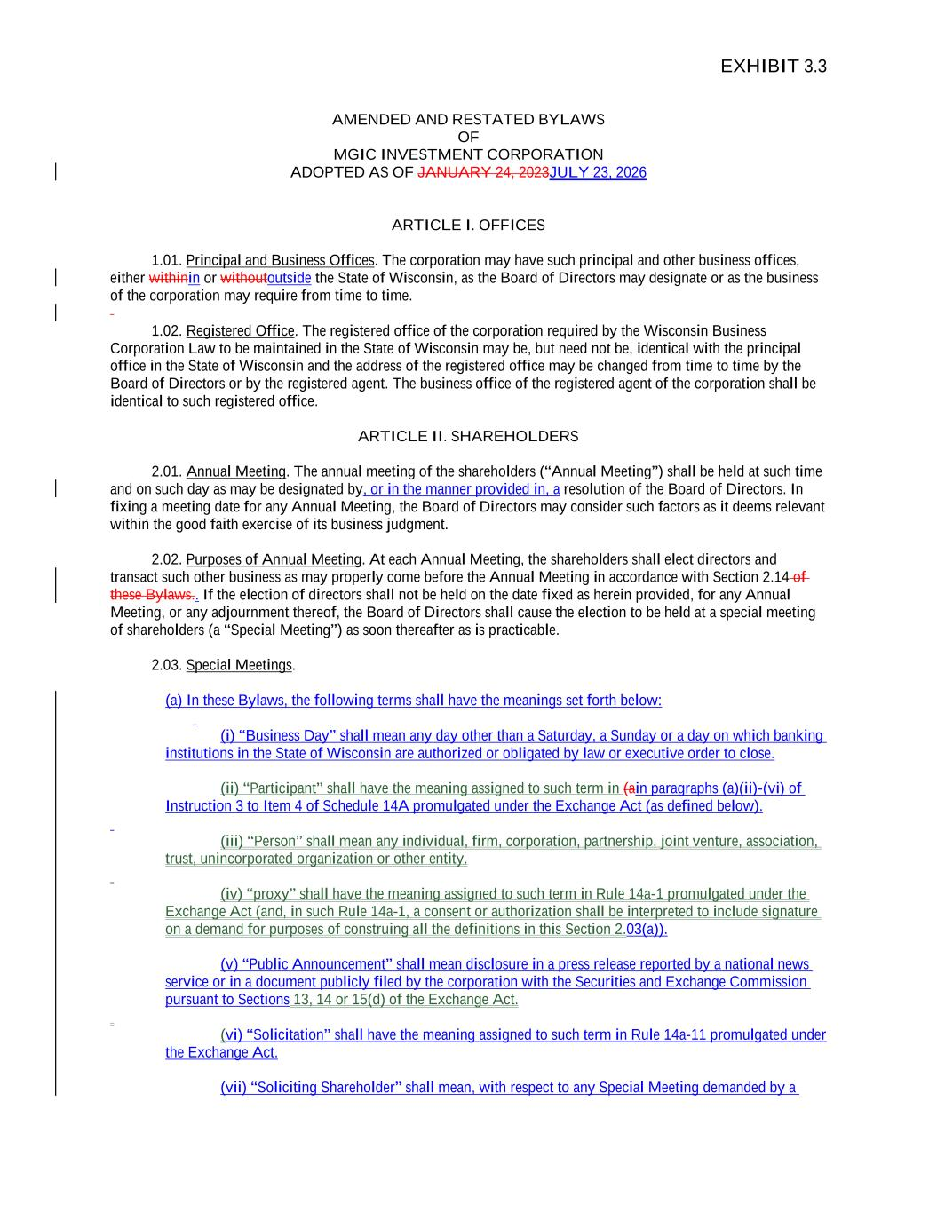
30
EXHIBIT 3.3 AMENDED AND RESTATED BYLAWS OF MGIC INVESTMENT CORPORATION ADOPTED AS OF JANUARY 24, 2023JULY 23, 2026 ARTICLE I. OFFICES 1.01. Principal and Business Offices. The corporation may have such principal and other business offices, either withinin or withoutoutside the State of Wisconsin, as the Board of Directors may designate or as the business of the corporation may require from time to time. 1.02. Registered Office. The registered office of the corporation required by the Wisconsin Business Corporation Law to be maintained in the State of Wisconsin may be, but need not be, identical with the principal office in the State of Wisconsin and the address of the registered office may be changed from time to time by the Board of Directors or by the registered agent. The business office of the registered agent of the corporation shall be identical to such registered office. ARTICLE II. SHAREHOLDERS 2.01. Annual Meeting. The annual meeting of the shareholders (“Annual Meeting”) shall be held at such time and on such day as may be designated by, or in the manner provided in, a resolution of the Board of Directors. In fixing a meeting date for any Annual Meeting, the Board of Directors may consider such factors as it deems relevant within the good faith exercise of its business judgment. 2.02. Purposes of Annual Meeting. At each Annual Meeting, the shareholders shall elect directors and transact such other business as may properly come before the Annual Meeting in accordance with Section 2.14 of these Bylaws.. If the election of directors shall not be held on the date fixed as herein provided, for any Annual Meeting, or any adjournment thereof, the Board of Directors shall cause the election to be held at a special meeting of shareholders (a “Special Meeting”) as soon thereafter as is practicable. 2.03. Special Meetings. (a) In these Bylaws, the following terms shall have the meanings set forth below: (i) “Business Day” shall mean any day other than a Saturday, a Sunday or a day on which banking institutions in the State of Wisconsin are authorized or obligated by law or executive order to close. (ii) “Participant” shall have the meaning assigned to such term in (ain paragraphs (a)(ii)-(vi) of Instruction 3 to Item 4 of Schedule 14A promulgated under the Exchange Act (as defined below). (iii) “Person” shall mean any individual, firm, corporation, partnership, joint venture, association, trust, unincorporated organization or other entity. (iv) “proxy” shall have the meaning assigned to such term in Rule 14a-1 promulgated under the Exchange Act (and, in such Rule 14a-1, a consent or authorization shall be interpreted to include signature on a demand for purposes of construing all the definitions in this Section 2.03(a)). (v) “Public Announcement” shall mean disclosure in a press release reported by a national news service or in a document publicly filed by the corporation with the Securities and Exchange Commission pursuant to Sections 13, 14 or 15(d) of the Exchange Act. (vi) “Solicitation” shall have the meaning assigned to such term in Rule 14a-11 promulgated under the Exchange Act. (vii) “Soliciting Shareholder” shall mean, with respect to any Special Meeting demanded by a

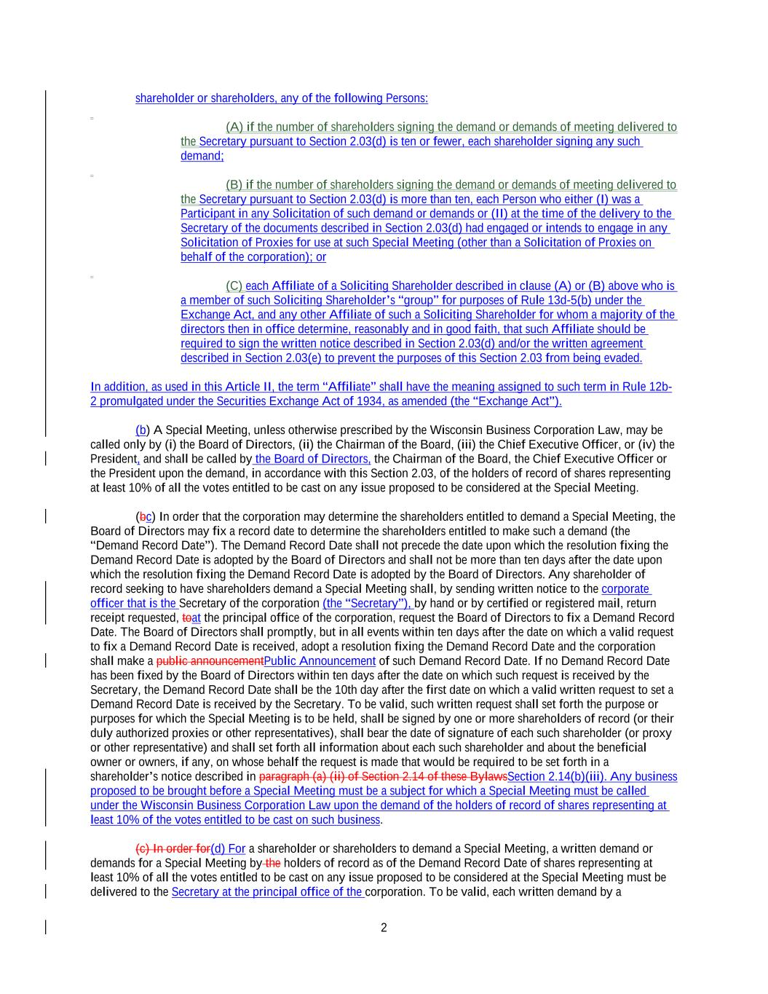
2 shareholder or shareholders, any of the following Persons: (A) if the number of shareholders signing the demand or demands of meeting delivered to the Secretary pursuant to Section 2.03(d) is ten or fewer, each shareholder signing any such demand; (B) if the number of shareholders signing the demand or demands of meeting delivered to the Secretary pursuant to Section 2.03(d) is more than ten, each Person who either (I) was a Participant in any Solicitation of such demand or demands or (II) at the time of the delivery to the Secretary of the documents described in Section 2.03(d) had engaged or intends to engage in any Solicitation of Proxies for use at such Special Meeting (other than a Solicitation of Proxies on behalf of the corporation); or (C) each Affiliate of a Soliciting Shareholder described in clause (A) or (B) above who is a member of such Soliciting Shareholder’s “group” for purposes of Rule 13d-5(b) under the Exchange Act, and any other Affiliate of such a Soliciting Shareholder for whom a majority of the directors then in office determine, reasonably and in good faith, that such Affiliate should be required to sign the written notice described in Section 2.03(d) and/or the written agreement described in Section 2.03(e) to prevent the purposes of this Section 2.03 from being evaded. In addition, as used in this Article II, the term “Affiliate” shall have the meaning assigned to such term in Rule 12b- 2 promulgated under the Securities Exchange Act of 1934, as amended (the “Exchange Act”). (b) A Special Meeting, unless otherwise prescribed by the Wisconsin Business Corporation Law, may be called only by (i) the Board of Directors, (ii) the Chairman of the Board, (iii) the Chief Executive Officer, or (iv) the President, and shall be called by the Board of Directors, the Chairman of the Board, the Chief Executive Officer or the President upon the demand, in accordance with this Section 2.03, of the holders of record of shares representing at least 10% of all the votes entitled to be cast on any issue proposed to be considered at the Special Meeting. (bc) In order that the corporation may determine the shareholders entitled to demand a Special Meeting, the Board of Directors may fix a record date to determine the shareholders entitled to make such a demand (the “Demand Record Date”). The Demand Record Date shall not precede the date upon which the resolution fixing the Demand Record Date is adopted by the Board of Directors and shall not be more than ten days after the date upon which the resolution fixing the Demand Record Date is adopted by the Board of Directors. Any shareholder of record seeking to have shareholders demand a Special Meeting shall, by sending written notice to the corporate officer that is the Secretary of the corporation (the “Secretary”), by hand or by certified or registered mail, return receipt requested, toat the principal office of the corporation, request the Board of Directors to fix a Demand Record Date. The Board of Directors shall promptly, but in all events within ten days after the date on which a valid request to fix a Demand Record Date is received, adopt a resolution fixing the Demand Record Date and the corporation shall make a public announcementPublic Announcement of such Demand Record Date. If no Demand Record Date has been fixed by the Board of Directors within ten days after the date on which such request is received by the Secretary, the Demand Record Date shall be the 10th day after the first date on which a valid written request to set a Demand Record Date is received by the Secretary. To be valid, such written request shall set forth the purpose or purposes for which the Special Meeting is to be held, shall be signed by one or more shareholders of record (or their duly authorized proxies or other representatives), shall bear the date of signature of each such shareholder (or proxy or other representative) and shall set forth all information about each such shareholder and about the beneficial owner or owners, if any, on whose behalf the request is made that would be required to be set forth in a shareholder’s notice described in paragraph (a) (ii) of Section 2.14 of these BylawsSection 2.14(b)(iii). Any business proposed to be brought before a Special Meeting must be a subject for which a Special Meeting must be called under the Wisconsin Business Corporation Law upon the demand of the holders of record of shares representing at least 10% of the votes entitled to be cast on such business. (c) In order for(d) For a shareholder or shareholders to demand a Special Meeting, a written demand or demands for a Special Meeting by the holders of record as of the Demand Record Date of shares representing at least 10% of all the votes entitled to be cast on any issue proposed to be considered at the Special Meeting must be delivered to the Secretary at the principal office of the corporation. To be valid, each written demand by a

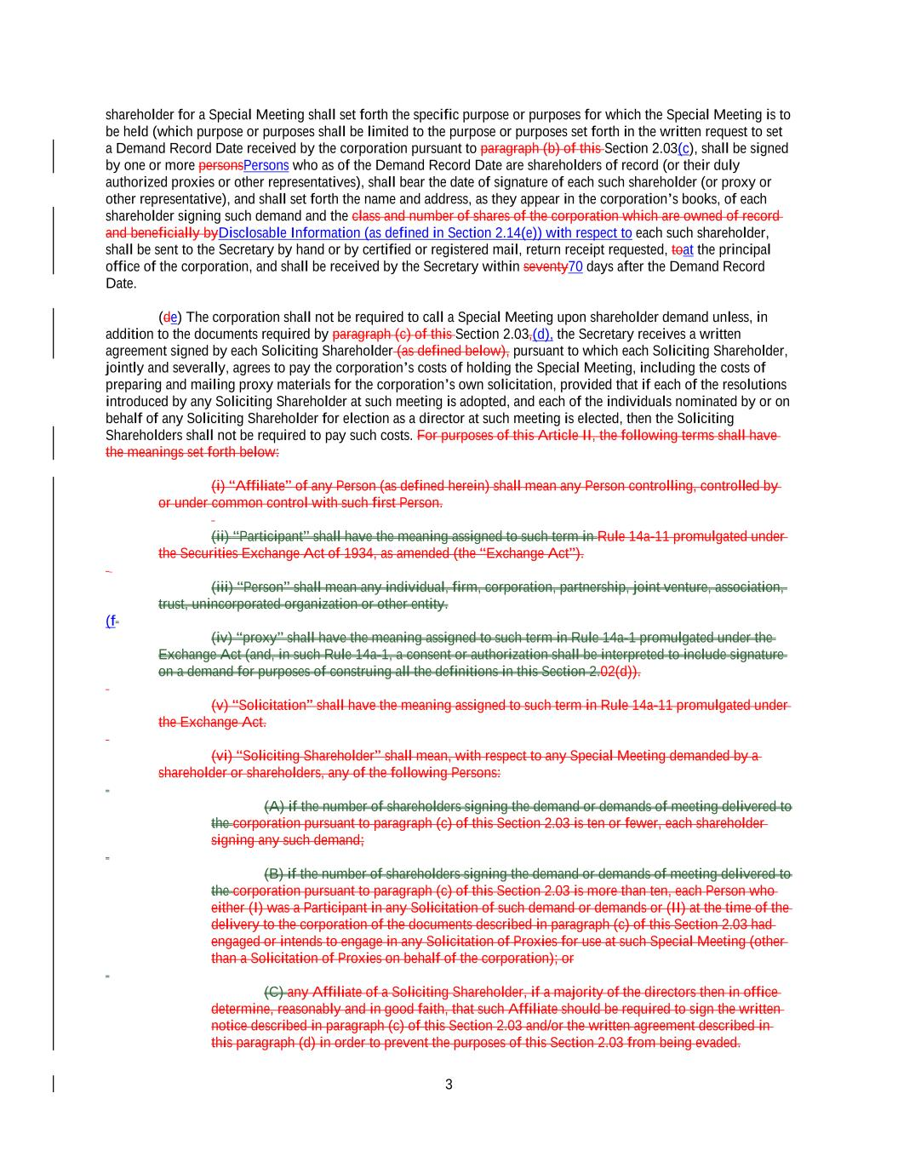
3 shareholder for a Special Meeting shall set forth the specific purpose or purposes for which the Special Meeting is to be held (which purpose or purposes shall be limited to the purpose or purposes set forth in the written request to set a Demand Record Date received by the corporation pursuant to paragraph (b) of this Section 2.03(c), shall be signed by one or more personsPersons who as of the Demand Record Date are shareholders of record (or their duly authorized proxies or other representatives), shall bear the date of signature of each such shareholder (or proxy or other representative), and shall set forth the name and address, as they appear in the corporation’s books, of each shareholder signing such demand and the class and number of shares of the corporation which are owned of record and beneficially byDisclosable Information (as defined in Section 2.14(e)) with respect to each such shareholder, shall be sent to the Secretary by hand or by certified or registered mail, return receipt requested, toat the principal office of the corporation, and shall be received by the Secretary within seventy70 days after the Demand Record Date. (de) The corporation shall not be required to call a Special Meeting upon shareholder demand unless, in addition to the documents required by paragraph (c) of this Section 2.03,(d), the Secretary receives a written agreement signed by each Soliciting Shareholder (as defined below), pursuant to which each Soliciting Shareholder, jointly and severally, agrees to pay the corporation’s costs of holding the Special Meeting, including the costs of preparing and mailing proxy materials for the corporation’s own solicitation, provided that if each of the resolutions introduced by any Soliciting Shareholder at such meeting is adopted, and each of the individuals nominated by or on behalf of any Soliciting Shareholder for election as a director at such meeting is elected, then the Soliciting Shareholders shall not be required to pay such costs. For purposes of this Article II, the following terms shall have the meanings set forth below: (i) “Affiliate” of any Person (as defined herein) shall mean any Person controlling, controlled by or under common control with such first Person. (ii) “Participant” shall have the meaning assigned to such term in Rule 14a-11 promulgated under the Securities Exchange Act of 1934, as amended (the “Exchange Act”). (iii) “Person” shall mean any individual, firm, corporation, partnership, joint venture, association, trust, unincorporated organization or other entity. (f (iv) “proxy” shall have the meaning assigned to such term in Rule 14a-1 promulgated under the Exchange Act (and, in such Rule 14a-1, a consent or authorization shall be interpreted to include signature on a demand for purposes of construing all the definitions in this Section 2.02(d)). (v) “Solicitation” shall have the meaning assigned to such term in Rule 14a-11 promulgated under the Exchange Act. (vi) “Soliciting Shareholder” shall mean, with respect to any Special Meeting demanded by a shareholder or shareholders, any of the following Persons: (A) if the number of shareholders signing the demand or demands of meeting delivered to the corporation pursuant to paragraph (c) of this Section 2.03 is ten or fewer, each shareholder signing any such demand; (B) if the number of shareholders signing the demand or demands of meeting delivered to the corporation pursuant to paragraph (c) of this Section 2.03 is more than ten, each Person who either (I) was a Participant in any Solicitation of such demand or demands or (II) at the time of the delivery to the corporation of the documents described in paragraph (c) of this Section 2.03 had engaged or intends to engage in any Solicitation of Proxies for use at such Special Meeting (other than a Solicitation of Proxies on behalf of the corporation); or (C) any Affiliate of a Soliciting Shareholder, if a majority of the directors then in office determine, reasonably and in good faith, that such Affiliate should be required to sign the written notice described in paragraph (c) of this Section 2.03 and/or the written agreement described in this paragraph (d) in order to prevent the purposes of this Section 2.03 from being evaded.

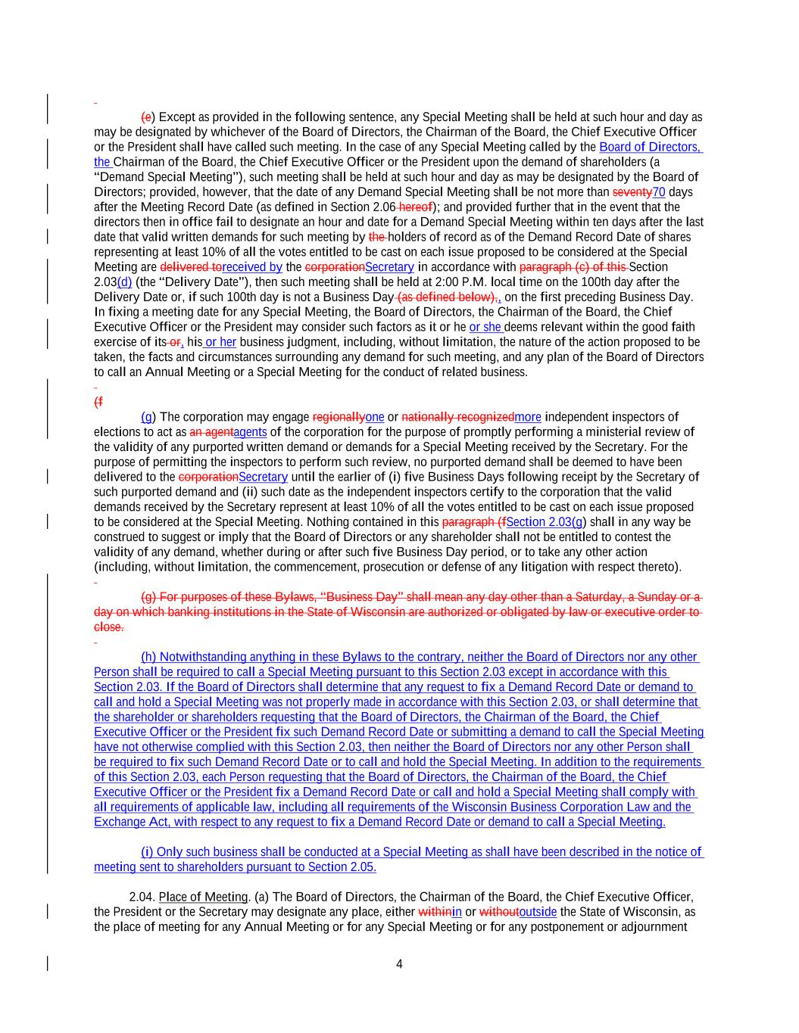
4 (e) Except as provided in the following sentence, any Special Meeting shall be held at such hour and day as may be designated by whichever of the Board of Directors, the Chairman of the Board, the Chief Executive Officer or the President shall have called such meeting. In the case of any Special Meeting called by the Board of Directors, the Chairman of the Board, the Chief Executive Officer or the President upon the demand of shareholders (a “Demand Special Meeting”), such meeting shall be held at such hour and day as may be designated by the Board of Directors; provided, however, that the date of any Demand Special Meeting shall be not more than seventy70 days after the Meeting Record Date (as defined in Section 2.06 hereof); and provided further that in the event that the directors then in office fail to designate an hour and date for a Demand Special Meeting within ten days after the last date that valid written demands for such meeting by the holders of record as of the Demand Record Date of shares representing at least 10% of all the votes entitled to be cast on each issue proposed to be considered at the Special Meeting are delivered toreceived by the corporationSecretary in accordance with paragraph (c) of this Section 2.03(d) (the “Delivery Date”), then such meeting shall be held at 2:00 P.M. local time on the 100th day after the Delivery Date or, if such 100th day is not a Business Day (as defined below),, on the first preceding Business Day. In fixing a meeting date for any Special Meeting, the Board of Directors, the Chairman of the Board, the Chief Executive Officer or the President may consider such factors as it or he or she deems relevant within the good faith exercise of its or, his or her business judgment, including, without limitation, the nature of the action proposed to be taken, the facts and circumstances surrounding any demand for such meeting, and any plan of the Board of Directors to call an Annual Meeting or a Special Meeting for the conduct of related business. (f (g) The corporation may engage regionallyone or nationally recognizedmore independent inspectors of elections to act as an agentagents of the corporation for the purpose of promptly performing a ministerial review of the validity of any purported written demand or demands for a Special Meeting received by the Secretary. For the purpose of permitting the inspectors to perform such review, no purported demand shall be deemed to have been delivered to the corporationSecretary until the earlier of (i) five Business Days following receipt by the Secretary of such purported demand and (ii) such date as the independent inspectors certify to the corporation that the valid demands received by the Secretary represent at least 10% of all the votes entitled to be cast on each issue proposed to be considered at the Special Meeting. Nothing contained in this paragraph (fSection 2.03(g) shall in any way be construed to suggest or imply that the Board of Directors or any shareholder shall not be entitled to contest the validity of any demand, whether during or after such five Business Day period, or to take any other action (including, without limitation, the commencement, prosecution or defense of any litigation with respect thereto). (g) For purposes of these Bylaws, “Business Day” shall mean any day other than a Saturday, a Sunday or a day on which banking institutions in the State of Wisconsin are authorized or obligated by law or executive order to close. (h) Notwithstanding anything in these Bylaws to the contrary, neither the Board of Directors nor any other Person shall be required to call a Special Meeting pursuant to this Section 2.03 except in accordance with this Section 2.03. If the Board of Directors shall determine that any request to fix a Demand Record Date or demand to call and hold a Special Meeting was not properly made in accordance with this Section 2.03, or shall determine that the shareholder or shareholders requesting that the Board of Directors, the Chairman of the Board, the Chief Executive Officer or the President fix such Demand Record Date or submitting a demand to call the Special Meeting have not otherwise complied with this Section 2.03, then neither the Board of Directors nor any other Person shall be required to fix such Demand Record Date or to call and hold the Special Meeting. In addition to the requirements of this Section 2.03, each Person requesting that the Board of Directors, the Chairman of the Board, the Chief Executive Officer or the President fix a Demand Record Date or call and hold a Special Meeting shall comply with all requirements of applicable law, including all requirements of the Wisconsin Business Corporation Law and the Exchange Act, with respect to any request to fix a Demand Record Date or demand to call a Special Meeting. (i) Only such business shall be conducted at a Special Meeting as shall have been described in the notice of meeting sent to shareholders pursuant to Section 2.05. 2.04. Place of Meeting. (a) The Board of Directors, the Chairman of the Board, the Chief Executive Officer, the President or the Secretary may designate any place, either withinin or withoutoutside the State of Wisconsin, as the place of meeting for any Annual Meeting or for any Special Meeting or for any postponement or adjournment

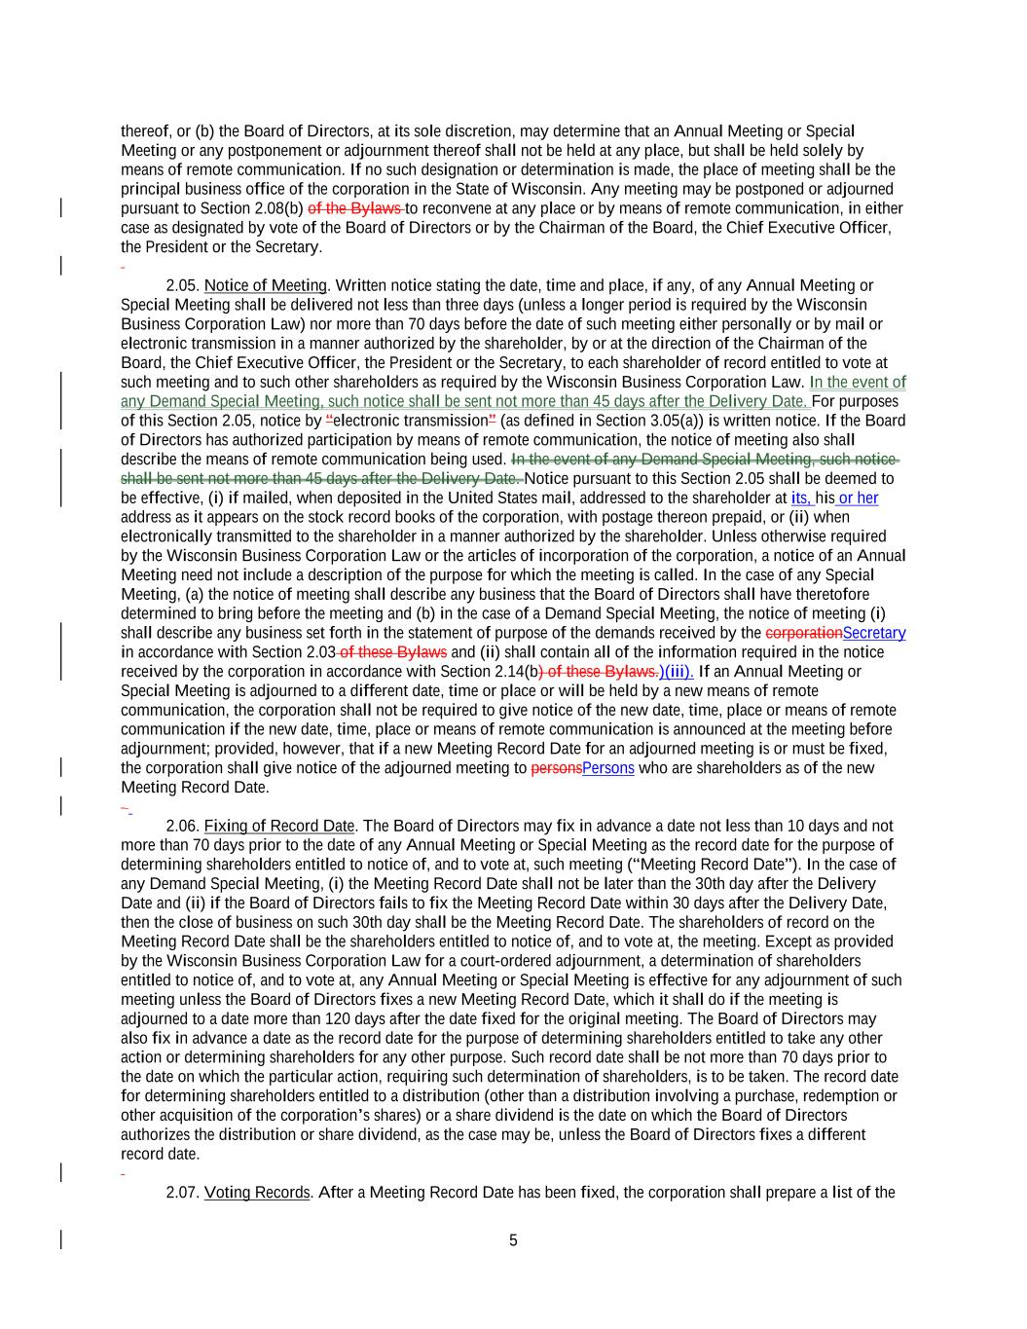
5 thereof, or (b) the Board of Directors, at its sole discretion, may determine that an Annual Meeting or Special Meeting or any postponement or adjournment thereof shall not be held at any place, but shall be held solely by means of remote communication. If no such designation or determination is made, the place of meeting shall be the principal business office of the corporation in the State of Wisconsin. Any meeting may be postponed or adjourned pursuant to Section 2.08(b) of the Bylaws to reconvene at any place or by means of remote communication, in either case as designated by vote of the Board of Directors or by the Chairman of the Board, the Chief Executive Officer, the President or the Secretary. 2.05. Notice of Meeting. Written notice stating the date, time and place, if any, of any Annual Meeting or Special Meeting shall be delivered not less than three days (unless a longer period is required by the Wisconsin Business Corporation Law) nor more than 70 days before the date of such meeting either personally or by mail or electronic transmission in a manner authorized by the shareholder, by or at the direction of the Chairman of the Board, the Chief Executive Officer, the President or the Secretary, to each shareholder of record entitled to vote at such meeting and to such other shareholders as required by the Wisconsin Business Corporation Law. In the event of any Demand Special Meeting, such notice shall be sent not more than 45 days after the Delivery Date. For purposes of this Section 2.05, notice by “electronic transmission” (as defined in Section 3.05(a)) is written notice. If the Board of Directors has authorized participation by means of remote communication, the notice of meeting also shall describe the means of remote communication being used. In the event of any Demand Special Meeting, such notice shall be sent not more than 45 days after the Delivery Date. Notice pursuant to this Section 2.05 shall be deemed to be effective, (i) if mailed, when deposited in the United States mail, addressed to the shareholder at its, his or her address as it appears on the stock record books of the corporation, with postage thereon prepaid, or (ii) when electronically transmitted to the shareholder in a manner authorized by the shareholder. Unless otherwise required by the Wisconsin Business Corporation Law or the articles of incorporation of the corporation, a notice of an Annual Meeting need not include a description of the purpose for which the meeting is called. In the case of any Special Meeting, (a) the notice of meeting shall describe any business that the Board of Directors shall have theretofore determined to bring before the meeting and (b) in the case of a Demand Special Meeting, the notice of meeting (i) shall describe any business set forth in the statement of purpose of the demands received by the corporationSecretary in accordance with Section 2.03 of these Bylaws and (ii) shall contain all of the information required in the notice received by the corporation in accordance with Section 2.14(b) of these Bylaws.)(iii). If an Annual Meeting or Special Meeting is adjourned to a different date, time or place or will be held by a new means of remote communication, the corporation shall not be required to give notice of the new date, time, place or means of remote communication if the new date, time, place or means of remote communication is announced at the meeting before adjournment; provided, however, that if a new Meeting Record Date for an adjourned meeting is or must be fixed, the corporation shall give notice of the adjourned meeting to personsPersons who are shareholders as of the new Meeting Record Date. 2.06. Fixing of Record Date. The Board of Directors may fix in advance a date not less than 10 days and not more than 70 days prior to the date of any Annual Meeting or Special Meeting as the record date for the purpose of determining shareholders entitled to notice of, and to vote at, such meeting (“Meeting Record Date”). In the case of any Demand Special Meeting, (i) the Meeting Record Date shall not be later than the 30th day after the Delivery Date and (ii) if the Board of Directors fails to fix the Meeting Record Date within 30 days after the Delivery Date, then the close of business on such 30th day shall be the Meeting Record Date. The shareholders of record on the Meeting Record Date shall be the shareholders entitled to notice of, and to vote at, the meeting. Except as provided by the Wisconsin Business Corporation Law for a court-ordered adjournment, a determination of shareholders entitled to notice of, and to vote at, any Annual Meeting or Special Meeting is effective for any adjournment of such meeting unless the Board of Directors fixes a new Meeting Record Date, which it shall do if the meeting is adjourned to a date more than 120 days after the date fixed for the original meeting. The Board of Directors may also fix in advance a date as the record date for the purpose of determining shareholders entitled to take any other action or determining shareholders for any other purpose. Such record date shall be not more than 70 days prior to the date on which the particular action, requiring such determination of shareholders, is to be taken. The record date for determining shareholders entitled to a distribution (other than a distribution involving a purchase, redemption or other acquisition of the corporation’s shares) or a share dividend is the date on which the Board of Directors authorizes the distribution or share dividend, as the case may be, unless the Board of Directors fixes a different record date. 2.07. Voting Records. After a Meeting Record Date has been fixed, the corporation shall prepare a list of the

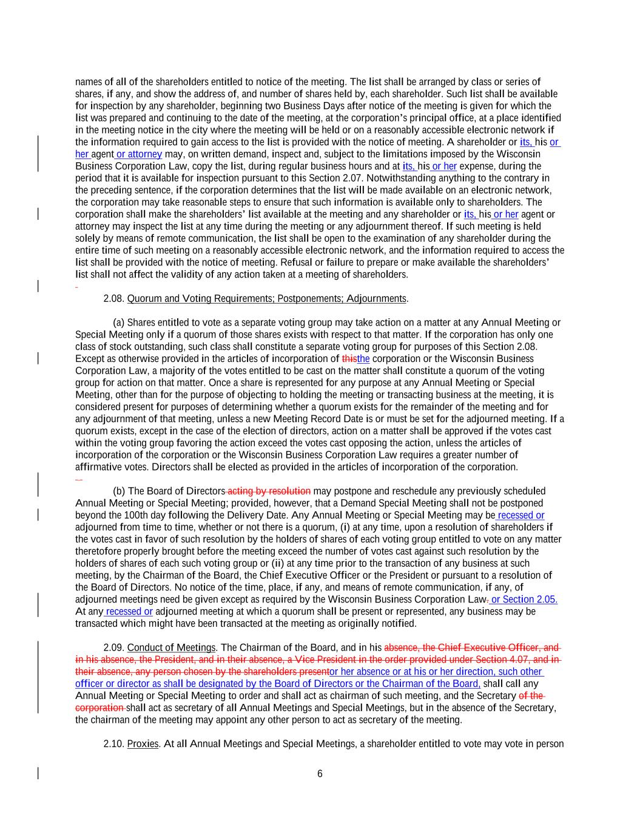
6 names of all of the shareholders entitled to notice of the meeting. The list shall be arranged by class or series of shares, if any, and show the address of, and number of shares held by, each shareholder. Such list shall be available for inspection by any shareholder, beginning two Business Days after notice of the meeting is given for which the list was prepared and continuing to the date of the meeting, at the corporation’s principal office, at a place identified in the meeting notice in the city where the meeting will be held or on a reasonably accessible electronic network if the information required to gain access to the list is provided with the notice of meeting. A shareholder or its, his or her agent or attorney may, on written demand, inspect and, subject to the limitations imposed by the Wisconsin Business Corporation Law, copy the list, during regular business hours and at its, his or her expense, during the period that it is available for inspection pursuant to this Section 2.07. Notwithstanding anything to the contrary in the preceding sentence, if the corporation determines that the list will be made available on an electronic network, the corporation may take reasonable steps to ensure that such information is available only to shareholders. The corporation shall make the shareholders’ list available at the meeting and any shareholder or its, his or her agent or attorney may inspect the list at any time during the meeting or any adjournment thereof. If such meeting is held solely by means of remote communication, the list shall be open to the examination of any shareholder during the entire time of such meeting on a reasonably accessible electronic network, and the information required to access the list shall be provided with the notice of meeting. Refusal or failure to prepare or make available the shareholders’ list shall not affect the validity of any action taken at a meeting of shareholders. 2.08. Quorum and Voting Requirements; Postponements; Adjournments. (a) Shares entitled to vote as a separate voting group may take action on a matter at any Annual Meeting or Special Meeting only if a quorum of those shares exists with respect to that matter. If the corporation has only one class of stock outstanding, such class shall constitute a separate voting group for purposes of this Section 2.08. Except as otherwise provided in the articles of incorporation of thisthe corporation or the Wisconsin Business Corporation Law, a majority of the votes entitled to be cast on the matter shall constitute a quorum of the voting group for action on that matter. Once a share is represented for any purpose at any Annual Meeting or Special Meeting, other than for the purpose of objecting to holding the meeting or transacting business at the meeting, it is considered present for purposes of determining whether a quorum exists for the remainder of the meeting and for any adjournment of that meeting, unless a new Meeting Record Date is or must be set for the adjourned meeting. If a quorum exists, except in the case of the election of directors, action on a matter shall be approved if the votes cast within the voting group favoring the action exceed the votes cast opposing the action, unless the articles of incorporation of the corporation or the Wisconsin Business Corporation Law requires a greater number of affirmative votes. Directors shall be elected as provided in the articles of incorporation of the corporation. (b) The Board of Directors acting by resolution may postpone and reschedule any previously scheduled Annual Meeting or Special Meeting; provided, however, that a Demand Special Meeting shall not be postponed beyond the 100th day following the Delivery Date. Any Annual Meeting or Special Meeting may be recessed or adjourned from time to time, whether or not there is a quorum, (i) at any time, upon a resolution of shareholders if the votes cast in favor of such resolution by the holders of shares of each voting group entitled to vote on any matter theretofore properly brought before the meeting exceed the number of votes cast against such resolution by the holders of shares of each such voting group or (ii) at any time prior to the transaction of any business at such meeting, by the Chairman of the Board, the Chief Executive Officer or the President or pursuant to a resolution of the Board of Directors. No notice of the time, place, if any, and means of remote communication, if any, of adjourned meetings need be given except as required by the Wisconsin Business Corporation Law. or Section 2.05. At any recessed or adjourned meeting at which a quorum shall be present or represented, any business may be transacted which might have been transacted at the meeting as originally notified. 2.09. Conduct of Meetings. The Chairman of the Board, and in his absence, the Chief Executive Officer, and in his absence, the President, and in their absence, a Vice President in the order provided under Section 4.07, and in their absence, any person chosen by the shareholders presentor her absence or at his or her direction, such other officer or director as shall be designated by the Board of Directors or the Chairman of the Board, shall call any Annual Meeting or Special Meeting to order and shall act as chairman of such meeting, and the Secretary of the corporation shall act as secretary of all Annual Meetings and Special Meetings, but in the absence of the Secretary, the chairman of the meeting may appoint any other person to act as secretary of the meeting. 2.10. Proxies. At all Annual Meetings and Special Meetings, a shareholder entitled to vote may vote in person

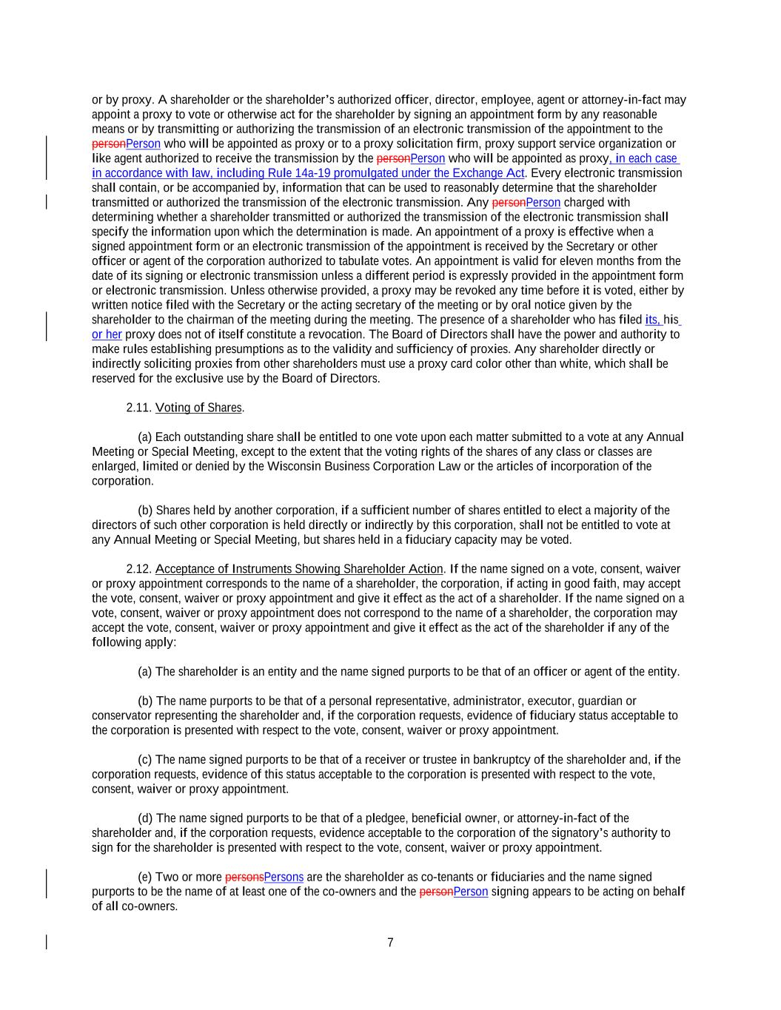
7 or by proxy. A shareholder or the shareholder’s authorized officer, director, employee, agent or attorney-in-fact may appoint a proxy to vote or otherwise act for the shareholder by signing an appointment form by any reasonable means or by transmitting or authorizing the transmission of an electronic transmission of the appointment to the personPerson who will be appointed as proxy or to a proxy solicitation firm, proxy support service organization or like agent authorized to receive the transmission by the personPerson who will be appointed as proxy, in each case in accordance with law, including Rule 14a-19 promulgated under the Exchange Act. Every electronic transmission shall contain, or be accompanied by, information that can be used to reasonably determine that the shareholder transmitted or authorized the transmission of the electronic transmission. Any personPerson charged with determining whether a shareholder transmitted or authorized the transmission of the electronic transmission shall specify the information upon which the determination is made. An appointment of a proxy is effective when a signed appointment form or an electronic transmission of the appointment is received by the Secretary or other officer or agent of the corporation authorized to tabulate votes. An appointment is valid for eleven months from the date of its signing or electronic transmission unless a different period is expressly provided in the appointment form or electronic transmission. Unless otherwise provided, a proxy may be revoked any time before it is voted, either by written notice filed with the Secretary or the acting secretary of the meeting or by oral notice given by the shareholder to the chairman of the meeting during the meeting. The presence of a shareholder who has filed its, his or her proxy does not of itself constitute a revocation. The Board of Directors shall have the power and authority to make rules establishing presumptions as to the validity and sufficiency of proxies. Any shareholder directly or indirectly soliciting proxies from other shareholders must use a proxy card color other than white, which shall be reserved for the exclusive use by the Board of Directors. 2.11. Voting of Shares. (a) Each outstanding share shall be entitled to one vote upon each matter submitted to a vote at any Annual Meeting or Special Meeting, except to the extent that the voting rights of the shares of any class or classes are enlarged, limited or denied by the Wisconsin Business Corporation Law or the articles of incorporation of the corporation. (b) Shares held by another corporation, if a sufficient number of shares entitled to elect a majority of the directors of such other corporation is held directly or indirectly by this corporation, shall not be entitled to vote at any Annual Meeting or Special Meeting, but shares held in a fiduciary capacity may be voted. 2.12. Acceptance of Instruments Showing Shareholder Action. If the name signed on a vote, consent, waiver or proxy appointment corresponds to the name of a shareholder, the corporation, if acting in good faith, may accept the vote, consent, waiver or proxy appointment and give it effect as the act of a shareholder. If the name signed on a vote, consent, waiver or proxy appointment does not correspond to the name of a shareholder, the corporation may accept the vote, consent, waiver or proxy appointment and give it effect as the act of the shareholder if any of the following apply: (a) The shareholder is an entity and the name signed purports to be that of an officer or agent of the entity. (b) The name purports to be that of a personal representative, administrator, executor, guardian or conservator representing the shareholder and, if the corporation requests, evidence of fiduciary status acceptable to the corporation is presented with respect to the vote, consent, waiver or proxy appointment. (c) The name signed purports to be that of a receiver or trustee in bankruptcy of the shareholder and, if the corporation requests, evidence of this status acceptable to the corporation is presented with respect to the vote, consent, waiver or proxy appointment. (d) The name signed purports to be that of a pledgee, beneficial owner, or attorney-in-fact of the shareholder and, if the corporation requests, evidence acceptable to the corporation of the signatory’s authority to sign for the shareholder is presented with respect to the vote, consent, waiver or proxy appointment. (e) Two or more personsPersons are the shareholder as co-tenants or fiduciaries and the name signed purports to be the name of at least one of the co-owners and the personPerson signing appears to be acting on behalf of all co-owners.

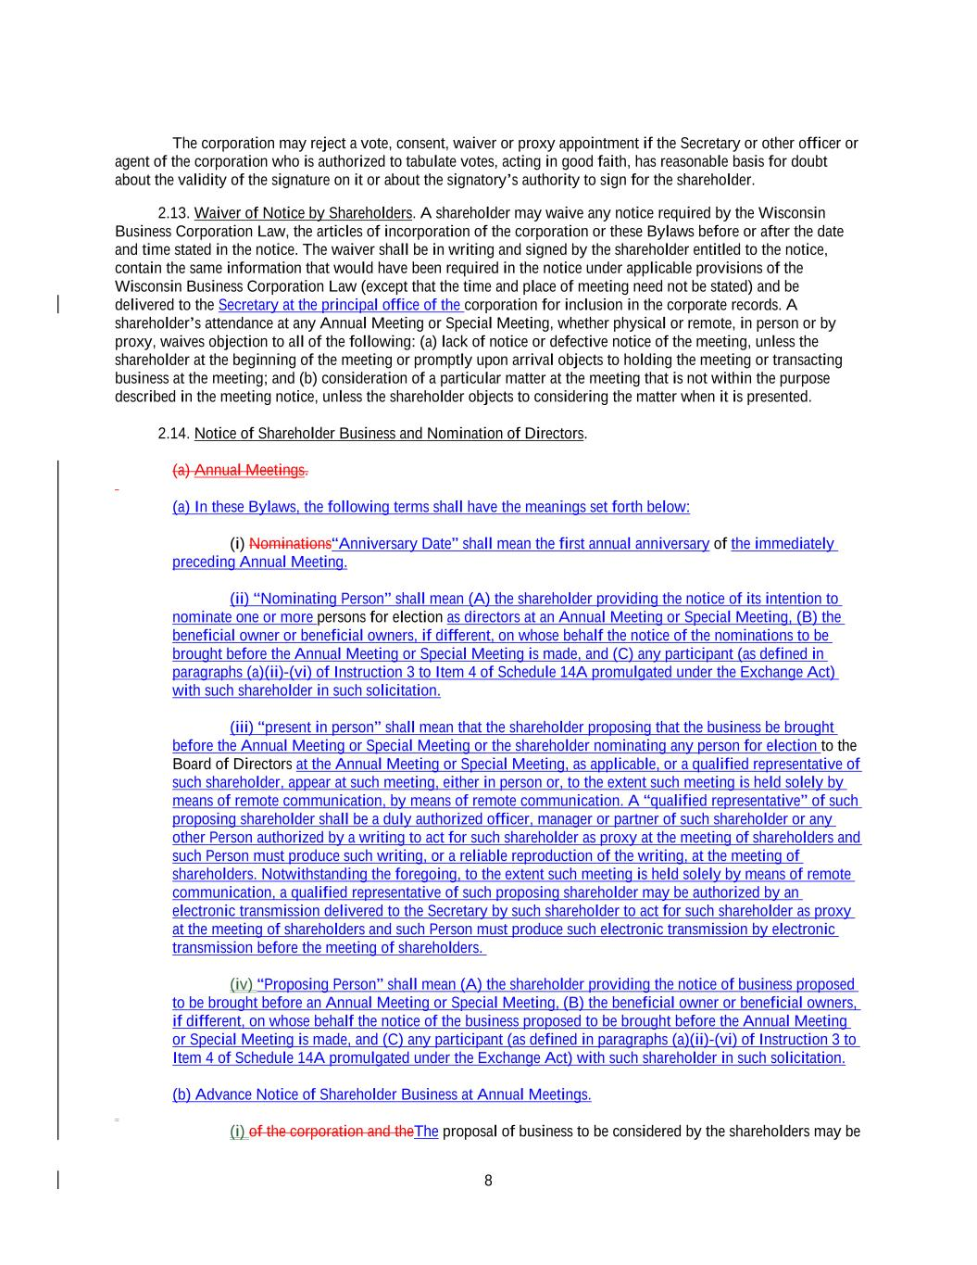
8 The corporation may reject a vote, consent, waiver or proxy appointment if the Secretary or other officer or agent of the corporation who is authorized to tabulate votes, acting in good faith, has reasonable basis for doubt about the validity of the signature on it or about the signatory’s authority to sign for the shareholder. 2.13. Waiver of Notice by Shareholders. A shareholder may waive any notice required by the Wisconsin Business Corporation Law, the articles of incorporation of the corporation or these Bylaws before or after the date and time stated in the notice. The waiver shall be in writing and signed by the shareholder entitled to the notice, contain the same information that would have been required in the notice under applicable provisions of the Wisconsin Business Corporation Law (except that the time and place of meeting need not be stated) and be delivered to the Secretary at the principal office of the corporation for inclusion in the corporate records. A shareholder’s attendance at any Annual Meeting or Special Meeting, whether physical or remote, in person or by proxy, waives objection to all of the following: (a) lack of notice or defective notice of the meeting, unless the shareholder at the beginning of the meeting or promptly upon arrival objects to holding the meeting or transacting business at the meeting; and (b) consideration of a particular matter at the meeting that is not within the purpose described in the meeting notice, unless the shareholder objects to considering the matter when it is presented. 2.14. Notice of Shareholder Business and Nomination of Directors. (a) Annual Meetings. (a) In these Bylaws, the following terms shall have the meanings set forth below: (i) Nominations“Anniversary Date” shall mean the first annual anniversary of the immediately preceding Annual Meeting. (ii) “Nominating Person” shall mean (A) the shareholder providing the notice of its intention to nominate one or more persons for election as directors at an Annual Meeting or Special Meeting, (B) the beneficial owner or beneficial owners, if different, on whose behalf the notice of the nominations to be brought before the Annual Meeting or Special Meeting is made, and (C) any participant (as defined in paragraphs (a)(ii)-(vi) of Instruction 3 to Item 4 of Schedule 14A promulgated under the Exchange Act) with such shareholder in such solicitation. (iii) “present in person” shall mean that the shareholder proposing that the business be brought before the Annual Meeting or Special Meeting or the shareholder nominating any person for election to the Board of Directors at the Annual Meeting or Special Meeting, as applicable, or a qualified representative of such shareholder, appear at such meeting, either in person or, to the extent such meeting is held solely by means of remote communication, by means of remote communication. A “qualified representative” of such proposing shareholder shall be a duly authorized officer, manager or partner of such shareholder or any other Person authorized by a writing to act for such shareholder as proxy at the meeting of shareholders and such Person must produce such writing, or a reliable reproduction of the writing, at the meeting of shareholders. Notwithstanding the foregoing, to the extent such meeting is held solely by means of remote communication, a qualified representative of such proposing shareholder may be authorized by an electronic transmission delivered to the Secretary by such shareholder to act for such shareholder as proxy at the meeting of shareholders and such Person must produce such electronic transmission by electronic transmission before the meeting of shareholders. (iv) “Proposing Person” shall mean (A) the shareholder providing the notice of business proposed to be brought before an Annual Meeting or Special Meeting, (B) the beneficial owner or beneficial owners, if different, on whose behalf the notice of the business proposed to be brought before the Annual Meeting or Special Meeting is made, and (C) any participant (as defined in paragraphs (a)(ii)-(vi) of Instruction 3 to Item 4 of Schedule 14A promulgated under the Exchange Act) with such shareholder in such solicitation. (b) Advance Notice of Shareholder Business at Annual Meetings. (i) of the corporation and theThe proposal of business to be considered by the shareholders may be

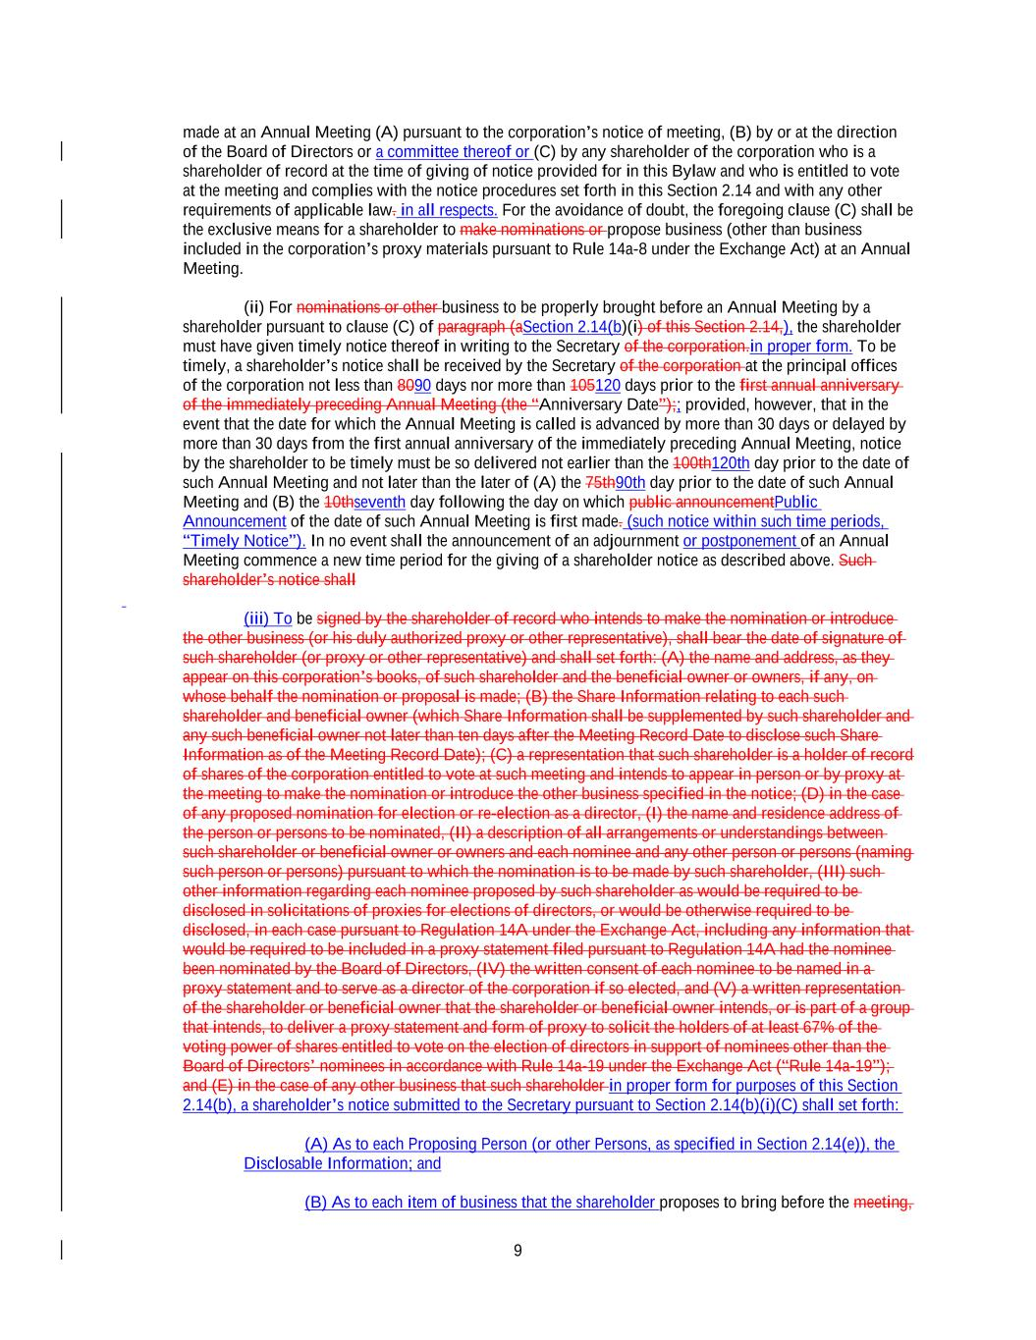
9 made at an Annual Meeting (A) pursuant to the corporation’s notice of meeting, (B) by or at the direction of the Board of Directors or a committee thereof or (C) by any shareholder of the corporation who is a shareholder of record at the time of giving of notice provided for in this Bylaw and who is entitled to vote at the meeting and complies with the notice procedures set forth in this Section 2.14 and with any other requirements of applicable law. in all respects. For the avoidance of doubt, the foregoing clause (C) shall be the exclusive means for a shareholder to make nominations or propose business (other than business included in the corporation’s proxy materials pursuant to Rule 14a-8 under the Exchange Act) at an Annual Meeting. (ii) For nominations or other business to be properly brought before an Annual Meeting by a shareholder pursuant to clause (C) of paragraph (aSection 2.14(b)(i) of this Section 2.14,), the shareholder must have given timely notice thereof in writing to the Secretary of the corporation.in proper form. To be timely, a shareholder’s notice shall be received by the Secretary of the corporation at the principal offices of the corporation not less than 8090 days nor more than 105120 days prior to the first annual anniversary of the immediately preceding Annual Meeting (the “Anniversary Date”);; provided, however, that in the event that the date for which the Annual Meeting is called is advanced by more than 30 days or delayed by more than 30 days from the first annual anniversary of the immediately preceding Annual Meeting, notice by the shareholder to be timely must be so delivered not earlier than the 100th120th day prior to the date of such Annual Meeting and not later than the later of (A) the 75th90th day prior to the date of such Annual Meeting and (B) the 10thseventh day following the day on which public announcementPublic Announcement of the date of such Annual Meeting is first made. (such notice within such time periods, “Timely Notice”). In no event shall the announcement of an adjournment or postponement of an Annual Meeting commence a new time period for the giving of a shareholder notice as described above. Such shareholder’s notice shall (iii) To be signed by the shareholder of record who intends to make the nomination or introduce the other business (or his duly authorized proxy or other representative), shall bear the date of signature of such shareholder (or proxy or other representative) and shall set forth: (A) the name and address, as they appear on this corporation’s books, of such shareholder and the beneficial owner or owners, if any, on whose behalf the nomination or proposal is made; (B) the Share Information relating to each such shareholder and beneficial owner (which Share Information shall be supplemented by such shareholder and any such beneficial owner not later than ten days after the Meeting Record Date to disclose such Share Information as of the Meeting Record Date); (C) a representation that such shareholder is a holder of record of shares of the corporation entitled to vote at such meeting and intends to appear in person or by proxy at the meeting to make the nomination or introduce the other business specified in the notice; (D) in the case of any proposed nomination for election or re-election as a director, (I) the name and residence address of the person or persons to be nominated, (II) a description of all arrangements or understandings between such shareholder or beneficial owner or owners and each nominee and any other person or persons (naming such person or persons) pursuant to which the nomination is to be made by such shareholder, (III) such other information regarding each nominee proposed by such shareholder as would be required to be disclosed in solicitations of proxies for elections of directors, or would be otherwise required to be disclosed, in each case pursuant to Regulation 14A under the Exchange Act, including any information that would be required to be included in a proxy statement filed pursuant to Regulation 14A had the nominee been nominated by the Board of Directors, (IV) the written consent of each nominee to be named in a proxy statement and to serve as a director of the corporation if so elected, and (V) a written representation of the shareholder or beneficial owner that the shareholder or beneficial owner intends, or is part of a group that intends, to deliver a proxy statement and form of proxy to solicit the holders of at least 67% of the voting power of shares entitled to vote on the election of directors in support of nominees other than the Board of Directors’ nominees in accordance with Rule 14a-19 under the Exchange Act (“Rule 14a-19”); and (E) in the case of any other business that such shareholder in proper form for purposes of this Section 2.14(b), a shareholder’s notice submitted to the Secretary pursuant to Section 2.14(b)(i)(C) shall set forth: (A) As to each Proposing Person (or other Persons, as specified in Section 2.14(e)), the Disclosable Information; and (B) As to each item of business that the shareholder proposes to bring before the meeting,

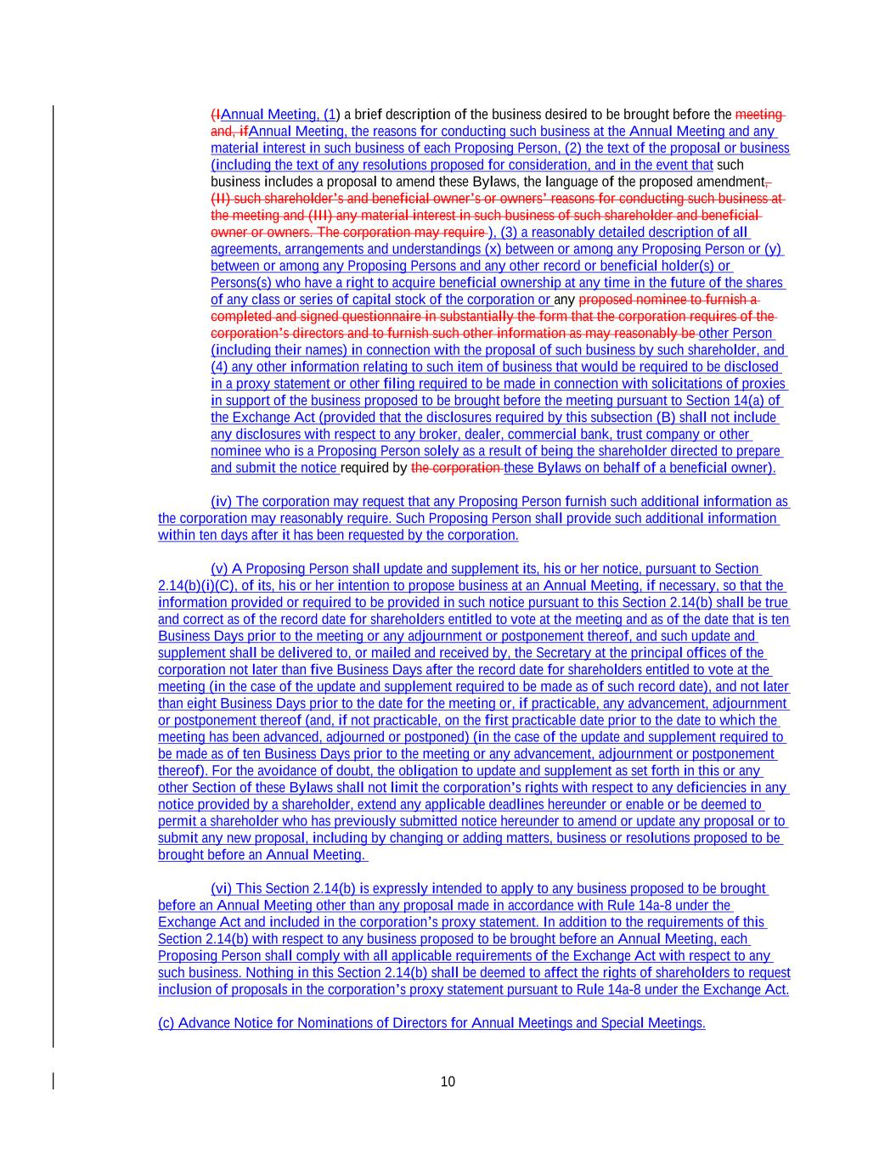
10 (IAnnual Meeting, (1) a brief description of the business desired to be brought before the meeting and, ifAnnual Meeting, the reasons for conducting such business at the Annual Meeting and any material interest in such business of each Proposing Person, (2) the text of the proposal or business (including the text of any resolutions proposed for consideration, and in the event that such business includes a proposal to amend these Bylaws, the language of the proposed amendment, (II) such shareholder’s and beneficial owner’s or owners’ reasons for conducting such business at the meeting and (III) any material interest in such business of such shareholder and beneficial owner or owners. The corporation may require ), (3) a reasonably detailed description of all agreements, arrangements and understandings (x) between or among any Proposing Person or (y) between or among any Proposing Persons and any other record or beneficial holder(s) or Persons(s) who have a right to acquire beneficial ownership at any time in the future of the shares of any class or series of capital stock of the corporation or any proposed nominee to furnish a completed and signed questionnaire in substantially the form that the corporation requires of the corporation’s directors and to furnish such other information as may reasonably be other Person (including their names) in connection with the proposal of such business by such shareholder, and (4) any other information relating to such item of business that would be required to be disclosed in a proxy statement or other filing required to be made in connection with solicitations of proxies in support of the business proposed to be brought before the meeting pursuant to Section 14(a) of the Exchange Act (provided that the disclosures required by this subsection (B) shall not include any disclosures with respect to any broker, dealer, commercial bank, trust company or other nominee who is a Proposing Person solely as a result of being the shareholder directed to prepare and submit the notice required by the corporation these Bylaws on behalf of a beneficial owner). (iv) The corporation may request that any Proposing Person furnish such additional information as the corporation may reasonably require. Such Proposing Person shall provide such additional information within ten days after it has been requested by the corporation. (v) A Proposing Person shall update and supplement its, his or her notice, pursuant to Section 2.14(b)(i)(C), of its, his or her intention to propose business at an Annual Meeting, if necessary, so that the information provided or required to be provided in such notice pursuant to this Section 2.14(b) shall be true and correct as of the record date for shareholders entitled to vote at the meeting and as of the date that is ten Business Days prior to the meeting or any adjournment or postponement thereof, and such update and supplement shall be delivered to, or mailed and received by, the Secretary at the principal offices of the corporation not later than five Business Days after the record date for shareholders entitled to vote at the meeting (in the case of the update and supplement required to be made as of such record date), and not later than eight Business Days prior to the date for the meeting or, if practicable, any advancement, adjournment or postponement thereof (and, if not practicable, on the first practicable date prior to the date to which the meeting has been advanced, adjourned or postponed) (in the case of the update and supplement required to be made as of ten Business Days prior to the meeting or any advancement, adjournment or postponement thereof). For the avoidance of doubt, the obligation to update and supplement as set forth in this or any other Section of these Bylaws shall not limit the corporation’s rights with respect to any deficiencies in any notice provided by a shareholder, extend any applicable deadlines hereunder or enable or be deemed to permit a shareholder who has previously submitted notice hereunder to amend or update any proposal or to submit any new proposal, including by changing or adding matters, business or resolutions proposed to be brought before an Annual Meeting. (vi) This Section 2.14(b) is expressly intended to apply to any business proposed to be brought before an Annual Meeting other than any proposal made in accordance with Rule 14a-8 under the Exchange Act and included in the corporation’s proxy statement. In addition to the requirements of this Section 2.14(b) with respect to any business proposed to be brought before an Annual Meeting, each Proposing Person shall comply with all applicable requirements of the Exchange Act with respect to any such business. Nothing in this Section 2.14(b) shall be deemed to affect the rights of shareholders to request inclusion of proposals in the corporation’s proxy statement pursuant to Rule 14a-8 under the Exchange Act. (c) Advance Notice for Nominations of Directors for Annual Meetings and Special Meetings.

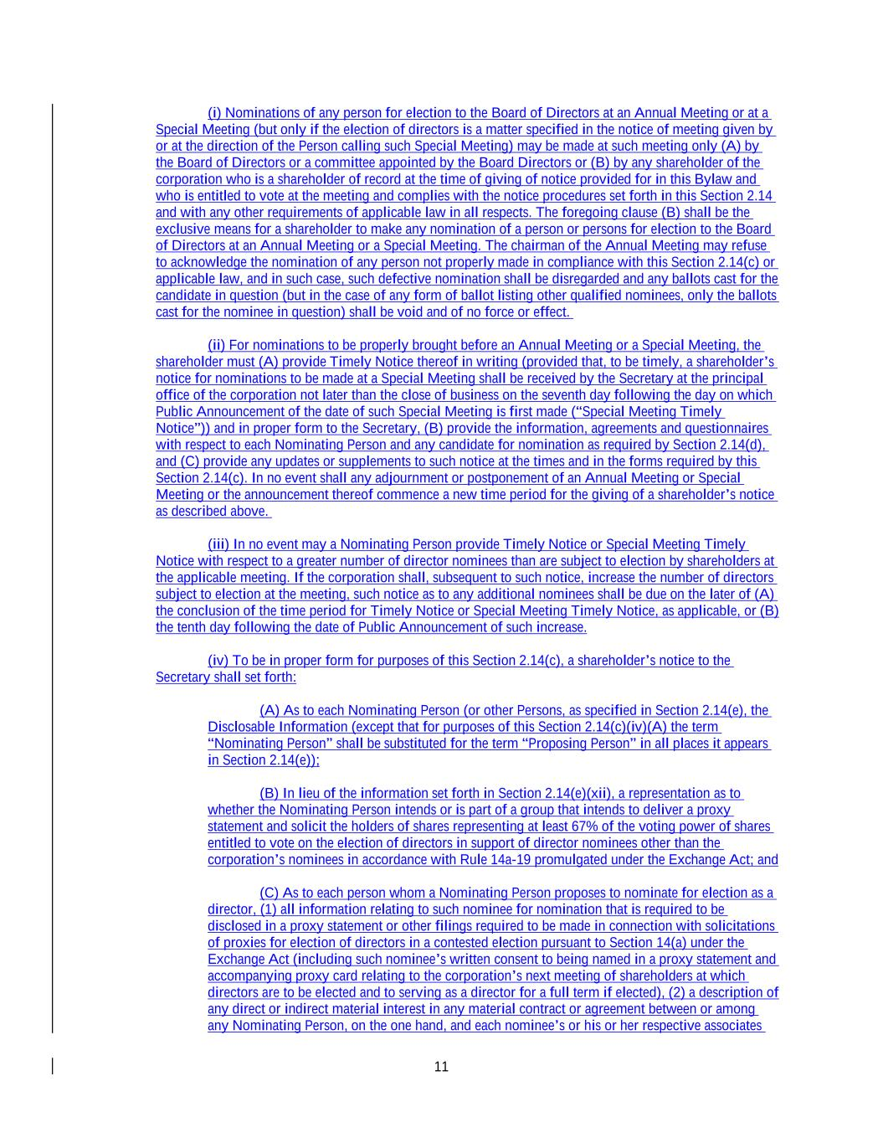
11 (i) Nominations of any person for election to the Board of Directors at an Annual Meeting or at a Special Meeting (but only if the election of directors is a matter specified in the notice of meeting given by or at the direction of the Person calling such Special Meeting) may be made at such meeting only (A) by the Board of Directors or a committee appointed by the Board Directors or (B) by any shareholder of the corporation who is a shareholder of record at the time of giving of notice provided for in this Bylaw and who is entitled to vote at the meeting and complies with the notice procedures set forth in this Section 2.14 and with any other requirements of applicable law in all respects. The foregoing clause (B) shall be the exclusive means for a shareholder to make any nomination of a person or persons for election to the Board of Directors at an Annual Meeting or a Special Meeting. The chairman of the Annual Meeting may refuse to acknowledge the nomination of any person not properly made in compliance with this Section 2.14(c) or applicable law, and in such case, such defective nomination shall be disregarded and any ballots cast for the candidate in question (but in the case of any form of ballot listing other qualified nominees, only the ballots cast for the nominee in question) shall be void and of no force or effect. (ii) For nominations to be properly brought before an Annual Meeting or a Special Meeting, the shareholder must (A) provide Timely Notice thereof in writing (provided that, to be timely, a shareholder’s notice for nominations to be made at a Special Meeting shall be received by the Secretary at the principal office of the corporation not later than the close of business on the seventh day following the day on which Public Announcement of the date of such Special Meeting is first made (“Special Meeting Timely Notice”)) and in proper form to the Secretary, (B) provide the information, agreements and questionnaires with respect to each Nominating Person and any candidate for nomination as required by Section 2.14(d), and (C) provide any updates or supplements to such notice at the times and in the forms required by this Section 2.14(c). In no event shall any adjournment or postponement of an Annual Meeting or Special Meeting or the announcement thereof commence a new time period for the giving of a shareholder’s notice as described above. (iii) In no event may a Nominating Person provide Timely Notice or Special Meeting Timely Notice with respect to a greater number of director nominees than are subject to election by shareholders at the applicable meeting. If the corporation shall, subsequent to such notice, increase the number of directors subject to election at the meeting, such notice as to any additional nominees shall be due on the later of (A) the conclusion of the time period for Timely Notice or Special Meeting Timely Notice, as applicable, or (B) the tenth day following the date of Public Announcement of such increase. (iv) To be in proper form for purposes of this Section 2.14(c), a shareholder’s notice to the Secretary shall set forth: (A) As to each Nominating Person (or other Persons, as specified in Section 2.14(e), the Disclosable Information (except that for purposes of this Section 2.14(c)(iv)(A) the term “Nominating Person” shall be substituted for the term “Proposing Person” in all places it appears in Section 2.14(e)); (B) In lieu of the information set forth in Section 2.14(e)(xii), a representation as to whether the Nominating Person intends or is part of a group that intends to deliver a proxy statement and solicit the holders of shares representing at least 67% of the voting power of shares entitled to vote on the election of directors in support of director nominees other than the corporation’s nominees in accordance with Rule 14a-19 promulgated under the Exchange Act; and (C) As to each person whom a Nominating Person proposes to nominate for election as a director, (1) all information relating to such nominee for nomination that is required to be disclosed in a proxy statement or other filings required to be made in connection with solicitations of proxies for election of directors in a contested election pursuant to Section 14(a) under the Exchange Act (including such nominee’s written consent to being named in a proxy statement and accompanying proxy card relating to the corporation’s next meeting of shareholders at which directors are to be elected and to serving as a director for a full term if elected), (2) a description of any direct or indirect material interest in any material contract or agreement between or among any Nominating Person, on the one hand, and each nominee’s or his or her respective associates

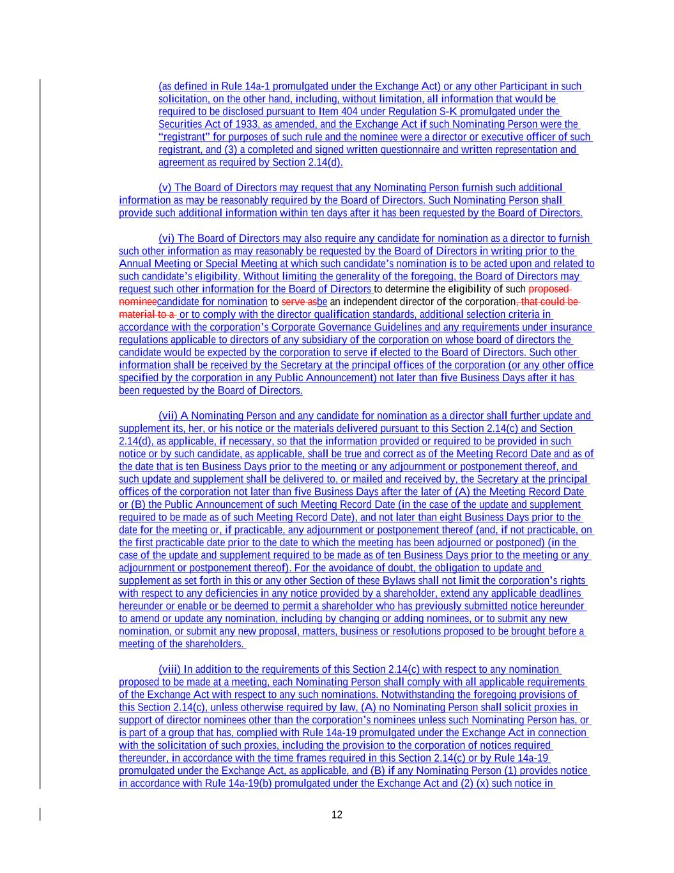
12 (as defined in Rule 14a-1 promulgated under the Exchange Act) or any other Participant in such solicitation, on the other hand, including, without limitation, all information that would be required to be disclosed pursuant to Item 404 under Regulation S-K promulgated under the Securities Act of 1933, as amended, and the Exchange Act if such Nominating Person were the “registrant” for purposes of such rule and the nominee were a director or executive officer of such registrant, and (3) a completed and signed written questionnaire and written representation and agreement as required by Section 2.14(d). (v) The Board of Directors may request that any Nominating Person furnish such additional information as may be reasonably required by the Board of Directors. Such Nominating Person shall provide such additional information within ten days after it has been requested by the Board of Directors. (vi) The Board of Directors may also require any candidate for nomination as a director to furnish such other information as may reasonably be requested by the Board of Directors in writing prior to the Annual Meeting or Special Meeting at which such candidate’s nomination is to be acted upon and related to such candidate’s eligibility. Without limiting the generality of the foregoing, the Board of Directors may request such other information for the Board of Directors to determine the eligibility of such proposed nomineecandidate for nomination to serve asbe an independent director of the corporation, that could be material to a or to comply with the director qualification standards, additional selection criteria in accordance with the corporation’s Corporate Governance Guidelines and any requirements under insurance regulations applicable to directors of any subsidiary of the corporation on whose board of directors the candidate would be expected by the corporation to serve if elected to the Board of Directors. Such other information shall be received by the Secretary at the principal offices of the corporation (or any other office specified by the corporation in any Public Announcement) not later than five Business Days after it has been requested by the Board of Directors. (vii) A Nominating Person and any candidate for nomination as a director shall further update and supplement its, her, or his notice or the materials delivered pursuant to this Section 2.14(c) and Section 2.14(d), as applicable, if necessary, so that the information provided or required to be provided in such notice or by such candidate, as applicable, shall be true and correct as of the Meeting Record Date and as of the date that is ten Business Days prior to the meeting or any adjournment or postponement thereof, and such update and supplement shall be delivered to, or mailed and received by, the Secretary at the principal offices of the corporation not later than five Business Days after the later of (A) the Meeting Record Date or (B) the Public Announcement of such Meeting Record Date (in the case of the update and supplement required to be made as of such Meeting Record Date), and not later than eight Business Days prior to the date for the meeting or, if practicable, any adjournment or postponement thereof (and, if not practicable, on the first practicable date prior to the date to which the meeting has been adjourned or postponed) (in the case of the update and supplement required to be made as of ten Business Days prior to the meeting or any adjournment or postponement thereof). For the avoidance of doubt, the obligation to update and supplement as set forth in this or any other Section of these Bylaws shall not limit the corporation’s rights with respect to any deficiencies in any notice provided by a shareholder, extend any applicable deadlines hereunder or enable or be deemed to permit a shareholder who has previously submitted notice hereunder to amend or update any nomination, including by changing or adding nominees, or to submit any new nomination, or submit any new proposal, matters, business or resolutions proposed to be brought before a meeting of the shareholders. (viii) In addition to the requirements of this Section 2.14(c) with respect to any nomination proposed to be made at a meeting, each Nominating Person shall comply with all applicable requirements of the Exchange Act with respect to any such nominations. Notwithstanding the foregoing provisions of this Section 2.14(c), unless otherwise required by law, (A) no Nominating Person shall solicit proxies in support of director nominees other than the corporation’s nominees unless such Nominating Person has, or is part of a group that has, complied with Rule 14a-19 promulgated under the Exchange Act in connection with the solicitation of such proxies, including the provision to the corporation of notices required thereunder, in accordance with the time frames required in this Section 2.14(c) or by Rule 14a-19 promulgated under the Exchange Act, as applicable, and (B) if any Nominating Person (1) provides notice in accordance with Rule 14a-19(b) promulgated under the Exchange Act and (2) (x) such notice in

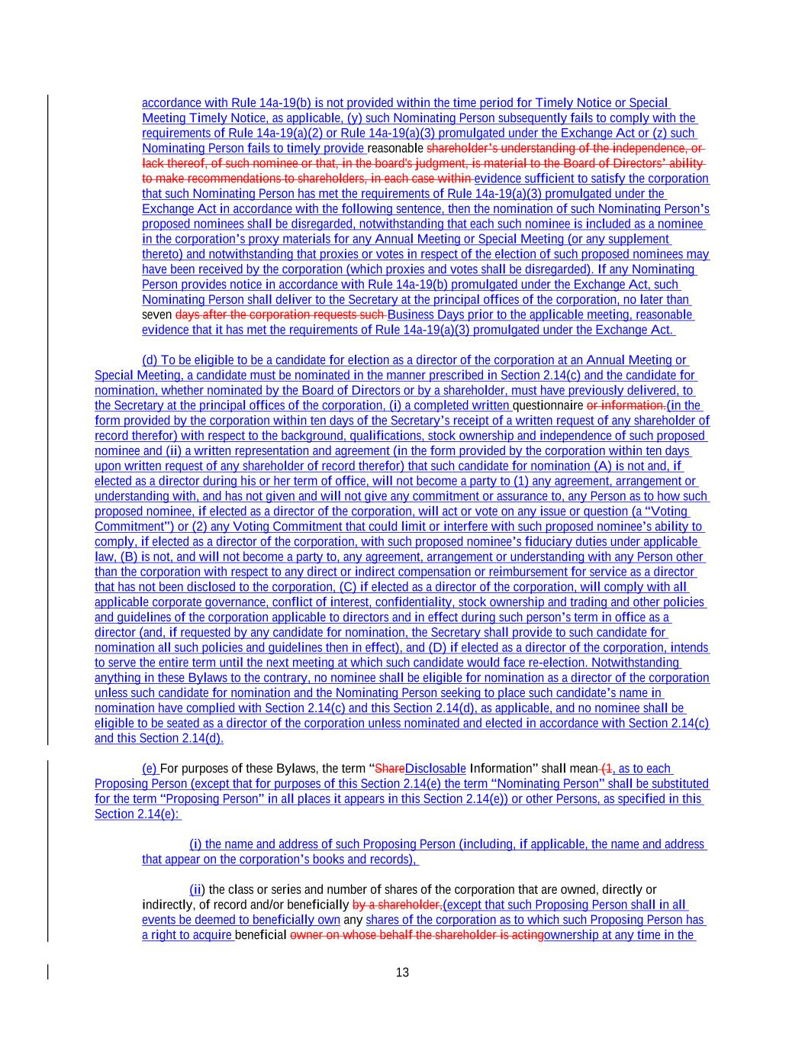
13 accordance with Rule 14a-19(b) is not provided within the time period for Timely Notice or Special Meeting Timely Notice, as applicable, (y) such Nominating Person subsequently fails to comply with the requirements of Rule 14a-19(a)(2) or Rule 14a-19(a)(3) promulgated under the Exchange Act or (z) such Nominating Person fails to timely provide reasonable shareholder’s understanding of the independence, or lack thereof, of such nominee or that, in the board's judgment, is material to the Board of Directors’ ability to make recommendations to shareholders, in each case within evidence sufficient to satisfy the corporation that such Nominating Person has met the requirements of Rule 14a-19(a)(3) promulgated under the Exchange Act in accordance with the following sentence, then the nomination of such Nominating Person’s proposed nominees shall be disregarded, notwithstanding that each such nominee is included as a nominee in the corporation’s proxy materials for any Annual Meeting or Special Meeting (or any supplement thereto) and notwithstanding that proxies or votes in respect of the election of such proposed nominees may have been received by the corporation (which proxies and votes shall be disregarded). If any Nominating Person provides notice in accordance with Rule 14a-19(b) promulgated under the Exchange Act, such Nominating Person shall deliver to the Secretary at the principal offices of the corporation, no later than seven days after the corporation requests such Business Days prior to the applicable meeting, reasonable evidence that it has met the requirements of Rule 14a-19(a)(3) promulgated under the Exchange Act. (d) To be eligible to be a candidate for election as a director of the corporation at an Annual Meeting or Special Meeting, a candidate must be nominated in the manner prescribed in Section 2.14(c) and the candidate for nomination, whether nominated by the Board of Directors or by a shareholder, must have previously delivered, to the Secretary at the principal offices of the corporation, (i) a completed written questionnaire or information.(in the form provided by the corporation within ten days of the Secretary’s receipt of a written request of any shareholder of record therefor) with respect to the background, qualifications, stock ownership and independence of such proposed nominee and (ii) a written representation and agreement (in the form provided by the corporation within ten days upon written request of any shareholder of record therefor) that such candidate for nomination (A) is not and, if elected as a director during his or her term of office, will not become a party to (1) any agreement, arrangement or understanding with, and has not given and will not give any commitment or assurance to, any Person as to how such proposed nominee, if elected as a director of the corporation, will act or vote on any issue or question (a “Voting Commitment”) or (2) any Voting Commitment that could limit or interfere with such proposed nominee’s ability to comply, if elected as a director of the corporation, with such proposed nominee’s fiduciary duties under applicable law, (B) is not, and will not become a party to, any agreement, arrangement or understanding with any Person other than the corporation with respect to any direct or indirect compensation or reimbursement for service as a director that has not been disclosed to the corporation, (C) if elected as a director of the corporation, will comply with all applicable corporate governance, conflict of interest, confidentiality, stock ownership and trading and other policies and guidelines of the corporation applicable to directors and in effect during such person’s term in office as a director (and, if requested by any candidate for nomination, the Secretary shall provide to such candidate for nomination all such policies and guidelines then in effect), and (D) if elected as a director of the corporation, intends to serve the entire term until the next meeting at which such candidate would face re-election. Notwithstanding anything in these Bylaws to the contrary, no nominee shall be eligible for nomination as a director of the corporation unless such candidate for nomination and the Nominating Person seeking to place such candidate’s name in nomination have complied with Section 2.14(c) and this Section 2.14(d), as applicable, and no nominee shall be eligible to be seated as a director of the corporation unless nominated and elected in accordance with Section 2.14(c) and this Section 2.14(d). (e) For purposes of these Bylaws, the term “ShareDisclosable Information” shall mean (1, as to each Proposing Person (except that for purposes of this Section 2.14(e) the term “Nominating Person” shall be substituted for the term “Proposing Person” in all places it appears in this Section 2.14(e)) or other Persons, as specified in this Section 2.14(e): (i) the name and address of such Proposing Person (including, if applicable, the name and address that appear on the corporation’s books and records), (ii) the class or series and number of shares of the corporation that are owned, directly or indirectly, of record and/or beneficially by a shareholder,(except that such Proposing Person shall in all events be deemed to beneficially own any shares of the corporation as to which such Proposing Person has a right to acquire beneficial owner on whose behalf the shareholder is actingownership at any time in the

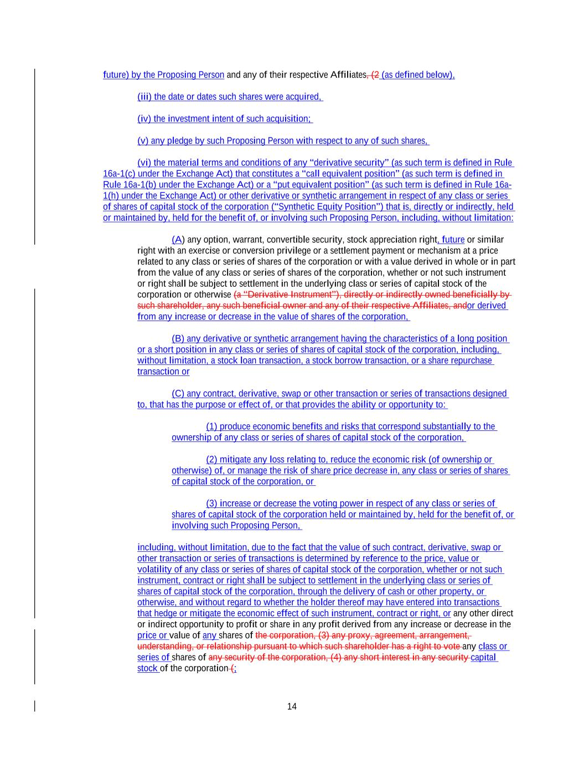
14 future) by the Proposing Person and any of their respective Affiliates, (2 (as defined below), (iii) the date or dates such shares were acquired, (iv) the investment intent of such acquisition; (v) any pledge by such Proposing Person with respect to any of such shares, (vi) the material terms and conditions of any “derivative security” (as such term is defined in Rule 16a-1(c) under the Exchange Act) that constitutes a “call equivalent position” (as such term is defined in Rule 16a-1(b) under the Exchange Act) or a “put equivalent position” (as such term is defined in Rule 16a- 1(h) under the Exchange Act) or other derivative or synthetic arrangement in respect of any class or series of shares of capital stock of the corporation (“Synthetic Equity Position”) that is, directly or indirectly, held or maintained by, held for the benefit of, or involving such Proposing Person, including, without limitation: (A) any option, warrant, convertible security, stock appreciation right, future or similar right with an exercise or conversion privilege or a settlement payment or mechanism at a price related to any class or series of shares of the corporation or with a value derived in whole or in part from the value of any class or series of shares of the corporation, whether or not such instrument or right shall be subject to settlement in the underlying class or series of capital stock of the corporation or otherwise (a “Derivative Instrument”), directly or indirectly owned beneficially by such shareholder, any such beneficial owner and any of their respective Affiliates, andor derived from any increase or decrease in the value of shares of the corporation, (B) any derivative or synthetic arrangement having the characteristics of a long position or a short position in any class or series of shares of capital stock of the corporation, including, without limitation, a stock loan transaction, a stock borrow transaction, or a share repurchase transaction or (C) any contract, derivative, swap or other transaction or series of transactions designed to, that has the purpose or effect of, or that provides the ability or opportunity to: (1) produce economic benefits and risks that correspond substantially to the ownership of any class or series of shares of capital stock of the corporation, (2) mitigate any loss relating to, reduce the economic risk (of ownership or otherwise) of, or manage the risk of share price decrease in, any class or series of shares of capital stock of the corporation, or (3) increase or decrease the voting power in respect of any class or series of shares of capital stock of the corporation held or maintained by, held for the benefit of, or involving such Proposing Person, including, without limitation, due to the fact that the value of such contract, derivative, swap or other transaction or series of transactions is determined by reference to the price, value or volatility of any class or series of shares of capital stock of the corporation, whether or not such instrument, contract or right shall be subject to settlement in the underlying class or series of shares of capital stock of the corporation, through the delivery of cash or other property, or otherwise, and without regard to whether the holder thereof may have entered into transactions that hedge or mitigate the economic effect of such instrument, contract or right, or any other direct or indirect opportunity to profit or share in any profit derived from any increase or decrease in the price or value of any shares of the corporation, (3) any proxy, agreement, arrangement, understanding, or relationship pursuant to which such shareholder has a right to vote any class or series of shares of any security of the corporation, (4) any short interest in any security capital stock of the corporation (;

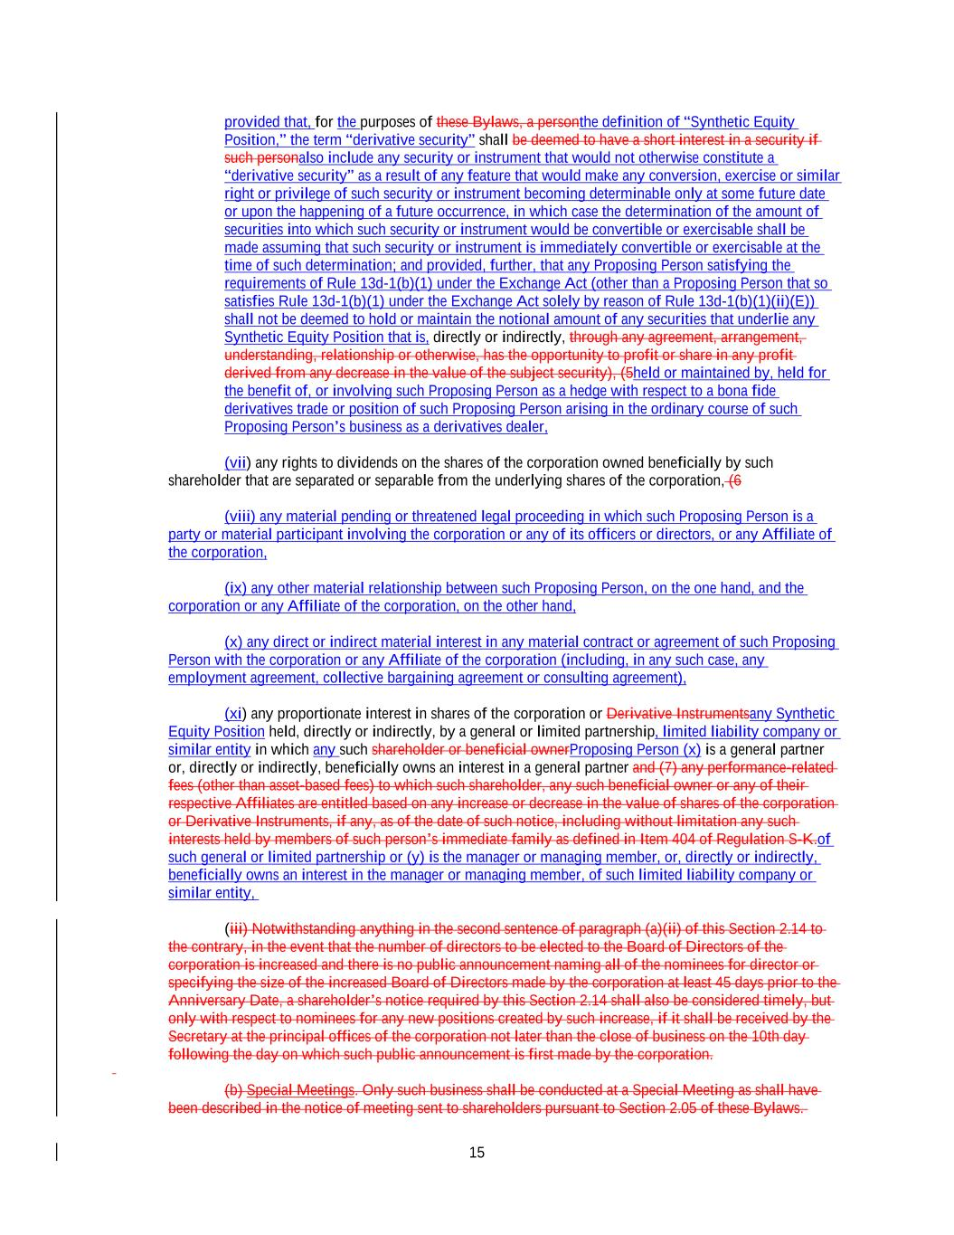
15 provided that, for the purposes of these Bylaws, a personthe definition of “Synthetic Equity Position,” the term “derivative security” shall be deemed to have a short interest in a security if such personalso include any security or instrument that would not otherwise constitute a “derivative security” as a result of any feature that would make any conversion, exercise or similar right or privilege of such security or instrument becoming determinable only at some future date or upon the happening of a future occurrence, in which case the determination of the amount of securities into which such security or instrument would be convertible or exercisable shall be made assuming that such security or instrument is immediately convertible or exercisable at the time of such determination; and provided, further, that any Proposing Person satisfying the requirements of Rule 13d-1(b)(1) under the Exchange Act (other than a Proposing Person that so satisfies Rule 13d-1(b)(1) under the Exchange Act solely by reason of Rule 13d-1(b)(1)(ii)(E)) shall not be deemed to hold or maintain the notional amount of any securities that underlie any Synthetic Equity Position that is, directly or indirectly, through any agreement, arrangement, understanding, relationship or otherwise, has the opportunity to profit or share in any profit derived from any decrease in the value of the subject security), (5held or maintained by, held for the benefit of, or involving such Proposing Person as a hedge with respect to a bona fide derivatives trade or position of such Proposing Person arising in the ordinary course of such Proposing Person’s business as a derivatives dealer, (vii) any rights to dividends on the shares of the corporation owned beneficially by such shareholder that are separated or separable from the underlying shares of the corporation, (6 (viii) any material pending or threatened legal proceeding in which such Proposing Person is a party or material participant involving the corporation or any of its officers or directors, or any Affiliate of the corporation, (ix) any other material relationship between such Proposing Person, on the one hand, and the corporation or any Affiliate of the corporation, on the other hand, (x) any direct or indirect material interest in any material contract or agreement of such Proposing Person with the corporation or any Affiliate of the corporation (including, in any such case, any employment agreement, collective bargaining agreement or consulting agreement), (xi) any proportionate interest in shares of the corporation or Derivative Instrumentsany Synthetic Equity Position held, directly or indirectly, by a general or limited partnership, limited liability company or similar entity in which any such shareholder or beneficial ownerProposing Person (x) is a general partner or, directly or indirectly, beneficially owns an interest in a general partner and (7) any performance-related fees (other than asset-based fees) to which such shareholder, any such beneficial owner or any of their respective Affiliates are entitled based on any increase or decrease in the value of shares of the corporation or Derivative Instruments, if any, as of the date of such notice, including without limitation any such interests held by members of such person’s immediate family as defined in Item 404 of Regulation S-K.of such general or limited partnership or (y) is the manager or managing member, or, directly or indirectly, beneficially owns an interest in the manager or managing member, of such limited liability company or similar entity, (iii) Notwithstanding anything in the second sentence of paragraph (a)(ii) of this Section 2.14 to the contrary, in the event that the number of directors to be elected to the Board of Directors of the corporation is increased and there is no public announcement naming all of the nominees for director or specifying the size of the increased Board of Directors made by the corporation at least 45 days prior to the Anniversary Date, a shareholder’s notice required by this Section 2.14 shall also be considered timely, but only with respect to nominees for any new positions created by such increase, if it shall be received by the Secretary at the principal offices of the corporation not later than the close of business on the 10th day following the day on which such public announcement is first made by the corporation. (b) Special Meetings. Only such business shall be conducted at a Special Meeting as shall have been described in the notice of meeting sent to shareholders pursuant to Section 2.05 of these Bylaws.

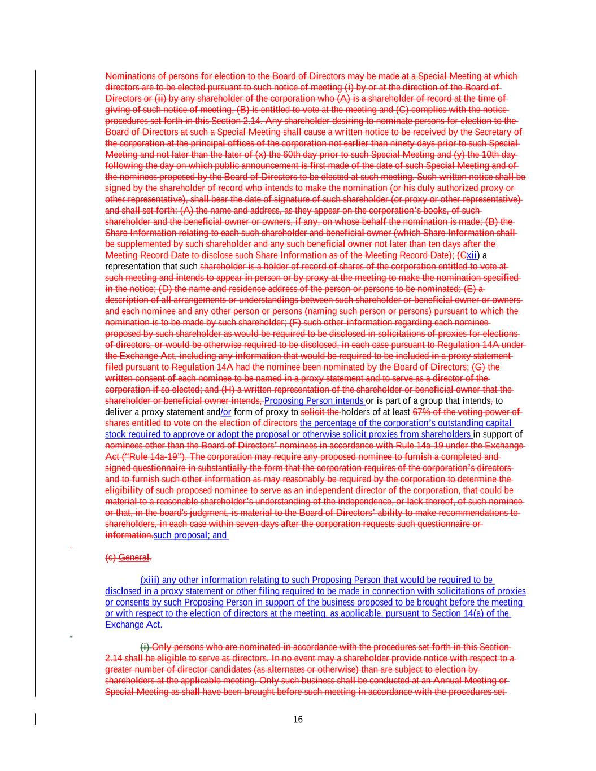
16 Nominations of persons for election to the Board of Directors may be made at a Special Meeting at which directors are to be elected pursuant to such notice of meeting (i) by or at the direction of the Board of Directors or (ii) by any shareholder of the corporation who (A) is a shareholder of record at the time of giving of such notice of meeting, (B) is entitled to vote at the meeting and (C) complies with the notice procedures set forth in this Section 2.14. Any shareholder desiring to nominate persons for election to the Board of Directors at such a Special Meeting shall cause a written notice to be received by the Secretary of the corporation at the principal offices of the corporation not earlier than ninety days prior to such Special Meeting and not later than the later of (x) the 60th day prior to such Special Meeting and (y) the 10th day following the day on which public announcement is first made of the date of such Special Meeting and of the nominees proposed by the Board of Directors to be elected at such meeting. Such written notice shall be signed by the shareholder of record who intends to make the nomination (or his duly authorized proxy or other representative), shall bear the date of signature of such shareholder (or proxy or other representative) and shall set forth: (A) the name and address, as they appear on the corporation’s books, of such shareholder and the beneficial owner or owners, if any, on whose behalf the nomination is made; (B) the Share Information relating to each such shareholder and beneficial owner (which Share Information shall be supplemented by such shareholder and any such beneficial owner not later than ten days after the Meeting Record Date to disclose such Share Information as of the Meeting Record Date); (Cxii) a representation that such shareholder is a holder of record of shares of the corporation entitled to vote at such meeting and intends to appear in person or by proxy at the meeting to make the nomination specified in the notice; (D) the name and residence address of the person or persons to be nominated; (E) a description of all arrangements or understandings between such shareholder or beneficial owner or owners and each nominee and any other person or persons (naming such person or persons) pursuant to which the nomination is to be made by such shareholder; (F) such other information regarding each nominee proposed by such shareholder as would be required to be disclosed in solicitations of proxies for elections of directors, or would be otherwise required to be disclosed, in each case pursuant to Regulation 14A under the Exchange Act, including any information that would be required to be included in a proxy statement filed pursuant to Regulation 14A had the nominee been nominated by the Board of Directors; (G) the written consent of each nominee to be named in a proxy statement and to serve as a director of the corporation if so elected; and (H) a written representation of the shareholder or beneficial owner that the shareholder or beneficial owner intends, Proposing Person intends or is part of a group that intends, to deliver a proxy statement and/or form of proxy to solicit the holders of at least 67% of the voting power of shares entitled to vote on the election of directors the percentage of the corporation’s outstanding capital stock required to approve or adopt the proposal or otherwise solicit proxies from shareholders in support of nominees other than the Board of Directors’ nominees in accordance with Rule 14a-19 under the Exchange Act (“Rule 14a-19”). The corporation may require any proposed nominee to furnish a completed and signed questionnaire in substantially the form that the corporation requires of the corporation’s directors and to furnish such other information as may reasonably be required by the corporation to determine the eligibility of such proposed nominee to serve as an independent director of the corporation, that could be material to a reasonable shareholder’s understanding of the independence, or lack thereof, of such nominee or that, in the board's judgment, is material to the Board of Directors’ ability to make recommendations to shareholders, in each case within seven days after the corporation requests such questionnaire or information.such proposal; and (c) General. (xiii) any other information relating to such Proposing Person that would be required to be disclosed in a proxy statement or other filing required to be made in connection with solicitations of proxies or consents by such Proposing Person in support of the business proposed to be brought before the meeting or with respect to the election of directors at the meeting, as applicable, pursuant to Section 14(a) of the Exchange Act. (i) Only persons who are nominated in accordance with the procedures set forth in this Section 2.14 shall be eligible to serve as directors. In no event may a shareholder provide notice with respect to a greater number of director candidates (as alternates or otherwise) than are subject to election by shareholders at the applicable meeting. Only such business shall be conducted at an Annual Meeting or Special Meeting as shall have been brought before such meeting in accordance with the procedures set

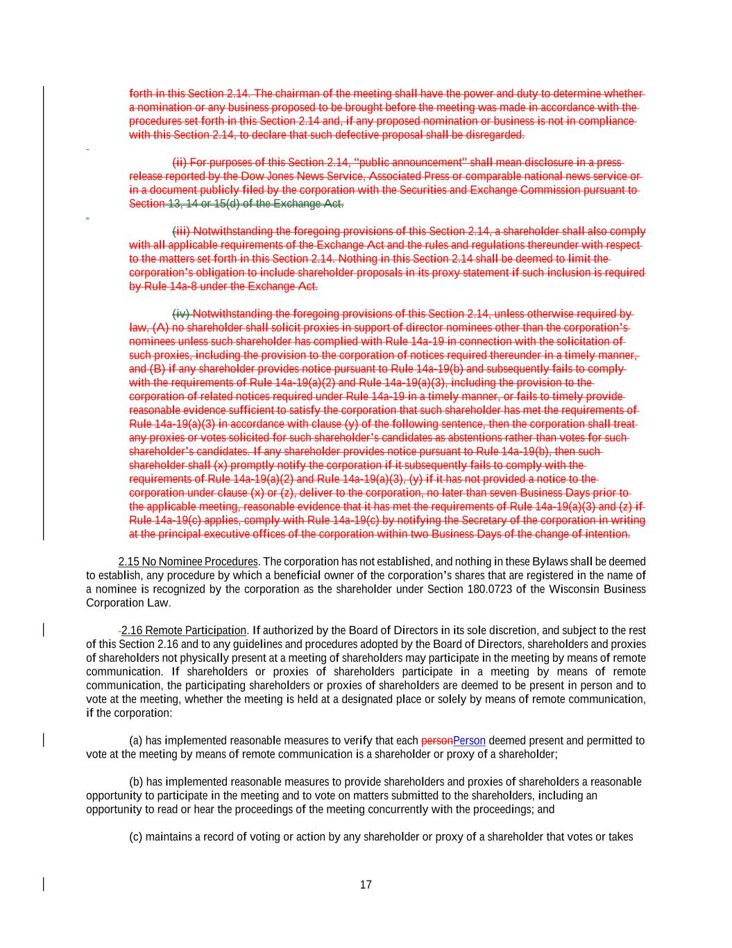
17 forth in this Section 2.14. The chairman of the meeting shall have the power and duty to determine whether a nomination or any business proposed to be brought before the meeting was made in accordance with the procedures set forth in this Section 2.14 and, if any proposed nomination or business is not in compliance with this Section 2.14, to declare that such defective proposal shall be disregarded. (ii) For purposes of this Section 2.14, “public announcement” shall mean disclosure in a press release reported by the Dow Jones News Service, Associated Press or comparable national news service or in a document publicly filed by the corporation with the Securities and Exchange Commission pursuant to Section 13, 14 or 15(d) of the Exchange Act. (iii) Notwithstanding the foregoing provisions of this Section 2.14, a shareholder shall also comply with all applicable requirements of the Exchange Act and the rules and regulations thereunder with respect to the matters set forth in this Section 2.14. Nothing in this Section 2.14 shall be deemed to limit the corporation’s obligation to include shareholder proposals in its proxy statement if such inclusion is required by Rule 14a-8 under the Exchange Act. (iv) Notwithstanding the foregoing provisions of this Section 2.14, unless otherwise required by law, (A) no shareholder shall solicit proxies in support of director nominees other than the corporation’s nominees unless such shareholder has complied with Rule 14a-19 in connection with the solicitation of such proxies, including the provision to the corporation of notices required thereunder in a timely manner, and (B) if any shareholder provides notice pursuant to Rule 14a-19(b) and subsequently fails to comply with the requirements of Rule 14a-19(a)(2) and Rule 14a-19(a)(3), including the provision to the corporation of related notices required under Rule 14a-19 in a timely manner, or fails to timely provide reasonable evidence sufficient to satisfy the corporation that such shareholder has met the requirements of Rule 14a-19(a)(3) in accordance with clause (y) of the following sentence, then the corporation shall treat any proxies or votes solicited for such shareholder’s candidates as abstentions rather than votes for such shareholder’s candidates. If any shareholder provides notice pursuant to Rule 14a-19(b), then such shareholder shall (x) promptly notify the corporation if it subsequently fails to comply with the requirements of Rule 14a-19(a)(2) and Rule 14a-19(a)(3), (y) if it has not provided a notice to the corporation under clause (x) or (z), deliver to the corporation, no later than seven Business Days prior to the applicable meeting, reasonable evidence that it has met the requirements of Rule 14a-19(a)(3) and (z) if Rule 14a-19(c) applies, comply with Rule 14a-19(c) by notifying the Secretary of the corporation in writing at the principal executive offices of the corporation within two Business Days of the change of intention. 2.15 No Nominee Procedures. The corporation has not established, and nothing in these Bylaws shall be deemed to establish, any procedure by which a beneficial owner of the corporation’s shares that are registered in the name of a nominee is recognized by the corporation as the shareholder under Section 180.0723 of the Wisconsin Business Corporation Law. 2.16 Remote Participation. If authorized by the Board of Directors in its sole discretion, and subject to the rest of this Section 2.16 and to any guidelines and procedures adopted by the Board of Directors, shareholders and proxies of shareholders not physically present at a meeting of shareholders may participate in the meeting by means of remote communication. If shareholders or proxies of shareholders participate in a meeting by means of remote communication, the participating shareholders or proxies of shareholders are deemed to be present in person and to vote at the meeting, whether the meeting is held at a designated place or solely by means of remote communication, if the corporation: (a) has implemented reasonable measures to verify that each personPerson deemed present and permitted to vote at the meeting by means of remote communication is a shareholder or proxy of a shareholder; (b) has implemented reasonable measures to provide shareholders and proxies of shareholders a reasonable opportunity to participate in the meeting and to vote on matters submitted to the shareholders, including an opportunity to read or hear the proceedings of the meeting concurrently with the proceedings; and (c) maintains a record of voting or action by any shareholder or proxy of a shareholder that votes or takes

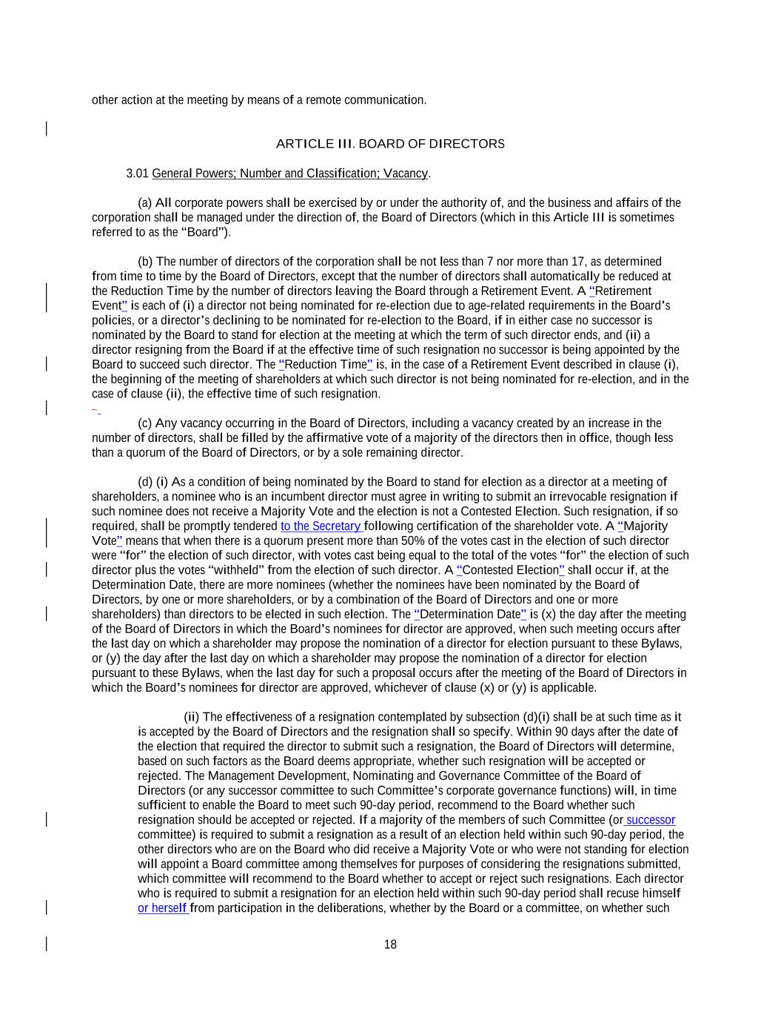
18 other action at the meeting by means of a remote communication. ARTICLE III. BOARD OF DIRECTORS 3.01 General Powers; Number and Classification; Vacancy. (a) All corporate powers shall be exercised by or under the authority of, and the business and affairs of the corporation shall be managed under the direction of, the Board of Directors (which in this Article III is sometimes referred to as the “Board”). (b) The number of directors of the corporation shall be not less than 7 nor more than 17, as determined from time to time by the Board of Directors, except that the number of directors shall automatically be reduced at the Reduction Time by the number of directors leaving the Board through a Retirement Event. A “Retirement Event” is each of (i) a director not being nominated for re-election due to age-related requirements in the Board’s policies, or a director’s declining to be nominated for re-election to the Board, if in either case no successor is nominated by the Board to stand for election at the meeting at which the term of such director ends, and (ii) a director resigning from the Board if at the effective time of such resignation no successor is being appointed by the Board to succeed such director. The “Reduction Time” is, in the case of a Retirement Event described in clause (i), the beginning of the meeting of shareholders at which such director is not being nominated for re-election, and in the case of clause (ii), the effective time of such resignation. (c) Any vacancy occurring in the Board of Directors, including a vacancy created by an increase in the number of directors, shall be filled by the affirmative vote of a majority of the directors then in office, though less than a quorum of the Board of Directors, or by a sole remaining director. (d) (i) As a condition of being nominated by the Board to stand for election as a director at a meeting of shareholders, a nominee who is an incumbent director must agree in writing to submit an irrevocable resignation if such nominee does not receive a Majority Vote and the election is not a Contested Election. Such resignation, if so required, shall be promptly tendered to the Secretary following certification of the shareholder vote. A “Majority Vote” means that when there is a quorum present more than 50% of the votes cast in the election of such director were “for” the election of such director, with votes cast being equal to the total of the votes “for” the election of such director plus the votes “withheld” from the election of such director. A “Contested Election” shall occur if, at the Determination Date, there are more nominees (whether the nominees have been nominated by the Board of Directors, by one or more shareholders, or by a combination of the Board of Directors and one or more shareholders) than directors to be elected in such election. The “Determination Date” is (x) the day after the meeting of the Board of Directors in which the Board’s nominees for director are approved, when such meeting occurs after the last day on which a shareholder may propose the nomination of a director for election pursuant to these Bylaws, or (y) the day after the last day on which a shareholder may propose the nomination of a director for election pursuant to these Bylaws, when the last day for such a proposal occurs after the meeting of the Board of Directors in which the Board’s nominees for director are approved, whichever of clause (x) or (y) is applicable. (ii) The effectiveness of a resignation contemplated by subsection (d)(i) shall be at such time as it is accepted by the Board of Directors and the resignation shall so specify. Within 90 days after the date of the election that required the director to submit such a resignation, the Board of Directors will determine, based on such factors as the Board deems appropriate, whether such resignation will be accepted or rejected. The Management Development, Nominating and Governance Committee of the Board of Directors (or any successor committee to such Committee’s corporate governance functions) will, in time sufficient to enable the Board to meet such 90-day period, recommend to the Board whether such resignation should be accepted or rejected. If a majority of the members of such Committee (or successor committee) is required to submit a resignation as a result of an election held within such 90-day period, the other directors who are on the Board who did receive a Majority Vote or who were not standing for election will appoint a Board committee among themselves for purposes of considering the resignations submitted, which committee will recommend to the Board whether to accept or reject such resignations. Each director who is required to submit a resignation for an election held within such 90-day period shall recuse himself or herself from participation in the deliberations, whether by the Board or a committee, on whether such

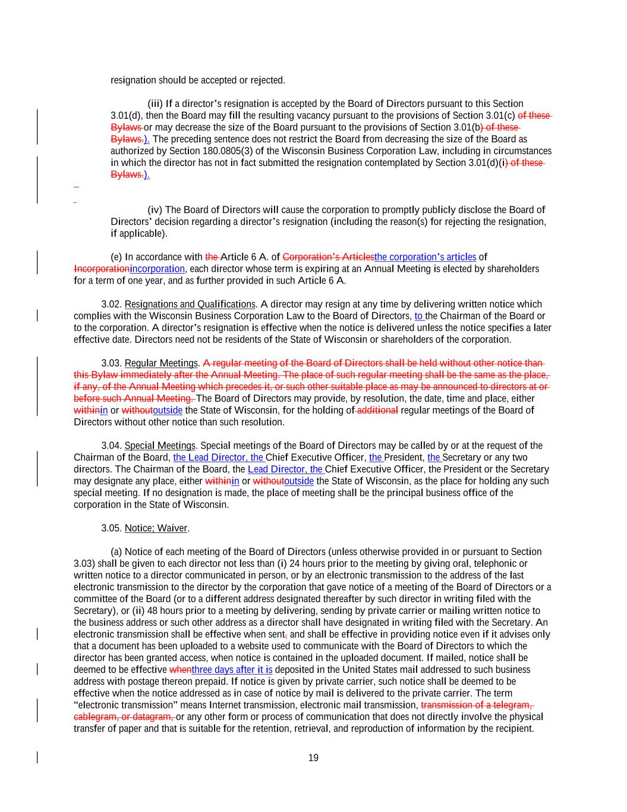
19 resignation should be accepted or rejected. (iii) If a director’s resignation is accepted by the Board of Directors pursuant to this Section 3.01(d), then the Board may fill the resulting vacancy pursuant to the provisions of Section 3.01(c) of these Bylaws or may decrease the size of the Board pursuant to the provisions of Section 3.01(b) of these Bylaws.). The preceding sentence does not restrict the Board from decreasing the size of the Board as authorized by Section 180.0805(3) of the Wisconsin Business Corporation Law, including in circumstances in which the director has not in fact submitted the resignation contemplated by Section 3.01(d)(i) of these Bylaws.). (iv) The Board of Directors will cause the corporation to promptly publicly disclose the Board of Directors’ decision regarding a director’s resignation (including the reason(s) for rejecting the resignation, if applicable). (e) In accordance with the Article 6 A. of Corporation’s Articlesthe corporation’s articles of Incorporationincorporation, each director whose term is expiring at an Annual Meeting is elected by shareholders for a term of one year, and as further provided in such Article 6 A. 3.02. Resignations and Qualifications. A director may resign at any time by delivering written notice which complies with the Wisconsin Business Corporation Law to the Board of Directors, to the Chairman of the Board or to the corporation. A director’s resignation is effective when the notice is delivered unless the notice specifies a later effective date. Directors need not be residents of the State of Wisconsin or shareholders of the corporation. 3.03. Regular Meetings. A regular meeting of the Board of Directors shall be held without other notice than this Bylaw immediately after the Annual Meeting. The place of such regular meeting shall be the same as the place, if any, of the Annual Meeting which precedes it, or such other suitable place as may be announced to directors at or before such Annual Meeting. The Board of Directors may provide, by resolution, the date, time and place, either withinin or withoutoutside the State of Wisconsin, for the holding of additional regular meetings of the Board of Directors without other notice than such resolution. 3.04. Special Meetings. Special meetings of the Board of Directors may be called by or at the request of the Chairman of the Board, the Lead Director, the Chief Executive Officer, the President, the Secretary or any two directors. The Chairman of the Board, the Lead Director, the Chief Executive Officer, the President or the Secretary may designate any place, either withinin or withoutoutside the State of Wisconsin, as the place for holding any such special meeting. If no designation is made, the place of meeting shall be the principal business office of the corporation in the State of Wisconsin. 3.05. Notice; Waiver. (a) Notice of each meeting of the Board of Directors (unless otherwise provided in or pursuant to Section 3.03) shall be given to each director not less than (i) 24 hours prior to the meeting by giving oral, telephonic or written notice to a director communicated in person, or by an electronic transmission to the address of the last electronic transmission to the director by the corporation that gave notice of a meeting of the Board of Directors or a committee of the Board (or to a different address designated thereafter by such director in writing filed with the Secretary), or (ii) 48 hours prior to a meeting by delivering, sending by private carrier or mailing written notice to the business address or such other address as a director shall have designated in writing filed with the Secretary. An electronic transmission shall be effective when sent, and shall be effective in providing notice even if it advises only that a document has been uploaded to a website used to communicate with the Board of Directors to which the director has been granted access, when notice is contained in the uploaded document. If mailed, notice shall be deemed to be effective whenthree days after it is deposited in the United States mail addressed to such business address with postage thereon prepaid. If notice is given by private carrier, such notice shall be deemed to be effective when the notice addressed as in case of notice by mail is delivered to the private carrier. The term “electronic transmission” means Internet transmission, electronic mail transmission, transmission of a telegram, cablegram, or datagram, or any other form or process of communication that does not directly involve the physical transfer of paper and that is suitable for the retention, retrieval, and reproduction of information by the recipient.

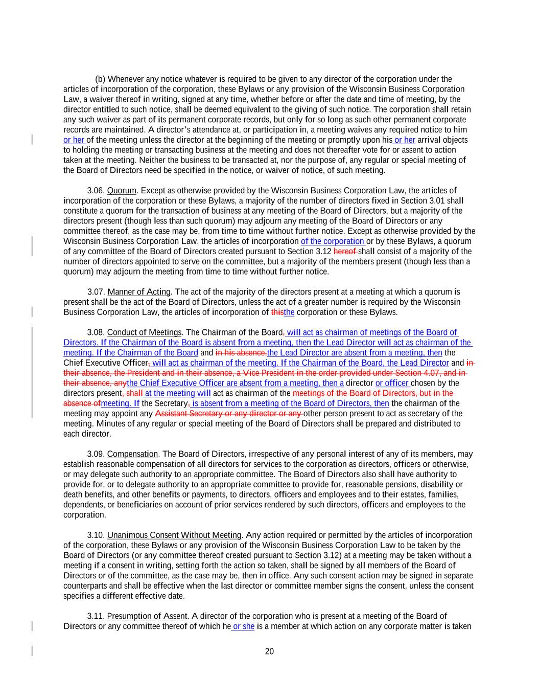
20 (b) Whenever any notice whatever is required to be given to any director of the corporation under the articles of incorporation of the corporation, these Bylaws or any provision of the Wisconsin Business Corporation Law, a waiver thereof in writing, signed at any time, whether before or after the date and time of meeting, by the director entitled to such notice, shall be deemed equivalent to the giving of such notice. The corporation shall retain any such waiver as part of its permanent corporate records, but only for so long as such other permanent corporate records are maintained. A director’s attendance at, or participation in, a meeting waives any required notice to him or her of the meeting unless the director at the beginning of the meeting or promptly upon his or her arrival objects to holding the meeting or transacting business at the meeting and does not thereafter vote for or assent to action taken at the meeting. Neither the business to be transacted at, nor the purpose of, any regular or special meeting of the Board of Directors need be specified in the notice, or waiver of notice, of such meeting. 3.06. Quorum. Except as otherwise provided by the Wisconsin Business Corporation Law, the articles of incorporation of the corporation or these Bylaws, a majority of the number of directors fixed in Section 3.01 shall constitute a quorum for the transaction of business at any meeting of the Board of Directors, but a majority of the directors present (though less than such quorum) may adjourn any meeting of the Board of Directors or any committee thereof, as the case may be, from time to time without further notice. Except as otherwise provided by the Wisconsin Business Corporation Law, the articles of incorporation of the corporation or by these Bylaws, a quorum of any committee of the Board of Directors created pursuant to Section 3.12 hereof shall consist of a majority of the number of directors appointed to serve on the committee, but a majority of the members present (though less than a quorum) may adjourn the meeting from time to time without further notice. 3.07. Manner of Acting. The act of the majority of the directors present at a meeting at which a quorum is present shall be the act of the Board of Directors, unless the act of a greater number is required by the Wisconsin Business Corporation Law, the articles of incorporation of thisthe corporation or these Bylaws. 3.08. Conduct of Meetings. The Chairman of the Board, will act as chairman of meetings of the Board of Directors. If the Chairman of the Board is absent from a meeting, then the Lead Director will act as chairman of the meeting. If the Chairman of the Board and in his absence,the Lead Director are absent from a meeting, then the Chief Executive Officer, will act as chairman of the meeting. If the Chairman of the Board, the Lead Director and in their absence, the President and in their absence, a Vice President in the order provided under Section 4.07, and in their absence, anythe Chief Executive Officer are absent from a meeting, then a director or officer chosen by the directors present, shall at the meeting will act as chairman of the meetings of the Board of Directors, but in the absence ofmeeting. If the Secretary, is absent from a meeting of the Board of Directors, then the chairman of the meeting may appoint any Assistant Secretary or any director or any other person present to act as secretary of the meeting. Minutes of any regular or special meeting of the Board of Directors shall be prepared and distributed to each director. 3.09. Compensation. The Board of Directors, irrespective of any personal interest of any of its members, may establish reasonable compensation of all directors for services to the corporation as directors, officers or otherwise, or may delegate such authority to an appropriate committee. The Board of Directors also shall have authority to provide for, or to delegate authority to an appropriate committee to provide for, reasonable pensions, disability or death benefits, and other benefits or payments, to directors, officers and employees and to their estates, families, dependents, or beneficiaries on account of prior services rendered by such directors, officers and employees to the corporation. 3.10. Unanimous Consent Without Meeting. Any action required or permitted by the articles of incorporation of the corporation, these Bylaws or any provision of the Wisconsin Business Corporation Law to be taken by the Board of Directors (or any committee thereof created pursuant to Section 3.12) at a meeting may be taken without a meeting if a consent in writing, setting forth the action so taken, shall be signed by all members of the Board of Directors or of the committee, as the case may be, then in office. Any such consent action may be signed in separate counterparts and shall be effective when the last director or committee member signs the consent, unless the consent specifies a different effective date. 3.11. Presumption of Assent. A director of the corporation who is present at a meeting of the Board of Directors or any committee thereof of which he or she is a member at which action on any corporate matter is taken

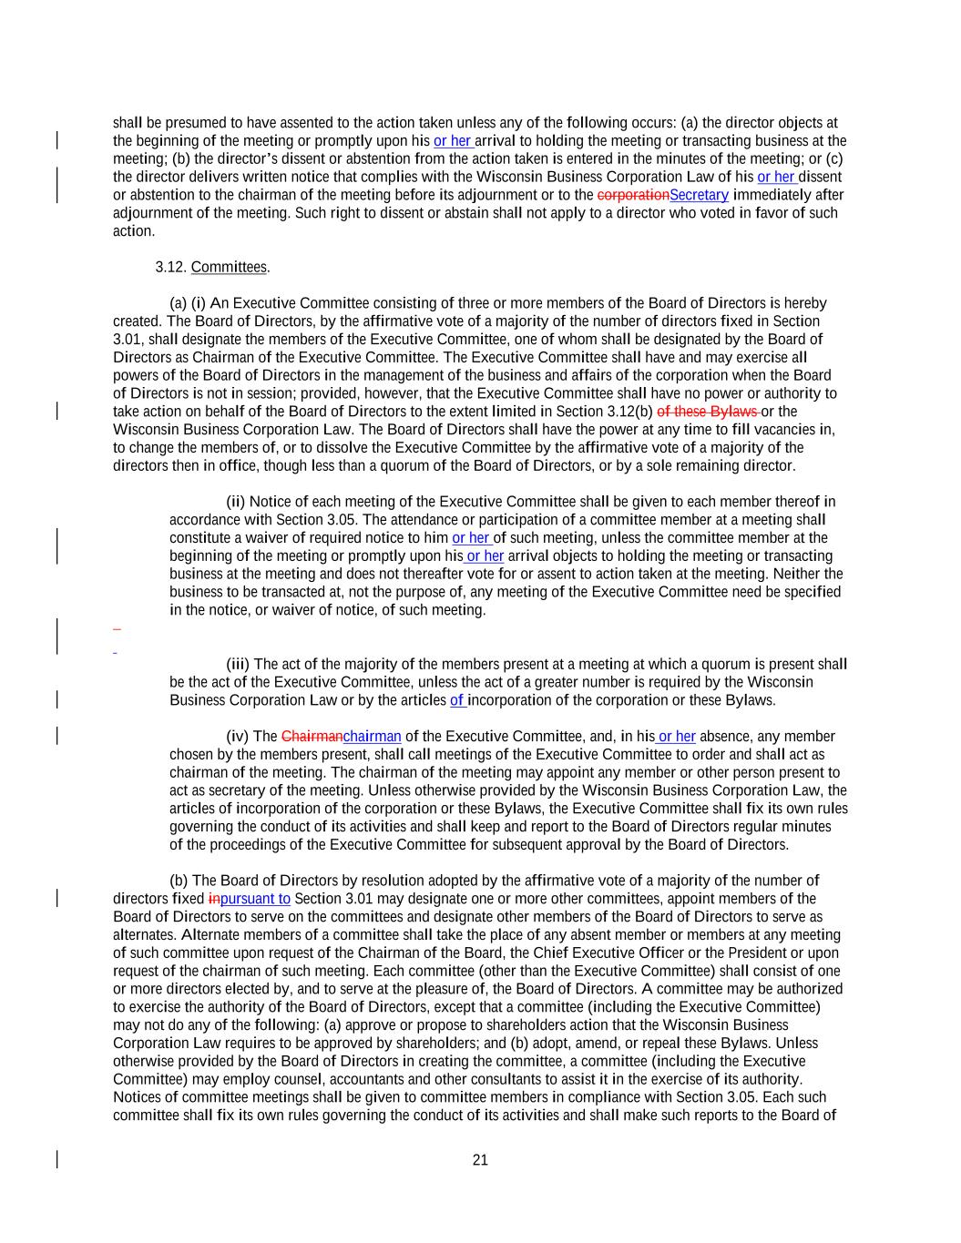
21 shall be presumed to have assented to the action taken unless any of the following occurs: (a) the director objects at the beginning of the meeting or promptly upon his or her arrival to holding the meeting or transacting business at the meeting; (b) the director’s dissent or abstention from the action taken is entered in the minutes of the meeting; or (c) the director delivers written notice that complies with the Wisconsin Business Corporation Law of his or her dissent or abstention to the chairman of the meeting before its adjournment or to the corporationSecretary immediately after adjournment of the meeting. Such right to dissent or abstain shall not apply to a director who voted in favor of such action. 3.12. Committees. (a) (i) An Executive Committee consisting of three or more members of the Board of Directors is hereby created. The Board of Directors, by the affirmative vote of a majority of the number of directors fixed in Section 3.01, shall designate the members of the Executive Committee, one of whom shall be designated by the Board of Directors as Chairman of the Executive Committee. The Executive Committee shall have and may exercise all powers of the Board of Directors in the management of the business and affairs of the corporation when the Board of Directors is not in session; provided, however, that the Executive Committee shall have no power or authority to take action on behalf of the Board of Directors to the extent limited in Section 3.12(b) of these Bylaws or the Wisconsin Business Corporation Law. The Board of Directors shall have the power at any time to fill vacancies in, to change the members of, or to dissolve the Executive Committee by the affirmative vote of a majority of the directors then in office, though less than a quorum of the Board of Directors, or by a sole remaining director. (ii) Notice of each meeting of the Executive Committee shall be given to each member thereof in accordance with Section 3.05. The attendance or participation of a committee member at a meeting shall constitute a waiver of required notice to him or her of such meeting, unless the committee member at the beginning of the meeting or promptly upon his or her arrival objects to holding the meeting or transacting business at the meeting and does not thereafter vote for or assent to action taken at the meeting. Neither the business to be transacted at, not the purpose of, any meeting of the Executive Committee need be specified in the notice, or waiver of notice, of such meeting. (iii) The act of the majority of the members present at a meeting at which a quorum is present shall be the act of the Executive Committee, unless the act of a greater number is required by the Wisconsin Business Corporation Law or by the articles of incorporation of the corporation or these Bylaws. (iv) The Chairmanchairman of the Executive Committee, and, in his or her absence, any member chosen by the members present, shall call meetings of the Executive Committee to order and shall act as chairman of the meeting. The chairman of the meeting may appoint any member or other person present to act as secretary of the meeting. Unless otherwise provided by the Wisconsin Business Corporation Law, the articles of incorporation of the corporation or these Bylaws, the Executive Committee shall fix its own rules governing the conduct of its activities and shall keep and report to the Board of Directors regular minutes of the proceedings of the Executive Committee for subsequent approval by the Board of Directors. (b) The Board of Directors by resolution adopted by the affirmative vote of a majority of the number of directors fixed inpursuant to Section 3.01 may designate one or more other committees, appoint members of the Board of Directors to serve on the committees and designate other members of the Board of Directors to serve as alternates. Alternate members of a committee shall take the place of any absent member or members at any meeting of such committee upon request of the Chairman of the Board, the Chief Executive Officer or the President or upon request of the chairman of such meeting. Each committee (other than the Executive Committee) shall consist of one or more directors elected by, and to serve at the pleasure of, the Board of Directors. A committee may be authorized to exercise the authority of the Board of Directors, except that a committee (including the Executive Committee) may not do any of the following: (a) approve or propose to shareholders action that the Wisconsin Business Corporation Law requires to be approved by shareholders; and (b) adopt, amend, or repeal these Bylaws. Unless otherwise provided by the Board of Directors in creating the committee, a committee (including the Executive Committee) may employ counsel, accountants and other consultants to assist it in the exercise of its authority. Notices of committee meetings shall be given to committee members in compliance with Section 3.05. Each such committee shall fix its own rules governing the conduct of its activities and shall make such reports to the Board of

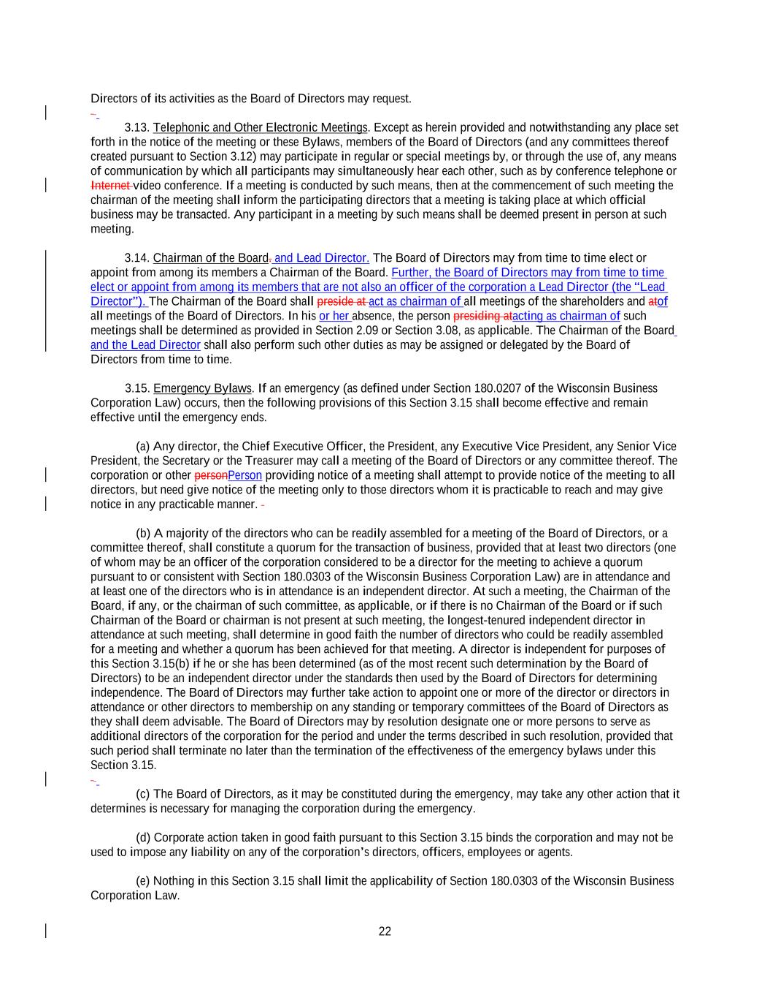
22 Directors of its activities as the Board of Directors may request. 3.13. Telephonic and Other Electronic Meetings. Except as herein provided and notwithstanding any place set forth in the notice of the meeting or these Bylaws, members of the Board of Directors (and any committees thereof created pursuant to Section 3.12) may participate in regular or special meetings by, or through the use of, any means of communication by which all participants may simultaneously hear each other, such as by conference telephone or Internet video conference. If a meeting is conducted by such means, then at the commencement of such meeting the chairman of the meeting shall inform the participating directors that a meeting is taking place at which official business may be transacted. Any participant in a meeting by such means shall be deemed present in person at such meeting. 3.14. Chairman of the Board. and Lead Director. The Board of Directors may from time to time elect or appoint from among its members a Chairman of the Board. Further, the Board of Directors may from time to time elect or appoint from among its members that are not also an officer of the corporation a Lead Director (the “Lead Director”). The Chairman of the Board shall preside at act as chairman of all meetings of the shareholders and atof all meetings of the Board of Directors. In his or her absence, the person presiding atacting as chairman of such meetings shall be determined as provided in Section 2.09 or Section 3.08, as applicable. The Chairman of the Board and the Lead Director shall also perform such other duties as may be assigned or delegated by the Board of Directors from time to time. 3.15. Emergency Bylaws. If an emergency (as defined under Section 180.0207 of the Wisconsin Business Corporation Law) occurs, then the following provisions of this Section 3.15 shall become effective and remain effective until the emergency ends. (a) Any director, the Chief Executive Officer, the President, any Executive Vice President, any Senior Vice President, the Secretary or the Treasurer may call a meeting of the Board of Directors or any committee thereof. The corporation or other personPerson providing notice of a meeting shall attempt to provide notice of the meeting to all directors, but need give notice of the meeting only to those directors whom it is practicable to reach and may give notice in any practicable manner. (b) A majority of the directors who can be readily assembled for a meeting of the Board of Directors, or a committee thereof, shall constitute a quorum for the transaction of business, provided that at least two directors (one of whom may be an officer of the corporation considered to be a director for the meeting to achieve a quorum pursuant to or consistent with Section 180.0303 of the Wisconsin Business Corporation Law) are in attendance and at least one of the directors who is in attendance is an independent director. At such a meeting, the Chairman of the Board, if any, or the chairman of such committee, as applicable, or if there is no Chairman of the Board or if such Chairman of the Board or chairman is not present at such meeting, the longest-tenured independent director in attendance at such meeting, shall determine in good faith the number of directors who could be readily assembled for a meeting and whether a quorum has been achieved for that meeting. A director is independent for purposes of this Section 3.15(b) if he or she has been determined (as of the most recent such determination by the Board of Directors) to be an independent director under the standards then used by the Board of Directors for determining independence. The Board of Directors may further take action to appoint one or more of the director or directors in attendance or other directors to membership on any standing or temporary committees of the Board of Directors as they shall deem advisable. The Board of Directors may by resolution designate one or more persons to serve as additional directors of the corporation for the period and under the terms described in such resolution, provided that such period shall terminate no later than the termination of the effectiveness of the emergency bylaws under this Section 3.15. (c) The Board of Directors, as it may be constituted during the emergency, may take any other action that it determines is necessary for managing the corporation during the emergency. (d) Corporate action taken in good faith pursuant to this Section 3.15 binds the corporation and may not be used to impose any liability on any of the corporation’s directors, officers, employees or agents. (e) Nothing in this Section 3.15 shall limit the applicability of Section 180.0303 of the Wisconsin Business Corporation Law.

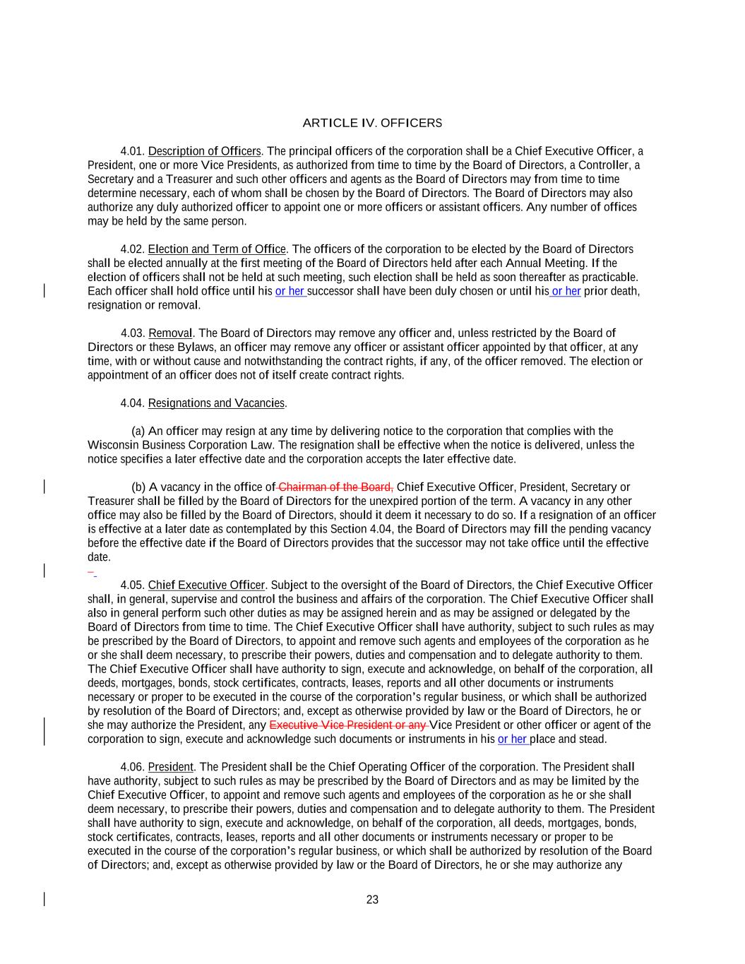
23 ARTICLE IV. OFFICERS 4.01. Description of Officers. The principal officers of the corporation shall be a Chief Executive Officer, a President, one or more Vice Presidents, as authorized from time to time by the Board of Directors, a Controller, a Secretary and a Treasurer and such other officers and agents as the Board of Directors may from time to time determine necessary, each of whom shall be chosen by the Board of Directors. The Board of Directors may also authorize any duly authorized officer to appoint one or more officers or assistant officers. Any number of offices may be held by the same person. 4.02. Election and Term of Office. The officers of the corporation to be elected by the Board of Directors shall be elected annually at the first meeting of the Board of Directors held after each Annual Meeting. If the election of officers shall not be held at such meeting, such election shall be held as soon thereafter as practicable. Each officer shall hold office until his or her successor shall have been duly chosen or until his or her prior death, resignation or removal. 4.03. Removal. The Board of Directors may remove any officer and, unless restricted by the Board of Directors or these Bylaws, an officer may remove any officer or assistant officer appointed by that officer, at any time, with or without cause and notwithstanding the contract rights, if any, of the officer removed. The election or appointment of an officer does not of itself create contract rights. 4.04. Resignations and Vacancies. (a) An officer may resign at any time by delivering notice to the corporation that complies with the Wisconsin Business Corporation Law. The resignation shall be effective when the notice is delivered, unless the notice specifies a later effective date and the corporation accepts the later effective date. (b) A vacancy in the office of Chairman of the Board, Chief Executive Officer, President, Secretary or Treasurer shall be filled by the Board of Directors for the unexpired portion of the term. A vacancy in any other office may also be filled by the Board of Directors, should it deem it necessary to do so. If a resignation of an officer is effective at a later date as contemplated by this Section 4.04, the Board of Directors may fill the pending vacancy before the effective date if the Board of Directors provides that the successor may not take office until the effective date. 4.05. Chief Executive Officer. Subject to the oversight of the Board of Directors, the Chief Executive Officer shall, in general, supervise and control the business and affairs of the corporation. The Chief Executive Officer shall also in general perform such other duties as may be assigned herein and as may be assigned or delegated by the Board of Directors from time to time. The Chief Executive Officer shall have authority, subject to such rules as may be prescribed by the Board of Directors, to appoint and remove such agents and employees of the corporation as he or she shall deem necessary, to prescribe their powers, duties and compensation and to delegate authority to them. The Chief Executive Officer shall have authority to sign, execute and acknowledge, on behalf of the corporation, all deeds, mortgages, bonds, stock certificates, contracts, leases, reports and all other documents or instruments necessary or proper to be executed in the course of the corporation’s regular business, or which shall be authorized by resolution of the Board of Directors; and, except as otherwise provided by law or the Board of Directors, he or she may authorize the President, any Executive Vice President or any Vice President or other officer or agent of the corporation to sign, execute and acknowledge such documents or instruments in his or her place and stead. 4.06. President. The President shall be the Chief Operating Officer of the corporation. The President shall have authority, subject to such rules as may be prescribed by the Board of Directors and as may be limited by the Chief Executive Officer, to appoint and remove such agents and employees of the corporation as he or she shall deem necessary, to prescribe their powers, duties and compensation and to delegate authority to them. The President shall have authority to sign, execute and acknowledge, on behalf of the corporation, all deeds, mortgages, bonds, stock certificates, contracts, leases, reports and all other documents or instruments necessary or proper to be executed in the course of the corporation’s regular business, or which shall be authorized by resolution of the Board of Directors; and, except as otherwise provided by law or the Board of Directors, he or she may authorize any

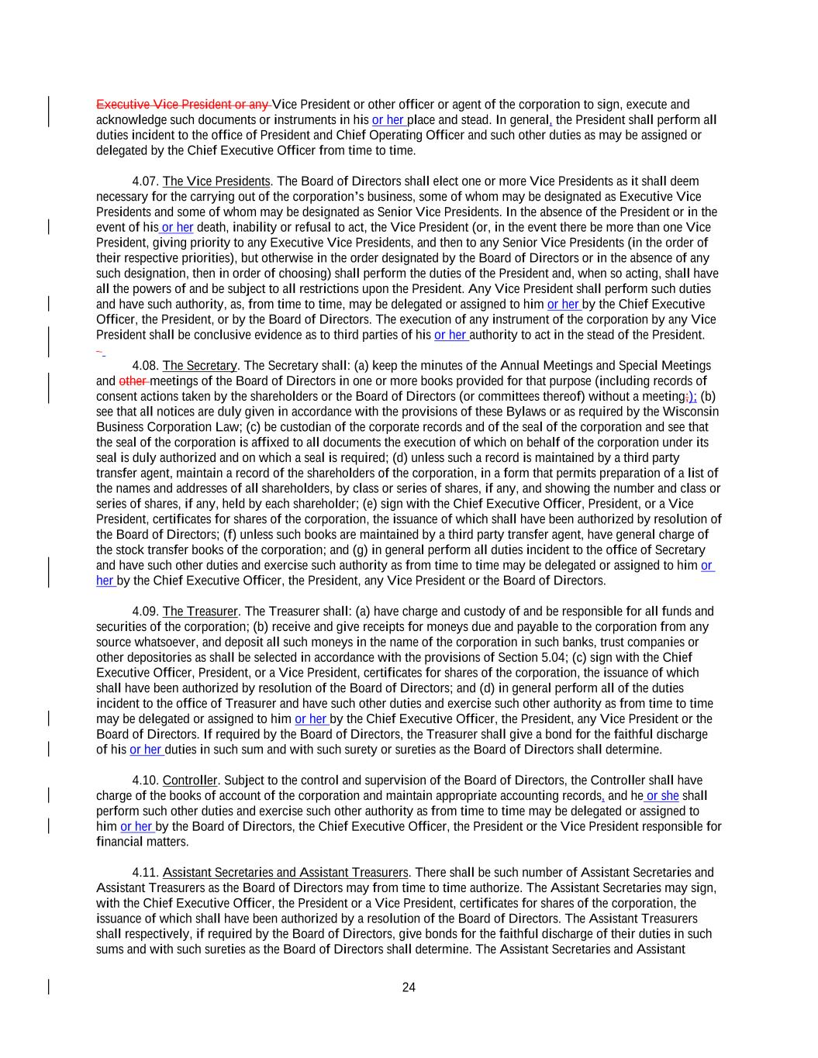
24 Executive Vice President or any Vice President or other officer or agent of the corporation to sign, execute and acknowledge such documents or instruments in his or her place and stead. In general, the President shall perform all duties incident to the office of President and Chief Operating Officer and such other duties as may be assigned or delegated by the Chief Executive Officer from time to time. 4.07. The Vice Presidents. The Board of Directors shall elect one or more Vice Presidents as it shall deem necessary for the carrying out of the corporation’s business, some of whom may be designated as Executive Vice Presidents and some of whom may be designated as Senior Vice Presidents. In the absence of the President or in the event of his or her death, inability or refusal to act, the Vice President (or, in the event there be more than one Vice President, giving priority to any Executive Vice Presidents, and then to any Senior Vice Presidents (in the order of their respective priorities), but otherwise in the order designated by the Board of Directors or in the absence of any such designation, then in order of choosing) shall perform the duties of the President and, when so acting, shall have all the powers of and be subject to all restrictions upon the President. Any Vice President shall perform such duties and have such authority, as, from time to time, may be delegated or assigned to him or her by the Chief Executive Officer, the President, or by the Board of Directors. The execution of any instrument of the corporation by any Vice President shall be conclusive evidence as to third parties of his or her authority to act in the stead of the President. 4.08. The Secretary. The Secretary shall: (a) keep the minutes of the Annual Meetings and Special Meetings and other meetings of the Board of Directors in one or more books provided for that purpose (including records of consent actions taken by the shareholders or the Board of Directors (or committees thereof) without a meeting;); (b) see that all notices are duly given in accordance with the provisions of these Bylaws or as required by the Wisconsin Business Corporation Law; (c) be custodian of the corporate records and of the seal of the corporation and see that the seal of the corporation is affixed to all documents the execution of which on behalf of the corporation under its seal is duly authorized and on which a seal is required; (d) unless such a record is maintained by a third party transfer agent, maintain a record of the shareholders of the corporation, in a form that permits preparation of a list of the names and addresses of all shareholders, by class or series of shares, if any, and showing the number and class or series of shares, if any, held by each shareholder; (e) sign with the Chief Executive Officer, President, or a Vice President, certificates for shares of the corporation, the issuance of which shall have been authorized by resolution of the Board of Directors; (f) unless such books are maintained by a third party transfer agent, have general charge of the stock transfer books of the corporation; and (g) in general perform all duties incident to the office of Secretary and have such other duties and exercise such authority as from time to time may be delegated or assigned to him or her by the Chief Executive Officer, the President, any Vice President or the Board of Directors. 4.09. The Treasurer. The Treasurer shall: (a) have charge and custody of and be responsible for all funds and securities of the corporation; (b) receive and give receipts for moneys due and payable to the corporation from any source whatsoever, and deposit all such moneys in the name of the corporation in such banks, trust companies or other depositories as shall be selected in accordance with the provisions of Section 5.04; (c) sign with the Chief Executive Officer, President, or a Vice President, certificates for shares of the corporation, the issuance of which shall have been authorized by resolution of the Board of Directors; and (d) in general perform all of the duties incident to the office of Treasurer and have such other duties and exercise such other authority as from time to time may be delegated or assigned to him or her by the Chief Executive Officer, the President, any Vice President or the Board of Directors. If required by the Board of Directors, the Treasurer shall give a bond for the faithful discharge of his or her duties in such sum and with such surety or sureties as the Board of Directors shall determine. 4.10. Controller. Subject to the control and supervision of the Board of Directors, the Controller shall have charge of the books of account of the corporation and maintain appropriate accounting records, and he or she shall perform such other duties and exercise such other authority as from time to time may be delegated or assigned to him or her by the Board of Directors, the Chief Executive Officer, the President or the Vice President responsible for financial matters. 4.11. Assistant Secretaries and Assistant Treasurers. There shall be such number of Assistant Secretaries and Assistant Treasurers as the Board of Directors may from time to time authorize. The Assistant Secretaries may sign, with the Chief Executive Officer, the President or a Vice President, certificates for shares of the corporation, the issuance of which shall have been authorized by a resolution of the Board of Directors. The Assistant Treasurers shall respectively, if required by the Board of Directors, give bonds for the faithful discharge of their duties in such sums and with such sureties as the Board of Directors shall determine. The Assistant Secretaries and Assistant

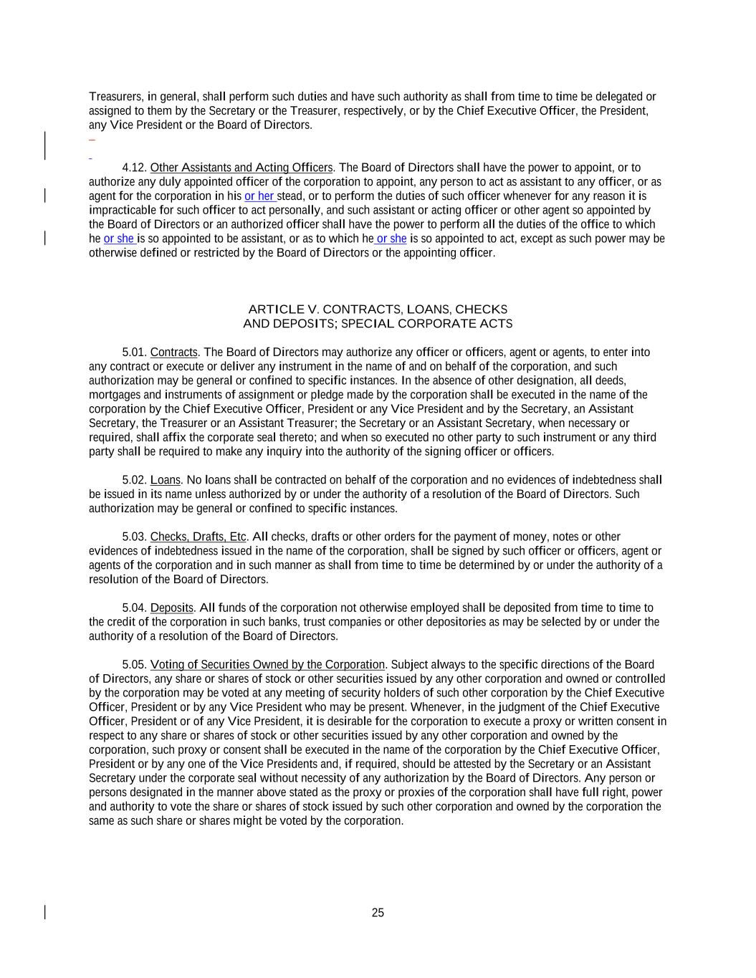
25 Treasurers, in general, shall perform such duties and have such authority as shall from time to time be delegated or assigned to them by the Secretary or the Treasurer, respectively, or by the Chief Executive Officer, the President, any Vice President or the Board of Directors. 4.12. Other Assistants and Acting Officers. The Board of Directors shall have the power to appoint, or to authorize any duly appointed officer of the corporation to appoint, any person to act as assistant to any officer, or as agent for the corporation in his or her stead, or to perform the duties of such officer whenever for any reason it is impracticable for such officer to act personally, and such assistant or acting officer or other agent so appointed by the Board of Directors or an authorized officer shall have the power to perform all the duties of the office to which he or she is so appointed to be assistant, or as to which he or she is so appointed to act, except as such power may be otherwise defined or restricted by the Board of Directors or the appointing officer. ARTICLE V. CONTRACTS, LOANS, CHECKS AND DEPOSITS; SPECIAL CORPORATE ACTS 5.01. Contracts. The Board of Directors may authorize any officer or officers, agent or agents, to enter into any contract or execute or deliver any instrument in the name of and on behalf of the corporation, and such authorization may be general or confined to specific instances. In the absence of other designation, all deeds, mortgages and instruments of assignment or pledge made by the corporation shall be executed in the name of the corporation by the Chief Executive Officer, President or any Vice President and by the Secretary, an Assistant Secretary, the Treasurer or an Assistant Treasurer; the Secretary or an Assistant Secretary, when necessary or required, shall affix the corporate seal thereto; and when so executed no other party to such instrument or any third party shall be required to make any inquiry into the authority of the signing officer or officers. 5.02. Loans. No loans shall be contracted on behalf of the corporation and no evidences of indebtedness shall be issued in its name unless authorized by or under the authority of a resolution of the Board of Directors. Such authorization may be general or confined to specific instances. 5.03. Checks, Drafts, Etc. All checks, drafts or other orders for the payment of money, notes or other evidences of indebtedness issued in the name of the corporation, shall be signed by such officer or officers, agent or agents of the corporation and in such manner as shall from time to time be determined by or under the authority of a resolution of the Board of Directors. 5.04. Deposits. All funds of the corporation not otherwise employed shall be deposited from time to time to the credit of the corporation in such banks, trust companies or other depositories as may be selected by or under the authority of a resolution of the Board of Directors. 5.05. Voting of Securities Owned by the Corporation. Subject always to the specific directions of the Board of Directors, any share or shares of stock or other securities issued by any other corporation and owned or controlled by the corporation may be voted at any meeting of security holders of such other corporation by the Chief Executive Officer, President or by any Vice President who may be present. Whenever, in the judgment of the Chief Executive Officer, President or of any Vice President, it is desirable for the corporation to execute a proxy or written consent in respect to any share or shares of stock or other securities issued by any other corporation and owned by the corporation, such proxy or consent shall be executed in the name of the corporation by the Chief Executive Officer, President or by any one of the Vice Presidents and, if required, should be attested by the Secretary or an Assistant Secretary under the corporate seal without necessity of any authorization by the Board of Directors. Any person or persons designated in the manner above stated as the proxy or proxies of the corporation shall have full right, power and authority to vote the share or shares of stock issued by such other corporation and owned by the corporation the same as such share or shares might be voted by the corporation.

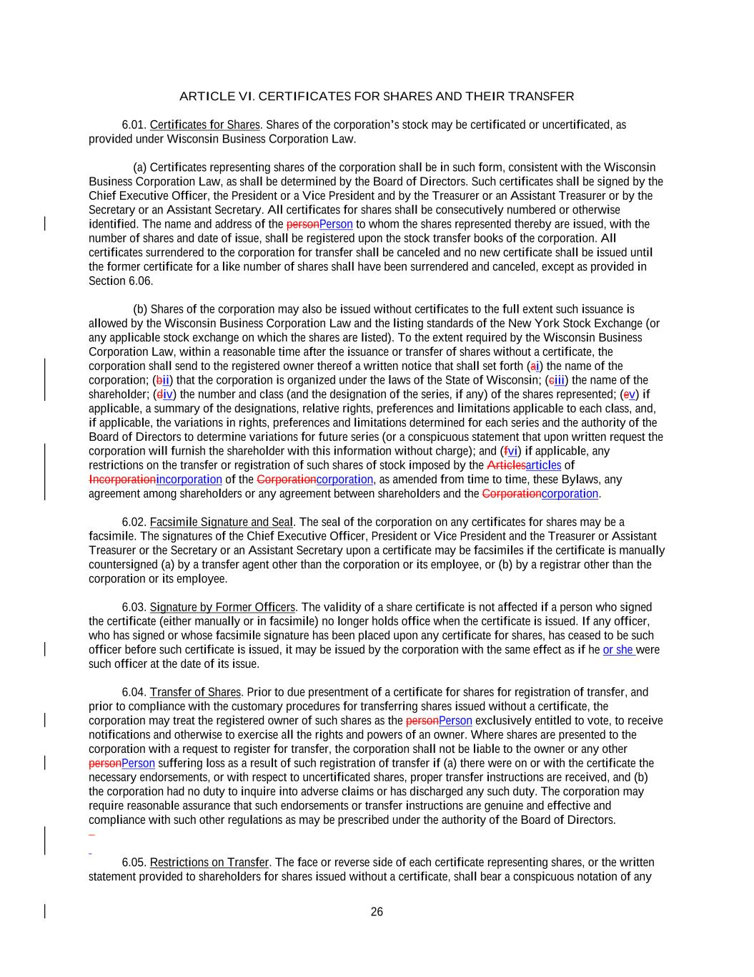
26 ARTICLE VI. CERTIFICATES FOR SHARES AND THEIR TRANSFER 6.01. Certificates for Shares. Shares of the corporation’s stock may be certificated or uncertificated, as provided under Wisconsin Business Corporation Law. (a) Certificates representing shares of the corporation shall be in such form, consistent with the Wisconsin Business Corporation Law, as shall be determined by the Board of Directors. Such certificates shall be signed by the Chief Executive Officer, the President or a Vice President and by the Treasurer or an Assistant Treasurer or by the Secretary or an Assistant Secretary. All certificates for shares shall be consecutively numbered or otherwise identified. The name and address of the personPerson to whom the shares represented thereby are issued, with the number of shares and date of issue, shall be registered upon the stock transfer books of the corporation. All certificates surrendered to the corporation for transfer shall be canceled and no new certificate shall be issued until the former certificate for a like number of shares shall have been surrendered and canceled, except as provided in Section 6.06. (b) Shares of the corporation may also be issued without certificates to the full extent such issuance is allowed by the Wisconsin Business Corporation Law and the listing standards of the New York Stock Exchange (or any applicable stock exchange on which the shares are listed). To the extent required by the Wisconsin Business Corporation Law, within a reasonable time after the issuance or transfer of shares without a certificate, the corporation shall send to the registered owner thereof a written notice that shall set forth (ai) the name of the corporation; (bii) that the corporation is organized under the laws of the State of Wisconsin; (ciii) the name of the shareholder; (div) the number and class (and the designation of the series, if any) of the shares represented; (ev) if applicable, a summary of the designations, relative rights, preferences and limitations applicable to each class, and, if applicable, the variations in rights, preferences and limitations determined for each series and the authority of the Board of Directors to determine variations for future series (or a conspicuous statement that upon written request the corporation will furnish the shareholder with this information without charge); and (fvi) if applicable, any restrictions on the transfer or registration of such shares of stock imposed by the Articlesarticles of Incorporationincorporation of the Corporationcorporation, as amended from time to time, these Bylaws, any agreement among shareholders or any agreement between shareholders and the Corporationcorporation. 6.02. Facsimile Signature and Seal. The seal of the corporation on any certificates for shares may be a facsimile. The signatures of the Chief Executive Officer, President or Vice President and the Treasurer or Assistant Treasurer or the Secretary or an Assistant Secretary upon a certificate may be facsimiles if the certificate is manually countersigned (a) by a transfer agent other than the corporation or its employee, or (b) by a registrar other than the corporation or its employee. 6.03. Signature by Former Officers. The validity of a share certificate is not affected if a person who signed the certificate (either manually or in facsimile) no longer holds office when the certificate is issued. If any officer, who has signed or whose facsimile signature has been placed upon any certificate for shares, has ceased to be such officer before such certificate is issued, it may be issued by the corporation with the same effect as if he or she were such officer at the date of its issue. 6.04. Transfer of Shares. Prior to due presentment of a certificate for shares for registration of transfer, and prior to compliance with the customary procedures for transferring shares issued without a certificate, the corporation may treat the registered owner of such shares as the personPerson exclusively entitled to vote, to receive notifications and otherwise to exercise all the rights and powers of an owner. Where shares are presented to the corporation with a request to register for transfer, the corporation shall not be liable to the owner or any other personPerson suffering loss as a result of such registration of transfer if (a) there were on or with the certificate the necessary endorsements, or with respect to uncertificated shares, proper transfer instructions are received, and (b) the corporation had no duty to inquire into adverse claims or has discharged any such duty. The corporation may require reasonable assurance that such endorsements or transfer instructions are genuine and effective and compliance with such other regulations as may be prescribed under the authority of the Board of Directors. 6.05. Restrictions on Transfer. The face or reverse side of each certificate representing shares, or the written statement provided to shareholders for shares issued without a certificate, shall bear a conspicuous notation of any

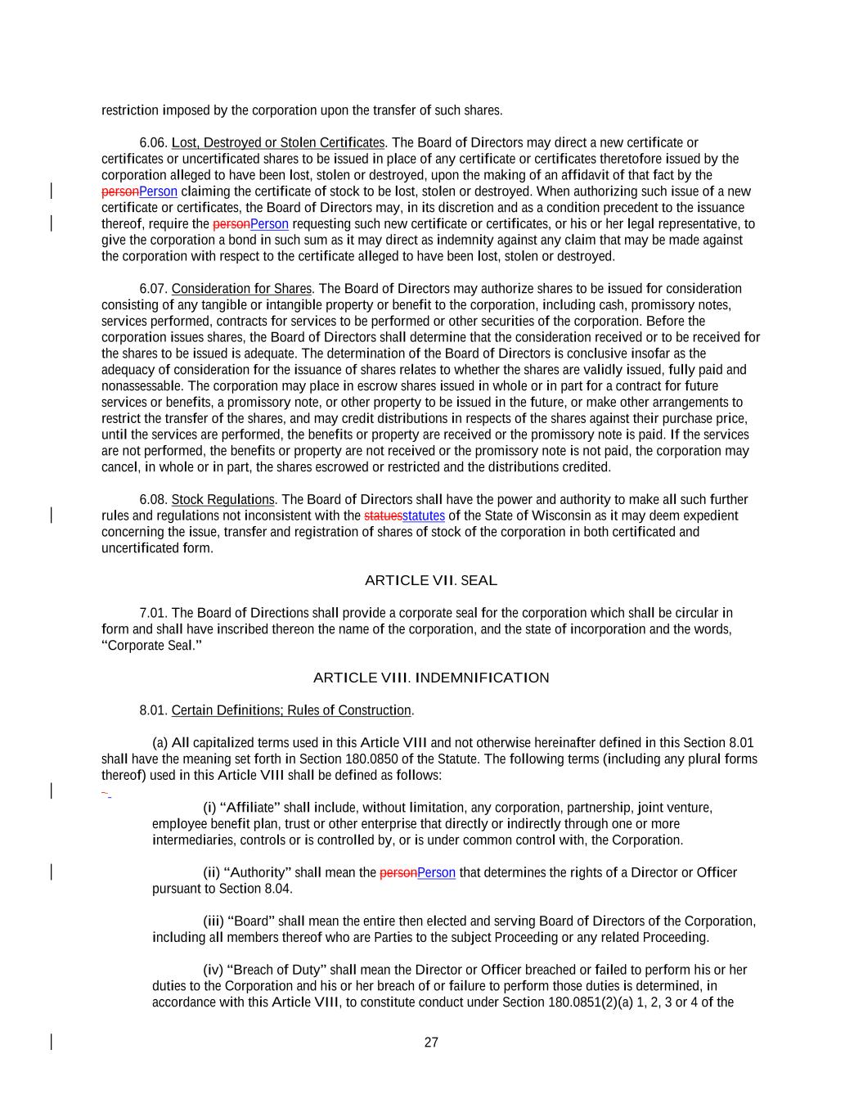
27 restriction imposed by the corporation upon the transfer of such shares. 6.06. Lost, Destroyed or Stolen Certificates. The Board of Directors may direct a new certificate or certificates or uncertificated shares to be issued in place of any certificate or certificates theretofore issued by the corporation alleged to have been lost, stolen or destroyed, upon the making of an affidavit of that fact by the personPerson claiming the certificate of stock to be lost, stolen or destroyed. When authorizing such issue of a new certificate or certificates, the Board of Directors may, in its discretion and as a condition precedent to the issuance thereof, require the personPerson requesting such new certificate or certificates, or his or her legal representative, to give the corporation a bond in such sum as it may direct as indemnity against any claim that may be made against the corporation with respect to the certificate alleged to have been lost, stolen or destroyed. 6.07. Consideration for Shares. The Board of Directors may authorize shares to be issued for consideration consisting of any tangible or intangible property or benefit to the corporation, including cash, promissory notes, services performed, contracts for services to be performed or other securities of the corporation. Before the corporation issues shares, the Board of Directors shall determine that the consideration received or to be received for the shares to be issued is adequate. The determination of the Board of Directors is conclusive insofar as the adequacy of consideration for the issuance of shares relates to whether the shares are validly issued, fully paid and nonassessable. The corporation may place in escrow shares issued in whole or in part for a contract for future services or benefits, a promissory note, or other property to be issued in the future, or make other arrangements to restrict the transfer of the shares, and may credit distributions in respects of the shares against their purchase price, until the services are performed, the benefits or property are received or the promissory note is paid. If the services are not performed, the benefits or property are not received or the promissory note is not paid, the corporation may cancel, in whole or in part, the shares escrowed or restricted and the distributions credited. 6.08. Stock Regulations. The Board of Directors shall have the power and authority to make all such further rules and regulations not inconsistent with the statuesstatutes of the State of Wisconsin as it may deem expedient concerning the issue, transfer and registration of shares of stock of the corporation in both certificated and uncertificated form. ARTICLE VII. SEAL 7.01. The Board of Directions shall provide a corporate seal for the corporation which shall be circular in form and shall have inscribed thereon the name of the corporation, and the state of incorporation and the words, “Corporate Seal.” ARTICLE VIII. INDEMNIFICATION 8.01. Certain Definitions; Rules of Construction. (a) All capitalized terms used in this Article VIII and not otherwise hereinafter defined in this Section 8.01 shall have the meaning set forth in Section 180.0850 of the Statute. The following terms (including any plural forms thereof) used in this Article VIII shall be defined as follows: (i) “Affiliate” shall include, without limitation, any corporation, partnership, joint venture, employee benefit plan, trust or other enterprise that directly or indirectly through one or more intermediaries, controls or is controlled by, or is under common control with, the Corporation. (ii) “Authority” shall mean the personPerson that determines the rights of a Director or Officer pursuant to Section 8.04. (iii) “Board” shall mean the entire then elected and serving Board of Directors of the Corporation, including all members thereof who are Parties to the subject Proceeding or any related Proceeding. (iv) “Breach of Duty” shall mean the Director or Officer breached or failed to perform his or her duties to the Corporation and his or her breach of or failure to perform those duties is determined, in accordance with this Article VIII, to constitute conduct under Section 180.0851(2)(a) 1, 2, 3 or 4 of the

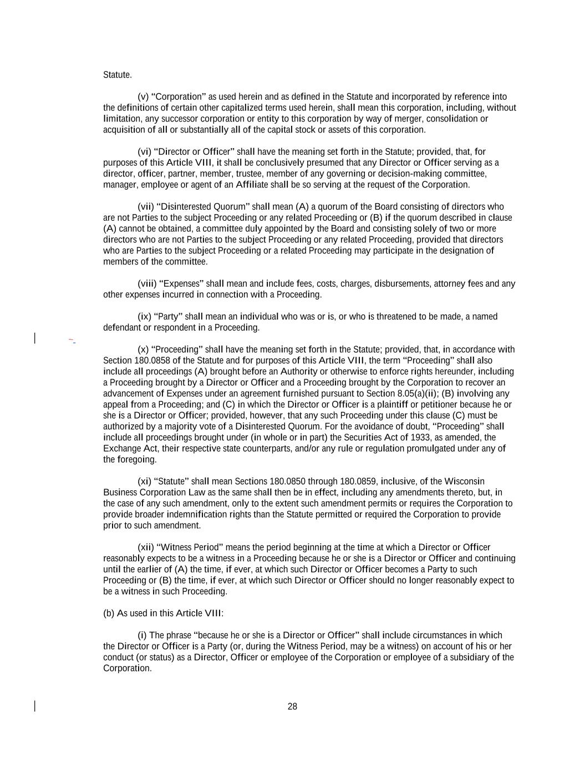
28 Statute. (v) “Corporation” as used herein and as defined in the Statute and incorporated by reference into the definitions of certain other capitalized terms used herein, shall mean this corporation, including, without limitation, any successor corporation or entity to this corporation by way of merger, consolidation or acquisition of all or substantially all of the capital stock or assets of this corporation. (vi) “Director or Officer” shall have the meaning set forth in the Statute; provided, that, for purposes of this Article VIII, it shall be conclusively presumed that any Director or Officer serving as a director, officer, partner, member, trustee, member of any governing or decision-making committee, manager, employee or agent of an Affiliate shall be so serving at the request of the Corporation. (vii) “Disinterested Quorum” shall mean (A) a quorum of the Board consisting of directors who are not Parties to the subject Proceeding or any related Proceeding or (B) if the quorum described in clause (A) cannot be obtained, a committee duly appointed by the Board and consisting solely of two or more directors who are not Parties to the subject Proceeding or any related Proceeding, provided that directors who are Parties to the subject Proceeding or a related Proceeding may participate in the designation of members of the committee. (viii) “Expenses” shall mean and include fees, costs, charges, disbursements, attorney fees and any other expenses incurred in connection with a Proceeding. (ix) “Party” shall mean an individual who was or is, or who is threatened to be made, a named defendant or respondent in a Proceeding. (x) “Proceeding” shall have the meaning set forth in the Statute; provided, that, in accordance with Section 180.0858 of the Statute and for purposes of this Article VIII, the term “Proceeding” shall also include all proceedings (A) brought before an Authority or otherwise to enforce rights hereunder, including a Proceeding brought by a Director or Officer and a Proceeding brought by the Corporation to recover an advancement of Expenses under an agreement furnished pursuant to Section 8.05(a)(ii); (B) involving any appeal from a Proceeding; and (C) in which the Director or Officer is a plaintiff or petitioner because he or she is a Director or Officer; provided, however, that any such Proceeding under this clause (C) must be authorized by a majority vote of a Disinterested Quorum. For the avoidance of doubt, “Proceeding” shall include all proceedings brought under (in whole or in part) the Securities Act of 1933, as amended, the Exchange Act, their respective state counterparts, and/or any rule or regulation promulgated under any of the foregoing. (xi) “Statute” shall mean Sections 180.0850 through 180.0859, inclusive, of the Wisconsin Business Corporation Law as the same shall then be in effect, including any amendments thereto, but, in the case of any such amendment, only to the extent such amendment permits or requires the Corporation to provide broader indemnification rights than the Statute permitted or required the Corporation to provide prior to such amendment. (xii) “Witness Period” means the period beginning at the time at which a Director or Officer reasonably expects to be a witness in a Proceeding because he or she is a Director or Officer and continuing until the earlier of (A) the time, if ever, at which such Director or Officer becomes a Party to such Proceeding or (B) the time, if ever, at which such Director or Officer should no longer reasonably expect to be a witness in such Proceeding. (b) As used in this Article VIII: (i) The phrase “because he or she is a Director or Officer” shall include circumstances in which the Director or Officer is a Party (or, during the Witness Period, may be a witness) on account of his or her conduct (or status) as a Director, Officer or employee of the Corporation or employee of a subsidiary of the Corporation.

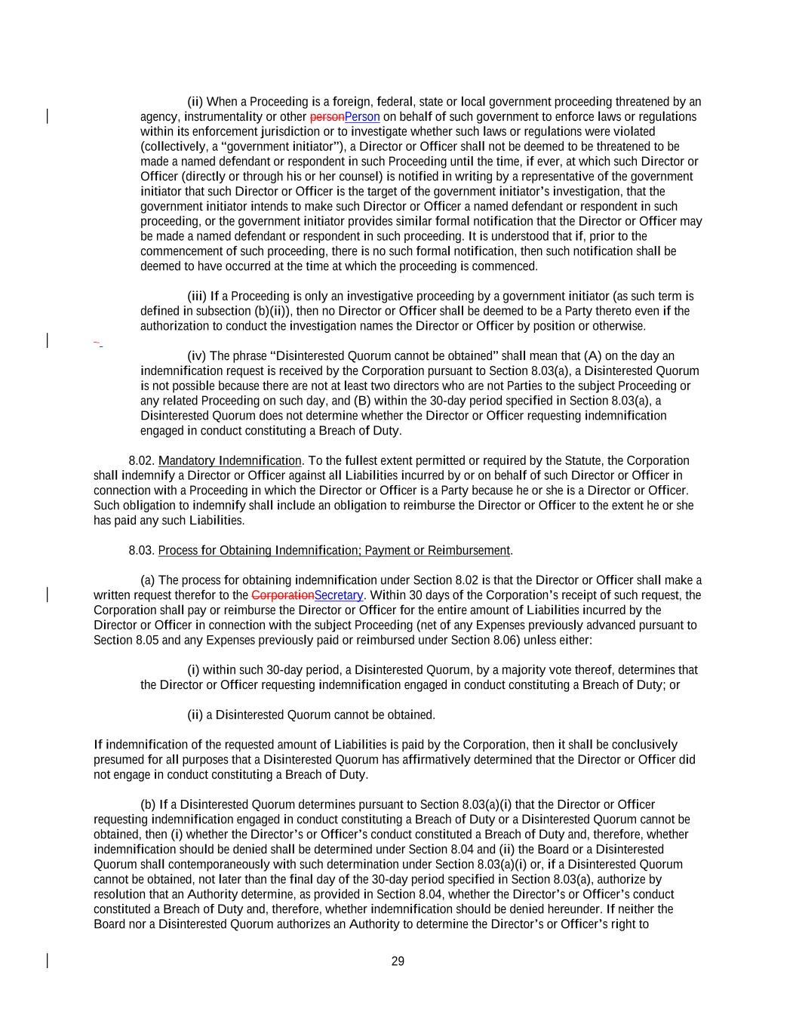
29 (ii) When a Proceeding is a foreign, federal, state or local government proceeding threatened by an agency, instrumentality or other personPerson on behalf of such government to enforce laws or regulations within its enforcement jurisdiction or to investigate whether such laws or regulations were violated (collectively, a “government initiator”), a Director or Officer shall not be deemed to be threatened to be made a named defendant or respondent in such Proceeding until the time, if ever, at which such Director or Officer (directly or through his or her counsel) is notified in writing by a representative of the government initiator that such Director or Officer is the target of the government initiator’s investigation, that the government initiator intends to make such Director or Officer a named defendant or respondent in such proceeding, or the government initiator provides similar formal notification that the Director or Officer may be made a named defendant or respondent in such proceeding. It is understood that if, prior to the commencement of such proceeding, there is no such formal notification, then such notification shall be deemed to have occurred at the time at which the proceeding is commenced. (iii) If a Proceeding is only an investigative proceeding by a government initiator (as such term is defined in subsection (b)(ii)), then no Director or Officer shall be deemed to be a Party thereto even if the authorization to conduct the investigation names the Director or Officer by position or otherwise. (iv) The phrase “Disinterested Quorum cannot be obtained” shall mean that (A) on the day an indemnification request is received by the Corporation pursuant to Section 8.03(a), a Disinterested Quorum is not possible because there are not at least two directors who are not Parties to the subject Proceeding or any related Proceeding on such day, and (B) within the 30-day period specified in Section 8.03(a), a Disinterested Quorum does not determine whether the Director or Officer requesting indemnification engaged in conduct constituting a Breach of Duty. 8.02. Mandatory Indemnification. To the fullest extent permitted or required by the Statute, the Corporation shall indemnify a Director or Officer against all Liabilities incurred by or on behalf of such Director or Officer in connection with a Proceeding in which the Director or Officer is a Party because he or she is a Director or Officer. Such obligation to indemnify shall include an obligation to reimburse the Director or Officer to the extent he or she has paid any such Liabilities. 8.03. Process for Obtaining Indemnification; Payment or Reimbursement. (a) The process for obtaining indemnification under Section 8.02 is that the Director or Officer shall make a written request therefor to the CorporationSecretary. Within 30 days of the Corporation’s receipt of such request, the Corporation shall pay or reimburse the Director or Officer for the entire amount of Liabilities incurred by the Director or Officer in connection with the subject Proceeding (net of any Expenses previously advanced pursuant to Section 8.05 and any Expenses previously paid or reimbursed under Section 8.06) unless either: (i) within such 30-day period, a Disinterested Quorum, by a majority vote thereof, determines that the Director or Officer requesting indemnification engaged in conduct constituting a Breach of Duty; or (ii) a Disinterested Quorum cannot be obtained. If indemnification of the requested amount of Liabilities is paid by the Corporation, then it shall be conclusively presumed for all purposes that a Disinterested Quorum has affirmatively determined that the Director or Officer did not engage in conduct constituting a Breach of Duty. (b) If a Disinterested Quorum determines pursuant to Section 8.03(a)(i) that the Director or Officer requesting indemnification engaged in conduct constituting a Breach of Duty or a Disinterested Quorum cannot be obtained, then (i) whether the Director’s or Officer’s conduct constituted a Breach of Duty and, therefore, whether indemnification should be denied shall be determined under Section 8.04 and (ii) the Board or a Disinterested Quorum shall contemporaneously with such determination under Section 8.03(a)(i) or, if a Disinterested Quorum cannot be obtained, not later than the final day of the 30-day period specified in Section 8.03(a), authorize by resolution that an Authority determine, as provided in Section 8.04, whether the Director’s or Officer’s conduct constituted a Breach of Duty and, therefore, whether indemnification should be denied hereunder. If neither the Board nor a Disinterested Quorum authorizes an Authority to determine the Director’s or Officer’s right to

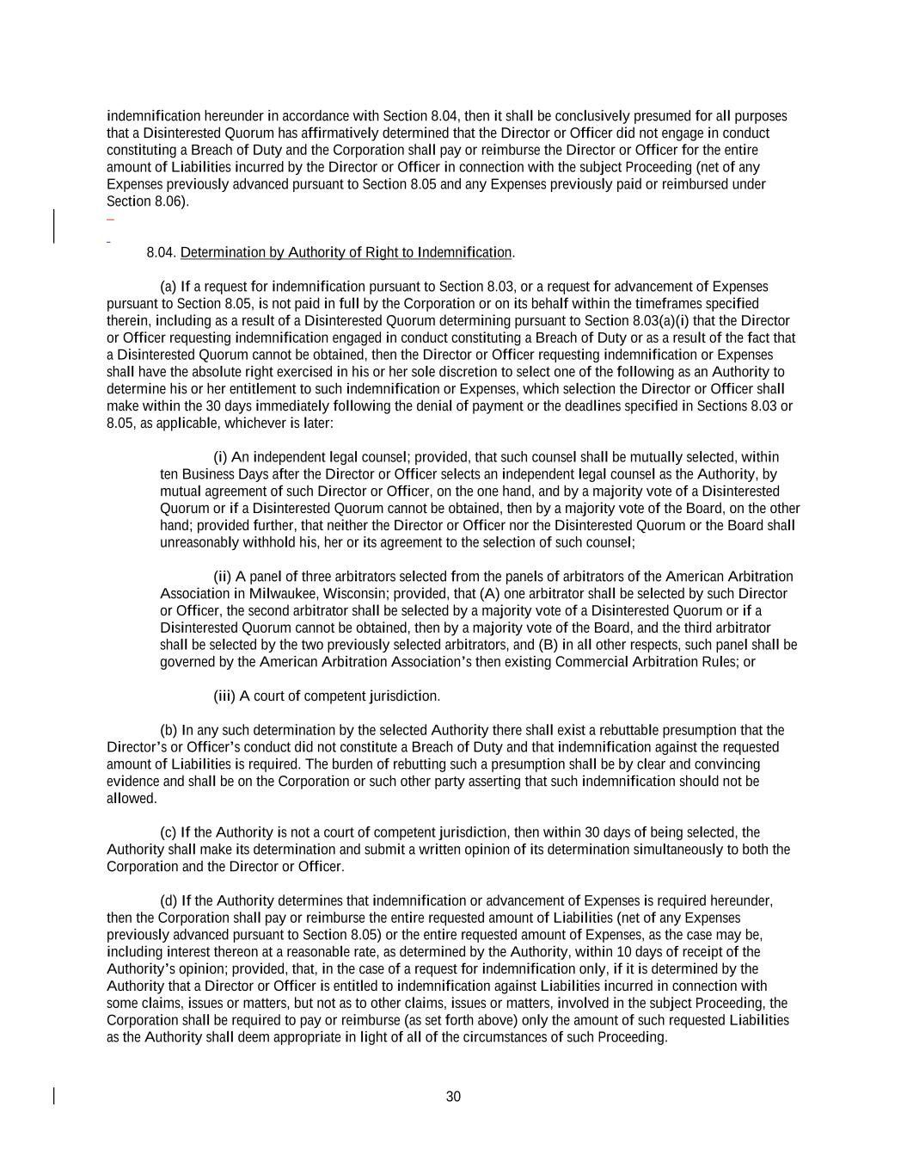
30 indemnification hereunder in accordance with Section 8.04, then it shall be conclusively presumed for all purposes that a Disinterested Quorum has affirmatively determined that the Director or Officer did not engage in conduct constituting a Breach of Duty and the Corporation shall pay or reimburse the Director or Officer for the entire amount of Liabilities incurred by the Director or Officer in connection with the subject Proceeding (net of any Expenses previously advanced pursuant to Section 8.05 and any Expenses previously paid or reimbursed under Section 8.06). 8.04. Determination by Authority of Right to Indemnification. (a) If a request for indemnification pursuant to Section 8.03, or a request for advancement of Expenses pursuant to Section 8.05, is not paid in full by the Corporation or on its behalf within the timeframes specified therein, including as a result of a Disinterested Quorum determining pursuant to Section 8.03(a)(i) that the Director or Officer requesting indemnification engaged in conduct constituting a Breach of Duty or as a result of the fact that a Disinterested Quorum cannot be obtained, then the Director or Officer requesting indemnification or Expenses shall have the absolute right exercised in his or her sole discretion to select one of the following as an Authority to determine his or her entitlement to such indemnification or Expenses, which selection the Director or Officer shall make within the 30 days immediately following the denial of payment or the deadlines specified in Sections 8.03 or 8.05, as applicable, whichever is later: (i) An independent legal counsel; provided, that such counsel shall be mutually selected, within ten Business Days after the Director or Officer selects an independent legal counsel as the Authority, by mutual agreement of such Director or Officer, on the one hand, and by a majority vote of a Disinterested Quorum or if a Disinterested Quorum cannot be obtained, then by a majority vote of the Board, on the other hand; provided further, that neither the Director or Officer nor the Disinterested Quorum or the Board shall unreasonably withhold his, her or its agreement to the selection of such counsel; (ii) A panel of three arbitrators selected from the panels of arbitrators of the American Arbitration Association in Milwaukee, Wisconsin; provided, that (A) one arbitrator shall be selected by such Director or Officer, the second arbitrator shall be selected by a majority vote of a Disinterested Quorum or if a Disinterested Quorum cannot be obtained, then by a majority vote of the Board, and the third arbitrator shall be selected by the two previously selected arbitrators, and (B) in all other respects, such panel shall be governed by the American Arbitration Association’s then existing Commercial Arbitration Rules; or (iii) A court of competent jurisdiction. (b) In any such determination by the selected Authority there shall exist a rebuttable presumption that the Director’s or Officer’s conduct did not constitute a Breach of Duty and that indemnification against the requested amount of Liabilities is required. The burden of rebutting such a presumption shall be by clear and convincing evidence and shall be on the Corporation or such other party asserting that such indemnification should not be allowed. (c) If the Authority is not a court of competent jurisdiction, then within 30 days of being selected, the Authority shall make its determination and submit a written opinion of its determination simultaneously to both the Corporation and the Director or Officer. (d) If the Authority determines that indemnification or advancement of Expenses is required hereunder, then the Corporation shall pay or reimburse the entire requested amount of Liabilities (net of any Expenses previously advanced pursuant to Section 8.05) or the entire requested amount of Expenses, as the case may be, including interest thereon at a reasonable rate, as determined by the Authority, within 10 days of receipt of the Authority’s opinion; provided, that, in the case of a request for indemnification only, if it is determined by the Authority that a Director or Officer is entitled to indemnification against Liabilities incurred in connection with some claims, issues or matters, but not as to other claims, issues or matters, involved in the subject Proceeding, the Corporation shall be required to pay or reimburse (as set forth above) only the amount of such requested Liabilities as the Authority shall deem appropriate in light of all of the circumstances of such Proceeding.

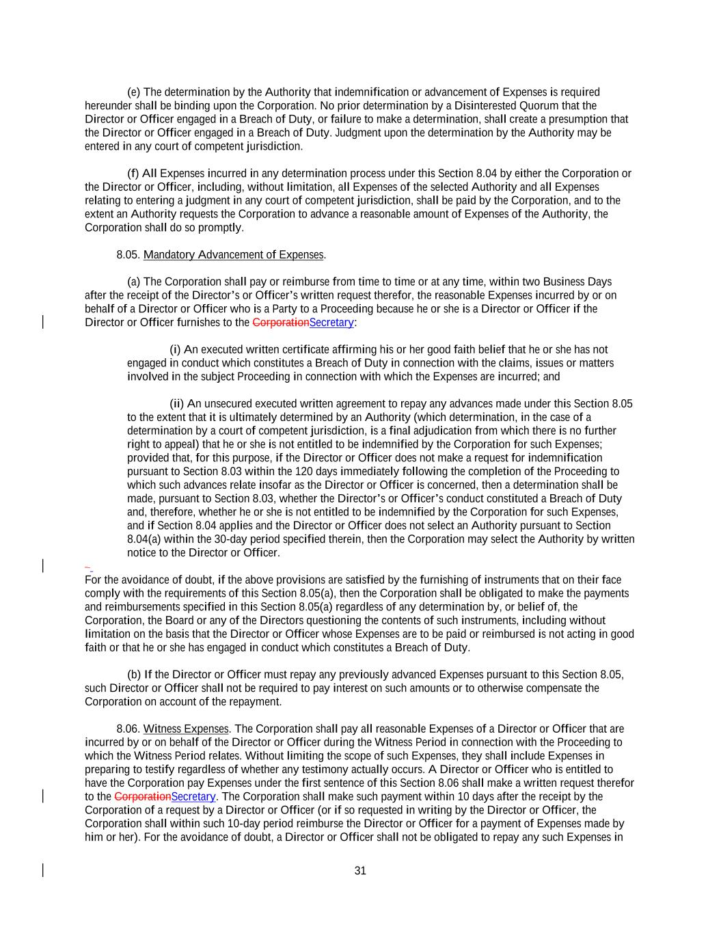
31 (e) The determination by the Authority that indemnification or advancement of Expenses is required hereunder shall be binding upon the Corporation. No prior determination by a Disinterested Quorum that the Director or Officer engaged in a Breach of Duty, or failure to make a determination, shall create a presumption that the Director or Officer engaged in a Breach of Duty. Judgment upon the determination by the Authority may be entered in any court of competent jurisdiction. (f) All Expenses incurred in any determination process under this Section 8.04 by either the Corporation or the Director or Officer, including, without limitation, all Expenses of the selected Authority and all Expenses relating to entering a judgment in any court of competent jurisdiction, shall be paid by the Corporation, and to the extent an Authority requests the Corporation to advance a reasonable amount of Expenses of the Authority, the Corporation shall do so promptly. 8.05. Mandatory Advancement of Expenses. (a) The Corporation shall pay or reimburse from time to time or at any time, within two Business Days after the receipt of the Director’s or Officer’s written request therefor, the reasonable Expenses incurred by or on behalf of a Director or Officer who is a Party to a Proceeding because he or she is a Director or Officer if the Director or Officer furnishes to the CorporationSecretary: (i) An executed written certificate affirming his or her good faith belief that he or she has not engaged in conduct which constitutes a Breach of Duty in connection with the claims, issues or matters involved in the subject Proceeding in connection with which the Expenses are incurred; and (ii) An unsecured executed written agreement to repay any advances made under this Section 8.05 to the extent that it is ultimately determined by an Authority (which determination, in the case of a determination by a court of competent jurisdiction, is a final adjudication from which there is no further right to appeal) that he or she is not entitled to be indemnified by the Corporation for such Expenses; provided that, for this purpose, if the Director or Officer does not make a request for indemnification pursuant to Section 8.03 within the 120 days immediately following the completion of the Proceeding to which such advances relate insofar as the Director or Officer is concerned, then a determination shall be made, pursuant to Section 8.03, whether the Director’s or Officer’s conduct constituted a Breach of Duty and, therefore, whether he or she is not entitled to be indemnified by the Corporation for such Expenses, and if Section 8.04 applies and the Director or Officer does not select an Authority pursuant to Section 8.04(a) within the 30-day period specified therein, then the Corporation may select the Authority by written notice to the Director or Officer. For the avoidance of doubt, if the above provisions are satisfied by the furnishing of instruments that on their face comply with the requirements of this Section 8.05(a), then the Corporation shall be obligated to make the payments and reimbursements specified in this Section 8.05(a) regardless of any determination by, or belief of, the Corporation, the Board or any of the Directors questioning the contents of such instruments, including without limitation on the basis that the Director or Officer whose Expenses are to be paid or reimbursed is not acting in good faith or that he or she has engaged in conduct which constitutes a Breach of Duty. (b) If the Director or Officer must repay any previously advanced Expenses pursuant to this Section 8.05, such Director or Officer shall not be required to pay interest on such amounts or to otherwise compensate the Corporation on account of the repayment. 8.06. Witness Expenses. The Corporation shall pay all reasonable Expenses of a Director or Officer that are incurred by or on behalf of the Director or Officer during the Witness Period in connection with the Proceeding to which the Witness Period relates. Without limiting the scope of such Expenses, they shall include Expenses in preparing to testify regardless of whether any testimony actually occurs. A Director or Officer who is entitled to have the Corporation pay Expenses under the first sentence of this Section 8.06 shall make a written request therefor to the CorporationSecretary. The Corporation shall make such payment within 10 days after the receipt by the Corporation of a request by a Director or Officer (or if so requested in writing by the Director or Officer, the Corporation shall within such 10-day period reimburse the Director or Officer for a payment of Expenses made by him or her). For the avoidance of doubt, a Director or Officer shall not be obligated to repay any such Expenses in

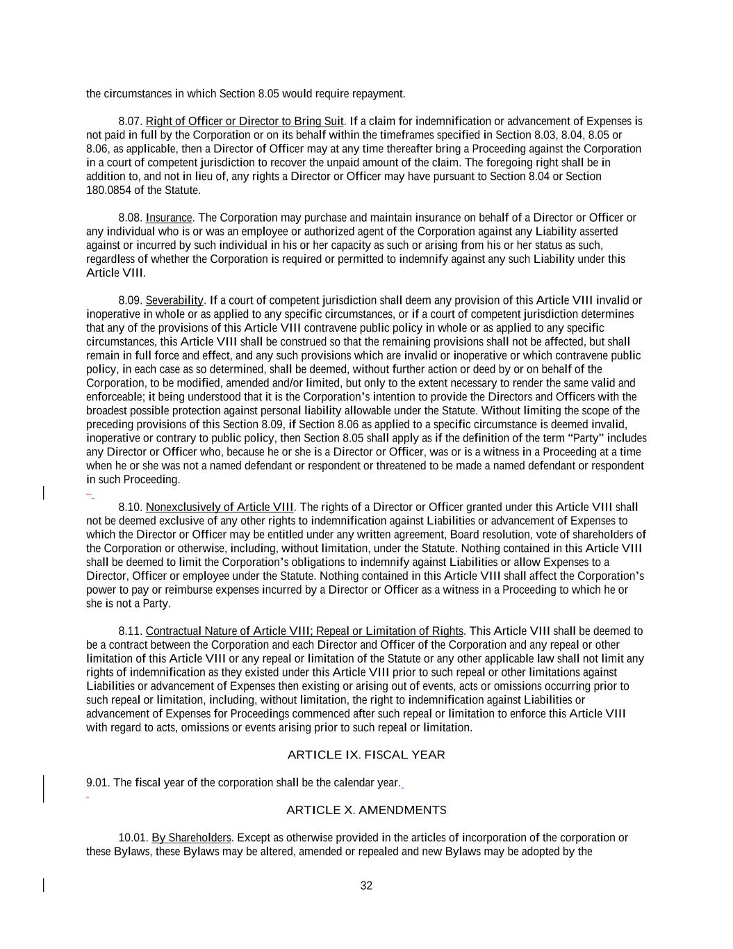
32 the circumstances in which Section 8.05 would require repayment. 8.07. Right of Officer or Director to Bring Suit. If a claim for indemnification or advancement of Expenses is not paid in full by the Corporation or on its behalf within the timeframes specified in Section 8.03, 8.04, 8.05 or 8.06, as applicable, then a Director of Officer may at any time thereafter bring a Proceeding against the Corporation in a court of competent jurisdiction to recover the unpaid amount of the claim. The foregoing right shall be in addition to, and not in lieu of, any rights a Director or Officer may have pursuant to Section 8.04 or Section 180.0854 of the Statute. 8.08. Insurance. The Corporation may purchase and maintain insurance on behalf of a Director or Officer or any individual who is or was an employee or authorized agent of the Corporation against any Liability asserted against or incurred by such individual in his or her capacity as such or arising from his or her status as such, regardless of whether the Corporation is required or permitted to indemnify against any such Liability under this Article VIII. 8.09. Severability. If a court of competent jurisdiction shall deem any provision of this Article VIII invalid or inoperative in whole or as applied to any specific circumstances, or if a court of competent jurisdiction determines that any of the provisions of this Article VIII contravene public policy in whole or as applied to any specific circumstances, this Article VIII shall be construed so that the remaining provisions shall not be affected, but shall remain in full force and effect, and any such provisions which are invalid or inoperative or which contravene public policy, in each case as so determined, shall be deemed, without further action or deed by or on behalf of the Corporation, to be modified, amended and/or limited, but only to the extent necessary to render the same valid and enforceable; it being understood that it is the Corporation’s intention to provide the Directors and Officers with the broadest possible protection against personal liability allowable under the Statute. Without limiting the scope of the preceding provisions of this Section 8.09, if Section 8.06 as applied to a specific circumstance is deemed invalid, inoperative or contrary to public policy, then Section 8.05 shall apply as if the definition of the term “Party” includes any Director or Officer who, because he or she is a Director or Officer, was or is a witness in a Proceeding at a time when he or she was not a named defendant or respondent or threatened to be made a named defendant or respondent in such Proceeding. 8.10. Nonexclusively of Article VIII. The rights of a Director or Officer granted under this Article VIII shall not be deemed exclusive of any other rights to indemnification against Liabilities or advancement of Expenses to which the Director or Officer may be entitled under any written agreement, Board resolution, vote of shareholders of the Corporation or otherwise, including, without limitation, under the Statute. Nothing contained in this Article VIII shall be deemed to limit the Corporation’s obligations to indemnify against Liabilities or allow Expenses to a Director, Officer or employee under the Statute. Nothing contained in this Article VIII shall affect the Corporation’s power to pay or reimburse expenses incurred by a Director or Officer as a witness in a Proceeding to which he or she is not a Party. 8.11. Contractual Nature of Article VIII; Repeal or Limitation of Rights. This Article VIII shall be deemed to be a contract between the Corporation and each Director and Officer of the Corporation and any repeal or other limitation of this Article VIII or any repeal or limitation of the Statute or any other applicable law shall not limit any rights of indemnification as they existed under this Article VIII prior to such repeal or other limitations against Liabilities or advancement of Expenses then existing or arising out of events, acts or omissions occurring prior to such repeal or limitation, including, without limitation, the right to indemnification against Liabilities or advancement of Expenses for Proceedings commenced after such repeal or limitation to enforce this Article VIII with regard to acts, omissions or events arising prior to such repeal or limitation. ARTICLE IX. FISCAL YEAR 9.01. The fiscal year of the corporation shall be the calendar year. ARTICLE X. AMENDMENTS 10.01. By Shareholders. Except as otherwise provided in the articles of incorporation of the corporation or these Bylaws, these Bylaws may be altered, amended or repealed and new Bylaws may be adopted by the

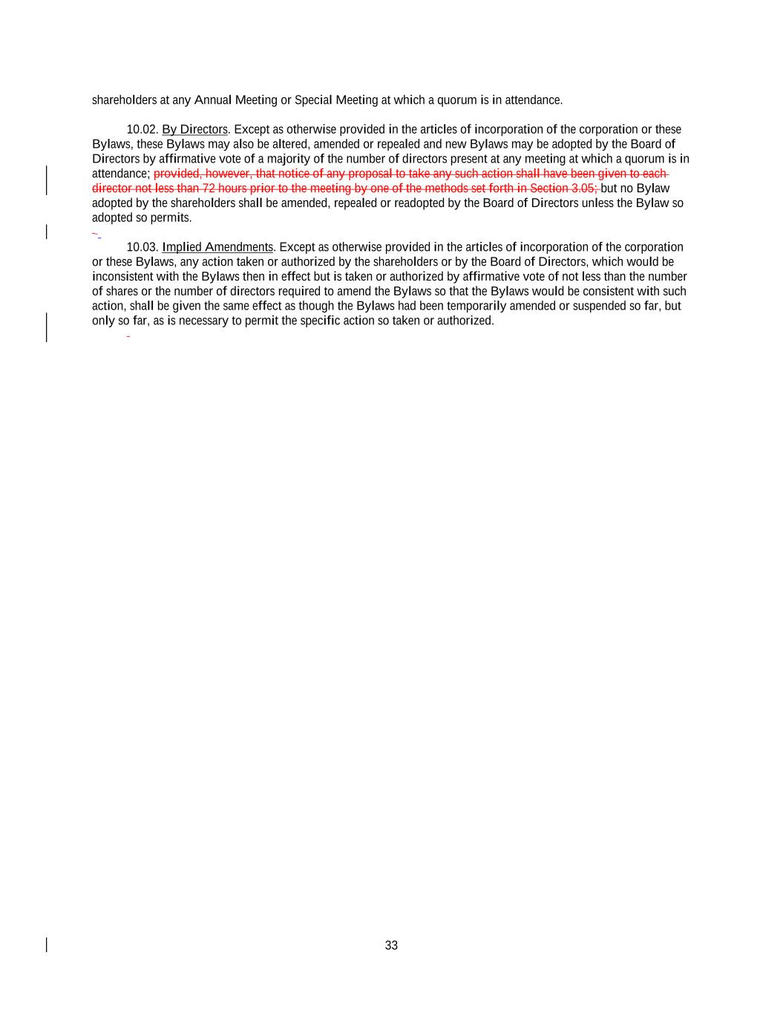
33 shareholders at any Annual Meeting or Special Meeting at which a quorum is in attendance. 10.02. By Directors. Except as otherwise provided in the articles of incorporation of the corporation or these Bylaws, these Bylaws may also be altered, amended or repealed and new Bylaws may be adopted by the Board of Directors by affirmative vote of a majority of the number of directors present at any meeting at which a quorum is in attendance; provided, however, that notice of any proposal to take any such action shall have been given to each director not less than 72 hours prior to the meeting by one of the methods set forth in Section 3.05; but no Bylaw adopted by the shareholders shall be amended, repealed or readopted by the Board of Directors unless the Bylaw so adopted so permits. 10.03. Implied Amendments. Except as otherwise provided in the articles of incorporation of the corporation or these Bylaws, any action taken or authorized by the shareholders or by the Board of Directors, which would be inconsistent with the Bylaws then in effect but is taken or authorized by affirmative vote of not less than the number of shares or the number of directors required to amend the Bylaws so that the Bylaws would be consistent with such action, shall be given the same effect as though the Bylaws had been temporarily amended or suspended so far, but only so far, as is necessary to permit the specific action so taken or authorized.

Exhibit 31.1
CERTIFICATIONS

I, Timothy J. Mattke, certify that:

1. |  |  | I have reviewed this quarterly report on Form 10-Q of MGIC Investment Corporation;
2. |  |  | Based on my knowledge, this report does not contain any untrue statement of a material fact or omit to state a material fact necessary to make the statements made, in light of the circumstances under which such statements were made, not misleading with respect to the period covered by this report;
3. |  |  | Based on my knowledge, the financial statements, and other financial information included in this report, fairly present in all material respects the financial condition, results of operations and cash flows of the registrant as of, and for, the periods presented in this report;
4. |  |  | The registrant's other certifying officer(s) and I are responsible for establishing and maintaining disclosure controls and procedures (as defined in Exchange Act Rules 13a-15(e) and 15d-15(e)) and internal control over financial reporting (as defined in Exchange Act Rules 13a-15(f) and 15d-15(f)) for the registrant and we have:
 |  |  | a) |  |  | Designed such disclosure controls and procedures, or caused such disclosure controls and procedures to be designed under our supervision, to ensure that material information relating to the registrant, including its consolidated subsidiaries, is made known to us by others within those entities, particularly during the period in which this report is being prepared;
 |  |  | b) |  |  | Designed such internal control over financial reporting, or caused such internal control over financial reporting to be designed under our supervision, to provide reasonable assurance regarding the reliability of financial reporting and the preparation of financial statements for external purposes in accordance with generally accepted accounting principles;
 |  |  | c) |  |  | Evaluated the effectiveness of the registrant's disclosure controls and procedures and presented in this report our conclusions about the effectiveness of the disclosure controls and procedures, as of the end of the period covered by this report based on such evaluation; and
 |  |  | d) |  |  | Disclosed in this report any change in the registrant's internal control over financial reporting that occurred during the registrant's most recent fiscal quarter (the registrant's fourth fiscal quarter in the case of an annual report) that has materially affected, or is reasonably likely to materially affect, the registrant's internal control over financial reporting; and
5. |  |  | The registrant's other certifying officer(s) and I have disclosed, based on our most recent evaluation of internal control over financial reporting, to the registrant's auditors and the audit committee of registrant's board of directors (or persons performing the equivalent functions):
 |  |  | a) |  |  | All significant deficiencies and material weaknesses in the design or operation of internal control over financial reporting which are reasonably likely to adversely affect the registrant's ability to record, process, summarize and report financial information; and
 |  |  | b) |  |  | Any fraud, whether or not material, that involves management or other employees who have a significant role in the registrant's internal control over financial reporting.

Date: July 29, 2026

/s/ Timothy J. Mattke
Timothy J. Mattke
Chief Executive Officer

Exhibit 31.2

CERTIFICATIONS

I, Nathaniel H. Colson, certify that:

1. |  |  | I have reviewed this quarterly report on Form 10-Q of MGIC Investment Corporation;
2. |  |  | Based on my knowledge, this report does not contain any untrue statement of a material fact or omit to state a material fact necessary to make the statements made, in light of the circumstances under which such statements were made, not misleading with respect to the period covered by this report;
3. |  |  | Based on my knowledge, the financial statements, and other financial information included in this report, fairly present in all material respects the financial condition, results of operations and cash flows of the registrant as of, and for, the periods presented in this report;
4. |  |  | The registrant's other certifying officer(s) and I are responsible for establishing and maintaining disclosure controls and procedures (as defined in Exchange Act Rules 13a-15(e) and 15d-15(e)) and internal control over financial reporting (as defined in Exchange Act Rules 13a-15(f) and 15d-15(f)) for the registrant and we have:
 |  |  | a) |  |  | Designed such disclosure controls and procedures, or caused such disclosure controls and procedures to be designed under our supervision, to ensure that material information relating to the registrant, including its consolidated subsidiaries, is made known to us by others within those entities, particularly during the period in which this report is being prepared;
 |  |  | b) |  |  | Designed such internal control over financial reporting, or caused such internal control over financial reporting to be designed under our supervision, to provide reasonable assurance regarding the reliability of financial reporting and the preparation of financial statements for external purposes in accordance with generally accepted accounting principles;
 |  |  | c) |  |  | Evaluated the effectiveness of the registrant's disclosure controls and procedures and presented in this report our conclusions about the effectiveness of the disclosure controls and procedures, as of the end of the period covered by this report based on such evaluation; and
 |  |  | d) |  |  | Disclosed in this report any change in the registrant's internal control over financial reporting that occurred during the registrant's most recent fiscal quarter (the registrant's fourth fiscal quarter in the case of an annual report) that has materially affected, or is reasonably likely to materially affect, the registrant's internal control over financial reporting; and
5. |  |  | The registrant's other certifying officer(s) and I have disclosed, based on our most recent evaluation of internal control over financial reporting, to the registrant's auditors and the audit committee of registrant's board of directors (or persons performing the equivalent functions):
 |  |  | a) |  |  | All significant deficiencies and material weaknesses in the design or operation of internal control over financial reporting which are reasonably likely to adversely affect the registrant's ability to record, process, summarize and report financial information; and
 |  |  | b) |  |  | Any fraud, whether or not material, that involves management or other employees who have a significant role in the registrant's internal control over financial reporting.

Date: July 29, 2026

/s/ Nathaniel H. Colson
Nathaniel H. Colson
Chief Financial Officer

Exhibit 32

SECTION 1350 CERTIFICATIONS

The undersigned, Timothy J. Mattke, Chief Executive Officer of MGIC Investment Corporation (the "Company"), and Nathaniel H. Colson, Chief Financial Officer of the Company, certify, pursuant to Section 906 of the Sarbanes-Oxley Act of 2002, 18 U.S. C. Section 1350, that to our knowledge:

(1)the Quarterly Report on Form 10-Q of the Company for the three months ended June 30, 2026 (the "Report") fully complies with the requirements of Section 13(a) or 15(d) of the Securities Exchange Act of 1934; and
(2)the information contained in the Report fairly presents, in all material respects, the financial condition and results of operations of the Company.

Date: July 29, 2026

/s/ Timothy J. Mattke
Timothy J. Mattke
Chief Executive Officer
/s/ Nathaniel H. Colson
Nathaniel H. Colson
Chief Financial Officer

